Drag on two co-axial rigid spheres moving normal to a plane: newtonian and Carreau fluids
J. P. Hsu, S. C. Yang, J. C. Chen
Department of Chemical Engineering, National Taiwan University, Taipei10617, Taiwan

1. Summary
The boundary effect and the presence of a nearby entity on the drag of a rigid entity is investigated by considering the movement of two identical, rigid, coaxial spheres normal to a plane in both a Newtonian and a Carreau fluid at a low to medium large Reynolds number. The parameters key to the phenomenon under consideration, including the nature of the fluid, the separation distance between two spheres, the distance between the near sphere and the plane, and the Reynolds number, on the drag coefficient are discussed. We show that the influence of a boundary on the drag coefficient is more important than that of the nature of a fluid and that of the separation distance between two spheres. The variation of the drag coefficient as a function of Reynolds number for a Carreau fluid is similar to that for a Newtonian fluid. Due to the shear-thinning nature of the former the drag coefficient in the former is smaller than that in the latter. The influence of the index parameter of a Carreau fluid becomes appreciable only if the Carreau number is sufficiently large. Correlations between the drag coefficient and the key parameters of a system are developed for the case when the Reynolds number is smaller than unity.

Keywords: sedimentation; two coaxial rigid spheres, Newtonian and Carreau fluid, boundary effect, normal to a plane, drag coefficient

2. Introduction
Evaluation of the drag on a particle as it moves in a fluid medium is a classic problem, and is of both fundamental and industrial importance. Sedimentation, which is often adopted to estimate the physical properties of a particle and is a typical unit operation in water and wastewater treatment, for example, involves this problem. Although both experimental and theoretical results are ample in the literature, the drag on a particle under general conditions has not been reported, and relevant investigations remain active. The difficulty involved depends largely on the degree of complexity of the associated flow field, which is related to the geometry of a particle, the nature of fluid medium, and the level of Reynolds number. In practice, the influence of neighbouring particles and that of a boundary also need be considered. These factors are usually taking into account by a correction factor, which is a function of the Reynolds number, the size and the geometry of a particle, and its relative position and distance from a boundary. For non-Newtonian fluids, the problem becomes even more complicated since the viscosity could be position dependent. Several attempts have been made to investigate the sedimentation of an isolated particle in a non-Newtonian fluid (Chhabra, 2007).

In this study the effects of the presence of a boundary and neighboring particles and the nature of fluid medium on the behaviour of a rigid sphere is investigated by considering two identical, coaxial spheres moving normal to a plane, both in a Newtonian and in a shear-thinning Carreau fluid. The flow field is solved numerically based on a finite element scheme and the influences of the key parameters of the system under consideration, including the separation distance between two spheres, the distance between a sphere and a plane, the Reynolds number, and the properties of a fluid, on the drag coefficient of a sphere are discussed.

3. Theory
Referring to Fig. 1, we consider the moving of two identical, rigid, coaxial spheres of radius r and diameter D normal to a plane with constant velocity u_{t}. Let h be the distance between the centre of the near sphere and the plane and S be the centre-to-centre distance between two spheres. The coordinates (x,y,z) with its origin located at the centreline of system are adopted. For convenience, both spheres are fixed in the space and the plane and the fluid moving with a relative velocity $u_{t}$ in the reverse direction.

In our case, the governing equations for the flow field need to be solved by taking the effect of shear thinning into account. To this end, FIDAP, a commercial software based on finite element scheme is adopted. The applicability of this software is justified by comparing the results obtained with the corresponding analytical results of Happel and Brenner (1983) for both a rigid sphere moving normal to a plane in a Newtonian fluid and two identical rigid spheres in an unbound Newtonian fluid.

4. Conclusions
The effects of the presence of a boundary and a nearby particle on the drag on a particle is investigated by considering two identical, co-axial, rigid spheres moving normal to a plane both in a Newtonian and in a Carreau fluid for a low to medium large Reynolds number. We show that the behaviors of the drag coefficient as the sphere-sphere distance and the sphere-boundary distance vary for the case of a Carreau fluid are similar to those for the case of a Newtonian fluid, except that the drag coefficient in the former is smaller than that in the latter. The influence of the boundary on the drag coefficient is more appreciable than that of the fluid nature. The influence of the index parameter of a Carreau fluid on the drag coefficient is insensitive to the level of Reynolds number; that influence becomes appreciable only if the Carreau number is sufficiently large. Regardless of the level of the Reynolds number, the critical separation distance, the sphere-boundary distance beyond which the boundary effect is unimportant, of the far sphere declines with the increase in the separation distance between two spheres. For the near sphere at a low Reynolds number, the critical separation distance increases with the increase in the separation distance between two spheres. For both spheres, the more significant the shear-thinning nature of a Carreau fluid, the shorter the critical separation distance is.

Acknowledgment
This work is supported by the National Science Council of the Republic of China.

References

Chhabra, R. P., Bubbles, Drops and Particles in Non-Newtonian Fluids, CRC Taylor & Francis, New York (2007).

Happel, J. and Brenner, H., Low Reynolds Number Hydrodynamics. Academic Press, New York (1983).

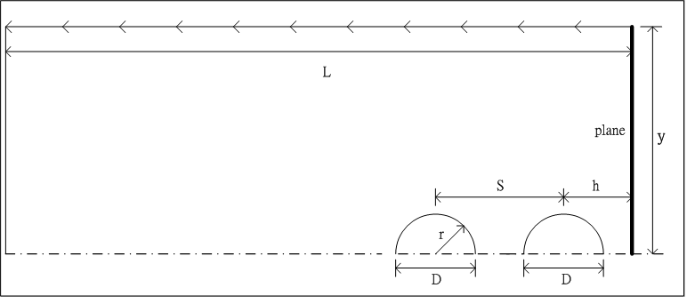
far sphere near sphere

Figure 1: Schematic representation of the problem considered

