Elimination of organic compounds in wastewater by advanced oxidation technologies (Abstract Nº 1201)

Santiago Rojano,ª Ángel Fernández,ª
Municipal Water Company of Malaga, Department of Research and Water Quality.
EDAR Guadalhorce, Crta. Azucarera-Intelhorce; Málaga-29004; Spain
E-mail: srr@emasa.es

- Summary
A rapid development of industry and other activities and the increment of population in last years is origining a serious problem of environmental pollution. Advanced oxidation technologies are proving to be important contributions to the treatment of water and air to remove harmful and toxic substances. These methods are very important because can degrade organic pollutants under moderate conditions.

The fundamental goal of this research work is the breakdown of the organic pollutants present in urban wastewater via advanced oxidation treatment. In our particular case, we used and evaluated some of these techniques, such as heterogenous photocatalysis with ultraviolet light using titanium dioxide as a catalyst and the photo-Fenton process. We have applied these procedures to mixtures of organic pollutants and; subsequently, to urban wastewater samples which have been purified via secondary biological treatment and proceed to evaluate the elimination performance of each technique.

Keywords: wastewater, pollutants, elimination, photocatalysis, Fenton

2. Extended abstract
A first objective of this research work consists in a study of the yield of advanced oxidation on degradation of pollutants mixtures in water. The photoreactor designed is formed by a cylindrical recipient of 3 liters of volume. The UV radiation comes from a half-pressure (125 w) mercury vapour lamp with a cooling jacket around it to avoid any thermal influences affecting the chemical processes taking place inside the reactor. This lamp is placed traversely to the reactor. The reactor possesses a magnetic system of agitation and key to extract samples. It has an entrance of synthetic air of high purity at three different levels. The air flow is 5 ml/minutes. The system leading to the production of hidroxyl radicals in solution. The hidroxyl radicals are species strong oxidizers than attack and destroy chemically to water pollutants. In this work, mixtures of organic pollutants are treated by heterogeneous photocatalysis with titanium dioxide and effect photo-Fenton. The whole process is carried out ambient temperature.

On the other hand, it was realiced a analysis of effect adittion of oxidants agents in order to increase degradation of pollutants. After treatment for 120 minutes, total organic carbon initial (TOC) was reduced to 44%, 25% y 91% with titanium dioxide, potassium peroxodisulphate and titanium dioxide, hydrogen peroxide and titanium dioxide, respectively.

Respect to photo-Fenton process, it leads to reduction of 87% total organic carbon initial in 120 minutes in the studied conditions. It is very important the high degradation conversion has been obtained in many of the studied cases. For this reason, advanced oxidation processes could be used for degradation of organic pollutants in wastewater.

The research work continues by application of photocatalysis with titanium dioxide and Fenton method to samples of urban wastewaters coming from a secondary biological treatment. We were carried out different experiences varying semiconductor concentration and solution pH to study the influence on degradation of organic matter contained in urban wastewater. In all cases, the degradation was evaluated by analysis of total organic carbon (TOC) in function of reaction time.

Comparing the two processes carried out, we can stress that the photo-Fenton method is faster during the early stages of reaction (0-40 minutes). For longer periods of operation (between 180 and 240 minutes) the degradation conversions of both methods tend to be similar and the final conversion of elimination of TOC is 90-95 %.

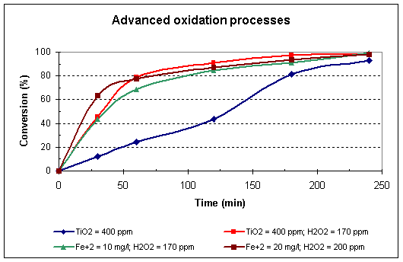
Graph: Degradation conversion in photocatalytic and Photo-Fenton tests.

3. References

Oppenlander, T. Photochemical Purification of Water and Air, Ed. Wiley-VCH (2002)

