Use of AI and data analytics in electric power distribution

Linas Mockus1, Bri-Mathias Hodge2, and Gintaras Reklaitis1  
1Purdue University, West Lafayette, IN, 47906, USA  
2National Renewable Energy Laboratory, Golden, CO 80401, USA

In this work we present a framework that employs AI and data analytics for the design and operation of electric power distribution systems. The novelty of the framework lies in the integrated application of the above tools to help with robust design/operation of electric power distribution systems. The framework will be exemplified by a case study with stochastic commercial and residential customer demands, as well as disruptions in primary and secondary distribution lines. The objective is to minimize power disruptions in the face of random demands and faults in distribution lines. It is important to note that both simulated and field data may be handled within this framework. The case study is based on simulated data.

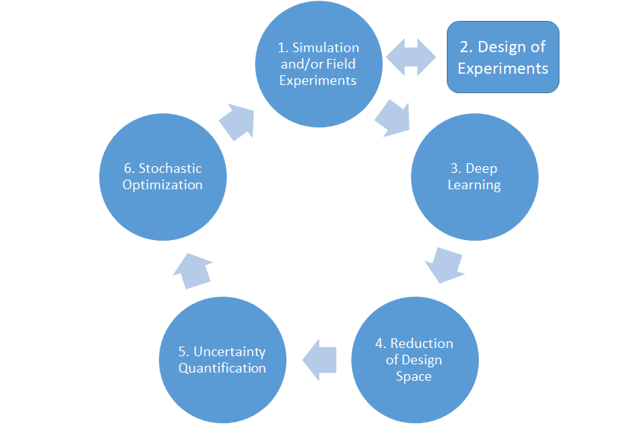

Figure 1. The proposed framework for robust design/operation

The framework includes the following major parts:

1. Simulation of the electric power distribution scenario in silico,
2. Design of Experiments (DoE) to explore the design space,
3. Deep learning to develop a model which relates design variables with specified power delivery metrics by using in silico and/or field data,
4. Reduction of the design space based on the Automatic Relevance Detection (ARD) of important inputs,
5. Uncertainty quantification (UQ) to quantify the uncertainty in power delivery metrics by employing the deep learning model,
6. Stochastic optimization of the electric power distribution system to determine where to invest resources to reach desired level of robustness, and
7. Determination if the design space needs to be explored further.

The illustrative example is a simple IEEE 34 bus test feeder (Stanisavljević, Katić, Dumnić, & Popadić, 2018). It was chosen for simplicity and because this grid is a customized version of the actual grid with nominal voltage of 24.9 kV, which is located in Arizona. The characteristics of this grid include: a very long grid, lightly loaded, two in-line regulating transformers designed to provide an acceptable voltage profile, one in-line transformer that powers a short section of the grid, unbalanced load and a shunt capacitor.

**1. Modeling & Simulation (M&S) of the electric power grid.** This step is needed to generate data for the subsequent step of deep learning. For illustrative purposes we have utilized OpenDSS (ERPI, 2016) but any electric power distribution M&S platform could be used instead. We chose OpenDSS since it has an interface with Python what allows running multiple electric power distributions concurrently.

**2. Design of experiments.** Design of experiments is key to provide adequate coverage of the design space. In our example the design space is defined by potential primary and secondary distribution line failures as well as the stochastic nature of commercial and residential customer demands. In the case study the number of failed lines were modelled via Poisson distribution and customer demands fluctuated around nominal load following normal distributions with knowns coefficients of variation.

**3. Deep Learning.** The deep learning step is employed to construct a model of how possible line failures and stochastic demands lead to smaller or larger electric power delivery metrics. The metric we have used is total undelivered power to the commercial and residential customers which are represented by corresponding loads. For this study we have used Bayesian neural networks to construct a stochastic classification model of how the metrics relate to line failures. The stochastic model is needed for the uncertainty quantification step.

**4. Reduction of the design space.** The step of design space reduction is based on automatic relevance determination (ARD) (Husmeier, 1999) which is an integral part of Bayesian neural network (BNN) (Neal, 1996) or Bayesian regularized artificial neural networks (BRANNs) (Burden & Winkler, 2008). Based on neural network weight estimates some input variables corresponding to failed primary/secondary delivery lines are concluded to be of no or little importance and therefore may be excluded thus effectively reducing the dimensionality of the design space. This a very important step in order to achieve real-time performance. Figure 2 shows the importance of different electric power distribution lines. Vertical axis correspond to 75 percentile of weight estimates provided by BNN. Lines with low importance may be removed from the model in order to reduce the design space and make the stochastic optimization problem more tractable. This is essential for accommodating large realistic problems such as Bay Area Synthetic Network (Mateo Garcia, Duenas Martinez, Elgindy, & Palmintier, 2018).

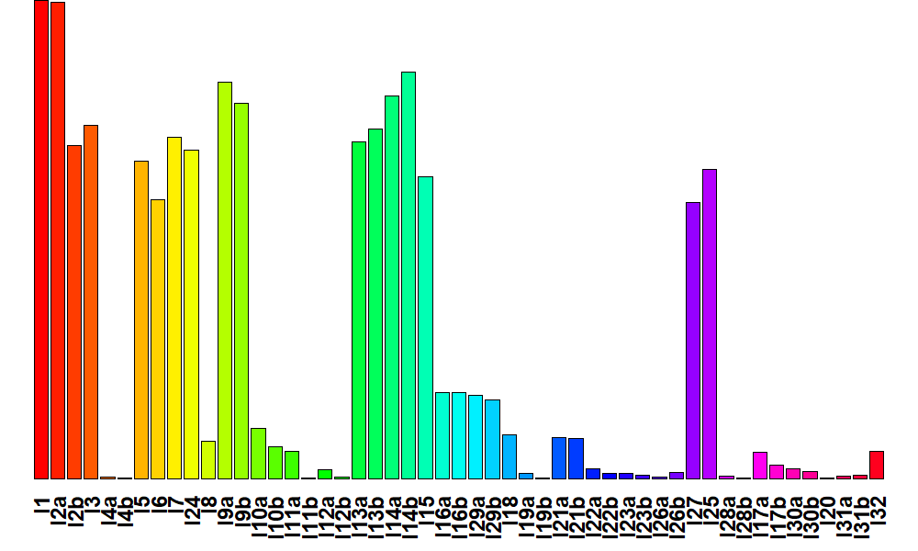

Figure 2. The importance of electric power delivery lines

**5. Uncertainty quantification (UQ).** The uncertainty quantification step consists of backward propagation of simulated in silico and/or field data through constructed neural network model to calibrate model parameters and forward propagation to determine the probability distributions for the metrics. In our case this serves to quantify the probability of undelivered power for different scenarios of line failures and stochastic demands at the desired confidence level. The UQ must be intimately integrated with a deep learning step. Both backward and forward propagation is a relatively straightforward procedure when using Bayesian neural networks for deep learning. The procedure is bit more complicated when using a traditional neural network model, but it might be required for real-time applications where computer clusters are not available.

**6. Stochastic optimization.** The last step is integrating the knowledge about the electric power delivery performance and determining where to invest resources to maximize robustness by employing stochastic optimization to the stochastic model attained by applying the uncertainty quantification. The neural network model combined with stochastic neural network weights serves as an input to the stochastic optimization procedure. The choice of scenarios for stochastic optimization involves a clustering algorithm which determines clusters of parameter values that lead to specified probability of power delivery metrics. In addition to those clusters the worst-case scenarios have to be determined from the constraints such as the number of lines to upgrade so as not to exceed practical limits (usually governed by cost). This is to ensure that the solution provided by a stochastic optimization procedure is robust.

In our case study we assume that resources are available to upgrade only three electric power distribution lines. The results of Differential Evolution algorithm (Storn & Price, 1997) used to minimize the expected undelivered power showed that resources should be allocated to upgrade lines l1, l2a, and l3. This confirmed our intuition since lines l1 and l2a are most important while l3 is also one of the most important electric power distribution lines. The steps need to be repeated if it is found that a desired level of robustness is not reached or for some other reasons. As part of future work, we are planning to apply the presented framework to Bay Area Synthetic Network. While we have used total undelivered power as performance metric, small customers might be removed in the model reduction step. Utilities have an obligation to serve all customers, so the loss of one customer for a long period of time is an issue. Thus, we also plan to utilize a more realistic metric such as the System Average Interruption Duration Index (SAIDI) or System Average Interruption Frequency Index (SAIFI) metrics.

# Acknowledgement

This work used the Extreme Science and Engineering Discovery Environment (XSEDE), which is supported by National Science Foundation grant number ACI-1548562.

# References

Burden, F., & Winkler, D. (2008). Bayesian regularization of neural networks. *Methods Mol Biol. , 458*, 25-44.

ERPI. (2016). *Distribution system Simulator, OpenDSS.* Retrieved from http://sourcefore.net/projects/electridsss

Husmeier, D. (1999). Automatic Relevance Determination (ARD). In *Neural Networks for Conditional Probability Estimation.* London: Springer.

Mateo Garcia, C., Duenas Martinez, P., Elgindy, T., & Palmintier, B. (2018, Feb 28). Retrieved from http://item.bettergrids.org/handle/1001/401

Neal, R. M. (1996). Bayesian Learning for Neural Networks. Springer.

Stanisavljević, A. M., Katić, V. A., Dumnić, B. P., & Popadić, B. P. (2018). A Brief Overview of the Distribution Test Grids with a Distributed Generation Inclusion Case Study. *Serbian Journal of Electrical Engineering, 15*(1), 115-129.

Storn, R., & Price, K. (1997). Differential evolution - a simple and efficient heuristic for global optimization over continuous spaces. *Journal of Global Optimization, 11*(4), 341–359.