Data Science Enablement with time series data using PI Integrators and OSIsoft Cloud Services
Akhilesh Jain*, Elizabeth Ammarell, Joy Wang, Landry Khounlavong
OSIsoft LLC.
San Leandro, CA 94577
Abstract Overview
Cleaning, shaping and contextualizing operational data to prepare it for advanced analytics projects requires coding or scripts and consumes significant amount of resources. OSIsoft’s PI System offers on-prem and cloud products as self-service data preparation tools that significantly reduce the time to prepare operational data for analysis within advanced analytics platforms. Using PI Integrators for Business Analytics and Data views in OSIsoft Cloud Services, subject matter experts can create trustworthy operational datasets for tools and platforms familiar to business users, analysts and data scientists effectively and iteratively. This document showcases how organizations are accelerating data science workflows and achieving their analytics goals by using PI Integrators for Business Analytics and Data views in OSIsoft Cloud Services.

Keywords
Data quality, cloud, data processing.
Introduction

Pre-processing data to prepare it for data science and machine learning projects consumes a significant amount of resources allocated to advanced analytics project. Pre-processing includes cleaning, shaping and contextualizing data to make it trustworthy and decision ready. Codes or scripts are used to identify issues related to data quality, fix them and send it to analytics tool of choice. This requires specialized knowledge of scripting and makes reiterating the process very challenging. We propose on-prem and cloud services which can shape time-series data from the PI System for use in a variety of analytics tools and platforms, accelerate workflows and optimize resources for analytics projects. In this document, we discuss two such offerings from OSIsoft: PI Integrators for Business Analytics and Data views in OSIsoft Cloud Services.

PI Integrators for Business Analytics
PI Integrator for Business Analytics transforms PI System data into a decision-ready format that can be consumed by business intelligence (BI) tools, such as Microsoft Power BI, Tableau, Tibco Spotfire, and QlikView. With BI tools, you can run retrospective analyses on large sets of your real-time PI System data. Such analyses make operational behaviors and patterns visible, so you can identify dependencies and correlations between different aspects of your operations. The advantages of using PI Integrator for Business Analytics are:

- Large data sets can be easily selected and imported. No coding is required to prepare the data and no knowledge of the source data is required.
- The size of the data set can be scaled up without requiring customization of the data importing procedures.
- PI System data can be merged with other data sets for aggregate-level analysis and consumed by a variety of business intelligence tools, data warehouses, and streaming platforms.
- Published data is synchronized with the PI System and automatically updated to reflect changes.
- Data is refreshed on a schedule or in response to changes to key values.
- The web-based user interface is easy to use, requiring no installation by end users.

Data Views in OSIsoft Cloud Services (OCS)
OSIsoft Cloud Services is operational cloud data platform which allows aggregation of data from multiple PI systems, cloud edge data sources all hosted and managed by OSIsoft.
With OCS, data views can be created which are user-selected subset of data stored in OSIsoft Cloud Services mapped into a customizable table format. A data view includes related data usually designed for use with a specific application or analysis. Data is selected using a query for one or more data items. Each column in a data view is mapped to a property of one or more data items. Data items can optionally be organized into data groups within the data view in order for users to more easily compare similar properties in the same column of a data view.
Data views provide the scale and resiliency for enterprise support that comes with the cloud architecture. OCS exposes the data as tabular datasets to allow for queries directly to the cloud. This minimizes redundant copying of data. OCS also provides programmatic data view creation and data retrieval with REST API.
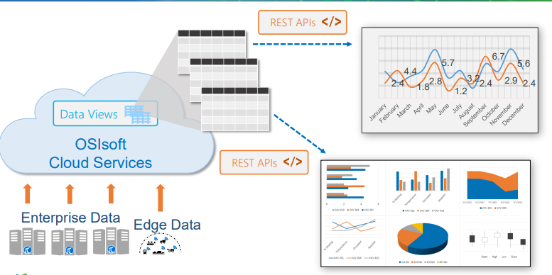

Figure 1. Data Views in OSIsoft Cloud Services

Conclusions
We have presented PI Integrators for Business Analytics and Data Views in OSIsoft Cloud Services as solution for sending data from PI system, cloud and other edge data sources to various analytics tools and platform. These applications help optimize the resources required for pre-processing the data and accelerate the data science workflows for achieving project goals.

* To whom all correspondence should be addressed

