Color monitoring in the manufacture of extruded polymer recycle
Ellen C. Keene*, Mark A. Rickard, Shari L. Kram, Stephanie Donati, Dane Powell
DuPont
Midland, Michigan 48642
Abstract Overview
Scrap material is generated during the manufacturing of extruded polymer products. This material is recycled by passing it through a secondary extruder. Optimization of operating discipline for managing recycled material, including avoidance of poor-quality recycle and its introduction into the primary extruder, can result in direct cost savings, and profit increases. Color of the recycled material is directly related to degradation of the extruded polymer. Therefore, an automated online color analysis system was developed to measure and evaluate color of extruded polymer for the recycle line. This machine vision imaging system provides real-time feedback to plant personnel. In the long term, color evaluation can also aid in process control by gaining a fundamental understanding of the relationship between plant operating conditions and recycle quality. Correlation development between color and other extruded polymer quality metrics is ongoing.

Keywords
FOPAM, process control, manufacturing, online imaging, machine vision, color analysis, extruded polymer
Introduction

Process control is critical in manufacturing environments. Color measurements are in manufacturing because they can correlate color to a material property or state. Therefore, careful evaluation of material color can help in manufacturing process control. For example, color can be used for product discrimination for inspection and sorting, measuring and matching, or color based material quality characteristics. Color, however, is a perception and not a physical property of an object. Perception of color depends on the object illumination, spectral reflectance, and the observer. Color evaluation by optical imaging measures color over a defined region and control over lighting and imaging geometry are necessary for robust, reproducible measurements. It is important to note that machine vision systems are not CIE calibrated and cannot give details about the visible spectrum like a colorimeter or spectrometer.
In the manufacture of extruded polymer, scrap material is generated and much of this material is recycled back through the production line. Prior to introduction into the primary extruder, the scrap material gets fed through a secondary extruder to convert the scrap back into a useable input (pellets) for mainline production. During process excursions, the recycled material can degrade resulting in poor-quality pellets. The color of the material is directly related to degradation chemistry and therefore, it is one metric of quality that can be easily monitored online. Therefore, an online color analysis method was desired to provide real-time feedback to plant personnel to more closely monitor recycle quality and improve control over the recycle process. In this application color evaluation was done by machine vision imaging with a color camera. The color camera acquires a RGB image using three color Bayer filter array (red, green, blue). Here, the extruded material was imaged and an image processing routine was developed such that each color can be measured, using L*a*b* color space, and changes in color are evaluated by a ΔE calculation to plot trends over extended time periods. Additionally, color statistics, such as mean and variances computed on a per-component (L*a*b*) basis over regions of interest are also collected. For any color deviations from the norm, process data are also collected for ongoing model development regarding polymer color, process conditions, and final product quality metrics.
Optical Imaging Setup and Color Evaluation
An online color analysis imaging set-up was installed using a high-resolution digital camera (JAI GO-5000C) equipped with a Ricoh 35 mm (FL-BC3518-9M) machine vision lens. The camera and lens were mounted inside a video module case (Tectivity; VMM085X055-J1) to protect the camera and lens from stray dust and water from the plant environment. A small LED spot light (Advanced Illumination, SL164-WHI) was installed parallel to the camera. Both camera and spot light were mounted ~45˚ to the side of the recycle extruder water bath approximately 10” from the extruded strand using articulated arms (Manfrotto Magic Arm 244) and clamps (Manfrotto Super Clamp 035RL and Camera Platform 143BKT). The imaging setup is shown in Figure 1.

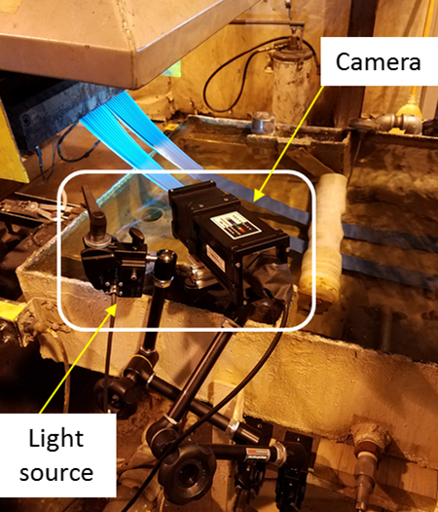
Figure 1: Optical Imaging Setup
Video recordings were saved as image sequences in a portable network graphics (PNG) image file format and analyzed in a Python image acquisition and processing script. The software script was designed to run unattended and real-time color data is displayed on a monitor in the production plant control room. The program acquires images at a user-defined time interval (default is 2.5 minutes) and evaluates variation in the mean color value in a region of interest (ROI) in L*a*b* color space. The mean and standard deviation of the L*, a*, and b* color channels as well as the calculated ΔE values are saved to a master spreadsheet. The online color analysis user interface, shown in Figure 2, displays the raw RGB image, the thresholded ROI image as well as color trend plots of the L*, a*, b*, and ΔE values.

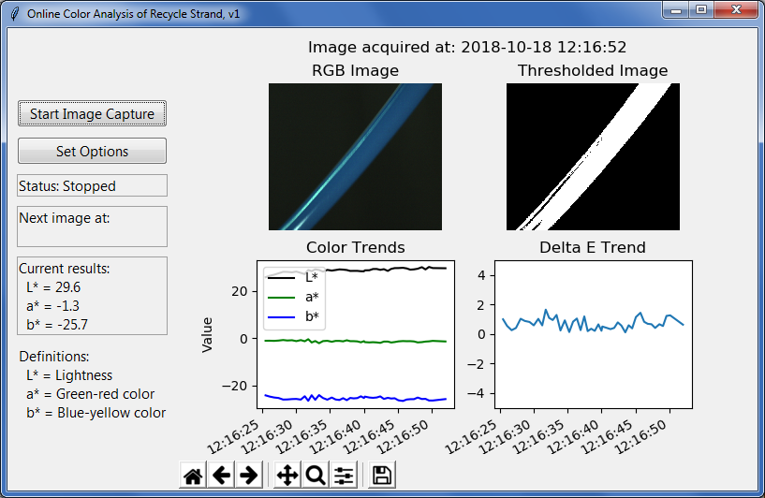
Figure 2: User interface for Online Color Analysis of Extruded Polymer Recycle Strand
Results and Discussion
The online color imaging system, set up in the manufacturing environment, has been found to provide valuable information regarding changes in the state of the recycled extruded polymer. During early proof of concept experiments, the same polymeric materials was repeatedly fed through a lab-scale extruder. The color was monitored with each pass and samples of the polymer were also collected for additional analytical testing. A direct correlation between polymer degradation products and change in sample color was observed with each subsequent pass of the material through the extruder (Figure 4).
Relevant plant conditions are collected whenever there is a change in the observed baseline color trend. For example, sample color changes were observed when the recycle extruder operating conditions were changed such as operating current or residence time. Additionally, discharge gel temperature was observed to have a direct impact on the color of the recycle polymer.
In the long term, color evaluation can aid in process control by gaining a fundamental understanding of the relationship between plant operating conditions and recycle quality as well as generate a list of root causes for off-spec colored material. Development of a correlation between color and various extruded polymer quality metrics is ongoing.

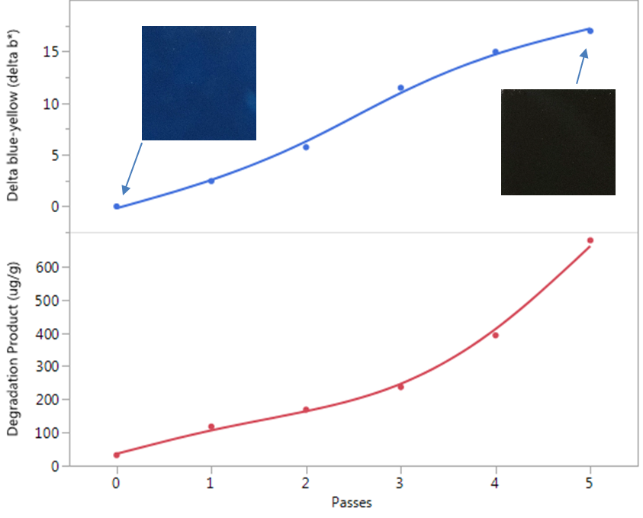Figure 4: Correlation between sample color change and degradation products
Conclusion
An online color analysis system was successfully implemented in a manufacturing environment. Real-time monitoring of extruded polymer strand gives operators feedback of the recycle process from the control room. Data collection has led to a greater understanding of the product color baseline and development of a statistical model connecting color changes with plant operating conditions and extruded polymer quality metrics are ongoing.

* To whom all correspondence should be addressed

