HyBrid Models: How can we teach physical laws to machine learning?
Harini Narayanan*, Michael Sokolov, Massimo Morbidelli and Alessandro Butté
Institute of Chemical and Bioengineering, ETH Zurich
Zurich, Switzerland
Abstract Overview
With most of the industries undergoing digital transformation and Quality by design being emphasized for (bio) pharmaceutical industries, the importance of process models has been realized in the recent times. Owing to the complex nature of the bioprocess, multivariate analysis and advanced machine learning techniques have been used for several applications. These process models can be made more robust by teaching them physical laws through hybrid semi parametric modeling. The advantages of such approach for microbial cultures have been demonstrated earlier. We quantitatively show the superiority of such models for mammalian cell culture in terms of accuracy, extrapolation and interpolation capabilities.

Keywords
Hybrid modeling, Process Analytics, Predictive models, Process Design and Optimization.
Introduction

Over the last few years, the biopharmaceuticals market has witnessed tremendous growth reaching a value of worth $186,470 million in 2017. Now, the biggest challenge of the industry is to produce high-quality products in a cost-effective manner. Additionally, the regulatory agencies such as FDA and EMA have in recent years emphasized on Quality by Design (QbD) in contrast to the traditional method of Quality by testing. To meet the market demands and to realize QbD, there is a need for rapid and efficient process development that calls for the use of model-based methods to assist at several stages of process development, monitoring, and control. To add to this is the industrial revolution or industry 4.0 where all the industries are undergoing a digital transformation. All these factors put together increases tremendously the need for efficient process models, opening doors for applying different techniques.
However, in bioprocesses, the lack of complete understanding of the metabolic network and reaction pathways observed in the cells, especially mammalian cells hinder the development of First Principle Models (FPMs). Thus, increased efforts have been devoted to the use of statistical models such as Partial Least Squares (PLS) models, Artificial Neural Networks (ANNs) and others using historical, online spectral and sensor data. However, one of the major limitations of statistical models is its invalidity or poor performance outside of the regions not explored in the underlying experiments. As a result, statistical models are not suitable for process design, development, and optimization.
In order to build a more robust model, the idea of grey box modeling or hybrid modeling approach has been explored earlier this decade (Schubert et al., 1994) and has regained attention in recent years (von Stosch et al., 2014). Hybrid models explore synergy between engineering know-how posed as a mechanistic equation and statistical or data-driven models. Given the complexity of mammalian cell cultures, the use of a hybrid approach to model such a system emerges as an obvious choice. Though multiple implementations of hybrid modeling have been demonstrated for microbial cell cultures (von Stosch et al, 2016), we for the first time showcase quantitatively the superiority of hybrid models in comparison to state of the art historical PLS (or multiway PLS) models. A mammalian cell culture fed batch dataset of 3.5 L scale that produces recombinant Fc fusion protein is used to illustrate the significance of hybrid models (Sokolov et al, 2015).

Methods
The FPMs provide a mixed system of differential - algebraic equation which often contains specific unknown parameters. The hybrid models establish a synergy by using statistical models to deduce these unknown parameters. Particularly, we pose mass-balance or pseudo mass-balance equations for bioreactor systems and use artificial neural networks to estimate the unknown specific rates. Through different bioprocess case studies, we showcase the added value of hybrid models compared to the state-of-the-art PLS models, in terms of: Predictive accuracy, interpolation and extrapolation capabilities and application in design of experiments for optimization of titer (concentration of monoclonal antibody produced).

Results
Hybrid models have the lowest errors in prediction for the key state variables namely viable cell density, glucose and lactate concentration and titer (see Figure 1). Lower prediction errors ensure reliable models that can be used as soft sensors to replace expensive analytics. The errors are standardized to the standard deviation across all times and all experimental observations. In absolute error, the average RMSE in prediction for titer is about 48 mg/L which is close to the analytical error of 30 mg/L. Similarly, viable cell density estimation has an absolute RMSE of 0.57 Million cells/mL with process analytical errors around 0.5 Million cells/mL.
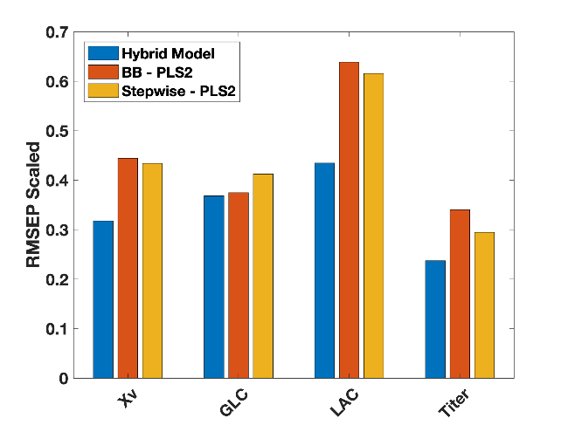
Figure 1: Comparison of the accuracy of the hybrid model against two statistical models (both based on PLS) in terms of standardized errors in prediction for viable cell density (Xv), Glucose (GLC), Lactate (LAC) and titer.

Secondly, given a fed-batch system with glucose feed from day 3, hybrid models correctly predict a daily continuous decrease in glucose concentration whereas the PLS models are not capable of incorporating the feeding strategies in a physically representative manner (See Figure 2). Given a change in the feeding strategy such as the amount of feed added or the days of feeding, a hybrid model can incorporate the information in a physically consistent manner whereas the statistical standard cannot capture this change.
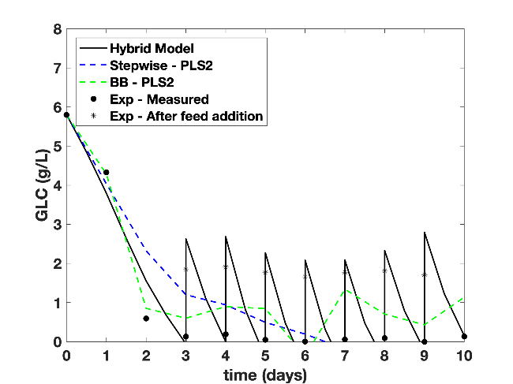
Figure 2: The concentration of glucose predicted by the three models as a function of time along with the experimental observation.

Additionally, the hybrid model is seen to predict process variables accurately outside of the trained or observed operating conditions highlighting its potential application in in-silico design of experiments and process optimization (results not shown here). Owing to their robustness, hybrid models can be used for sequential process optimization via iterative learning and experimentation. As a result, reducing the number of experiments needed to achieve the optimal operating condition.

Conclusion
A success in efficient data management and analytics is expected to have a tremendous effect on improving process development strategies and reducing manufacturing costs, thus making these therapies more available to society. We show that a modest modeling effort is sufficient to generate a hybrid model capable of predicting the complete evolution of the process variables and titer solely based on the initial conditions and the process operating conditions. Hybrid modeling also shows good interpolation and extrapolation capabilities in comparison to statistical models, which face intrinsic limitations to predict outside their training process condition space. This extrapolation capability is not only central for model-based process optimization but also for process scale-up, technology transfer and decision-making in process development. Thus, we strongly believe in investing efforts in the direction of hybrid modeling for process optimization and further extend its application to process monitoring and control.

References
Food and Drug Administration, Guidance for Industry PAT — A Framework for Innovative Pharmaceutical. 2004, 19.
﻿European Medicines Agency, Guideline on process validation for the manufacture of biotechnology-derived active substances and data to be provided in the regulatory submission. 2016, 44, 4.
Schubert, J., Simutis, R., Dors, M., Havlik, I., et al., Bioprocess optimization and control: Application of hybrid modelling. J. Biotechnol. 1994, 35, 51–68.
﻿Sokolov, M., Soos, M., Neunstoecklin, B., Morbidelli, M., et al., Fingerprint detection and process prediction by multivariate analysis of fed-batch monoclonal antibody cell culture data. Biotechnol. Prog. 2015, 31, 1633–1644.
von Stosch, M., Oliveira, R., Peres, J., Feyo de Azevedo, S., Hybrid semi-parametric modeling in process systems engineering: Past, present and future. Comput. Chem. Eng. 2014, 60, 86–101.
von Stosch, M., Hamelink, J.-M., Oliveira, R., Hybrid modeling as a QbD/PAT tool in process development: an industrial E. coli case study. Bioprocess Biosyst. Eng. 2016, 39, 773–784.

* Harini Narayanan, Institute of Chemical and Bioengineering, Vladmir – Prelog-Weg 1, 8093 Zurich Switzerland. Email: nharini@chem.ethz.ch

