a novel Quasi-deterministic MONTE CARLO method for Estimation of probability distributions
F. Rossi*, L. Mockus and G. Reklaitis
Purdue University, Forney Hall of Chemical Engineering, 480 Stadium Mall Drive, West Lafayette, IN 47907
Abstract Overview
This contribution proposes a novel quasi-deterministic Monte Carlo method (ODMCMC) for estimation of probability distributions (PDFs). Unlike conventional Monte Carlo samplers, ODMCMC makes use of numerical optimization techniques to draw optimal samples from the high probability regions of the PDF of interest. This quasi-deterministic sampling scheme allows efficient estimation of both unimodal and multimodal probability density functions, even in the presence of high parameter correlation. The results, reported in this contribution, indicate that ODMCMC can approximate complex PDFs with fewer samples than conventional Monte Carlo methods.

Keywords
Applied statistics, Model uncertainty quantification, PDF estimation, Markov-chain Monte Carlo.
Introduction

Numerical algorithms for estimation of probability density functions are the backbone of advanced process design, monitoring and optimization techniques, such as stochastic dynamic optimization (Rossi et al., 2016), robust state estimation (Mondal et al., 2010) and real-time risk assessment (Si et al., 2012). Due to the increasing availability of accessible experimental/process data, the latter have attracted the attention of both industry and academia. Therefore, the development of new and more efficient methods for PDF estimation may enable the systematic application of advanced process design, monitoring and optimization strategies to industrial plants, which may benefit process economics and improve process safety.
Most of the conventional algorithms for estimation of probability distributions, e.g. Metropolis-Hastings, Gibbs sampling and Hamiltonian Monte Carlo (Gamerman and Lopes, 2006), consist of random sampling strategies, designed to draw samples from the high probability regions of the PDF of interest (in most applications, an implicit formulation of this PDF is provided by Bayes theorem). These algorithms are well-established, accurate and reliable but suffer from some important drawbacks: (I) considerable computational cost; (II) poor scalability and limited intrinsic concurrency; and (III) poor performance in the presence of high parameter correlation. Moreover, they are inefficient when it comes to solving density estimation problems, in which we need to approximate the shape of the PDF of interest as well as its moments (the solution of probability density estimation problems is essential for risk assessment purposes). Therefore, this contribution proposes a new Monte Carlo algorithm, called ODMCMC, which mitigates some of the aforementioned limitations.
More specifically, ODMCMC is a quasi-deterministic Monte Carlo algorithm, which makes use of optimization to draw optimal samples from the PDF of interest. This innovative sampling scheme allows accurate estimation of complex PDFs at a reasonable computational cost, exhibits good scalability features, and generates optimal samples for density estimation purposes. As a result of this sampling strategy, ODMCMC can outperform other Monte Carlo algorithms in the estimation of both unimodal and multimodal probability density functions. This conclusion is supported by the results, reported in the second to last section of this abstract.

Rationale of Quasi-deterministic Monte Carlo
ODMCMC is a quasi-deterministic Monte Carlo algorithm, in which sampling is performed by numerical optimization. Specifically, this method does not rely on conventional random strategies to sample the target PDF, which only accept a small fraction of all the samples analyzed. Rather, it selects optimal samples by iterative solution of small-scale, multi-objective optimization problems, which measure the degree of optimality of every single sample based on two indices, namely, its linear and angular distances from all the other samples and its probability density. This innovative sampling approach can efficiently identify samples, which uniformly span only those regions of the uncertainty space that are associated with high values of probability density. Therefore, it allows ODMCMC to approximate both unimodal and multi-modal PDFs with fewer samples than conventional Monte Carlo methods, and to generate empirical distributions which are optimal for probability density estimation purposes. This consideration suggests ODMCMC should be more computationally efficient than conventional Monte Carlo samplers.

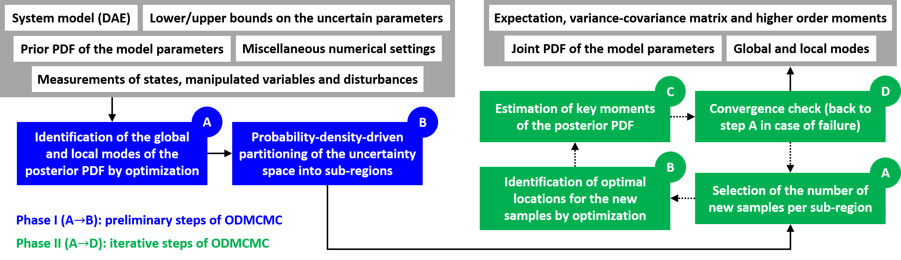

Figure 1. Architecture of the ODMCMC algorithm

The architecture of ODMCMC is summarized in . The algorithm is comprised of two phases, called Phase I and Phase II, of which the second is executed in an iterative fashion until convergence is reached.
Phase I involves first computation of all the modes of the target PDF via multi-start optimization methods (step A), and then division of the uncertainty space into an appropriate number of sub-regions (step B).
Phase II involves iterative execution of steps A, B and C in series, until the variation in the moments of the target PDF over two consecutive iterations is smaller than some predefined error tolerance (step D). In step A, we compute the number of samples that must be added to every region of the uncertainty space in the current iteration. Step B involves identification of the optimal locations of the new samples by solving as many independent, multi-objective optimization problems as the number of sub-regions. Finally, in step C, we estimate the moments of the posterior PDF, using the samples selected up to the current iteration.
As a final remark, note that the bottlenecks for computational efficiency in ODMCMC lie in step A of Phase I and step B of Phase II, both of which are parallelizable. Therefore, ODMCMC exhibits very good scalability features, unlike most conventional Monte Carlo methods.

Improvements to the Space Partitioning Algorithm
Step B of Phase I has a considerable impact on the performance of ODMCMC. Currently, the uncertainty space is divided into sub-regions, selected such that every one of them encompasses an appropriate interval of values of probability density. Although this approach is suitable for low-dimensional spaces (N_{DIM} ≤ 5), it suffers from the curse of dimensionality. Therefore, we also propose another space partitioning method, inspired by algorithms for multidimensional integration (Hahn, 2005), which should be suitable for high-dimensional spaces (Figure 2). This partitioning scheme includes two separate phases. In the first, we split the uncertainty space into hypercubic sub-regions, using hyperplanes that pass by the modes of the target PDF. In the second, we continue to split the sub-regions, associated with the highest and lowest probability values, until certain convergence conditions are met. At the end of every iteration, we also eliminate all those sub-regions, in which the maximum value of the target PDF is smaller than a certain user-defined threshold. This alternative space partitioning scheme may be appropriate for spaces with up to a few dozen dimensions, thus should allow us to solve most of the PDF estimation problems, encountered in real-life applications.

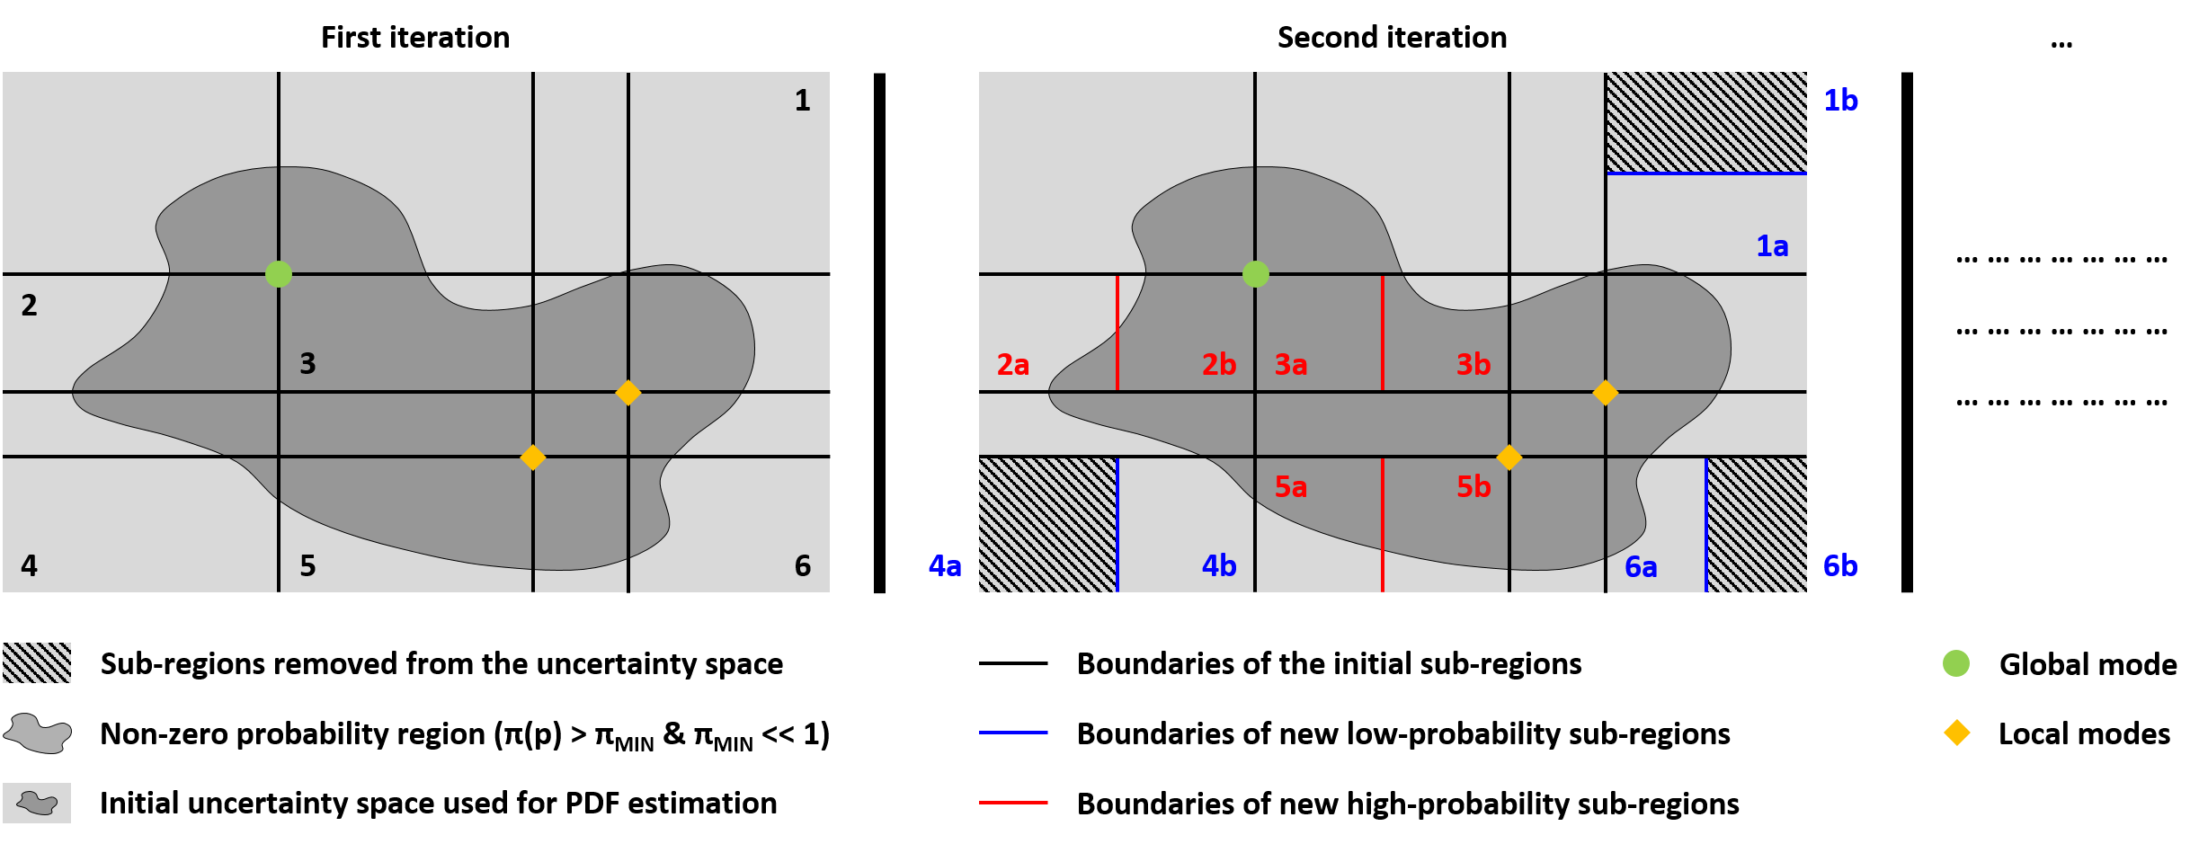

Figure 2. Rationale of an alternative space partitioning algorithm suitable for high-dimensional spaces

Estimation of Unimodal and Multimodal PDFs
The level of performance, offered by ODMCMC, has been assessed using two small-scale PDF estimation problems, in which we know the analytical form of the target PDF (Figure 3). The same exact problems have been solved by two conventional Monte Carlo samplers, specifically Metropolis-Hastings and Hamiltonian Monte Carlo (mhMCMC and hmtMCMC).
ODMCMC outperforms both of the conventional Monte Carlo methods, as it can estimate the target PDF more accurately, using the same number of samples as the other two methods. In addition, ODMCMC offers faster convergence of the approximate PDF to the true one, as a function the number of samples used in the calculations.

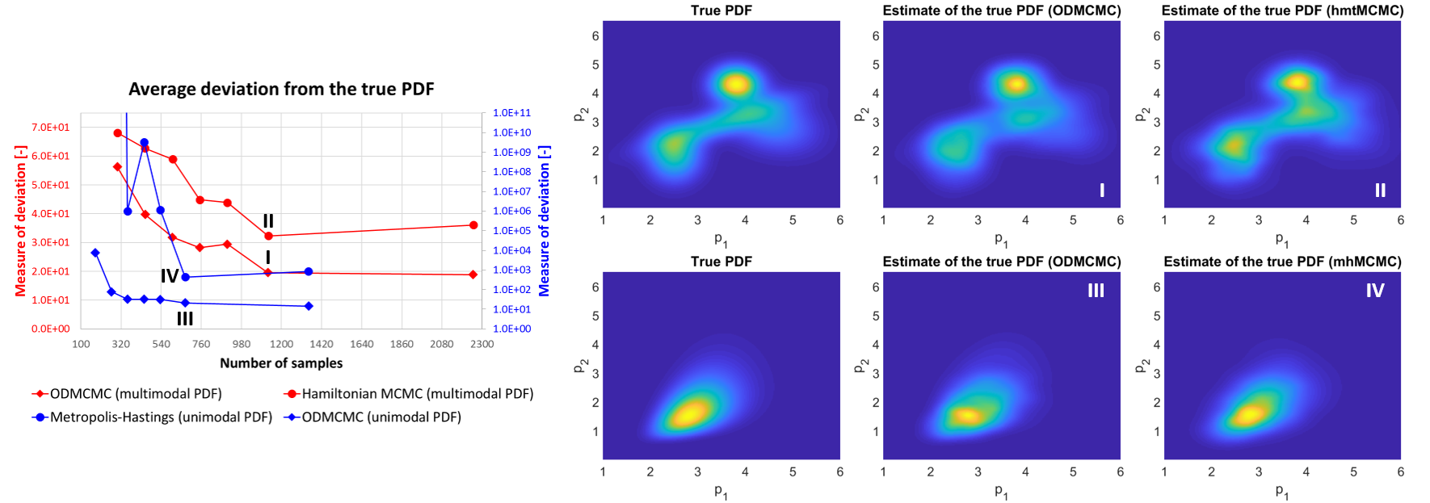

Figure 3. Results of two small-scale PDF estimation problems

Conclusions
The case studies, analyzed in this contribution, confirm that ODMCMC is more accurate and efficient than conventional Monte Carlo methods for small-scale PDF estimation problems. Future work will investigate whether ODMCMC is also superior for large-scale problems.

References
Gamerman, D., Lopes, H. F. (2006). Markov Chain Monte Carlo - Stochastic simulation for Bayesian inference. Taylor & Francis Group. New York, NY.
Hahn, T. (2005). Cuba - a library for multidimensional numerical integration. Comput. Phys. Commun., 168, 78.
Mondal, S., Chakraborty, G., Bhattacharyy, K. (2010). LMI approach to robust unknown input observer design for continuous systems with noise and uncertainties. Int. J. Control Autom., 8, 210.
Si, H., Ji, H., Zeng, X. (2012). Quantitative risk assessment model of hazardous chemicals leakage and application. Safety Sci., 50, 1452.
Rossi, F., Reklaitis, G., Manenti, F., Buzzi-Ferraris, G. (2016). Multi-scenario robust online optimization and control of fed-batch systems via dynamic model-based scenario selection. AIChE J., 62, 3264.

* To whom all correspondence should be addressed

