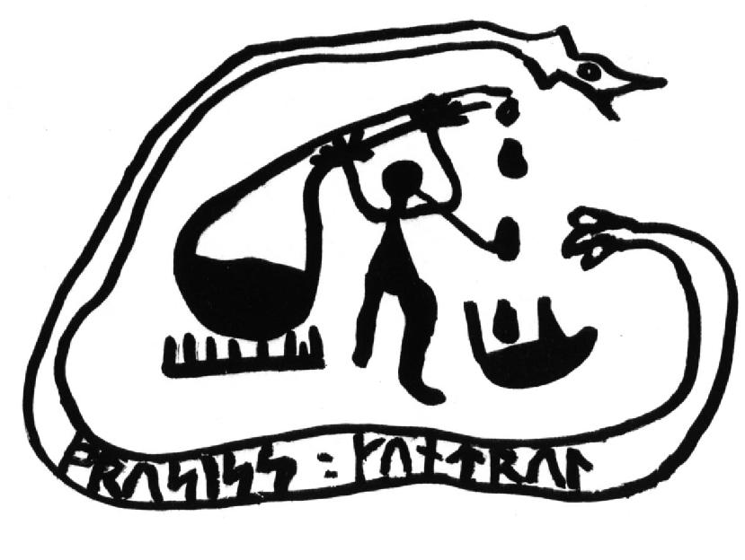
Nordic Process Control Group

Report on

Nordic Five Tech Universities’ Education in areas related to process systems engineering

Sirkka-Liisa Jämsä-Jounela, TKK
Mikko Vermasvuori, TKK
Anna Kähö, TKK

The purpose of this report is to list courses of the Universities forming the Nordic Five Tech alliance in order to help exchange of students between the universities.

Chalmers
Code | Name | Credits | Period
CHEMICAL ENGINEERING
KAA102 | Advanced separation technology | 7.5 | 4
PROCESS CONTROL
KVM075 | Optimization with energy and environmental applications | 6 | 4
ESS101 | Modelling and simulation | 7.5 | 1
??? | Digital control | 7.5 | 2
??? | Nonlinear and adaptive control | 7.5 | 4
PLANT DESIGN
KSK061 | Sustainable process performance indicators | 7.5 | 4
POLYMERS
KBT025 | Polymer chemistry and physics | 7.5 | 2
MPM080 | Engineering polymers | 7.5 | 3
KPO020 | Polymer technology, advanced course | 7.5 | 4
ECOLOGY
FFR160 | Sustainable development | 7.5 | 1
KAA111 | Advanced chemical engineering design | 6 | 1
KBT110 | Advanced chemical engineering and process analytical technology | 7.5 | 3
KKM067 | Ecodesign | 7.5 | 4
BMT010 | Global issues in sustainable development | 7.5 | 4
MODELING & SIMULATION
FFR 120 | Simulation of Complex Systems | 7.5 | 2
OTHER INTERESTING COURSES
KBT120 | Experimental design | 7.5 | 1

The Royal Institute of Technology (KTH)
Code | Name | Credits | Period
CHEMICAL ENGINEERING
KE2080 | Chemical Engineering in Fine and Specialty Chemicals | 7.5 | 1
KE2120 | Chemical Engineering, Design Course | 15 | 4
KE2060 | Computational Project in Chemical Engineering | 7.5 | 4
KE2130 | Process Chemistry | 7.5 | 3
ECOLOGY
MJ2691 | Technology and Sustainable Development | 6 | 2
MJ2640 | Cleaner Production | 6 | 3
MJ2620 | Environmental Technology, Advanced Course | 6 | 4
MJ2630 | Waste Management, Advanced Course | 6 | 4
POLYMERS
KF3100 | Polymer Physics | 6 | 2
KF2180 | Biopolymers | 7.5 | 3
KF2220 | Biopolymers | 7.5 | 3
KF2290 | Polymer Processing | 6 | 3
KF3090 | Polymer Chemistry | 6 | 3
PROCESS CONTROL
2E1262 | Nonlinear Control | 7.5 | 2
2E1126 | Measurement Systems, Project Course | 6 | 3
2E1245 | Hybrid and Embedded Control Systems | 7.5 | 3
2E1246 | Hybrid and Embedded Control Systems, Advanced Course |  | 3
2E1252 | Control Theory and Practice, Advanced Course | 7.5 | 3
2E1282 | Modelling of Dynamical Systems | 6 | 4

The Norwegian University of Science and Technology (NTNU)
Code | Name | Credits | Semester
CHEMICAL ENGINEERING
TKP4100 | Fluid flow and heat transfer | 7.5 | Spring
TKP4105 | Separation technology | 7.5 | Fall
TKP4160 | Transport phenomena | 7.5 | Fall
TKP4150 | Petrochemistry and oil refining | 7.5 | Spring
TKP4740 | Separation and environmental technology, specialization | 22.5 | Fall
PROCESS CONTROL
TK8106 | Distributed Real Time Operating Systems | 7.5 | Fall
TTK4150 | Nonlinear Control Systems | 7.5 | Fall
KP8115 | Advanced Process Control | 7.5 | Fall
TKP4135 | Chemical process dynamics and optimization | 7.5 | Spring
TKP4140 | Process Control | 7.5 | Fall
TFY4190 | Instrumentation | 7.5 | Spring
TK8101 | Optimal Control of Dynamics Systems | 7.5 | Spring
PLANT DESIGN
TKP4160 | Process design | 7.5 | Spring
TKP4170 | Process design, project | 7.5 | Fall
KP8100 | Advanced Process Simulation | 7.5 | Fall
POLYMERS
TKP4115 | Surface and colloid chemistry | 7.5 | Spring
TKP4130 | Polymer chemistry | 7.5 | Spring
TKP4710 | Colloid and polymer chemistry, specialization | 22.5 | Fall
CHEMICAL REACTION ENGINEERING
TKP4110 | Chemical reaction engineering | 7.5 | Fall
TKP4145 | Reactor technology | 7.5 | Spring
TKP4155 | Reaction kinetics and catalysis | 7.5 | Fall
TKP4700 | Catalysis and petrochemistry, specialization | 22.5 | Fall
TKP4730 | Reactor technology, specialization | 22.5 | Fall
ECOLOGY
TEP4223 | LCA and Eco-Efficiency | 7.5 | Fall
TEP5100 | Industrial Ecology, Project | 15 | Fall
OTHER INTERESTING COURSES
TKP4720 | Process systems engineering, specialization | 22.5 | Fall
TKP4125 | Paper and fiber technology | 7.5 | Spring
TKP4750 | Paper and fibertechnology, specialization | 22.5 | Fall

The Technical University of Denmark
Code | Name | Credits | Semester
CHEMICAL ENGINEERING
28420 | Separation Processes | 7.5 | Fall
28423 | Phase Equilibria for Separation Processes | 5 | Spring
28231 | Laboratory in Chemical and Biochemical Engineering | 5 | June
28361 | Chemical Engineering Model Analysis | 7.5 | Fall
28910 | Numerical Solution of Mathematical Models in Chemical Engineering | 7.5 | Spring
PROCESS CONTROL
28150 | Introduction to Process Control | 5 | Fall
28451 | Optimising Plantwide Control | 7.5 | Spring
28851 | Chemical Plant Operation | 5 | January
28911 | Multivariable Process Identification for Model Predictive Process Plant Control | 10 | Fall
POLYMERS
28213 | Polymer Technology | 5 | Fall
28212 | Polymer Chemistry | 5 | Spring
28904 | Polymer Physics | 7.5 | Spring
28811 | Polymers in Processes and Products | 5 | January
ECOLOGY
28375 | Air Pollution Control | 5 | Spring
MODELING & SIMULATION
28901 | Advanced Computer Aided Modelling | 7.5 | June

Helsinki University of Technology (TKK)
Code | Name |  | Credits | Period
CHEMICAL ENGINEERING
KE-42.3000 | Chemical engineering, laboratory course |  | 3 | 1
KE-42.4000 | Chemical engineering, advanced lab. course |  | 3 | 1
KE-42.4010 | Chemical engineering, excercise course on special topics |  | 3 - 7 | 1
KE-42.4120 | Process development |  | 4 | 1
KE-42.6010 | Distillation design |  | 4 | 2
KE-42.6500 | Unit operations of Environmental technology |  | 5 | 3
KE-42.5500 | Physical properties in chemical engineering |  | 4 | 3
PROCESS CONTROL
KE-90.4100 | Production planning in practice |  | 4 | 1
KE-90.5100 | Process monitoring |  | 4 | 1
KE-90.4520 | Information Technology in Process Automation |  | 3 | 2
KE-90.3100 | Process modeling and simulation |  | 6 | 2
KE-90.4510 | Control applications in process industries |  | 6 | 3
KE-90.3500 | Process modeling and simulation in practice |  | 3 | 3
KE-90.4500 | Project work in process automation |  | 3 | 4
KE-90.2500 | Basics in production planning and control |  | 6 | 4
PLANT DESIGN
KE-107.3100 |  | Process simulation | 3 | 1
KE-107.4000 |  | Process safety | 3 | 1
KE-107.6010 |  | Special study in plant design | 1 - 7 | 1
KE-107.6000 |  | Special course in plant design | 1 - 5 | 1
KE-107.4300 |  | Process design I | 3 | 2
KE-107.4600 |  | Process design II | 3 | 3
KE-107.5500 |  | Plant design II | 7 | 3
POLYMERS
KE-100.3700 |  | Polymerization engineering | 6 | 3

