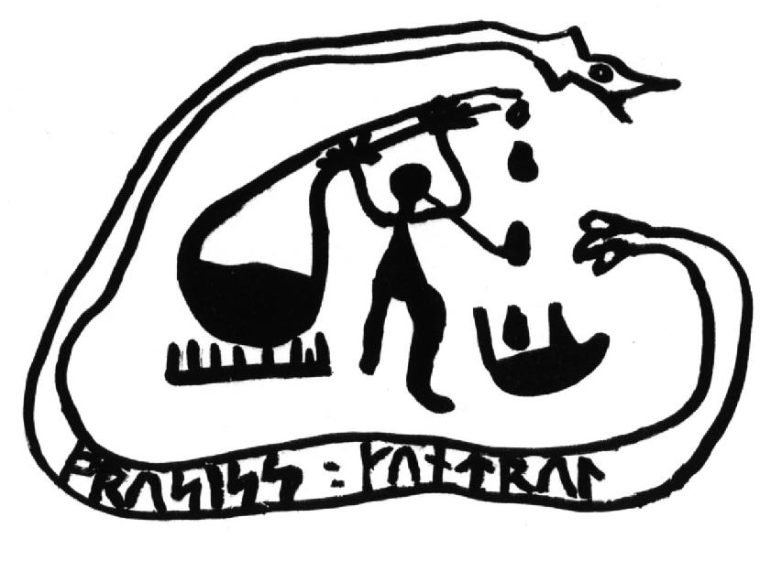

Nordic Process Control Group Board Meeting
Porsgrunn, Norway
Thursday, January 29, 2009, 17:30-18:30 hrs
Venue: Telemark University College, B-203

AGENDA

- Roll Call
- Approval of Agenda
- Approval of Minutes of Previous Meeting ( Espoo 23 August, 2007)
- The 15th NPC Workshop Report
- The 16th NPC Workshop
- NPC Award
- New Chair of WG
- Changes in Membership
- Nordic Cooperation
- Other Business
- Date and Place of Next Meeting

