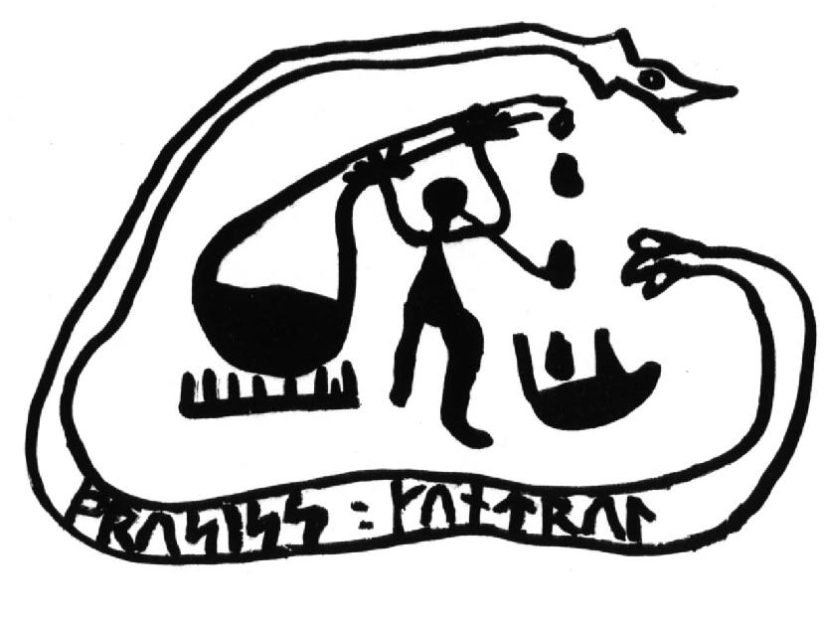
Nordic Process Control Group Board Meeting
Porsgrunn, Norway
Thursday, January 29, 2009, 18:00-19:00 hrs
Venue: Telemark University College, B-203

Working Group Chair SL Jämsä-Jounela opened the meeting at 6:00 PM and welcomed participants and the guests to the board meeting of the Nordic Process Control Group.

- Roll Call

Present:
Sten Bay Jorgensen
Sigurd Skogestad
Jorgen Knudsen
Claes Breitholtz
Kurt erik Häggblom
Bjarne Foss
Annika Leonard
Alf Isaksson
Bernt Lie
Hans Aalto
Bjorn Glemmestad

Invited guest: Tore Hägglund

Not present:

Jan Richard Sagli

Apologies were received from
Elling W. Jacobsen
Kaj Juslin
Jan Peter Axelsson

- Approval of Agenda

The agenda was unanimously approved.

- Approval of Minutes of Previous Meeting ( Espoo 23 August, 2007)

The minutes was approved.

- The 15th NPC Workshop

The 15th NPC Workshop was running smoothly. The number of delegates was about 60. The Group Chair Jämsä-Jounela expressed great appreciation to Prof. Bernt Lie for his excellent work to make the workshop successful.

- Changes in Membership

Leaving:

Prof. Sten Bay Jorgensen, NTNU, Norway
Dr. Jorgen Knudsen, FLS-Automation, Denmark
Dr. Jan Richard Sagli, Statoil, Norway

New:

Prof. Tore Hägglund, Lund, Sweden
John Bagterp Jorgensen, DTU, Denmark
Gurkan Sinn, DTU, Denmark

Other:

Jorgen Knudsen proposed that the Board would invite Mr Tommy Mølbak from Denmark to the industrial member of the group. This proposal was accepted and Jorgen Knudsen will discuss with Molbak about his availability.

The number of the board members was agreed to be increased from 16 to 17.

- The 16th NPC Workshop

The next NPC workshop will be held in Lund, Sweden, August 2010.

- The 17th NPC Workshop

The 17th NPC Workshop will be held in Denmark, 2012.

- The new Chairman and the co-chair of the NPCG

According to the new policy established in Espoo, 2007, the organizer of the workshop is the WG Chair, and the organizer of the next is the WG co-chair.

Prof. Tore Hägglund was selected for the next chairman of the NPCG starting August 2009. John Jorgensen was selected for the co-chair of the working group.

- NPC Award 2010: Confidential

The candidate has accepted to come and receive the award.

- Other Business

none

- Next WG meeting

26 August 2010 in Lund.

Sirkka-Liisa Jämsä-Jounela

