Project proposal: Temperature control for exothermic CSTR
Krister Forsman, Perstorp AB, 2012-03-22
Controlling the temperature in an exothermic chemical reactor poses a challenge, since the process itself is both non-linear and unstable. In many cases the process has a time delay, because the cooling is effectuated by a cooling water flow, the influence of which takes some time to reach the reactor solution. This is the case regardless of whether the heat exchanger is placed inside the reactor, or in an exterior circulation loop the reactor. These three factors (non-linearity, instability, delay) alone make this control problem quite a challenging one. In addition we have process variations that require the control to be robust.
We study continuous stirred reactors, with process layout as showed in Figure 1. Within the Perstorp group there are several reactors of this type. The mixing inside the reactor is assumed to be perfect.
Figure 1: Continuous reactor.
Farily straightforward mass and heat balances in combination with the Arrhenius equation [1] gives us a system of differential and algebraic equations that govern the system (for a particular class of reactions), namely equations (1) – (5). The state variables are C_{A,out} and T_{out}.
$$q_{\text{in}}C_{A,\text{in}}−q_{\text{out}}C_{A,\text{out}}=V k C_{A,\text{out}}\left(C_{B,\text{in}}−C_{A,\text{in}}+C_{A,\text{out}}\right)+\frac{d}{\text{dt}}C_{A,\text{out}}$$ | (1)
$$k=k_{0}\text{exp}\left(\frac{−E_{a}}{{\text{RT}}_{\text{out}}}\right)$$ | (2)
$$\frac{d}{\text{dt}}T_{\text{out}}=\frac{P_{\text{in}}+P_{\text{react}}−P_{\text{out}}−P_{\text{cool}}}{V ρ_{\text{out}} c_{v,\text{out}}}$$ | (3)
$P_{\text{out}}=q_{\text{out}} ρ_{\text{out}} T_{\text{out}} c_{v,\text{out}}$, $P_{\text{in}}=q_{\text{in}}ρ_{\text{in}}T_{\text{in}}c_{v,\text{in}}$ | (4)
$P_{\text{react}}=H\left(q_{\text{in}}C_{A,\text{in}}−q_{\text{out}}C_{A,\text{out}}\right)$$=H V k C_{A,\text{out}}\left(C_{B,\text{in}}−C_{A,\text{in}}+C_{A,\text{out}}\right)$ | (5)
If we linearize these equations we will probably get a process transfer function like
$$G\left(s\right)=\frac{{\text{Ke}}^{−\text{sL}}}{1−\text{sT}}, L>0, T>0$$ | (6)
Figure 2 shows a real world setpoint step response for a reactor temperature, controlled by a PI-controller. This type of SP responses agrees with what we get when simulating systems with transfer functions of the type (6). We see the typical initial undershoot response of the controller output (cooling power), and also a tendency of instability before the response settles. Most likely, this feedback controller can be improved.
Figure 2: Temperature setpoint change for exothermic reactor.
Figure 3 shows a simulated setpoint change for a the process $\frac{e^{−\text{sL}}}{1−5s}$, controlled by a PI-controller with gain 4.3, integration time 4.7 and β-factor = 0. We see that it exhibits the same characteristics as the measured reponse. This serves as a motivation to study process transfer functions of the type (6).
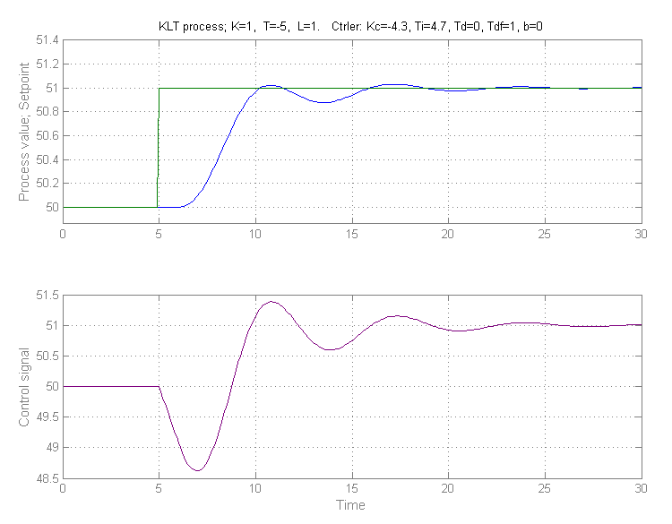
Figure 3: Simulated SP step response for an unstable process.
The practicing process control engineers would benefit greatly from having a simple methodology for tuning PID controllers for this type of processes. Linearizing the process may provide a path forward towards deriving such a method. Ideally, the method should use only the physical properties of the process, so that the amount of field tests needed is minimized.
Another extremely important and interesting question is whether it is possible to estimate the reaction kinetics parameters, in this case k₀ and E_{a}, using normal operations data, and what the requirements are on the data in that case.
A project plan may look as follows. The scope can be reduced if there is not enough time available:
- Verify the mass and heat balances, and linearize this model around a generic equilibrium.
- Investigate which simple PID controller tuning methods that are available for this type of linear processes. If there are none, then suggest one.
- Match the parameters in the suggested tuning method with the physical parameters of the process.
- Quantify fundamental limitations on control performance. Here [2] is a useful reference.
- Can normal operations data be used to estimate the kinetics parameters k₀ and E_{a}?
- Will a non-linear controller structure significantly improve achieveable control performance?

References
[1] H.S. Fogler: Elements of Chemical Reaction Engineering. Prentice Hall, 2005.
[2] S. Skogestad and I. Postlethwaite: Multivariable Feedback Control: Analysis and Design. Wiley. 2005.

