NTNU Faculty of Natural Sciences and Technology
Norwegian University of Science Department of Chemical Engineering
and Technology


-

TKP4170 PROCESS DESIGN. PROJECT

Title:  Process Design and Economic Investigation of LPG Production from Natural Gas Liquids (NGL) | Keyword (3-4):  LPG Recovery, Petlyuk Column, Economic Evaluation
Written by:  Eldar Khabibullin, Feby Febrianti, Juejing Sheng and Sulalit Bandyopadhyay | Time of work:  August 26th, 2010 – November 18th, 2010
Supervisor:  Sigurd Skogestad  Co-Supervisors: Mehdi Panahi and Maryam Ghadrdan | Number of pages: 99  Main report: 74  Appendix : 25
EXTRACT OF WORK AND CONCLUSIONS
Postulations and dimension of work:
The LPG recovery plant operates on Natural Gas Liquids (NGL), entering from two sources, with a total flowrate of 33 tonnes/hour and produces Liquified Petroleum Gas (LPG) along with Natural Gasoline as the primary products. The process is studied using conventional columns and also Petlyuk columns as alternative to the conventional ones.
The plant will be built in Norway as a part of a gas processing plant. Thus, the steam used for reboiler of the column is considered to be generated as part of steam generation for the whole plant. In order to have an economic process, instead of using refrigerant it is suggested to use sea water, at 10ºC for condenser.
Conclusions and recommendations:
Out of the six alternative cases studied, three conventional and three with Petlyuk columns, the Petlyuk column producing LPG and natural gasoline, is found out to be economically most profitable. However, all the configurations are found to be highly sensitive to both raw materials as well as product prices.

Date and signature:

TABLE OF CONTENTS
ACKNOWLEDGEMENT iv
ABSTRACT v
1 INTRODUCTION 1
1.1 Definition and Properties 1
1.2 LPG Applications and Markets 2
1.3 LPG Recovery Technology 6
1.3.1 Conventional Technology 6
1.3.2 Petlyuk Column 10
2 PROJECT BASIS 14
2.1 Feed Streams 14
2.2 Product Specifications 14
2.3 Project Scope 15
2.4 Assumptions 17
3 PROCESS DESCRIPTIONS 18
3.1 Conventional Column 18
3.1.1 Process Flow 19
3.1.2 Parameters 21
3.1.3 Modelling 22
3.2 Petlyuk Column 33
3.2.1 Minimum Energy Mountain Diagram 33
3.2.2 Modelling and Simulation of Petlyuk Columns 42
4 FLOWSHEET CALCULATIONS 52
4.1 Mass Balance 52
4.2 Energy Balance 52
4.3 Equipment Sizing 53
5 COST ESTIMATION 55
5.1 Fixed capital cost 55
5.2 Working capital cost 57
5.3 Operating Cost 58
6 INVESTMENT ANALYSIS 64
6.1 Internal Rate of Return 64
6.2 Net Present Value 65
6.3 Pay-back Period 65
6.4 Sensitivity Analysis 66
7 DISCUSSION 68
8 CONCLUSIONS AND RECOMMENDATIONS 69
LIST OF SYMBOLS 70
REFERENCES 73

APPENDICES 75
Appendix A - Computational Procedure for V_{min} diagram 75
Appendix B – Equipment Sizing 81
Appendix C - Petlyuk Column Calculations 87
Appendix D - Steam Calculations for Petlyuk Column 93
Appendix E - Capital Cost Estimation 94
Appendix F – Cash Flows for Different Alternatives 99

ACKNOWLEDGEMENT

We express our profound gratitude to our Project Supervisor, Prof. Sigurd Skogestad, Professor, Chemical Engineering Department, NTNU, Norway for his constant supervision and valuable guidance. This small endeavor would not have seen the light of the day without his constant scientific support, fruitful discussions in various capacities.
We would also like to extend our whole-hearted thanks and gratitude to Mehdi Panahi and Maryam Ghadrdan for their untiring help and constructive criticisms which have helped the course of the work immensely.
Our special thanks also go to Dr. Ivar J. Halvorsen, senior Scientist at SINTEF Electronics and Cybernetics, Automatic Control, for allowing us to use his MATLAB codes and also for his enlightening and fruitful scientific discussions with us.
We would also like to thank Prof Magne Hillestad, Professor, Chemical Engineering Department, NTNU, Norway, the coordinator for this course (TKP 4170) for explaining to us the project work and also necessary requisites for the same.

NTNU, November 2010

ABSTRACT

Liquefied Petroleum Gas (LPG) is used as a potential fuel in several parts of the world. The price of LPG has been steadily increasing over the last few years as demand for the product has increased and oil prices have shifted upwards. It is generally synthesized from crude oil (40%) or from natural gas (60%). This project mainly focuses on design and simulation of an LPG plant, which processes feed from natural gas wells to produce LPG along with, natural gasoline (C5+) having a higher value as separate product. The same is carried out using two alternatives, the conventional approach and the use of Petlyuk columns, as a means to heat-integrate and reduce operating as well as investment costs.
Six cases are studied with various final products, decided based on market studies and different column configurations, analyzed on an economic basis. There are two feeds to the plant, one from the Natural gas (NG) wells, containing around 79% of C5+ and the other from dehydration units of NG processing plants, containing 52% C5+, with a total flowrate of 34 tonnes/hr. UNISIM simulations have been done for all the conventional cases in order to setup the process flow sheets and size the various equipments, while short cut calculations have been done for the Petlyuk columns to arrive at comparable states with the conventional.
Economic analysis, with internal rate of return (IRR) and Net present worth (NPW) as the economic parameters have been carried out for all the six cases. The Petlyuk configurations appear more profitable as compared to the conventional cases, with the Petlyuk configuration producing LPG and natural gasoline (C5+), seemingly the best. However, sensitivity analysis shows that the project is highly sensitive to change in raw material prices and product prices, hence, this could turn out to be a risky project for a new investor, while, it would be not so for an already established big industrial company.

INTRODUCTION
In natural gas processing plants, several stages of separation and fractionation are used to purify the natural gas from the liquid heavier hydrocarbons. This separated liquid is named as natural gas liquids (NGL). The raw NGL is sent to LPG recovery plant to separate LPG (i-C₃ and i-C₄) from stabilized NGL (C₅+). Both products are very valuable and expensive in the market.
LPG is commonly used as a fuel in heating appliances and vehicles and increasingly replacing chlorofluorocarbons as an aerosol propellant and a refrigerant to reduce damage to the ozone layer (Wikipedia).
In this project, LPG recovery plant is designed using commercial software (Unisim) and investigated for economics of the process. Furthermore, the use of Petlyuk column as an alternative to conventional columns for LPG is also discussed in order to find the most economic process for LPG production.

Definition and Properties
Liquefied Petroleum Gas (LPG) is a mixture of hydrocarbon gases, primary propane and butane. The exact composition of LPG varies according to its source, processing principles and depends on the season. For example, in winter it contains more propane (propane vapor pressure at 25⁰C is 9.36 bar), in summer more butane (butane vapor pressure at 25⁰C is 2.44 bar).
LPG is odorless, colorless and non-toxic. To reduce the danger of an explosion from undetected leaks, commercial LPG usually contains an odorizing agent, such as ethanethiol, which gives it a distinctive pungent odor. LPG has a higher calorific value (94 MJ/m³ equivalents to 26.1 kWh) than natural gas (38 MJ/m³ equivalents to 10.6 kWh) (Wikipedia). The properties of LPG are tabulated in Table 1.1.

Table 1.1 - Properties of LPG (Petroleum Fuel Facilities, 1999)
Name of the Property | Value for LPG
Freezing Point | -187⁰C
Specific Gravity | 0.588
Vapor Pressure at 38⁰C | 1212kPa
Heat Content | 50 221 kJ/kg

LPG Applications and Markets
Application of LPG varies from food to transport industry. Its consumption depends on the local market conditions. LPG is widely used in the Food Industry like hotels, restaurants, bakeries, canteens, resorts etc. Low sulphur content and controllable temperature makes LPG the most preferred fuel in the food industry.

Glass & Ceramic
The manufacture of glass / ceramic products is complicated by numerous chemical reactions which occur during the process. The use of a clean fuel like LPG enhances the product quality thereby reducing technical problems related to the manufacturing activity. LPG being a gaseous fuel gets easily regulated and complements the heating process.

Building Industry
LPG being a premium gaseous fuel makes it ideal for usage in the Cement manufacturing process. The ease in regulation and soft quality of the LPG flame and low sulphur content are the key advantages both with regard to cement quality and kiln operability.

Metal Industry
The metal industry is indeed one of the most important consumers of energy. LPG being a far superior fuel as compared to the other heavy fuels helps improve the cost of operation and strikes an economic balance between fuel price and quality of the end product. The application is basically for cutting, heating and melting. Both ferrous and non-ferrous metals are frequently cast into shapes by melting and injection or pouring into suitable patterns and moulds. LPG in this case is an ideal fuel for meeting the requirement of temperature regulation and desired quality.

Farming Industry
LPG is the ideal fuel for production of food by agriculture and animal husbandry. Drying of crops and other farm products requires clean and sulphur free fuel for drying activity to avoid any transfer of bad taste or smell to the dried crops.

Aerosol Industry
An aerosol formulation is a blend of an active ingredient with propellant,emulsifiers, perfumes, etc. LPG, being environment friendly, has replaced the ozone depleting CFC gases which were earlier used by the aerosol Industry.

Automotive Industry
Automotive LPG is a clean fuel with high octane, aptly suited for vehicles both in terms of emissions and cost of the fuel. The main advantage of using automotive LPG: it is free of lead, very low in sulphur, metals, aromatics and other contaminants. Unlike natural gas, LPG is not a Green House Gas. The following table lists the preferred LPG composition in Europe.

Table 1.2 - LPG Composition (% by Volume) as Automotive Fuel in Europe (West Virginia University)
Country | Propane | Butane
Austria | 50 | 50
Belgium | 50 | 50
Denmark | 50 | 50
France | 35 | 65
Greece | 20 | 80
Ireland | 100 | -
Spain | 30 | 70
Sweden | 95 | 5
United Kingdom | 100 | -
Germany | 90 | 10

Cogeneration using LPG
LPG is an ideal fuel for electricity & heat / electricity and comfort cooling. This finds varied applications in industries requiring power and steam, power and hot air. LPG is ideally suited for shopping malls, offices requiring power and air conditioning.
LPG has lower calorific value then petrol, so it provides less miles per gallon, however in European countries LPG tax levels are much lower than both diesel and unleaded so it is still a far more cost effective way to run your car. The tax break is due to evidence that suggests that LPG is better for the environment than the mainstream fuels.
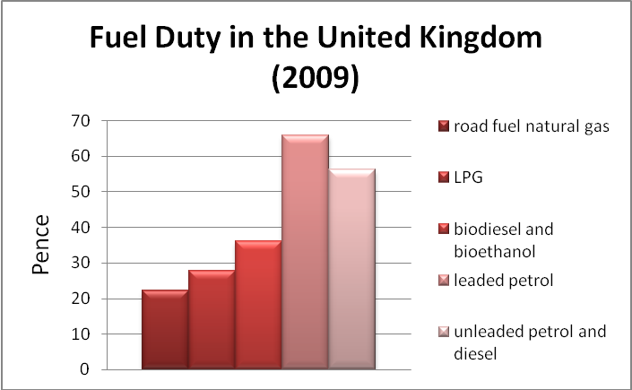
Figure 1.1 - Taxes for Fuel

The cost of LPG is a lot lower than unleaded or diesel fuel, but its price has been gradually rising since it was first introduced. The chart below tracks the historical prices for LPG.

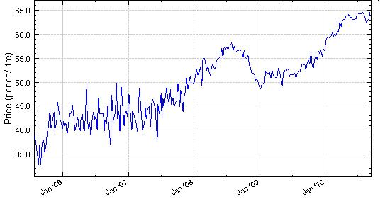
Figure 1.2 – LPG Historical Prices

The current LPG Prices in Europe are presented in Table 1.3. Meanwhile, the prices for Propane, iso-Butane, n-Butane, Field Grade Butane and Natural Gasoline are presented in Table 1.4. These specifications were taken from OPIC and Argus NGL Americans Methodology. Prices are for commercial volumes of the products, which can be sold on CME Group Market (NYMEX) in New York (CME, 2010).
Table 1.3 – LPG Prices in Europe (www.energy.eu)
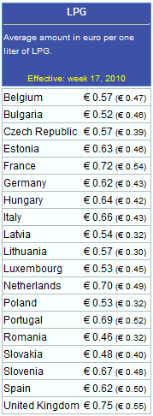

Table 1.4 – LPG Specifications and Prices
Product | Specification | Price ($/gallon) | Price ($/kg)
Propane | 90% propane minimum, 5% propylene maximum, 0.507 relative density and 90,830 btu/gal | 1.17594 | 0.62447
Iso-Butane | 96% iso-butane minimum, 4% normal butane maximum, 3% propane maximum, 0.563 relative density and 98,950 btu/gal | 1.60083 | 0.7761
n-Butane | 94% normal butane minimum, 6% iso-butane maximum, 0.35% propane maximum, 1.5% pentanes and heavier maximum, 0.35% olefins maximum, 0.584 relative density and 102,916 btu/gal | 1.54661 | 0.75447
Field Grade Butane | Mix of n-Butane and Iso-Butane (35% iC4+ 65% nC4) | 1.4383 | 0.76213
Natural Gasoline | C₅+, 0.664 relative density and 115,021 btu/gal | 1.90315 | 1.08716

LPG Recovery Technology
There are several technologies which have been developed in order to extract LPG from natural gas liquids (NGL). Some researches and simulations have also been done to find the most optimum and economic technology. In this project, the conventional LPG recovery is used as comparison with Petlyuk column to investigate the economic process of LPG production from NGL.

Conventional Technology
Natural gas processing begins at the wellhead. The composition of the raw natural gas extracted from producing wells depends on the type, depth, and location of the underground deposits and the geology of the area. The natural gas produced from oil wells is generally classified as “associated-dissolved,” meaning that the natural gas is associated with or dissolved in crude oil. Natural gas production without any association with crude oil is classified as “non-associated.” About 60% of the world supply of LPG comes from associated gas processing, and 40% of the LPG is produced in oil refineries from crude distillation, fluid catalytic cracking units, hydrocrackers, etc. The worldwide estimated production of LPG in 2005 was estimated at 250 million tons per year.
Gas Processing Plant
There are several stages of gas processing:
Gas-oil separators
In many instances pressure relief at the wellhead will cause a natural separation of gas from oil (using a conventional closed tank, where gravity separates the gas hydrocarbons from the heavier oil). In some cases, however, a multi-stage gas-oil separation process is needed to separate the gas stream from the crude oil. These gas-oil separators are commonly closed cylindrical shells, horizontally mounted with inlets at one end, an outlet at the top for removal of gas, and an outlet at the bottom for removal of oil.

Condensate separator
Condensates are most often removed from the gas stream at the wellhead through the use of mechanical separators. In most instances, the gas flow into the separator comes directly from the wellhead, since the gas-oil separation process is not needed.

Dehydration
A dehydration process is needed to eliminate water which may cause the formation of hydrates. Hydrates form when a gas or liquid containing free water experiences specific temperature/pressure conditions. Dehydration is the removal of this water from the produced natural gas and is accomplished through several methods. Among these is the use of ethylene glycol (glycol injection) system as an absorption mechanism to remove water and other solids from the gas stream. Alternatively, adsorption dehydration may be used, utilizing dry-bed dehydrators towers, which contain desiccants such as silica gel and activated alumina, to perform the extraction.

Contaminant removal
Removal of contaminants includes the elimination of hydrogen sulphide, carbon dioxide, water vapor, helium, and oxygen. The most commonly used technique is to first direct the flow though a tower containing an amine solution. Amines absorb sulphur compounds from natural gas and can be reused repeatedly. After desulphurization, the gas flow is directed to the next section, which contains a series of filter tubes. As the velocity of the stream reduces in the unit, primary separation of remaining contaminants occurs due to gravity.

Methane separation
Cryogenic processing and absorption methods are some of the ways to separate methane from natural gas liquids (NGLs). The cryogenic method is better at extraction of the lighter liquids, such as ethane, than is the alternative absorption method. Essentially, cryogenic processing consists of lowering the temperature of the gas stream to around -120 degrees Fahrenheit. While there are several ways to perform this function, the turbo expander process is most effective, using external refrigerants to chill the gas stream. The quick drop in temperature that the expander is capable of producing, condenses the hydrocarbons in the gas stream, but maintains methane in its gaseous form.
The absorption method, on the other hand, uses a “lean” absorbing oil to separate the methane from the NGLs. While the gas stream is passed through an absorption tower, the absorption oil soaks up a large amount of the NGLs. The “enriched” absorption oil, now containing NGLs, exits the tower at the bottom. The enriched oil is fed into distillers where the blend is heated to above the boiling point of the NGLs, while the oil remains fluid. The oil is recycled while the NGLs are cooled and directed to a fractionator tower. Another absorption method that is often used is the refrigerated absorption method where the lean oil is chilled rather than heated, a feature that enhances recovery rates somewhat (Tobin et al., 2006).

Fractionation
The stripper bottom product from the LPG extraction plant consists of propane, butane and natural gasoline with some associated ethane and lighter components. This is the feed to the LPG fractionation plant where it is separated into a gas product, propane, butane and NGL.

LPG Fractionation Plant
Most commonly used LPG fractionation system is described in Figure 1.3.

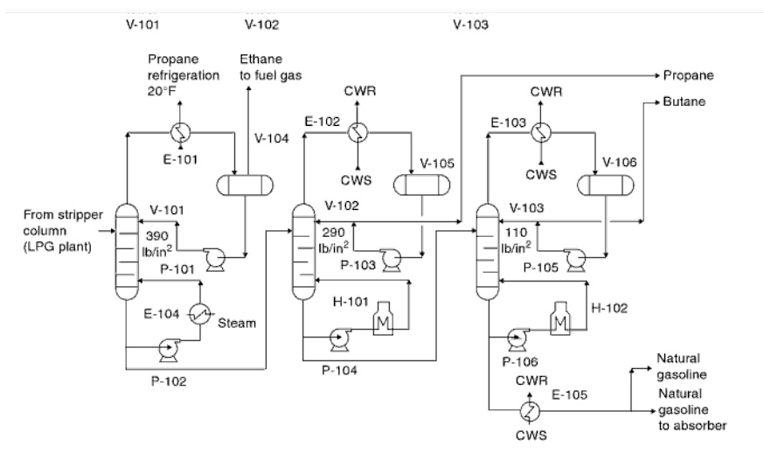
Figure 1.3 – LPG Fractionation System
Deethanizer
As can be seen from the Figure 1.3, the stripper bottoms from the extraction plant enter deethanizer column V-101 near the top. The overhead vapor is partially condensed in deethanizer condenser E-101 by heat exchange with medium-level propane at -6.67 °C. Condensed overhead product in overhead reflux drum V-104 is pumped back to the deethanizer by reflux pump. The non-condensed vapor, mainly ethane, leaves the plant to fuel the gas system. Heat is supplied to the column by forced circulation reboiler E-104. The deethanizer column operates at approximately 26.9 bar. Approximately 98% of the propane in the deethanizer feed is recovered in the bottom product. The residual ethane concentration is reduced to approximately 0.8 mole % in the bottom product. The bottom product from deethanizer drains into depropanizer column V-102.

Depropanizer
Deethanizer bottoms are expanded from 26.9 bar to 20 bar and enter depropanizer V-102 as mixed-phase feed. The depropanizer fractionates the feed into a propane-rich product and a bottom product comprised of butane and natural gasoline. Tower V-102 overhead vapor is totally condensed in the depropanizer condenser E-102 by cooling water. Condensate is collected in depropanizer column reflux drum V-105. A part of the condensed overhead product is sent back to the column as reflux via pump P-103 while the remaining part is withdrawn as a liquid propane product. Column V-102 reboiler heat is supplied by direct-fired heater H-101. Reboiler circulation is aided by reboiler circulation pump P-104. The bottom product is sent to debutanizer.

Debutanizer
The depropanizer bottoms are expanded from approximately 20 bar to 7.6 bar and then enter the debutanizer column as a mixed-phase feed. The column feed is fractionated into a butane-rich overhead product and natural gasoline bottoms. The columns overhead are totally condensed in the debutanizer condenser E-103 by heat exchange with cooling water, and condensate is collected in reflux drum V-106. The debutanizer reflux and product pump P-105 serve the dual purpose of supplying reflux to the column and allowing withdrawal of column overhead product butane from the reflux drum. The column reboil heat is supplied by a direct-fired debutanizer reboiler H-102, and boiler circulation is aided by debutanizer reboiler circulating pump P-106. The bottom product leaving the column is cooled in product cooler E-105. A part of the gasoline product is recycled to the LPG extraction unit and serves as lean oil for the absorber column (Parkash, 2003).

Product Treatment Plant
Propane and butane products from the fractionation plant contain impurities in the form of sulphur compounds and residual water that must be removed to meet product specifications. The impurities are removed by absorption on molecular sieves. Each product is treated in a twin fixed-bed molecular sieve unit. Regeneration is done by sour gas from the stripper overhead followed by vaporized LPG product. Operating conditions are listed in Table 1.5 and impurities to be removed are listed in Table 1.6.

Table 1.5 – Molecular Sieve Product Treating Process Operating Conditions
Operating variable | Units | Propane | Butane
Pressure | Bar | 22.4 | 10.7
Temperature | C⁰ | 43.3 | 43.3
Phase |  | Liquid | Liquid

Table 1.6 – Typical Contaminant Level in Untreated LPG
Contaminants | Units | Propane | Butane
H₂O | wt ppm | 10 | Trace
H₂S | wt ppm | 100 | Trace
COS | wt ppm | 34 | Trace
C₃SH | wt ppm | 100 | 40
C₂H₅SH | wt ppm | Trace | 220

Petlyuk Column
Distillation plays an important role in splitting raw product streams into more useful product streams with specified compositions. It is particularly well suited for high purity separations since any degree of separation can be obtained with a fixed energy consumption by increasing the number of equilibrium stages. However, industrial distillation processes are commonly known to be highly energy-demanding operations. According to Ognisty (1995), the energy inputs to distillation columns account for roughly 3% of the total energy consumption in the U.S (Christiansen et al., 1997). Thus, it becomes an obvious challenge to devise newer technologies to facilitate energy efficient separation arrangements. This study aims at using Petlyuk columns as an alternative to conventional configuration.
In order to increase the process efficiency of such distillation processes, the following two alternatives have been proposed both in the literature and by industrial practitioners. These include:
- Integration of Conventional Distillation Arrangements - Includes sequential arrangement of distillation columns with energy integration between the columns or other parts of the plant.
- Design of new configurations - Includes Dividing Wall Column; which consists of an ordinary column shell with the feed and side stream product draw divided by a vertical wall through a set of trays, first proposed by Wright (1949). The same configuration is usually denoted as a Petlyuk column after Petlyuk et al (1965) who studied the scheme theoretically. The fully thermally coupled column (Triantafyllou and Smith 1992) is also a modification of the Dividing Wall Column. These new configurations offer both energy and capital savings.

For the separation of ternary mixtures, three schemes have received particular attention; (a) the system with a side rectifier (b) the system with a side stripper and (c) the fully thermally coupled system, or Petlyuk column. Such systems have been shown to provide significant energy savings with respect to the conventional direct and indirect distillation sequences. Through the use of liquid-vapor interconnecting streams between two columns, two major effects can be obtained; one, the elimination of one heat transfer equipment from the distillation system, and two, a reduction in the energy consumption of the distillation process.

Definition of a Petlyuk Column
A column arrangement separating three or more components using a single reboiler and a single condenser, in which any degree of separation (purity) can be obtained by increasing the number of stages (provided the reflux is above a certain minimum value) (Christiansen et al., 1997).

Basics of a Petlyuk Column
The Petlyuk column consists of a pre-fractionator followed by a main column from which three product streams are obtained (Figure 1.4 (a) and (b)) (Wolff and Skogestad, 1995) and this arrangement has been shown to provide higher energy savings than the systems with side columns, with savings of up to 30% when compared to conventional schemes (Glinos and Malone, 1988; Fidkowski and Krolikowski, 1990).

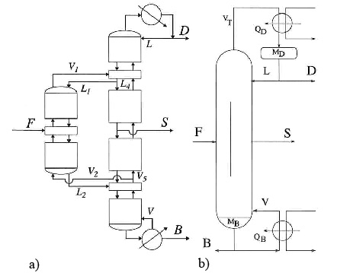
Figure 1.4 – Petlyuk Colom
(a) Stream notation for Petlyuk design with Pre-fractionator and main Column
(b) Practical implementation integrating. Pre-fractionator and main Column

The Petlyuk column has been studied theoretically for a considerable amount of time, but still few of these integrated columns have been built. One of the main reasons for this is the fact that it has many more degrees of freedom in both operation and design as compared to an ordinary distillation column. This undoubtedly makes the design of both the column and its control system more complex.
The Petlyuk design consists of a pre-fractionator with reflux and boilup from the downstream column, whose product is fed to a 2-feed, 3-product column, resulting in a setup with only one reboiler and one condenser. The practical implementation of such a column can be accomplished in a single shell by inserting a vertical wall through the middle section of the column, thus separating the feed and the side product draw (Wright, 1949). Petlyuk’s main reason for this design was to avoid thermodynamic losses from mixing different streams at the feed tray location. The product streams are denoted as D, S and B (and Feed F), with ternary components 1, 2 and 3.

PROJECT BASIS

Feed Streams
Feed streams used for the simulation are given in the Table 2.1. Both streams are NGL, coming from first stage separator from well and from dehydration unit.

Table 2.1 - Feeds Streams
Property | Feed 1 [from well] | Feed 2 [from dehydration unit]
Temperature | 25 ºC | 25 ºC
Pressure | 30 bar | 30 bar
Mass flowrate | 25 ton/hr | 8 ton/hr
Composition (mole fraction)
CH₄ | 0.097 | 0.130
C₂H₆ | 0.029 | 0.080
C₃H₈ | 0.035 | 0.100
i-C₄ | 0.018 | 0.055
n-C₄ | 0.028 | 0.113
i-C₅ | 0.026 | 0.104
n-C₅ | 0.025 | 0.091
n-C₆ | 0.064 | 0.122
n-C₇ | 0.090 | 0.110
n-C₈ | 0.150 | 0.072
n-C₉ | 0.110 | 0.020
n-C₁₀ | 0.090 | 0.003
C₁₁ | 0.079 | 0.000
C₁₂ | 0.071 | 0.000
C₁₃ | 0.031 | 0.000
C₁₄ | 0.023 | 0.000
C₁₅ | 0.018 | 0.000
C₁₆ | 0.014 | 0.000
H₂O | 0.002 | 0.000

Product Specifications
Product specifications are defined based on commercial products in LPG market. As described previously, specifications of the LPG products were taken from OPIC and Argus NGL Americans Methodology. These products can be sold on CME Group Market (NYMEX) in New York (CME, 2010). LPG product specifications are given in the Table 2.2.

Table 2.2 - Product Specifications
No. | Product | % Min | Other Components | % Max | Relative density | Price ($/gal)
1 | n-Butane | 94 | i-butane | 6 | 0.584 | 1.54661
1 | n-Butane | 94 | propane | 0.35 | 0.584 | 1.54661
1 | n-Butane | 94 | pentane | 1.5 | 0.584 | 1.54661
1 | n-Butane | 94 | olefin | 0.35 | 0.584 | 1.54661
2 | i-Butane | 96 | n-butane | 4 | 0.563 | 1.60083
2 | i-Butane | 96 | propane | 3 | 0.563 | 1.60083
3 | Propane | 90 | propylene | 5 | 0.507 | 1.17594
4 | C₅+ | - | - | - | 0.664 | 1.90315
5 | Field Grade Butane | - | i-butane | 35 | - | 1.43830
5 | Field Grade Butane | - | n-butane | 65 | - | 1.43830

The product specification above is used as initial basis to model the simulation. However, final decision about the product will be made after analysis of the economics of the project.

Project Scope
Simplified block flow diagram describing the project scope is shown in the Figure 2.1. Both streams of NGL from wells and dehydration unit will be further processed through LPG recovery unit to extract NGL into those products, propane, iso-butane, n-butane and heavier hydrocarbons (C₅+) as specified in Table 2.2 above.
There are 2 types of LPG extraction unit that will be discussed. The first one is conventional process which separates the product step by step using several columns. The other one is using Petyuk column. There are total 6 cases which are analyzed in this project. The alternative cases are developed based on economic consideration to extract raw NGL into different LPG products as shown in Table 2.3.

Figure 2.1 - Block Flow Diagram

Table 2.3 – Alternative Cases
Case | Description | Products
1 | Conventional Columns | Propane  i-Butane  n-Butane  Natural Gasoline (C5+)
2 | Conventional Columns | Propane  Butane (i-C4 + n-C4)  Natural Gasoline (C5+)
3 | Conventional Columns | LPG (C3, i-C4 & n-C4)  Natural Gasoline (C5+)
4 | Petlyuk Columns | Propane  i-Butane  n-Butane  Natural Gasoline (C5+)
5 | Petlyuk Columns | Propane  Butane (i-C4 + n-C4)  Natural Gasoline (C5+)
6 | Petlyuk Columns | LPG (C3, i-C4 & n-C4)  Natural Gasoline (C5+)

Assumptions
Several assumptions are used for designing this LPG recovery plant as well as simulating the process using Unisim software.

- Location
The LPG recovery plant will be built in Norway.
- The LPG plant is part of gas processing plant, so that steam used for reboiler of the column is considered to be generated as part of steam generation for the whole plant. Then, it just needs to add the duty required to generate more steam, not to build the new boiler for the steam.
- In order to economise process, instead of using refrigerant it is suggested to use sea water for condenser.
- Sea water temperature for condenser 10ºC.
- Both conventional and petlyuk produce the same amount of the products.

PROCESS DESCRIPTIONS
In this project, LPG extraction using both conventional fractionation column and Petlyuk column are modelled and discussed separately.

Conventional Column
Generally, the processes for 3 different cases for conventional column are the same. In this chapter, the simulation for conventional column is done for case 1 only. This simulation also represents case 2 and case 3 by reducing the number of the columns based on specified products.
There are 4 columns used in this conventional process. First stage of LPG extraction from NGL is Deethanizer. In this column, methane and ethane will be separated at the top of the column as vapor phase. The heavier hydrocarbons (C₃+) will flow at the bottom in liquid phase for next entering the Debutanizer column. In this column, propane and butane are separated and go to the top of the column, while the stabilized natural gas liquid (C₅+) flows at the bottom. In order to obtain pure specified propane product, propane and butane are separated in Depropanizer Column. Propane goes to the top and butane goes to the bottom. Then finally, n-butane and iso-butane are separated in butane splitter to get the specified products.
Simplified conventional fractionation process is illustrated by Process Flow Diagram in Figure 3.1 below.
Figure 3.1 – Simplified Process Flow Diagram
Detailed process flow, parameter used and modelling a simulation are explained afterwards.

Process Flow
As described in introduction, technology and process for LPG extraction using conventional column is typically the same as previous one. The differences are in selecting operating conditions (pressure and temperature) of each column and arrangement of the columns. Those are defined and determined based on feed stream conditions and composition, specifications of the product and economics of the process. Detailed process flow diagram is shown in Figure 3.2.
The process consists of mainly four distillation columns. The specification of feeds is given in Table 2.1. Initial feeds from both the separation units from the well and from the dehydration unit are mixed before entering the deethanizer. In order to meet the operating pressure of deethanizer, mixed feed (30 bar, 25ºC) is expanded through expansion valve to 26 bar. Further explanation about selecting operating pressure will be described in modeling sub-chapter 3.1.3.
In the deethanizer column, methane and ethane are expected to be separated and flow through the top of the column. Since there is no requirement to liquefy methane and ethane, especially in small amounts, these components will be kept in vapor phase and additional condenser is unnecessary. The boiling point of mixed methane and ethane, in this case at pressure 18 bar, is -52.55ºC, which means that refrigerant is required to condense the gas. For economic reasons, refrigerant will not be used in this process.
In this deethanizer, 100% methane and ethane in mixed feed can be separated and leaves the top of the column at 18 bar and 37.53ºC. This product will be used internally as a fuel to generate the steam which is used for reboiler of the column. Heat is supplied to the column by forced circulation using reboiler pump P-101 to reboiler E-101 and into the column. The heavier hydrocarbons other than ethane leave the column as bottom product in liquid phase at 26 bar and 246.7ºC. Next it is sent to debutanizer column.
Since the bottom product of deethanizer composed of small amount of propane (2 % of mass fraction) and butane (5 % of mass fraction), debutanizer is used instead of depropanizer. So that smaller columns will be used for next extraction. This is not only for economic reason, but also for efficiency of the separation as it is easier to extract the product this way and less duty will be required for reboiler E-102.
Before entering debutanizer column, the deethanizer bottom product is expanded from 26 bar to 17 bar and fed into debutanizer as mixed-phase feed. This feed is fractionated into mixed propane and butane as overhead product and heavier hydrocarbons (C₅+) as bottom product. Then the overhead product is totally condensed in the condenser E-103 by heat exchange with cooling water, and condensate is collected in reflux drum D-101. The cooling water is sea water with temperature 10ºC. The reflux drum should be used in order to prevent cavitation on the pump due to vapor phase. The debutanizer reflux and product pump P-103 serve the dual purpose of supplying reflux to the column and allowing withdrawal of column overhead product butane from the reflux drum. The column heat is supplied by a reboiler E-102, and circulation is aided by debutanizer reboiler circulating pump P-102.
About 100% propane and 99% butane can be recovered from the feed at the overhead column product. This stream leaves the column at 16 bar and 76.75ºC and is sent to depropanizer column to separate propane and butane. Meanwhile, the bottom product composed of pentane and heavier hydrocarbons will be stored as natural gasoline. Since the bottom product has high temperature (252.3ºC), it will be cooled by heat exchanger E-108 before being sent to the storage.
Propane and butane stream is expanded from 16 bar to 10 bar and enters the depropanizer as mixed-phase feed. The depropanizer separates propane as overhead product and butane as bottom product. Condenser E-105 is used to totally condense the overhead vapor from depropanizer. Sea water is used for cooling. Condensate is collected in depropanizer column reflux drum D-102. A part of the condensed overhead product is sent back to the column as reflux via pump P-105 while the remaining part is withdrawn as a liquid propane product. Depropanizer reboiler heat is supplied by reboiler E-104. Reboiler circulation is aided by reboiler circulation pump P-104.
It is about 99.9% of propane can be recovered as top product and 99.9% of butane is recovered as bottom product. The butane product is field grade butane which is composed of 34% i-butane and 65% n-butane. This is next being sent to butane splitter to get i-butane and n-butane products separately, since it could be sold with higher price than field grade butane.
The field grade butane is expanded from 10 bar to 5 bar before enter the butane splitter. I-butane is recovered as overhead product and n-butane as bottom product. I-butane is totally condensed by condenser E-107. Condensate is collected in reflux drum D-103. A part of the condensed overhead product is sent back to the column as reflux via pump P-107 while the remaining part is withdrawn as a liquid i-butane product. Butane splitter heat is supplied by reboiler E-106. Reboiler circulation is aided by reboiler circulation pump P-106.
Butane splitter column separates 96% mole of i-butane in the overhead product and 96% mole of n-butane in the bottom product. Both products have higher price than field grade butane. The whole process flow diagram is shown in Figure 3.2 below.

Figure 3.2 - Process Flow Diagram

Parameters
Modelling and simulating the LPG extraction process flow above is not as simple as the description, especially to converge the distillation column with Unisim. The parameters below should be considered in order to find a good result of simulation and the process as well as minimize the errors of the calculation.

- Operating pressure of the column
- Temperature of top product – avoid using refrigerant
- Number of stages
- Column specification
- Temperature profile at each tray
- Product specification
- Reboiler duty

Modelling
Generally, the process modelling for LPG extraction with Unisim is divided into 5 main sections. Those are feed conditioning, deethanizer, debutanizer, depropanizer and butane splitter. The additional condenser and reboiler are also explained separately. Each section will be described step by step below.

Feed Conditioning
As mentioned in the project basis, there are 2 feed streams of NGL. The compositions and conditions of both streams are given. Feed streams are natural gas liquids that come from first stage of separation unit from well stream (feed 1) and from dehydration unit (feed 2). Both streams have the same condition of pressure and temperature, that is 25 ºC and 30 bar, but different compositions and mass flow rates. These NGL feeds will be extracted into 3 LPG products, propane, iso-butane and n-butane. The products were selected based on demand in LPG market. Furthermore, specifications of each product were determined referring to current commercial prices.
First step of the LPG extraction process is feed conditioning before entering the deethanizer column. Regarding feeds composition which still contains 22.7 % mole and 10.9 % mole of methane and ethane, there are 3 alternatives for conditioning. First alternative is to mix both feeds and expand the mixed feed to a certain pressure. Then use a separator to remove lighter hydrocarbons. The lighter hydrocarbons are expected methane and ethane. The process is illustrated in Figure 3.3. This alternative requires one separator vessel with capacity 33 ton/hr.

Figure 3.3 – Feed Conditioning Alternative 1

Second alternative is to expand and separate the gas of each stream. Then bottom stream of each separator is mixed before entering the Deethanizer column as shown in Figure 3.4.

Figure 3.4 – Feed Conditioning Alternative 2

Next alternative is to mix both feed stream, expand the mixed feed and enter the deethanizer column without using the separator. This is the most simple and economic alternative. The process is shown in Figure 3.5.

Figure 3.5 – Feed Conditioning Alternative 3

The simulation were done for 3 alternatives to choose the most economic and feasible process. Considering the process specification and economic such as number of tray, quality of the products, reboiler duties and equipment cost, it resulted alternative 3 as the chosen conditioning process as shown in Table 3.1.

Table 3.1 – Feed Conditioning Alternative Comparison

Deethanizer
After selected the feed conditioning process, next step is defining the process in the deethanizer column as well as converging the column. As mentioned previously, in order to minimize the cost, it is avoided to use refrigerant. Therefore, there will be no condenser that is used at the overhead column stream as shown in Figure 3.6. Methane and ethane as top products will be separated in gas phase. By deleting the condenser there will be no reflux stream at the top of column, so that the NGL feed will enter the column at the top stage inlet.

Figure 3.6 – Deethanizer Column

First step to do after defined stream connection is selecting the operating pressure at the top and the bottom of the column. As initial guess, 26.9 bar pressure was used based on reference. Since the feed pressure is 30 bar, expansion valve is added in order to meet the operating pressure of the column. Afterwards select the parameter which will be used as column specification to converge the deethanizer column. In this case, since condenser is not used, there will be only one column specification needs to be defined to converge the column.
Selecting operating pressure at the top and the bottom of the column is very important to separate the methane and ethane from the NGL. The lower the pressure the more the vapour phase. The operating pressure has to be selected so that most methane and ethane flow to overhead column and keep propane and heavier hydrocarbons as the bottom product. The best result is to select operating pressure 18 bar at the top stage and 26 bar at the bottom stage.
Next step is selecting the column specification. As mentioned previously, there is only one column specification in modelling the deethanizer column. In this case, the bottom product flow rate is selected since it is the recommended and default specification for the column. Other specification can also be selected, for example component fraction at the top or bottom stage, but it would be very difficult to converge the column. It depends on the composition of the feed. In this case, the composition of methane and ethane in the feed is quite less, so that it is very difficult to remain all the propane and heavier hydrocarbons in the bottom stage.
Practically, some trials have to be done to find the best result. As well as selecting operating pressure and column specification, defining the number of stages is also quite important. The more the number of stages means the better the separation process. In the other hand, more number of stages means higher column is required and the cost will be more expensive. Therefore, the number of stages has to be selected the optimum one considering both separation efficiency and cost. As initial guess, the number of stages is defined based on reference.
In order to find the optimum number of stages, the temperature profile of each tray would help. As well as the column converged by using initial guess of number of stages, it can be reduced to the optimum one by considering the temperature profile of each tray. At the point where the column is no longer converged, the previous number is selected as the optimum one. In this case, the optimum number of stages for deethanizer is 18 stages.
After converged the column and find the optimum one based on the separation efficiency and economic consideration, the simulation is continued to modelling the debutanizer column.

Debutanizer
As mentioned previously in process description, for economic reason, debutanizer will be used after deethanizer instead of depropanizer, so that the next separation will use smaller column. Debutanizer is used to separate butane and lighter hydrocarbons at the top and heavier hydrocarbons at the bottom. Modelling the debutanizer by Unisim is shown in Figure 3.7 below. Both condenser and reboiler are used.

Figure 3.7 – Debutanizer Column
Basically, the steps in modelling the debutanizer column are almost the same like modelling deetanizer. The differences are in selecting the column specifications. Since both condenser and reboiler are used, there are 2 column specifications to be defined in order to converge the column. In this case, components recovery of the top product is selected as column specification. As it is expected to separate propane and butane at the top and heavier hydrocarbons at the bottom, so that components recovery of the propane and butane as the top product are selected.
Even though most propane and butane can be recovered as the top product, there is one specification should be considered, that is reboiler duty. It is possible to have 99.99% of propane and butane at the top, but more reboiler duty will be required. Thus, the fraction of components recovery should be selected by considering minimum reboiler duty in order to minimize the cost for the steam.
As well as modelling deethanizer, selecting operating pressure and number of stages are also done in modelling debutanizer. Initial guess value for both specification are also based on reference then have some trial to find the optimum value.

Depropanizer
Depropanizer is used after debutanizer column in order to separate propane and butane. The modelling steps are almost the same with debutanizer. Both condenser and reboiler are used as shown in Figure 3.8. In this column, propane liquid is produced as overhead product and butane as bottom product.

Figure 3.8 – Depropanizer Column
Modelling the depropanizer column is simpler since it only has 2 compositions in the feed. Components recovery is also used as column specification. There is no significant reboiler duty difference in changing the recovery fraction value. Selecting operating pressure and number of stages are also done using initial guess value from reference. Some trials still have to be done to find the optimum value.

Butane Splitter
Butane from depropanizer column is next separated into i-butane and n-butane in butane splitter column. It is typically the same as the depropanizer column as shown in Figure 3.9. Components recovery is still used as column specification. But it is more difficult than two previous columns to meet the products specification for n-butane and i-butane, since it is very sensitive with changing value of component recovery. So that some trials have to be done to select the optimum components recovery value for both n-butane and i-butane in order to meet the specification of the product. Selecting operating pressure and number of stages are still done using initial guess value from reference.

Figure 3.9 – Butane Splitter

The overall modelling of simulation using Unisim is shown by Figure 3.10. As mentioned previously, this simulation represents case 1 and the other cases are illustrated in Figure 3.11 for case 2 and Figure 3.12 for case 3.

Figure 3.10 – Process Flowsheet Case 1

Figure 3.11 – Process Flowsheet Case 2
Figure 3.12 – Process Flowsheet Case 3

Reboiler and Condenser
Reboiler and condenser are parts of the columns. Reboiler is used to supply heat into the column, so that the lighter hydrocarbons will be vaporized and go up to the top stage. Steam is used to heat up a part of bottom product and recycle it into the column. Meanwhile, condenser is used to condense the overhead vapor so the liquid product will be produced which partially recycled into the column as reflux.
In simulation, as part of a distillation column, both reboiler and condenser are defined based on requirement in order to meet product specifications.

Recirculation Pumps
Recirculation pump is used to recycle the reflux and heat supply into the column. It is not shown in the simulation but still need to be calculated for the cost estimation.

Petlyuk Column

Minimum Energy Mountain Diagram
The starting point for Petlyuk column simulations is to plot Minimum Energy Mountain Diagram. Minimum Energy Mountain Diagram or just Vmin-diagram is introduced to effectively visualize how the minimum energy consumption is related to the feed component distribution for all possible operating points.
A main result is a simple graphical visualization of minimum energy and feed component distribution. The assumptions are constant relative volatilities, constant molar flows constant and infinite number of stages (Halvorsen and Skogestad, 2002).

Underwood equation
For a multicomponent mixture the vapor flow rate for a given separation can be calculated using Underwood’s equations. The minimum vapor flow rate at the top of the column is given as (Engelien and Sigurd Skogestad, 2005):

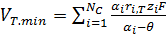

The common Underwood roots are given as the N-1 solutions of the feed equation:
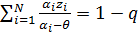 ,
The solutions obeys

K-values and Relative Volatility
The K-value (vapor-liquid distribution ratio) for a component i is defined as:
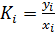 ,
The relative volatility between components i and j is defined as:
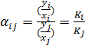 ,
K value depends strongly on temperature and pressure. DePriester charts can be used to determine K value.

In addition, it is possible to apply rough empirical formula to estimate relative volatility.
,
where 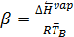,
,
If know is unknown, a typical value can be used for many cases (Halvorsen and Skogestad, 1999). But in practice it easier to take K-values directly from Hysys or Unisim.

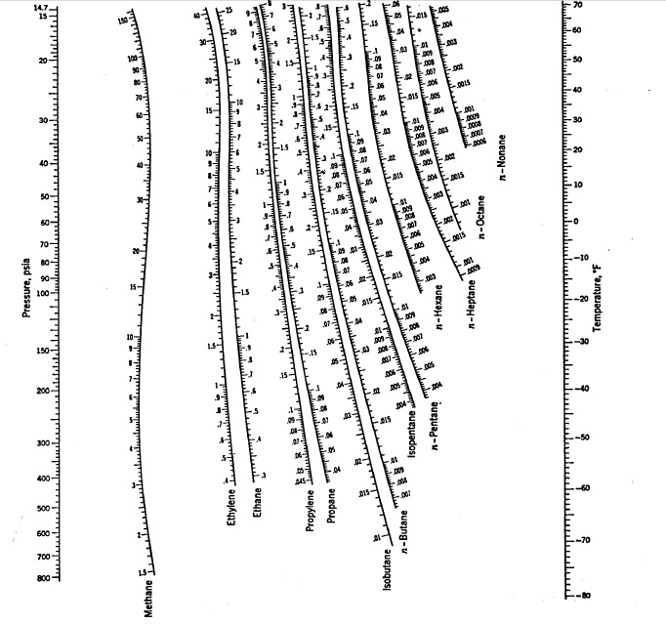
Figure 3.13 – DePriester Chart (Depriester, 1953)

Computational Procedure
UWMulti in Mathlab was used to solve Underwoods equation, Feed equation and to plot V_{min} diagram. The program was designed by Ivar Halvorsen.

Table 3.2 – K values, Relative Volatilities and Composition of the Feed
Component | K values | Relative volatilities | zf
CH4 | 9.919368675 | 13635622.5 | 8.66E-02
C2H6 | 1.965425837 | 2701765.2 | 4.46E-02
C3H8 | 0.585428568 | 804757.2 | 5.81E-02
i-C4 | 0.242096011 | 332796.4 | 3.16E-02
n-C4 | 0.174953747 | 240499.5 | 5.92E-02
i-C5 | 7.27E-02 | 99990.6 | 5.49E-02
n-C5 | 5.52E-02 | 75918.4 | 4.96E-02
n-C6 | 1.81E-02 | 24888.0 | 8.70E-02
n-C7 | 6.16E-03 | 8474.7 | 1.00E-01
n-C8 | 2.11E-03 | 2900.2 | 0.1265589
n-C9 | 7.56E-04 | 1039.1 | 8.09E-02
n-C10 | 2.79E-04 | 382.9 | 6.14E-02
C11 | 9.90E-05 | 136.1 | 5.29E-02
C12 | 4.09E-05 | 56.2 | 4.76E-02
C13 | 1.32E-05 | 18.2 | 2.08E-02
C14 | 4.06E-06 | 5.6 | 1.54E-02
C15 | 1.93E-06 | 2.7 | 1.21E-02
C16 | 7.27E-07 | 1.0 | 9.38E-03

Vmin-diagram for 18 Feed Components
A V_{min}-diagram for the given feed is shown on the Figure 3.12. The peaks show minimum energy operation for sharp split between adjacent components.

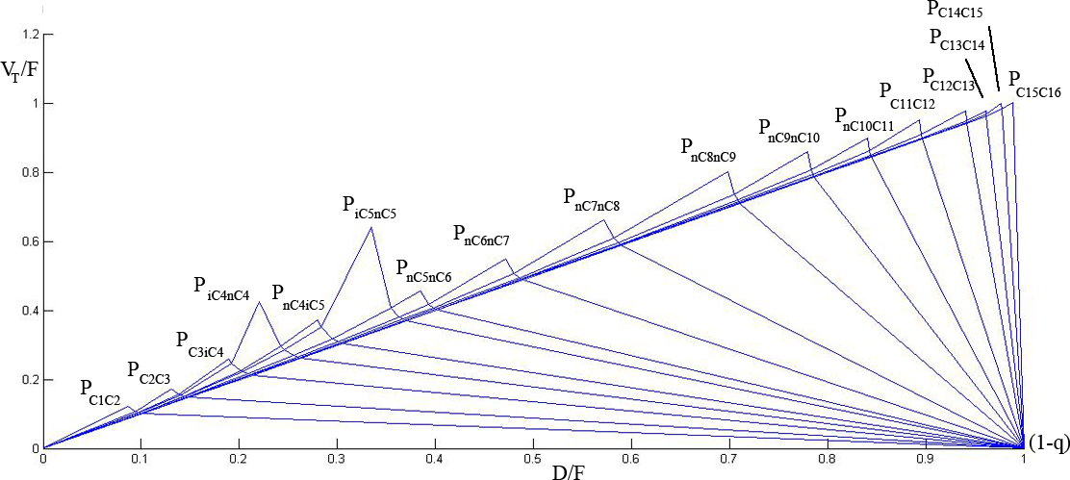
Figure 3.14 - V_{min} Diagram for 18 Feed Components
The highest peak determines the maximum minimum vapour flow requirement in the arrangement. But in this study there is no need to separate C15 from C16, because the final products should be LPG and NGL. It is important to separate only C1C2, C3, iC4, nC4 and C5+ from each other.

Five products in 18 component feed
In Petlyuk arrangement all columns are directly (fully thermally) coupled. The total number of internal directly coupled two-product columns to separate M products is (M - 1) + (M - 2) + ... = M(M - 1)/2. There are (M – 1) product splits, and these can be related to M - 1 minimum-energy operating points (peaks) in the Vmin diagram (Halvorsen and Skogestad, 2002).
M(M - 1)/2=5*(5-1)/2=10

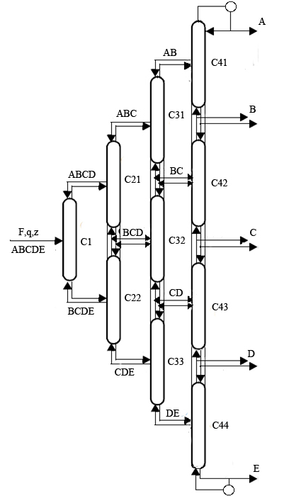
A – C1C2, B – C3, C – iC4, D – nC4, E – C5+
Figure 3.15 – Five Products Petlyuk Arrangement for LPG and NGL Production
V_{min} diagram for a given 18-component feed (C1-C16) is shown in the Figure 3.14. This feed should be separated into five procuts (C1C2, C3, iC4, nC4, C5+). The plot shows the Vmin-diagram for the feed components (blue line) and the equivalent diagram for the products (red line). The specification for products is shown in Table 3.3. The reason for 6% of iC4 in the nC4 is the descreasing of V_{min} energy for iC4/nC4 split. Due to the specification it is possible to obtaint iC4 and nC4 with 96% purity.

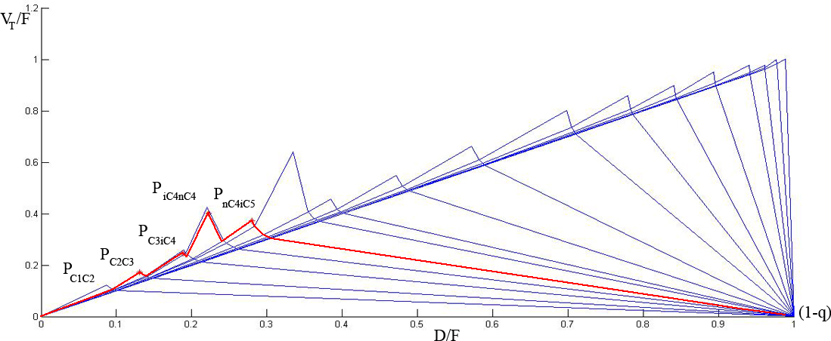
Figure 3.16 - Assessment of Minimum Vapour Flow for Separation of a 18-Component Feed into 5 Products (C1C2, C3, iC4, nC4, C5+)

Table 3.3 – Specification of Feed Component Recoveries in Products C1C2, C3, iC4, nC4, C5+
Product | Light Key Impurity Specification | Heavy Key Impurity Specification | Comments
C1C2 |  | 0% C3 | All of C1, most of C2
C3 | 0% C2 | 5% iC4 | Sharp C3/iC4 split
iC4 | 0% C3 | 4% nC4
nC4 | 6% iC4 | 0%C5+
C5+ | 0% | 100% C5+ | All heavy components

The result of minimum energy solution for each split is given in Table 3.4. Each split gives us the peaks and knots (P_{ij}) in the V_{min} diagram for five products (red line). The highest peak is iC4/nC4 split V_{T.min}=0.4033. This is the maximum minimum vapor flow requirement in the arrangement and it is directly related C43. All heat for vaporization has to be supplied in the bottom, but the other peaks are lower. Column C41, C42, C44 will get a higher vapor load then required.

Table 3.4 – Minimum Energy Solution for Each Split
Split | Column | V_{T.min}
ABCD/BCDE | C1 | 0.1510
ABC/BCD | C21 | 0.1547
BCD/CDE | C22 | 0.2251
AB/BC | C31 | 0.1565
BC/CD | C32 | 0.2468
CD/DE | C33 | 0.2954
A/B | C41 | 0.1728
B/C | C42 | 0.2474
C/D | C43 | 0.4033
D/E | C44 | 0.3720

Heat Exchangers at the Side Stream Junctions
To set all flow rates independently in columns C44, C43, C42, C41, it is possible to withdraw liquid products and use a heat exchanger where the duty corresponds to the change in vapour flow. This vapour change may be taken from V_{min} diagram as the difference between peaks. Heat exchangers are unnecessary at the internal feed junction, because any amount of liquid of vapor can be taken from the succeeding column.
This scheme gives full flexibility in controlling the two degrees of freedom in each internal column. The Vmin-diagram gives minimum vapour requirements for every section for the specified separation, but when the peaks are different heat can be removed of supplied at the boiling points of the intermediate components. The highest peak will set the same vapour flow requirement through the most demanding intersection in both cases.
For columns C44 and C43 the difference between vapor flow is V_{min}=0.3720-0.4033=-0.0313, for C43 and C42 V_{min}=0.1559 and it is possible to install heat exchanger between them. The same for columns C42 and C41 with V_{min}=0.0746. To sum it up with heat exchangers in the sidestream junctions, each column is supplied with its minimum energy requirement (Halvorsen, 2001).
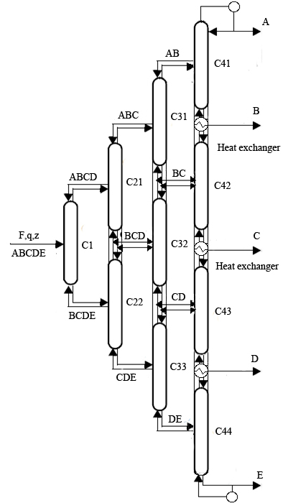
Figure 3.17 – Extended Arrangement for Five Products Petlyuk Column with Heat
Exchangers at the Sidestream Junctions

Four products in 18 component feed
Four products Petlyuk column arrangement can be used to obtain the following components: C1C2, C3, iC4nC4, C5+. The difference with the previous five products arrangement is in the combination of iC4 and nC4 in one product. It may be dictated by economic situation.

For this case the total number of internal directly coupled columns will be 4*(4-1)/2=6. Four products Petlyuk column is shown on the Figure 3.16.

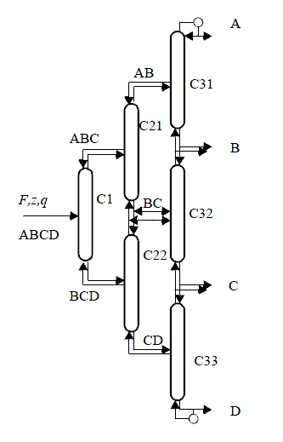
A – C1, C2 ; B – C3 ; C – iC4, nC4 ; D – C5+
Figure 3.18 – Four products Petlyuk Arrangement for LPG and NGL Production

To decrease minimum energy for iC4nC4/C5 split the heavy key impurity C5+ in iC4nC4 is specified to 5%. In this case the saparation of iC4/nC5 is avoided. The new V_{min} diagram for four products is shown on the Figure 3.17.

Table 3.5 – Specification of Feed Component Recoveries in Products C₁C₂, C₃, iC₄nC₄, C₅+
Product | LK Impurity Specification | HK Impurity Specification | Comments
C₁C₂ |  | 0% C₃ | All of C₁, most of C₂
C₃ | 0% C₂ | 5% iC₄nC₄ | Sharp C₃/iC₄ split
iC₄nC₄ | 0% C₃ | 1% C₅+
C₅+ | 1% iC₄nC₄ | 99% C₅+ | All heavy components

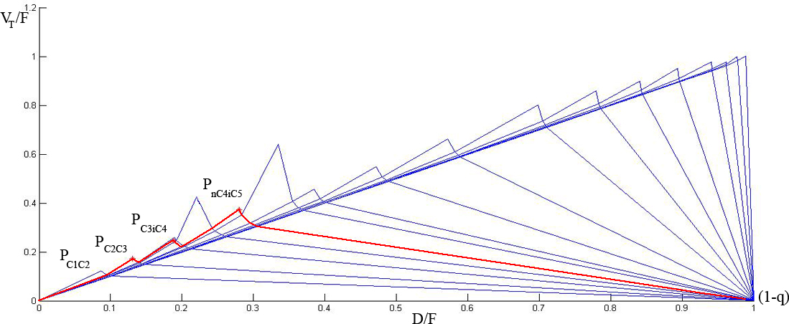
Figure 3.19 - Assessment of Minimum Vapour Flow for Separation of a 18-Component Feed into 4 Products (C₁C₂, C₃, iC₄nC₄, C₅+).

The resulting minimum-energy solution for each split is given in the Table 3.6. The highest peak is iC4nC4/C5+ split V_{T.min} = 0.3559. This is the maximum minimum vapor flow requirement in the arrangement and it is directly related C33.

Table 3.6 – Minimum Energy Solution for Each Split
Split | Column | V_{T.min}
ABC/BCD | C1 | 0.1547
AB/BC | C21 | 0.1565
BC/CD | C22 | 0.2468
A/B | C31 | 0.1728
B/C | C32 | 0.2474
C/D | C33 | 0.3559

Modelling and Simulation of Petlyuk Columns
The main idea of revisiting the idea of Petlyuk column was to be able to simulate a Petlyuk column as an alternative to the use of conventional columns as described in Chapter 3. The driving force behind this was the fact that theoretical studies have shown that such an arrangement can save, on average, around 30% of energy cost compared to conventional arrangement.
Thus, the specifications mentioned in Table 2.2 were set as the required product specifications from the Petlyuk Column (Unisim simulation), highlighted in Figure 3.18 and internal column configuration (Unisim simulation) shown in Figure 3.19.

Figure 3.20 – Unisim Simulation of LPG Plant Using Petlyuk Column

Figure 3.21 – Unisim Simulation Showing Petlyuk Column Internal Configuration

Parameters used for convergence of simulation
There were fourteen degrees of freedom for the Petlyuk column and the parameters used for convergence are shown in Table 3.7. Initial guess values for the vapor flow rates in the various columns were taken from Vmin diagram plotted for 4-products (Figure 3.21).

Table 3.7 – Parameters for Petlyuk Column
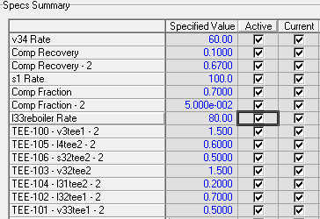

However, convergence of the same could not be achieved and it was thus necessary to do short cut calculations for three-product Petlyuk columns for three different cases.

Estimations of Component Flow rates by Product Specifications and Material Balance
It is assumed that the feed to the Petlyuk Column contains three components A, B, C in decreasing order of their relative volatilities (Muralikrishna et al, 2002).
Assumptions: i) No C appears in the distillate.
ii) No A appears in the bottom.

Figure 3.22 – Internal Configuration of 4-Products Petlyuk Column

In general, specifications are made on the following product compositions:
x_{D,A}, x_{M,B}, x_{B,C},
The seven unknown variables related to the output of the column are:
The equations resulting from the specifications are:
(1)

(2)
(3)
(4)
The component material balance equations give:
(5)
(6)
(7)
Material balance around the prefractionator yields:
(8)
(9)
While following such a representation, the following condition must hold in order for the three columns to be reducible to a dividing wall column:
(10)
For ease of construction of the column, the number of plates on either side of the dividing wall should be equal, although this is not a necessary condition:
(11)

Design Equations for the Dividing Wall Column (DWC)
Column 1 (Prefractionator):
The pre-fractionator operates with the light key and heavy key as A and C respectively, with the component B distributing. The two Underwood roots can be calculated from the following equation:
(12)
Where
The two Underwood roots are used in the following equations:
(13)
(14)

d_{1A}, d_{1B} are specified and then the values of d_{1C,Underwood} and R_{1,min} can be calculated.
(15 a)

if R.H.S of 15(a) > 0
= 0 (15 b)
if R.H.S of 15(a) < 0
From equations (13) and (15), we get the value R_{1,min} as
(16)

At total reflux:
Fenske equation gives the minimum number of theoretical stages for a specified separation. The equation can be written for any pair of components, provided they distribute between the distillate and the bottoms.
For a given d_{1A}, d_{1B} , the Fenske equation reduces to:
(17)

And
(18)

Hence, for a given (d_{1A}, d_{1B} ) d_{1C, Fenske} can be calculated by evaluating the right hand sides of Equations (17) and (18):
(19)

At finite reflux:
Once, the flow rates of C in the distillate at minimum and infinite reflux have been found out, the flow rate of C in the distillate of Column 1 at a finite reflux ratio R₁ greater than the minimum, can be found out
(20)

Thereafter, Gilliland Correlation may be used to determine the actual number of stages in Column 1:
(21)
(22)

(23)
Having known d_{1A}, d_{1B} and d_{1C}, b_{1A}, b_{1B} and b_{1C} can be found out by using:
(24)
(25)
(26)
The vapour flows in the rectifying and the stripping sections of the column can be found out as:
(27)
(28)

Column 2 and Column 3:
The Underwood root Ө is such that as component C is heavier than the heavy key component B and is found from the following equation:
(29)

Where q₂ is calculated from
(30)
(31)
As,
(32)
And F₂ = D₁ where
(33)

Underwood root Ψ such that can be similarly calculated from the following equation and with a similar argument as above:
(34)
Where
(35)
Now, the Underwood equations can be used to determine the minimum reflux ratios for the two columns as follows:
(36)
Where, d_{2A} and d_{2B} are the same as d_{A} and d_{B} respectively.
Similarly,
(37)
Where,
(38)
(39)
(40)
Where, b_{1A}, b_{1B} and b_{1C} are obtained from the pre-fractionator calculations, and b_{3B} and b_{3C} are the same as b_{B} and b_{C} respectively.

At total reflux:

Fenske Equation gives:

(41)

(42)

At finite refluxes:

Reflux ratios R₂ and R₃ are not independent variables and need to satisfy the following equations, before they can actually be used to calculate the number of stages in the columns using Gilliland Correlations:
(43)

(44)
(45)

Substituting equations 44 and 45 in equation 43, we get:

(46)

Gilliland correlations as in the previous can now be used to compute the number of stages in the Columns 2 and 3 for a chosen R₂ and R₃.

A check is made whether the condition demonstrated by equation 11 is satisfied or else an iterative approach is used for refining the guessed R₂ and R_{3.}

Results of Short Cut Calculations
The short cut calculations illustrated above have been used to compute the number of stages in the pre-fractionator and the two columns for the 3 different cases. Detailed calculations are presented in Appendix C.
However, the number of stages N₁, N₂ and N₃ calculated using the above equations were quite small compared to real life scenario. This may be attributed to the fact that in real distillation problems, relative volatilities change along the height of the column, Petlyuk columns operate under semi-vacuum pressures and the influence of dividing wall on the number of stages. Thus the actual number of stages for the Petlyuk Column is taken as ‘k’ times the minimum number of stages. The value of k is chosen smaller for Case 4 owing to relatively lesser reflux ratios compared to the other two cases. The same values for the three cases are tabulated in Table 3.8.

Table 3.8 – Petlyuk Column Calculation Results for 3 Cases
Case | N_{1,min} | N_{2.min} | N_{3,min} | k | Actual Number of trays
Case 4 | 5.2806 | 6.99 | 21.23 | 2.5 | 84
Case 5 | 7.8232 | 16.39 | 6.34 | 3.0 | 92
Case 6 | 2.5982 | 3.50 | 3.17 | 3.0 | 29

FLOWSHEET CALCULATIONS

Mass Balance
UniSIM was used to perform the mass balance for the system. The overall mass balance is summarized in Table 4.1.

Table 4.1 - Overall Mass Balance
MASS IN |  | MASS OUT
Stream | In (kg/h) | Stream | Out (kg/h)
Feed 1 | 25000 | C1+C2 | 1486
Feed 2 | 8000 | C5+ | 29140
 |  | C3 | 659
 |  | iC4 | 575.6
 |  | nC4 | 1136
Total | 33000 | Total | 32996.6
Difference = Mass In - Mass Out = |  | 3.4 kg/h
% Error = |  | 0.01 %

The percentage of error is smaller than 1 %, and thus acceptable. The component mass balance is summarized in Table 4.2.

Table 4.2 - Component Mass Balance
Object | Mass In (kg/h) | Mass Out (kg/h) | Error (kg/h) | % Error
DeEthanizer | 33000 | 32996 | 4 | 0.0121
DeButanizer | 31510 | 31511 | -1 | -0.00317
Propane column | 2371 | 2371 | 0 | 0
Butane column | 1712 | 1711.6 | 0.4 | 0.0234
Total | 68593 | 68589.6 | 3.4 | 0.03233

The percentage of error for each component is much smaller than 0.1%, and thus acceptable.

Energy Balance
The heat flows in and out of the system are summarized in Table 4.3 and Table 4.4 respectively.

Table 4.3 – Heat flows in to the system Table 4.4 – Heat flows in to the system
Streams In | Heat Flow  (10⁷ kJ/h) |  | Streams Out | Heat Flow  (10⁷ kJ/h)
Feed 1 | -5.499 |  | C1C2 | -0.5202
Feed 2 | -1.986 |  | C5 | -4.515
E-101 | 1.95 |  | C3 | -0.1798
E-102 | 1.045 |  | Ic4 | -0.152
E-104 | 0.4132 |  | Nc4 | -0.282
E-106 | 0.7112 |  | E-103 | -1.133
 |  |  | E-105 | 0.4251
 |  |  | E-107 | 0.7257
Total | -3.3656 |  | Total | -3.3652

Heat flow in – Heat flow out = -3.3656x 10⁷ kJ/h – (-3.3652) x 10⁷ kJ/h
= -0.0004 x 10⁷ kJ/h

The percentage of error is 0.01189 %, which is acceptable.

Table 4.5 – Component Heat Balance
Object | Heat In  (10⁷ kJ/h) | Heat Out  (10⁷ kJ/h) | Error  (10⁷ kJ/h) | % Error
DeEthanizer | -5.535 | -5.5362 | 0.0012 | -0.022
DeButanizer | -3.971 | -3.9694 | -0.0016 | 0.04
Propane column | -0.1742 | -0.1742 | 0 | 0
Butane column | 0.2917 | 0.2917 | 0 | 0
Total | -9.3885 | -9.3881 | 0.0001 | 0.018

Equipment Sizing
The main equipment used in the process is summarized in Table 4.6 and Table 4.7. For details about the calculation, see Appendix B.

Table 4.6 – Main Equipment I
Description | Height/length [m] | Diameter [mm] | # Trays | Trays Space [m] | Thickness  [mm]
Deethanizer | 21.6 | 1600 | 30 | 0.6 | 8
Debutanizer | 33.84 | 1400 | 47 | 0.6 | 6.35
Depropanizer | 20.4 | 1000 | 34 | 0.5 | 6.35
Butane Splitter | 25.2 | 1000 | 42 | 0.5 | 6.35

Table 4.7 – Main Equipment II
Description | Tag | Duty [kW] | Surface area [m²] | Type
Deethanizer Reboiler | E-101 | 5414 | 573.6 | Kettle
Debutanizer Reboiler | E-102 | 2907 | 445.5 | Kettle
Depropanizer Reboiler | E-104 | 1166 | 35.9 | Kettle
Butane Splitter Reboiler | E-106 | 1976 | 55.5 | Kettle
Debutanizer Condenser | E-103 | 3148 | 361 | Shell and tube
Depropanizer Condenser | E-105 | 1199 | 1141 | Shell and tube
Butane Splitter Condenser | E-107 | 2016 | 864 | Shell and tube

Table 4.8 – Other Equipments
Name Tag | Description
V-101 | Deethanizer Expansion Valve
V-102 | Debutanizer Expansion Valve
V-103 | Depropanizer Expansion Valve
V-104 | Butane Splitter Expansion Valve
P-101 | Deethanizer Reboiler Circulation Pump
P-102 | Debutanizer Reboiler Circulation Pump
P-103 | Debutanizer Condenser Circulation Pump
P-104 | Depropanizer Reboiler Circulation Pump
P-105 | Depropanizer Condenser Circulation Pump
P-106 | Butane Splitter Reboiler Circulation Pump
P-107 | Butane Splitter Condenser Circulation Pump
D-101 | Debutanizer Reflux Drum
D-102 | Depropanizer Reflux Drum
D-103 | Butane Splitter Reflux Drum
T-101 | Methane and Ethane Storage Tank
T-102 | Natural Gasoline Storage Tank
T-103 | Propane Storage Tank
T-104 | i-Butane Storage Tank
T-105 | n-Butane Storage Tank
E-108 | Natural Gasoline Condenser

COST ESTIMATION

Fixed capital cost
The fixed capital cost is estimated to get an approximate price for the total plant installed and running. These calculations are based on given percentages (West, Ronald E., et al, 2003). Major equipment costs are calculated as describes in Appendix E. The major costs for different cases are shown in the tables below.

Table 5.1 - Major Equipment Cost of Case 1*
Equipment | Cost ($)
Column | 425571.51
Tray | 60651.54
Heat exchangers | 29157889.63
Tank | 340002.30
Pump | 141088.33
Major equipment cost | 30705203.31

* Equipment number in case 1: 4 columns, 109 column trays, 7 heat exchangers, 5 tanks and 3 pumps

Table 5.2 - Major Equipment Cost of Case 2*
Equipment | Cost ($)
Column | 363798.73
Tray | 420259.99
Heat exchangers | 21992155.77
Tank | 261950.94
Pump | 105377.44
Major equipment cost | 23143542.86

* Equipment number in case 2: 3 columns, 79 column trays, 5 heat exchangers, 4 tanks and 2 pumps

Table 5.3 - Major Equipment Cost of Case 3*
Equipment | Cost ($)
Column | 332369.64
Tray | 325525.98
Heat exchangers | 10626537.25
Tank | 189908.08
Pump | 61737.53
Major equipment cost | 11536078.49

* Equipment number in case 3: 2 columns, 55 column trays, 3 heat exchangers, 3 tanks and 1 pump

Table 5.4 - Major Equipment Cost of Case 4*
Equipment | Cost ($)
Column | 437508.85
Tray | 714012.12
Heat exchangers | 17494733.78
Tank | 300389.13
Pump | 91761.83
Major equipment cost | 19038405.72

* Equipment number in case 4: 3 columns, 139 column trays, 5 heat exchangers, 5 tanks and 2 pumps

Table 5.5 - Major Equipment Cost of Case 5*
Equipment | Cost ($)
Column | 288814.33
Tray | 565991.48
Heat exchangers | 13973566.09
Tank | 285109.76
Pump | 39031.59
Major equipment cost | 151552512.25

* Equipment number in case 5: 2 columns, 122 column trays, 3 heat exchangers, 4 tanks and 1 pump

Table 5.6 - Major Equipment Cost of Case 6*
Equipment | Cost ($)
Column | 88218.72
Tray | 331447.72
Heat exchangers | 11607252.13
Tank | 64754.35
Pump | 80258.79
Major equipment cost | 12171931.71

* Equipment number in case 6: 1 columns, 28 column trays, 2 heat exchangers, 3 tanks and 1 pump

The fixed capital costs for different cases are listed in Tables 5.7. The cost estimation of Petlyuk columns has been done similarly, using 1.6 times the investment cost of an equi-sized conventional column. The factor takes into account costs of dividing wall, thicker shell and other unknown costs.

Table 5.7 - Fixed Capital Cost for Different Cases
Fixed Capital cost | Percent of delivered equipment cost | Cost (MUSD)
Fixed Capital cost | Percent of delivered equipment cost | Case1 | Case2 | Case3 | Case4 | Case5 | Case6
Purchased equipment delivered, E | 100 | 30.71 | 23.14 | 11.54 | 19.04 | 15.15 | 12.17
Purchased equipment installation | 47 | 14.43 | 10.88 | 5.42 | 8.95 | 7.12 | 5.72
Instrumentation and controls (installed) | 36 | 11.05 | 8.33 | 4.15 | 6.85 | 5.45 | 4.38
Piping (installed) | 68 | 20.88 | 15.74 | 7.84 | 12.95 | 2.56 | 2.06
Electrical systems (installed) | 11 | 3.38 | 2.55 | 1.27 | 2.09 | 1.96 | 1.58
Buildings (inclduing servics) | 18 | 5.53 | 4.17 | 2.08 | 3.43 | 0.92 | 0.74
Yard improvements | 10 | 3.07 | 2.31 | 1.15 | 1.90 | 0.71 | 0.57
Services facilities (installed) | 70 | 21.49 | 16.20 | 8.08 | 13.33 | 0.33 | 0.27
Engineering and supervision | 33 | 10.13 | 7.64 | 3.81 | 6.28 | 5.00 | 4.02
Construction expenses | 41 | 12.59 | 9.49 | 4.73 | 7.81 | 6.21 | 4.99
Legal expenses | 4 | 1.23 | 0.93 | 0.46 | 0.76 | 0.61 | 0.49
Contractor's fee | 22 | 6.76 | 5.09 | 2.54 | 4.19 | 3.33 | 2.68
Contingency | 44 | 13.51 | 10.18 | 5.08 | 8.38 | 6.67 | 5.36
Fixed capital investment |  | 154.75 | 116.64 | 58.14 | 95.95 | 56.04 | 45.02

Working capital cost
The working capital is the amount of capital required to start up the plant and to finance the first couple of months of operating before the plant starts earning, this capital is used to cover salaries, raw material inventories and contingencies. It will be recovered at the end of the project and represents a float of money to get the project started. These costs are necessary at start-ups and it implies raw materials and intermediates in the process. The working capital was assumed to be 3% of the fixed capital cost (West, Ronald E., et al, 2003). The total investment for the plant is listed in Table 5.8.

Table 5.8 - The Total Investment
Investment | Cost (MUSD)
Investment | Case1 | Case2 | Case3 | Case4 | Case5 | Case6
Fixed capital cost | 154.75 | 116.64 | 58.14 | 95.95 | 56.04 | 45.02
Working capital cost | 4.64 | 3.50 | 1.74 | 2.88 | 1.68 | 1.35
Total investment | 159.40 | 120.14 | 59.89 | 98.83 | 57.72 | 46.37

Operating Cost
All expenses directly connected with the manufacturing operation or the physical equipment of a process plant itself are included in the operating costs (Peters, 1991). Operating costs are divided into three categories: direct manufacturing costs, fixed manufacturing costs and general expenses.
Direct manufacturing costs represent operating expenses that vary with production rate. When product demand drops, production rate is reduced to less than the design capacity. A reduction in the factors making up the direct manufacturing costs is observed.
Fixed manufacturing costs are independent of changes in production rate. They include property taxes, insurance and depreciation, which are charged at constant rates even when the plant is not in operation.
General expenses represent an overhead burden that is necessary to carry out business functions. They include management, sales, financing, and research functions. General expenses seldom vary with production level (Turton, 2008).

Direct Costs
Raw materials costs
The raw materials in the process are natural gas liquids (NGL) and steam.

Natural Gas Liquids
The price for 1MBtu is 7USD (for 1000 cubic foot of NG). It is necessary to calculate the price for Raw NGL Feed for the plant. The Lower Heating Value in the Feed Stream is 4.264*10⁶ KJ/kgmole. To make heating value in KJ/m3 it should be multiplied by molar density:

Heating value = 4.264*10⁶*5.746=24.5*10⁶ KJ/m3 [KJ/kgmole * kgmole/m3=KJ/m3]

The value 24.5*10⁶ KJ/m3 corresponds to 23.221 MBtu/m3. It means that one m³ of Raw Feed can produce 23.221 MBtu of energy. So, 0.0431 m3 of Raw Feed will produce 1 MBtu of energy and this amount of energy costs apporximately 7 USD.
If 43.1 liters of Raw Feed costs 7USD, then 158.9 liters of Raw feed costs 25.8USD. So, one barrel of Raw Feed will cost 25.8USD (or 0.3USD per kg). The price for product (natural gasoline) is 67.3 USD/Bbl. It is possible to assume that the real price will be 20% higher and equals to 31 USD/bbl (or 0.36 USD per kg). Annual raw NGL feed cost:
Feed 1 = 25000 kg * 24 * 360 * 0.36$ = 77.76 MUSD/Year,
Feed 2 = 8000 kg * 24 * 360 * 0.36$ = 24.883 MUSD/Year,
Total Feed cost = 102.643 MUSD/Year.

Steam
It was assumed that this plant is supplied by steam from another industrial producer. The cost of high pressure steam is 29.97 USD/tonne (Turton, 2009). The necessary amount of high pressure steam is shown in the Table 5.9.

Table 5.9 – The Amount of Steam and Price
Case | Steam Flow Rate, tonnes/h | Price, MUSD/year
Conventional Columns
1 | 514.974 | 130.233
2 | 424.713 | 107.407
3 | 372.511 | 96.458
Petlyuk Column
4 | 394.296 | 102.099
5 | 326.937 | 84.657
6 | 286.547 | 74.199

Utility prices
Utilities prices consist of the process natural gas and the electricity for cooling water pumping.

Natural Gas
This plant produces natural gas (methane and ethane). The internal price for natural gas in Statoil ASA is shown on the Figure 5.1. An average price for last 4 years is 0.23 $/Sm³ (or 1.44 NOK/Sm³). It will be used for the entire operating period.

Annual price for gas = 1444.2 Sm³/h * 24 * 360 * 0.23 $/Sm³ = 2.867 MUSD/Year.
It is possible to earn 2.867 MUSD/Year by selling gas from the LPG recovery plant.

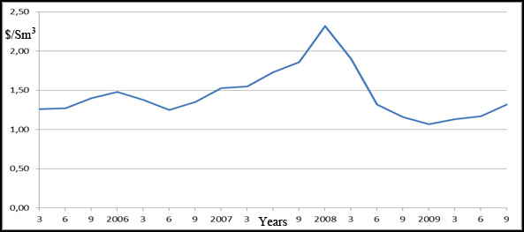
Figure 5.1 – The Internal Price for Natural Gas in Statoil

Cooling water
The price of electric power for the industry in Norway is given in the Figure 5.2 (Statistics Norway, 2010). The price is assumed to be constant and equal to 0.05 $/kWh throughout the whole period of production.
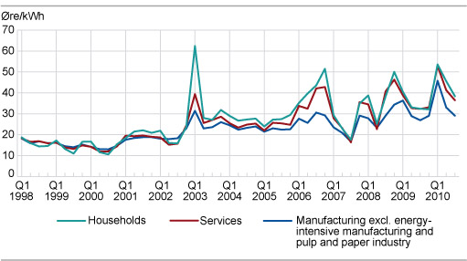
Figure 5.2 – Electric Power Prices in Norway

The cost of the cooling water is the cost of pumping the cooling water through the system, costs for water make-up and chemical treatment of the water. As shown in Figure 5.3 the pumping cost is assumed to be 0.01$ per 1m³ of water per hour. The pumping cost for 6 cases is summarized in Table 5.10.

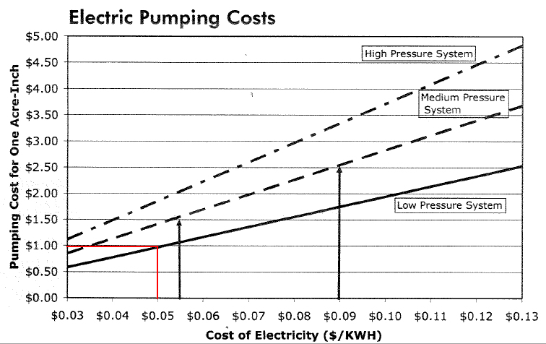
Figure 5.3 – Pumping Cost

Table 5.10 – The Amount of Water and Pumping Cost (for Petlyuk assumed 20% less)
Case | Water flow rate, m³/h | Price, MUSD/year
Conventional Columns
1 | 362.349 | 0.031
2 | 187.982 | 0.016
3 | 87.727 | 0.0076
Petlyuk Column
4 | 289.879 | 0.024
5 | 150.386 | 0.0128
6 | 70.181 | 0.0061

Operating labor
The following formula may be used for labor requirements estimations:
N_{OL} = (6.29+31.7P²+0.23N_{np})^{0.5},
where N_{OL} is the number of operators per shift,
P is the number of processing steps (for example, transportation and distribution),
N_{np} is the number of nonparticulate processing steps and includes compression, heating, cooling, mixing. Four and one-half operators are hired for each operator needed in the plant any time (Turton, 2008).
For the first case there are four distillation towers in the process, seven heat exchangers and five tanks so N_{np}=16.
N_{OL}=(6.29+0.23 * 16)^{0.5}=3.16 operator per shift.
Operating labour = 3.16 * 4.5 = 14.22 (rounding to the nearest integer gives 15)
Labor costs = 15 * 100000$/year=1.5 MUSD/Year.
Operating labour for 6 cases is tabulated in Table 5.11.
Table 5.11 – Operating Labour
Case | Number of main equipment | N_{np} | Labor requirements, N_{OL} | Number of labors | Labor cost, MUSD/Year
Conventional Columns
1 | Four towers, seven heat exchangers, five tanks | 16 | 3.16 | 15 | 1.5
2 | Three towers, five heat exchangers, four tanks | 12 | 3 | 14 | 1.4
3 | Two towers, three heat exchangers, three thanks | 8 | 2.89 | 13 | 1.3
Petlyuk Column
4 | Three towers, five heat exchangers, five tanks | 13 | 3.046 | 14 | 1.4
5 | Two towers, three heat exchangers, four tanks | 9 | 2.89 | 13 | 1.3
6 | One tower, two heat exchangers, three thanks | 6 | 2.77 | 13 | 1.3

The following formula was used to calculate operating cost for the plant:

This formula coefficients take into account direct manufacturing costs (raw materials, utilities, operating labor, supervisory, maintenance and repair, laboratory charges and patents), fixed operating costs, (depreciation, taxes and insurance, plant overhead costs), general manufacturing expenses (administration costs, distribution and selling costs, research and development and future worth factor).

Table 5.12 – Total Operating Cost
Case | Fixed capital investment FCI, MUSD | Raw materials C_{RM}, MUSD/Year | Utilities C_{UT}, MUSD/Year | Operating labor C_{OL}, MUSD/Year | Operating cost, MUSD/Year
Conventional Columns
1 | 159.397 | 232.876 | 2.836 | 1.5 | 351.918
2 | 120.143 | 210.05 | 2.851 | 1.4 | 307.608
3 | 59.886 | 198.101 | 2.8594 | 1.3 | 268.178
Petlyuk Column
4 | 99.198 | 204.742 | 2.843 | 1.4 | 292.59
5 | 58.008 | 187.3 | 2.8542 | 1.3 | 254.127
6 | 45.606 | 176.842 | 2.8609 | 1.3 | 236.215

INVESTMENT ANALYSIS
Profitability is the measure of the amount of profit that can be obtained from a given situation. It is as common denominator for all business activities. The determination and analysis of profits obtainable from the investment of capital and the choice of the best investment among various alternatives are major goals of the investment analysis (Peters, 1991).
The life time of the project was assumed to be 20 years. The depreciation for the plant is estimated to be at 10 percent. The tax to be paid to the government is assumed to be at 38%. The summary of investment analysis for 6 cases is shown in Table 6.1.

Table 6.1 – Performance Measurement of the Investment
Description | Conventional Columns |  |  | Petlyuk Column
Description | Case 1 | Case 2 | Case 3 | Case 4 | Case 5 | Case 6
IRR | - | - | 13% | - | 31% | 62%
NPV, M$ | -781.701 | -307.330 | 26.767 | -137.529 | 127.356 | 241.557
PBP, Years | - | - | 7.8 | - | 3.5 | 1.8

The Cases 1,2 and 4 yielded negative IRR and NPV, because they have negative annual cash flows and are thus unprofitable.

Internal Rate of Return
The internal rate of return on an investment or project is the "annualized effective compounded return rate" or discount rate that makes the net present value of all cash flows (both positive and negative) from a particular investment equal to zero. The higher a project's internal rate of return, the more desirable it is to undertake the project. IRR can be used to rank several prospective projects a firm is considering. Assuming all other factors are equal among the various projects, the project with the highest IRR would be considered the best and undertaken first.
Formula for calculations of IRR:
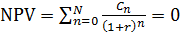,
Excel was used for calculate IRR. The highest IRR has the sixth case (Petlyuk column). So, it is the most attractive case for investments.

Net Present Value
Net Present Value is another method to evaluate the investment. NPV is an indicator of how much value an investment or project adds to the firm. If it is positive, the project may be accepted.In this method the value of cash earned in the future are converted to the present value through the following equation:
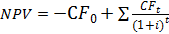,
The discount rate is assumed to be 8%.

Pay-back Period
Pay-back is the period of time required for the return on an investment to "repay" the sum of the original investment. The cash flow diagram shows the predicted cumulative net cash flow over the life of the project. The annual cash flow corresponds to the money that goes out minus the money that comes in. The first and second cases are unprofitable. The pay-back period for case 3 is shown in the Figure 6.1.

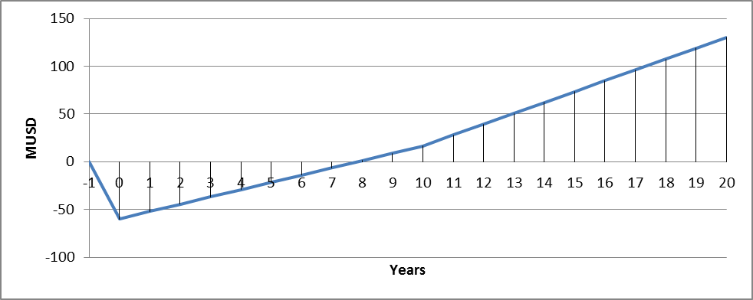
Figure 6.1 – Pay-back Period of Case 3

The pay-back period for case 5 is shown in the Figure 6.2.

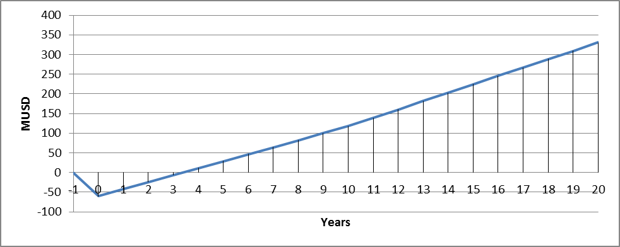
Figure 6.2 – Pay-back Period of Case 5

The pay-back period for case 6 is shown in the Figure 6.3.

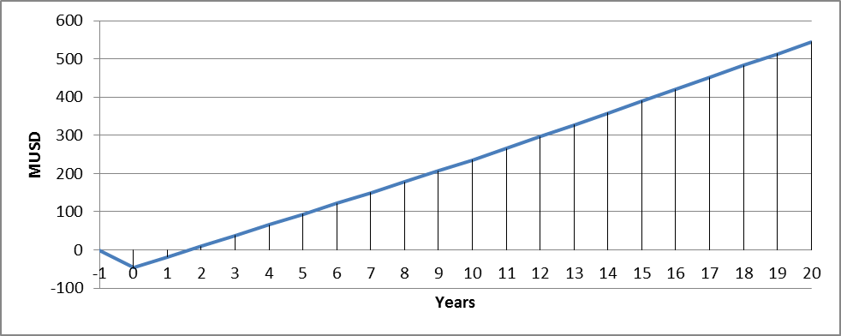
Figure 6.3 – Pay-back Period of Case 6

Sensitivity Analysis
Sensitivity analysis is made to evaluate the influence of the changing of different parameters on the project economy. Sensitivity analysis allows the analyst to get a feel for the impact of the variability of individual inputs on overall economic results. In general, if the sensitivity analysis reveals that reasonable changes in an uncertain input variable will not change the relative economic ranking of project alternatives or undermine the project's economic justification, then the analyst can have reasonable comfort that the results are robust.

In the following section the economics of the LPG plant is evaluated at changes in the raw material costs, variation in product prices and capital investment. The resulting values are shown in Figure 6.4 and Figure 6.5.

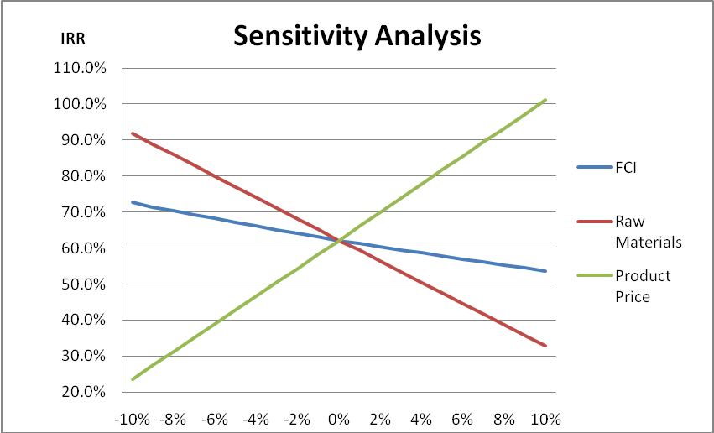
Figure 6.4 – Sensitivity Analysis of Case 6

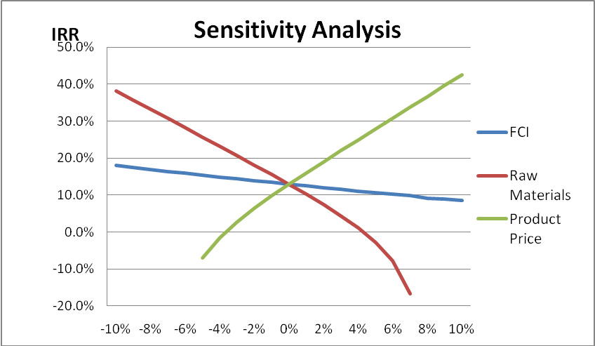
Figure 6.5 – Sensitivity Analysis of Case 3

DISCUSSION
There are two different alternatives for the LPG recovery plant: to build it in a conventional way or to use Petlyuk columns. The second alternative gives significant savings in operating cost, because it allows using less steam in the process. But there are many difficulties associated with the operation of Petlyuk columns. It is rather difficult to control them, because of comparatively larger number of degrees of freedom compared to a similar capacity conventional column. Petlyuk columns are higher and heavier than conventional columns and the effective installation of packings and the dividing walls often determines the realisation of such columns in practice. Nowadays there are not many plants operating with such columns and only few companies are being able to control maintained production via these processes.
Sensitivity analysis shows that the product performance depends very much on product prices and raw materials’ prices. It means that the project is very risky, even small deviation of prices can influence appreciably on the economical parameters. For example, increasing product price may lead to huge profits, but at the same time there is a risk of price decrease and huge money losses for some period of time. This risk is high for small companies or single investor, but it is acceptable for a big company with an established market. However, the main idea in the plant process design is to create really good technological scheme which will be able to show the better performance than the average competitor plant on the market.
In addition, there are different alternatives for final products. In this case the main product is NGL and there is no need to separate propane from butane or iso-butane from normal-butane. The flow rate of these components is relatively small compared to NGL flow rate and it is rather uneconomical to expend money for utilities. But all these components have different prices and specifications, and more so, the prices fluctuate over time so the choice of the plant’s design is also based on these facts. However, in order to account for varying prices, relatively long term future values have been used in the cost estimations outlined here, with the basic assumption that price variations average out over a comparatively longer time interval.

CONCLUSIONS AND RECOMMENDATIONS

This study considered two main alternatives for the LPG recovery: conventional plant and Petlyuk column. For conventional process, Unisim simulation shows that it is about 20,770 ton/year which corresponds to 88% of LPG product can be recovered from raw NGL, which has total flow rate of 289,080 ton/year.
To analyse and design Petlyuk columns, Vmin diagram and short cut calculations have been used. The results of calculations show that Petlyuk columns have 20-30% less energy requirements compared with conventional columns. This fact reflects that Petlyuk column configurations are more economical.
The study reveals that it is most profitable to produce two products that are LPG (C3, i-C4 & n-C4) and natural gasoline (C5+) from the given raw NGL feed. Both LPG extraction processes using conventional columns and Petlyuk column are economically profitable with the IRR for the former being 13% and the latter being 62% and NPV being respectively 27 MUSD and 242 MUSD.
However, both alternatives are highly sensitive to changes in the raw material and product prices. The sensitivity analysis showed that a 1% change in raw material prices may cause around 3% change in IRR values. Thus, this project can be recommended for an already established industrial company, while it would be a risky project for a single investor or a small enterprise.

LIST OF SYMBOLS

Symbol | Unit | Description
∆H_{r} | kJ/mol | Heat of reaction
∆H_{vap} | kJ/kg | Mass heat of vaporization
°C | °C | Temperature in celsius
K | K | Temperature in kelvin
c_{p} | kJ/kg°C | Spesific heat capacity
J | Nm | Energy
W | J/s | Watt
t | 1000 kg | Mass, tonne
v | m/s | Fluid velocity
V | m³ | Volume
A | m² | Area
M | kg | Mass
g | 0,001 kg | Gram
E | J | Energy
kWh | J | Energy
M | - | Mega
G | - | Giga
K | - | Kilo
Q | J/s | Heat energy
U | W/m²K | Overall heat transfer coefficient
Pa | N/m² | Pressure, Pascal
k | mol^{1-n}L^{n-1}s⁻¹  (n^{th} order) | Reaction rate constant
 | - | Distillate composition
 | - | Underwood roots
 | - | Composition vector
F | kgmol/h | Molar flowrate
 | - | Relative volatilities
 | - | Number of components
q | - | Feed liquid fraction
 | - | Vapor-liquid distribution
y_{i} | - | Vapor-liquid equilibrium concentration of component i in the vapor phase
x_{i} | - | Vapor-liquid equilibrium concentration of component i in the liquid phase
T_{bj} | K | Temperature of boiling for j component
T_{bi} | K | Temperature of boiling for i component
x_{DA} | - | Mole fraction of A in the distillate of the dividing wall column
x_{DB} | - | Mole fraction of B in the distillate of the dividing wall column
x_{MA} | - | Mole fraction of A in the sidestream of the dividing wall column
x_{MB} | - | Mole fraction of B in the sidestream of the dividing wall column
x_{MC} | - | Mole fraction of C in the sidestream of the dividing wall column
x_{BB} | - | Mole fraction of B in the bottoms of the dividing wall column
x_{BC} | - | Mole fraction of C in the bottoms of the dividing wall column
d_{A} | - | Flow rate of A in the distillate of the dividing wall column
d_{B} | - | Flow rate of B in the distillate of the dividing wall column
m_{A} | - | Flow rate of A in the sidestream of the dividing wall column
m_{B} | - | Flow rate of B in the sidestream of the dividing wall Column
m_{C} | - | Flow rate of C in the sidestream of the dividing wall column
b_{B} | - | Flow rate of B in the bottoms of the dividing wall column
b_{C} | - | Flow rate of C in the bottoms of the dividing wall column
f_{A} | - | Flow rate of A in the feed to the dividing wall column
f_{B} | - | Flow rate of B in the feed to the dividing wall column
f_{C} | - | Flow rate of C in the feed to the dividing wall column
N_{i;min} | - | Minimum number of allowable stages for column i
N_{i} | - | Number of stages for column i
n_{i} | - | Number of stages above the feed stage of column i
p_{i} | - | Number of stages below the feed stage of column i
V_{i} | - | Vapour flow rate in the rectifying section of column i
V_{i} | - | Vapour flow rate in the stripping section of column i
L_{i} | - | Liquid flow rate in the rectifying section of column i
L_{i} | - | Liquid flowrate in the stripping section of column i
q | - | Quality (saturated liquid fraction) of feed to the prefractionator
q_{i} | - | Quality (saturated liquid fraction) of feed to the column i
D_{i} | - | Total distillate flow rate from column i
B_{i} | - | Total bottoms flow rate from column i
R_{i;min} | - | Minimum reflux ratio for column i
Ri | - | Reflux ratio for column i
α_{A} | - | Relative volatility of A with respect to C
α_{B} | - | Relative volatility of B with respect to C
α_{C} | - | Relative volatility of C with respect to C
d_{1A} | - | Flow rate of A in the distillate of column i
d_{1B} | - | Flow rate of B in the distillate of column i
d_{1C} | - | Flow rate of C in the distillate of column i
b_{1A} | - | Flow rate of A in the bottoms of column i
b_{1B} | - | Flow rate of B in the bottoms of column i
b_{1C} | - | Flow rate of C in the bottoms of column i
F | - | Feed to the prefractionator
F₂ | - | Feed to column 2
F₃ | - | Feed to column 3
M | - | Sidestream flow rate
d_{1C;Underwood} | - | Flow rate of C in the distillate of 1 at minimum reflux (given d_{1A}, d_{1B})
d_{1C;Fenske} | - | Flow rate of C in the distillate of 1 at infinite reflux (given d_{1A},d_{1B})
d_{1C} | - | Flow rate of C in the distillate of 1 at reflux ratio (given d_{1A}, d_{1B})
X_{i} | - | Reflux factor of the Gilliland correlation for column i
Y_{i} | - | Plate factor of the Gilliland correlation for column i
N_{total} | - | Total number of plates of the dividing wall column
S_{i} | - | Boilup ratio of column i

REFERENCES
Argus NGL Americans Methodology from
http://web04.us.argusmedia.com/ArgusStaticContent//Meth/NGL%20AmericasMeth_Latest.pdf
Christiansen A, Skogestad S. and Lien K. ``Complex Distillation Arrangements: Extending the Petlyuk ideas'', Computers and Chem. Engng., 21, Suppl., S237-S242 (1997). (Supplement from symposium PSE-97/ESCAPE-7, Trondheim, Norway, 25-29 May 1997)
Christiansen A.C., Skogestad S. and Lien K, ``Partitioned Petlyuk arrangements for quaternary separations'', Proc. symposium Distillation and Absorbtion 97 (R. Darton, Ed.), 745-756, Maastricht, Netherlands, 8-10 Sept. 1997. Published by IChemE, UK.
CME 2010 prices from http://www.cmegroup.com/trading/energy/petrochemicals/mont-belvieu-iso-butane-5-decimal-opis-swap-futures_quotes_settlements_futures.html
Depriester C.L., Chemical Eng. Progr. Symposium Ser., 49 (7), 1 (1953).
Engelien H.K. and Skogestad S. Minimum Energy Diagrams for Multieffect Distillation Arrangements. Published online April 25, 2005 in Wiley InterScience. From http://onlinelibrary.wiley.com/doi/10.1002/aic.10453/abstract
Fenske, M. R., 1932, Fractionation of straight-run Pennsylvania gasoline, Ind Eng Chem, 24: 482.
Gilliland, E. R., 1940, Optimum feed-plate composition in multicomponent rectification, Ind Eng Chem, 32: 918.
Halvorsen I. J. and Skogestad S. Distillation Theory, 1999. From
http://www.nt.ntnu.no/users/skoge/publications/1999/DistillationTheory/original/distillationtheory.pdf
Halvorsen I. J. and Skogestad S. Minimum Energy Consumption in Multicomponent Distillation: Part I. The Vmin-diagram for a Two-product Column. 2002. From
http://www.nt.ntnu.no/users//skoge/publications/2003/Distillation_energy_Petlyuk_parts1-3/Part_2/old/PetlyukVmin_paper.pdf
Halvorsen I. J. and Skogestad S. Minimum Energy Consumption in Multicomponent Distillation: Part III. The Vmin-diagram for a Two-product Column. 2002. From
http://www.nt.ntnu.no/users//skoge/publications/2003/Distillation_energy_Petlyuk_parts1-3/Part_2/old/PetlyukVmin_paper.pdf

Halvorsen I.J. Minimum Energy Requirements in Complex Distillation Arrangements. A thesis for the degree of Dr.Ing. 2001.
K. Muralikrishna, K.P Madhavan, S.S Shah, Development of Dividing Wall Distillation Column Design Space for a specified separation, Trans I.Cheme, 2002, 80, 155.
NDSU Agroculture, 2010. From http://www.ag.ndsu.edu/ndsuag/
OPIC Methodology from http://www.opisnet.com/methodology.asp#nglforwards
Parkash Surinder. Petroleum fuels manufacturing. McGraw-Hill, New York, 2003, p. 3-11.
Peters M. and Timmerhaus K. Plant Design and Economics For Chemical Engineers. Fourth Edition, McGraw-Hill International, 1991, pp. 910.
Petroleum Fuel Facilities. MIL-HDBK-1022A, Department of defense of the United States, 1999, p. 34.
Richard Turton, Richard C. Bailie, Wallace B. Whiting, Joseph A. Shaeiwitz. Analysis, Synthesis, and Design of Chemical Processes, Third Edition. Prentice Hall, 2008, pp. 1088.
Statistics Norway, 2010. From http://www.ssb.no/elkraftpris_en/fig-2010-10-01-03-en.html
Tobin James, Shambaugh Phil, Mastrangelo Erin. Natural Gas Processing: The Crucial Link Between Natural Gas Production and Its Transportation to Market, Energy Information Administration, Office of Oil and Gas, January 2006
Treybal, R. E., 1980,Mass Transfer Operations, 3rd ed. (McGraw Hill)
Underwood, A. J. V., 1932, The theory and practice of testing stills, Trans IChemE, Part A, Chem Eng Res Des, 10: 112–152.
Underwood, A. J. V., 1946, J Inst Petroleum, 32: 598–626.
Underwood, A. J. V., 1948, Fractional distillation of multicomponent mixtures, Chem Eng Prog, 44: 603.
West Virginia University. Alternative Fuel Vehicle Training Program. From
http://www.wps.com/LPG/WVU-review.html
Wolff E. and Skogestad S., ``Operation of integrated three-product (Petlyuk) distillation columns'', Ind.Eng.Chem.Res., 34, 6, 2094-2103 (1995)
Wolff, E. A. and Skogestad, S., 1995, Operation of Petlyuk distillation columns, Ind Eng Chem Res, 34: 2094.

APPENDICES

Appendix A - Computational Procedure for V_{min} diagram
>> help UWmulti
UWmulti(theta,alfa,zf,qf)
[Vs,Ds,Rs,Keys]=UWmulti(theta,alfa,zf,qf)
[Vs,Ds,Rs,Keys]=UWmulti(theta,alfa,zf,qf,F)
[Vs,Ds,Rs,Keys,theta,VM,h]=UWmulti(theta,alfa,zf,qf,F,inkey,plotflag)
[Vs,Ds,Rs,Keys,theta,VM,h]=UWmulti(theta,alfa,zf,qf,F,[],plotflag)
[Vs,Ds,Rs,Keys,theta,VM,h]=UWmulti([],alfa,zf,qf,1,[],1)

Compute the minimum energy points of the multicomponent-mountains
Every set V,D and R is computed as the point of minimum
energy comsumption for a legal combination of LK and HK
Vs=[V1;V2;...],Ds=[D1; ...],R=[R1;R2....]
Keys=[LK1,HK1;LK2,HK2;.....]
theta: underwood roots, as from theta=UWroots(alfa,zf,qf)
VM : equation matrix
h : figure handle(s) from plotting
inkey : If included in argument list, compute for Keys==inkeys
plotflag: If plotflag==1 or nargout==0, plot the regions

Author I. Halvorsen 990417

>> alfa=[13635622.5, 2701765.2, 804757.2, 332796.4, 240499.5, 99990.6, 75918.4, 24888.0, 8474.7, 2900.2, 1039.1, 382.9, 136.1, 56.2, 18.2, 5.6, 2.7, 1]

alfa =

1.0e+007 *

Columns 1 through 9

1.3636 0.2702 0.0805 0.0333 0.0240 0.0100 0.0076 0.0025 0.0008

Columns 10 through 18

0.0003 0.0001 0.0000 0.0000 0.0000 0.0000 0.0000 0.0000 0.0000

>> zf=[8.66E-02, 4.46E-02, 5.81E-02, 3.16E-02, 5.92E-02, 5.49E-02, 4.96E-02, 8.70E-02, 1.00E-01, 0.1265589, 8.09E-02, 6.14E-02, 5.29E-02, 4.76E-02, 2.08E-02, 1.54E-02, 1.21E-02, 9.38E-03]

zf =

Columns 1 through 9

0.0866 0.0446 0.0581 0.0316 0.0592 0.0549 0.0496 0.0870 0.1000

Columns 10 through 18

0.1266 0.0809 0.0614 0.0529 0.0476 0.0208 0.0154 0.0121 0.0094

>> qf=0.9987
qf =0.9987

>> F=1
F =1

>> plotflag=1
plotflag =1

>> [Vs,Ds,Rs,Keys,theta,VM,h]=UWmulti([],alfa,zf,qf,1,[],1)

For five products
>> help UWrspec
(components)
[V,D,R,XT,XB]=UWrspec(VM,zf,LK,HK,LKV,HKV)
[V,D,R] =UWrspec(VM,zf,LK,HK,LKV,HKV)
[V,D,R] =UWrspec(VM,zf,LK,HK,LKV,HKV,F)

Compute operating point as function of two specified component recoveries

VM : equation matrix as returned from UWmulti
zf : feed composition
LK : Light key index
HK : Light key index (Note HK>LK)
LKV : Specification of light key recovery in rectifying section
HKV : Specification of heavy key recovery in rectifying section
: Note HK>LK and LKV>HKV

V : Overhead vapour flow rate
D : Overhead product
R : Overhead product recoveries
XT : Overhead product composition
XB : Bottoms product composition

>> LK=2

LK =2

>> HK=3

HK =3

>> LKV=1

LKV =1

>> HKV=0

HKV =0

>> [V,D,R] =UWrspec(VM,zf,LK,HK,LKV,HKV)

V =0.1728

D =0.1312

R =

Columns 1 through 16

1 1 0 0 0 0 0 0 0 0 0 0 0 0 0 0

Columns 17 through 18

0 0

>> plot(D,V,'r*')
>> LK=3

LK =3

>> HK=4

HK =4

>> LKV=0.95

LKV =0.9500

>> HKV=0.05

HKV =0.0500

>> [V,D,R] =UWrspec(VM,zf,LK,HK,LKV,HKV)

V =0.2474

D =0.1880

R =

Columns 1 through 9

1.0000 1.0000 0.9500 0.0500 0 0 0 0 0

Columns 10 through 18

0 0 0 0 0 0 0 0 0

>> plot(D,V,'r*')
>> LK=4

LK =4

>> HK=5

HK =5

>> LKV=0.96

LKV =0.9600

>> HKV=0.04

HKV =0.0400

>> [V,D,R] =UWrspec(VM,zf,LK,HK,LKV,HKV)

V =0.4033

D =0.2220

R =

Columns 1 through 9

1.0000 1.0000 1.0000 0.9600 0.0400 0 0 0 0

Columns 10 through 18

0 0 0 0 0 0 0 0 0

>> plot(D,V,'r*')
>> LK=5

LK =

5

>> HK=6

HK =6

>> LKV=1

LKV =1

>> HKV=0

HKV =0

>> [V,D,R] =UWrspec(VM,zf,LK,HK,LKV,HKV)

V =0.3720

D =0.2801

R =

Columns 1 through 16

1 1 1 1 1 0 0 0 0 0 0 0 0 0 0 0

Columns 17 through 18

0 0

>> plot(D,V,'r*')

For four products

>> help UWrspec
[V,D,R,XT,XB]=UWrspec(VM,zf,LK,HK,LKV,HKV)
[V,D,R] =UWrspec(VM,zf,LK,HK,LKV,HKV)
[V,D,R] =UWrspec(VM,zf,LK,HK,LKV,HKV,F)

Compute operating point as function of two specified component recoveries

VM : equation matrix as returned from UWmulti
zf : feed composition
LK : Light key index
HK : Light key index (Note HK>LK)
LKV : Specification of light key recovery in rectifying section
HKV : Specification of heavy key recovery in rectifying section
: Note HK>LK and LKV>HKV

V : Overhead vapour flow rate
D : Overhead product
R : Overhead product recoveries
XT : Overhead product composition
XB : Bottoms product composition

>> LK=2

LK =2

>> HK=3

HK =3

>> LKV=1

LKV =1

>> HKV=0

HKV =0

>> [V,D,R] =UWrspec(VM,zf,LK,HK,LKV,HKV)

V =0.1728

D = 0.1312

R =

Columns 1 through 16

1 1 0 0 0 0 0 0 0 0 0 0 0 0 0 0

Columns 17 through 18

0 0

>> plot(D,V,'r*')
>> LK=3

LK =3

>> HK=4

HK =4

>> LKV=0.95

LKV =0.9500

>> HKV=0.05

HKV =0.0500

>> [V,D,R] =UWrspec(VM,zf,LK,HK,LKV,HKV)

V =0.2474

D =0.1880

R =

Columns 1 through 9

1.0000 1.0000 0.9500 0.0500 0 0 0 0 0

Columns 10 through 18

0 0 0 0 0 0 0 0 0

>> plot(D,V,'r*')
>> LK=5

LK =5

>> HK=6

HK =6

>> LKV=0.99

LKV =0.9900

>> HKV=0.01

HKV =0.0100

>> [V,D,R] =UWrspec(VM,zf,LK,HK,LKV,HKV)

V =0.3683

D =0.2801

R =

Columns 1 through 9

1.0000 1.0000 1.0000 1.0000 0.9900 0.0100 0 0 0

Columns 10 through 18

0 0 0 0 0 0 0 0 0

>> plot(D,V,'r*')

Appendix B – Equipment Sizing
- Diameter of the column
The tray spacing was set to 0,5 m.
The column diameter was calculated according to the following equations (Sinnot, 2009)
Where is the maximum allowable vapor velocity, based on the gross (total) column cross sectional area, m/s, and l_{t} is the tray spacing in meters.

Where D_{c} is the column diameter in meters, is the maximum vapor rate in kg/s.

- Thickness of the column
The thickness of the shell is calculated using the equations below:

Where t= the thickness of the shell
P = the internal pressure, psi
Ri= the internal radius, in
S= the allowable stress, psi
E = the joint efficiency.
In the calculation, using S=20000 psi and E=0.85

- Tray spacing:
The recommended tray spacing is given by (Treybal, 1980) according to the diameter of the column.

- The height of the column
Assume the tray efficiency
=0.85
The number of real tray=0.85the number of ideal tray
The height of the column = the number of the real tray tray spacing
The overall height=1.2the height of the column, considering the length of the head account for 20% of the overall height.

Table B.1 - Key Data of the Equipment
Variable | Deethanizer | Debutanizer | Propane Column | Butane Column
u_{t} [m/s] | 0.284 | 0.141 | 0.209 | 0.296
ρ_{L}[kg/m³] | 678.8 | 488.6 | 504.8 | 539.6
ρ_{v} [kg/m³] | 16.96 | 45.98 | 22.88 | 12.46
V_{v}[m/s] | 9.17 | 8.75 | 0.659 | 0.476
D_{c} ,mm | 1.55 | 1.31 | 0.419 | 0.405
Shell thickness, mm | 8 | 6.35 | 6.35 | 6.35
Tray number | 30 | 47 | 34 | 42
Tray spacing,m | 0.6 | 0.6 | 0.5 | 0.5
Height,m | 21.6 | 33.84 | 20.4 | 25.2

- Sizing of condensers and reboilers
Heat transfer coefficients for the fluids used in the model are given in table below.

Table B.2 – Heat Transfer Coefficients (Skogestad, 2003)
Fluids | Heat transfer coefficients  [W/m² K]
High pressure process stream - water | 570
High pressure process stream - vaporizing water (assumed) | 500
High pressure process stream - high pressure vapor | 450
High pressure process stream - high pressure process stream | 450
Low pressure process stream - water | 140
Boiling liquid- condensing vapor | 800
Boiling liquid - cooling of super heated steam (assumed) | 800
The exchanger area was calculated by using the duty given from UniSIM. The log mean temperature difference was calculated for each reboiler and condenser.
Example:
Duty: Q (given from UniSIM)
=LMTD (log mean temperature difference) =
Where, is the temperature difference between the hot inlet stream and cold outlet is stream and is the difference between the hot outlet stream and the cold inlet stream.
Using the relation:

The heat exchanger area could then be calculated. The results are shown in Table B.3.

A. Condenser calculation
- The amount of cooling water needed for the condenser for debutanizer. The sea temperature used for condense is 10 ºC, assume the outlet temperature is 40 ºC.

℃

The heat exchanger area:

$$A=\frac{Q}{KΔt}=\frac{1\text{.}\text{133}×{\text{10}}^{7}}{\text{570}×\text{55}}=\text{361}m^{2}$$

The amount of cooling water needed for the condenser for propane column. The sea temperature used for condense is 10 ºC, assume the outlet temperature is 20 ºC

℃
The heat exchanger area:

$$A=\frac{Q}{KΔt}=\frac{4\text{.}\text{316}×{\text{10}}^{6}}{\text{570}×6\text{.}\text{63}}=\text{1141}m^{2}$$

The amount of cooling water needed for the condenser for butane column The sea temperature used for condense is 10 ºC, assume the outlet temperature is 20 ºC

℃
The heat exchanger area:

$$A=\frac{Q}{KΔt}=\frac{7\text{.}\text{257}×{\text{10}}^{6}}{\text{570}×\text{14}\text{.}\text{72}}=\text{864}m^{2}$$

B. Reboiler calculation
Assume the temperature of inlet steam is 300℃ and temperature of outlet steam 260℃

The amount of steam need for the reboiler for the deethanizer column
The stream needs to be heated from 193.6℃ to 246.7℃
℃
The heat exchanger area:

$$A=\frac{Q}{KΔt}=\frac{1\text{.}\text{949}×{\text{10}}^{7}}{\text{570}×\text{59}\text{.}6}=\text{573}\text{.}6m^{2}$$

The amount of steam need for the reboiler for the debutanizer column
The stream needs to be heated from 224.7℃ to 252.3℃
℃
The heat exchanger area:

$$A=\frac{Q}{KΔt}=\text{570}\frac{1\text{.}\text{046}×{\text{10}}^{7}}{\text{570}×\text{41}\text{.}\text{19}}=\text{445}\text{.}5m^{2}$$

The amount of steam need for the reboiler for the propane column
The stream needs to be heated from 73.99℃ to 74.74℃
℃
The heat exchanger area:
$$A=\frac{Q}{KΔt}=\frac{4\text{.}\text{197}×{\text{10}}^{6}}{\text{570}×\text{205}}=\text{35}\text{.}9m^{2}$$

The amount of steam need for the reboiler for the butane column
The stream needs to be heated from 50.02℃ to 50.28℃
℃
The heat exchanger area:
$$A=\frac{Q}{KΔt}=\frac{7\text{.}\text{257}×{\text{10}}^{6}}{\text{570}×\text{229}}=\text{55}\text{.}5m^{2}$$

Table B.3 – Key Heat Exchanger Data
Description | Tag | Duty [kW] | Surface area [m²] | Type
Deethanizer Reboiler | E-101 | 5414 | 573.6 | Kettle
Debutanizer Reboiler | E-102 | 2907 | 445.5 | Kettle
Depropanizer Reboiler | E-104 | 1166 | 35.9 | Kettle
Butane Splitter Reboiler | E-106 | 1976 | 55.5 | Kettle
Debutanizer Condenser | E-103 | 3148 | 361 | Shell and tube
Depropanizer Condenser | E-105 | 1199 | 1141 | Shell and tube
Butane Splitter Condenser | E-107 | 2016 | 864 | Shell and tube

Appendix C - Petlyuk Column Calculations
Case 4:
A = C3, B = i-C4 C = n-C4

Table B.4 – Flowrates and Specifications
Component i | Relative Volatilities (α_{i}) | Feed Flowrates (f_{i}, kg mol/hr)  From UNISIM | Distillate Flowrates in column 1 (d_{1i}, kg mol/hr)  Based on Assumed Recovery | Specifications
A | 3.343 | 14.94 | 14.92(99% recovery) | x_{D,A}=0.9
B | 1.383 | 10.11 | 5.06(50% recovery) | x_{M,B} =0.96
C | 1.000 | 18.84 |  | x_{B,C} =0.94
 |  | F= f_{A} + f_{B} + f_{C} = 44.34 |  | = 0.25

Table B.5 – Underwood Roots Calculated Using UWMULTI
Feasible Underwood roots
From equation 12 | ɸ₁= 2.1834, ɸ₂= 1.2068
From equation 29 | θ= 1.4930
From equation 34 | Ψ = 1.2127

Table B.6 – Calculated Variables
Calculated from Equation | Calculated variable
15(b) | d_{1C,Underwood} = 0
16 | R_{1,min} = 0.7090
17 | N_{1,min} = 5.2806
19 | d_{1C,Fenske} = 2.8801
20 | d_{1C}= 0.9112
21 | X₁ = 0.3164
22 | Y₁ = 0.3689
23 | N₁ = 8.95219=9
24 | b_{1A} = 0.1400
25 | b_{1B} = 5.0550
26 | b_{1C} = 17.9288
27 | V₁ = 51.9156
28 | = 42.8655
32 | q₂ = -1.5
33 | D₁ = 20.7662
9 | = 65.9893
35 | q₃ = 2.8537
By solving equations  - to (7) | d_{A} = 14.697
By solving equations  - to (7) | d_{B} = 1.1633
By solving equations  - to (7) | m_{A} = 0.2430
By solving equations  - to (7) | m_{B} = 7.8067
By solving equations  - to (7) | m_{C} = 0.974
By solving equations  - to (7) | b_{B} = 1.1400
By solving equations  - to (7) | b_{C} = 17.8660
38 | d_{3A} = 0.1400
39 | d_{3B} = 3.9150
40 | d_{3C} = 0.0630
36 | R_{2,min} = -0.2477
37 | R_{3,min} = 6.7028
41 | N_{2,min} = 6.9900
42 | N_{3,min} = 21.2300
Chosen | R₂ = 6.0000
46 | R₃ = 13.3541
21 | X₂ = 0.8925
22 | Y₂ = 0.0476
23 | N₂= 7.3878=8
21 | X₃ =0 .0616
22 | Y₃ = 0.5946
23 | N₃ = 29.5077=30

Table B.7 – Number of Stages in Each Column
Column | No. of stages
Prefractionator | 9
Column 1 | 8
Column 2 | 30
Petlyuk Column | Total no. of stages = 47

Case 5:
A = C3, B = i-C4 and n-C4, C = C5+
Table B.8 – Flowrates and Specifications
Component i | Relative Volatilities (α_{i}) | Feed Flowrates (f_{i}, kg mol/hr)  from UNISIM | Distillate Flowrates in Column 1 (d_{1i}, kg mol/hr)  Based on Assumed Recovery | Specifications
A | 5.324 | 16.27 | 15.46 (95% recovery) | x_{D,A}=0.9
B | 3.652 | 29.13 | 14.58 (50% recovery) | x_{M,B} =0.95
C | 1.000 | 241.60 |  | x_{B,C} =0.99
 |  | F= f_{A} + f_{B} + f_{C} = 287.03 |  | = 0.15

Table B.9 – Underwood Roots Calculated Using UWMULTI
Feasible Underwood Roots
From equation 12 | ɸ₁= 4.7770, ɸ₂= 2.6871
From equation 29 | θ= 4.8696
From equation 34 | Ψ = 2.2763

Table B.10 – Calculated Variables
Calculated from Equation | Calculated variable
15(a) | d_{1C,Underwood} = 51.0599
16 | R_{1,min} = 0.1051
17 | N_{1,min} = 7.8232
19 | d_{1C,Fenske} = 0.0097
20 | d_{1C}= 1.0000
21 | X₁ = 0.5579
22 | Y₁ = 0.2156
23 | N₁ = 10.2489 = 11
24 | b_{1A} = 0.8100
25 | b_{1B} = 14.5800
26 | b_{1C} = 240.6000
27 | V₁ = 77.6000
28 | = 77.5713
32 | q₂ = -1.5
33 | D₁ = 31.0400
9 | = 333.5613
35 | q₃ = 1.3030
By solving equations  - to (7) | d_{A} = 15.2190
By solving equations  - to (7) | d_{B} = 1.6910
By solving equations  - to (7) | m_{A} = 1.0510
By solving equations  - to (7) | m_{B} = 25.0420
By solving equations  - to (7) | m_{C} = 1.327
By solving equations  - to (7) | b_{B} = 2.4270
By solving equations  - to (7) | b_{C} = 240.2730
38 | d_{3A} = 0.8100
39 | d_{3B} = 12.1530
40 | d_{3C} = 0.3270
36 | R_{2,min} = 9.2450
37 | R_{3,min} = 1.5147
41 | N_{2,min} = 16.3900
42 | N_{3,min} = 6.3400
Chosen | R₂ = 11.0000
46 | R₃ = 8.4296
21 | X₂ = 0.1462
22 | Y₂ = 0.5086
23 | N₂= 34.3797= 35
21 | X₃ = .7333
22 | Y₃ = 0.1231
23 | N₃ = 7.3690= 8

Table B.11 – Number of Stages in Each Column
Column | No. of stages
Prefractionator | 11
Column 1 | 35
Column 2 | 8
Petlyuk Column | Total no. of stages = 54

Case 6:
A = C1,C2, B = C3,i-C4 and n-C4, C = C5+

Table B.12 – Flowrates and Specifications
Component i | Relative Volatilities (α_{i}) | Feed Flowrates (f_{i}, kg mol/hr)  from UNISIM | Distillate Flowrates in Column 1 (d_{1i}, kg mol/hr)  Based on Assumed Recovery | Specifications
A | 129.844 | 53.82 | 53.36 (99% recovery) | x_{D,A}=0.98
B | 6.075 | 50.99 | 2.0 (4% recovery) | x_{M,B} =0.99
C | 1.000 | 243.29 |  | x_{B,C} =0.99
 |  | F= f_{A} + f_{B} + f_{C} = 348.1 |  | = 0.1

Table B.13 – Underwood Roots Calculated Using UWMULTI
Feasible Underwood Roots
From equation 12 | ɸ₁= 15.2685, ɸ₂= 2.7558
From equation 29 | θ= 6.4900
From equation 34 | Ψ = 2.5425

Table B.14 – Calculated Variables
Calculated from Equation | Calculated variable
15(a) | d_{1C,Underwood} = 1.9457
16 | R_{1,min} = 0.0298
17 | N_{1,min} = 2.5982
19 | d_{1C,Fenske} = 0.0914
20 | d_{1C}= 0.0914
21 | X₁ = 0.3135
22 | Y₁ = 0.3710
23 | N₁ = 4.7210 = 5
24 | b_{1A} = 0.4580
25 | b_{1B} = 48.9900
26 | b_{1C} = 243.1986
27 | V₁ = 83.1801
28 | = 72.5631
32 | q₂ = -0.5000
33 | D₁ = 55.4534
9 | = 365.2097
35 | q₃ = 1.2480
By solving equations  - to (7) | d_{A} = 53.3610
By solving equations  - to (7) | d_{B} = 1.0890
By solving equations  - to (7) | m_{A} = 0.4590
By solving equations  - to (7) | m_{B} = 47.4480
By solving equations  - to (7) | m_{C} = 14.4030
By solving equations  - to (7) | b_{B} = 2.453
By solving equations  - to (7) | b_{C} = 228.8870
38 | d_{3A} = 0.4580
39 | d_{3B} = 46.5470
40 | d_{3C} = 14.3120
36 | R_{2,min} = -0.2609
37 | R_{3,min} = 0.1618
41 | N_{2,min} = 3.5000
42 | N_{3,min} = 3.1700
Chosen | R₂ = 11.0000
46 | R₃ = 8.3011
21 | X₂ = 0.9384
22 | Y₂ = 0.0270
23 | N₂= 3.6209= 4
21 | X₃ =0.8751
22 | Y₃ = 0.0555
23 | N₃ = 3.4129= 4

Table B.15 – Number of Stages in Each Column
Column | No. of stages
Prefractionator | 5
Column 1 | 4
Column 2 | 4
Petlyuk Column | Total no. of stages = 13

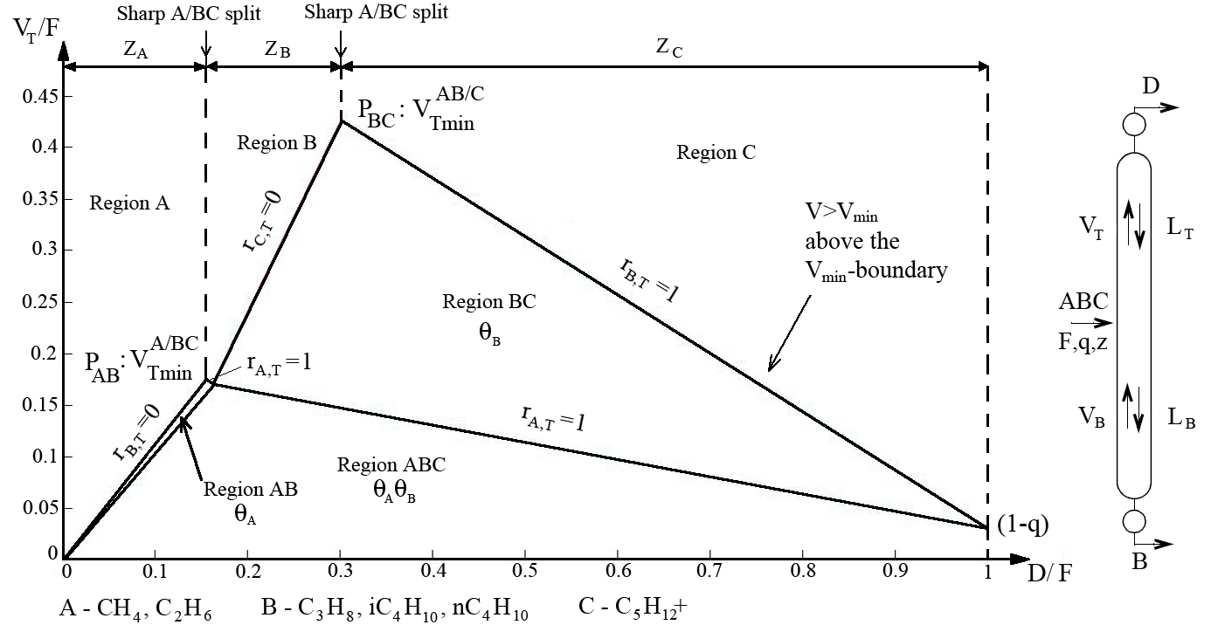
Figure C.1 - Vmin Diagram for the Third Alternative Petlyuk Column

Appendix D - Steam Calculations for Petlyuk Column
Vapour flow rate in the stripping section of column 3 is a measure of the Petlyuk column reboiler duty. It can be found from the formula:
Calculated values of for different Petlyuk alternatives are shown in the Table 16.

Table D.1 – Results of Calculations for
Case | Vapour flow rate , kgmole/h | Molecular weight | Vapour flow rate , kg/h
1) Deethanizer – Debutanizer – Petlyuk Column | 101.9 | 53.46 | 5447.6
2) Deethanizer – Petlyuk Column | 202.9 | 110.2 | 22359
3) Petlyuk Column | 642.8 | 94.81 | 60943

The heat input is directly related to vaporization can be found from the formula:
Assume the temperature of inlet steam is 300℃ and temperature of outlet steam is 260℃. The amount of steam can be calculated from the formula:
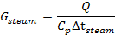
The results of calculations are shown in the Table D.2.

Table D.2 – Calculations for Steam Amount
Case | Heat of vaporization, kJ/kg | Heat input, 10^6 kJ | Steam flow rate , kg/h
1) Deethanizer – Debutanizer – Petlyuk Column | 336 | 1.83 | 21785
2) Deethanizer – Petlyuk Column | 318 | 7.1 | 84524
3) Petlyuk Column | 394 | 24.024 | 286547

Appendix E - Capital Cost Estimation
In this project the estimation of the fixed capital investment was based on the module costing technique, which is a common technique to estimate the cost of a new chemical plant (Turton, 2003). This costing technique relates all costs back to the purchased cost of equipment evaluated for some base conditions, which is equipment made of carbon steel and operating at ambient pressure. Deviations from these base conditions are handled by using multiplying factors that depends on the following:

- The specific equipment type
- The specific system pressure
- The specific materials of construction

Equation 1 is used to calculate the bare module cost, , which includes both direct and indirect cost for each piece of equipment.

(1)

where C_{BM} is bare module equipment cost including indirect and direct costs, F_{BM} are the bare module factor, which is a multiplication factor to account for the direct and indirect cost, as well as the material of construction and the operating pressure assosiated with the equipment. C⁰_{p} are the purchased cost for the base conditions, which is equipment made of carbon steel operating at ambient pressure.

Purchased equipment cost
Data for the purchased equipment cost of, at ambient operating pressure and using carbon steel construction are given by the parameter, C_{p}⁰, were calculated by the following equation given by Turton (Turton, 2003):

(2)

where A is the capacity or size parameter for the equipment. Values for the parameters K₁, K₂ and K₃, depends on the equipment type.

Pressure factors
As the pressure at which a piece of equipment operates increase, the thickness of the walls of the equipment will also increase.

Process vessels
To calculate the pressure factors for process vessels and distillation towers the following equation given by Turton was used:

for >0.0063m (3)

Where, P is the operating pressure, and D represent the diameter of the vessel.
For less than 1, then =1

Other process equipment
The pressure factor for the remaining process equipment, are given by the following equation (Turton, 2003):

(4)

Where, the unit for pressure are barg. The constants C₁, C₂ , and C₃ depends on the equipment type.

Bare module and material factors
The bare module factor also depends on the choice of material of construction. This is accounted for by a material factor F_{M}. The way the material factor, F_{M}, as well as the pressure factor, F_{P}, relates to the bare module factor differentiate somewhat according to the equipment.

The bare module factors for the various equipments are given by the following equation:
(5)
Where the constant B₁ and B₂ depend on equipment type, these values are given. The material factors F_{M} used were given by Turton. For some kind of equipment only the bare module factor, F_{BM}, are given, and the bare module is calculated directly from this value. The basis for calculating the bare module factor from different equipment, are given in Table E.1.

Table E.1 - Equations for Bare Module Cost for Various Equipments
Equipment type | Equation for Bare Module Cost
Column
Valve trays | for N<20 and =1 for N≥20
Heat exchangers,Tanks

Pump shaft power
The shaft power - the power required transferred from the motor to the shaft of the pump - depends on the efficiency of the pump and can be calculated as:
$$\text{Ps}=\frac{P_{h}}{η}=\frac{q×ρ×g×h}{3\text{.}6×{\text{10}}^{6}}$$
Where Ps = shaft power(KW)
P_{h} = power (KW)
$η$ = pump efficiency
Q = flow capacity(m³/h)
$ρ$= density of fluid (kg/m³)
$h$= differential head (m)

Effect of time on purchased equipment cost
All cost-estimating methods use historical data, and are themselves forecasts of future costs. The method usually used to update historical cost data makes use of published cost indices. These relate present costs to past costs by taking the economic conditions into account. This following equpation:
Where C_{BM} is the purchased bare module cost and I is the cost index,
Subscripts: 2001 refers to base time when cost is known. 2008 refers to time when cost is desired.

Table E.2 - Major Equipment Cost for Conventional Process
Colums | V[m³] | K1 | K2 | K3 | logCP,0 | CP,0 | D[M] | P[barg] | Fp | Fm | Cbm($) | I2001 | I2008 | Cbm($)
Deethanizer | 43.416 | 3.4974 | 0.4485 | 0.1074 | 4.5199 | 33107.1400 | 1.6 | 20.99 | 3.8370 | 1 | 127030.4873 | 397 | 574 | 183666.2461
Debutanizer | 52.092 | 3.4974 | 0.4485 | 0.1074 | 4.5839 | 38362.9615 | 1.4 | 15.49 | 2.6809 | 1 | 102848.8639 | 397 | 574 | 148703.3951
Propane column | 16.02 | 3.4974 | 0.4485 | 0.1074 | 4.1936 | 15615.3341 | 1 | 8.49 | 1.3921 | 1 | 21737.5373 | 397 | 574 | 31429.0842
Butane column | 59.37 | 3.4974 | 0.4485 | 0.1074 | 4.6307 | 42724.3856 | 1 | 3.49 | 1.0000 | 1 | 42724.3856 | 397 | 574 | 61772.7892

Column trays | Area[m²] | K1 | K2 | K3 | logCP,0 | CP,0 | TRAY | Fq | Fm | Cbm($) | I2001 | I2008 | Cbm($)
Deethanizer | 2.01 | 3.3322 | 0.4838 | 0.3434 | 3.5105 | 3239.3232 | 30 | 1 | 1 | 97179.6948 | 397 | 574 | 140506.6620
Debutanizer | 1.54 | 3.3322 | 0.4838 | 0.3434 | 3.4350 | 2722.6878 | 47 | 1 | 1 | 127966.3278 | 397 | 574 | 185019.3254
Propane column | 0.784 | 3.3322 | 0.4838 | 0.3434 | 3.2849 | 1927.1059 | 34 | 1 | 1 | 65521.6002 | 397 | 574 | 94734.0013
Butane column | 2.356 | 3.3322 | 0.4838 | 0.3434 | 3.5598 | 3629.3117 | 42 | 1 | 1 | 152431.0895 | 397 | 574 | 220391.5501

Heat Exchangers | Area  [m²] | K1 | K2 | K3 | logCP,0 | CP,0 | C1 | C2 | C3 | P | LOGFp | Fp | Fm | B1 | B2 | Cbm($) | I2001 | I2008 | Cbm($)
Reboiler-Deethanizer | 573.6 | 4.46 | -0.527 | 0.39 | 6.01 | 1043775.39 | -0.00164 | -0.00627 | 0.0123 | 24.99 | 0.0136 | 1.0319 | 1 | 1.63 | 1.66 | 3489250.0167 | 397 | 574 | 5044910.6035
Reboiler-Debutanizer | 445.5 | 4.46 | -0.527 | 0.39 | 5.84 | 694683.46 | -0.00164 | -0.00627 | 0.0123 | 15.99 | 0.0086 | 1.0201 | 1 | 1.63 | 1.66 | 2308673.6331 | 397 | 574 | 3337981.5250
Reboiler-Propane column | 35.9 | 4.46 | -0.527 | 0.39 | 4.60 | 39849.39 | -0.00164 | -0.00627 | 0.0123 | 8.99 | 0.0036 | 1.0083 | 1 | 1.63 | 1.66 | 131650.3184 | 397 | 574 | 190345.8005
Reboiler-Butane column | 55.5 | 4.46 | -0.527 | 0.39 | 4.74 | 55907.27 | -0.00164 | -0.00627 | 0.0123 | 3.99 | -0.0010 | 0.9978 | 1 | 1.63 | 1.66 | 183728.7775 | 397 | 574 | 265643.1191
Condenser-Debutanizer | 361 | 3.99 | 0.066 | 0.24 | 5.75 | 564243.22 | -0.4045 | 0.1859 | 0 | 14.99 | -0.1859 | 0.6518 | 1 | 1.74 | 1.55 | 1551789.3993 | 397 | 574 | 2243645.1264
Condenser-Propane column | 1141 | 3.9912 | 0.0668 | 0.243 | 6.4667 | 2929183.5759 | -0.4045 | 0.1859 | 0 | 7.99 | -0.2367 | 0.5798 | 1 | 1.74 | 1.55 | 7729239.1430 | 397 | 574 | 11175272.7156
Condenser-Butane column | 864 | 3.9912 | 0.0668 | 0.243 | 6.2828 | 1917677.4757 | -0.4045 | 0.1859 | 0 | 2.99 | -0.3161 | 0.4830 | 1 | 1.74 | 1.55 | 4772362.4096 | 397 | 574 | 6900090.7383

Table E.3 - Other Equipment Cost for Conventional Process
Tanks | Flow[m³/h] | v | k1 | k2 | k3 | logCP,0 | CP,0 | fm | Cbm($) | I2001 | I2008 | Cbm($)
feed tank | 48.89 | 122.225 | 4.8509 | -0.3973 | 0.1445 | 4.6511 | 44786.5458 | 1 | 44786.5458 | 397 | 574 | 64754.3509
c1c2 | 81.66 | 204.15 | 4.8509 | -0.3973 | 0.1445 | 4.7042 | 50604.5736 | 1 | 50604.5736 | 397 | 574 | 73166.3104
c5+ | 63.01 | 157.525 | 4.8509 | -0.3973 | 0.1445 | 4.6756 | 47379.3249 | 1 | 47379.3249 | 397 | 574 | 68503.1045
c3 | 1.329 | 3.3225 | 4.8509 | -0.3973 | 0.1445 | 4.6830 | 48196.4697 | 1 | 48196.4697 | 397 | 574 | 69684.5683
ic4 | 1.057 | 2.6425 | 4.8509 | -0.3973 | 0.1445 | 4.7090 | 51164.4617 | 1 | 51164.4617 | 397 | 574 | 73975.8212
nc4 | 2.098 | 5.245 | 4.8509 | -0.3973 | 0.1445 | 4.6398 | 43631.5827 | 1 | 43631.5827 | 397 | 574 | 63084.4546
Ic4+Nc4 | 3.155 | 7.8875 | 4.8509 | -0.3973 | 0.1445 | 4.6108 | 40812.7888 | 1 | 40812.7888 | 397 | 574 | 59008.9188
C3-iC4-nC4 | 4.484 | 11.21 | 4.8509 | -0.3973 | 0.1445 | 4.5931 | 39181.7010 | 1 | 39181.7010 | 397 | 574 | 56650.6205

Pumps | Shaft power [KW] | Cbm($) | I2001 | I2008 | Cbm($)
Condenser- for debutanizer | 44.0398 | 42700 | 397 | 574 | 61737.5315
Condenser- for propane column | 26.8214 | 30183 | 397 | 574 | 43639.9043
Condenser- for butane column | 17.4447 | 24699 | 397 | 574 | 35710.8967

Appendix F – Cash Flows for Different Alternatives
Table F.1 – Cash Flows for Conventional and Petlyuk Cases
Years | Conventional Columns |  |  | Petlyuk Column
Years | Case 1, M$ | Case 2, M$ | Case 3, M$ | Case 1, M$ | Case 2, M$ | Case 3, M$
0 | -159.397 | -120.143 | -59,886 | -3,9041 | -58,008 | -46,594
1 | -63,383 | -19,0654 | 12,3394 | -3,9041 | 17,741176 | 28,10026
2 | -63,383 | -19,0654 | 12,3394 | -3,9041 | 17,741176 | 28,10026
3 | -63,383 | -19,0654 | 12,3394 | -3,9041 | 17,741176 | 28,10026
4 | -63,383 | -19,0654 | 12,3394 | -3,9041 | 17,741176 | 28,10026
5 | -63,383 | -19,0654 | 12,3394 | -3,9041 | 17,741176 | 28,10026
6 | -63,383 | -19,0654 | 12,3394 | -3,9041 | 17,741176 | 28,10026
7 | -63,383 | -19,0654 | 12,3394 | -3,9041 | 17,741176 | 28,10026
8 | -63,383 | -19,0654 | 12,3394 | -3,9041 | 17,741176 | 28,10026
9 | -63,383 | -19,0654 | 12,3394 | -3,9041 | 17,741176 | 28,10026
10 | -63,383 | -19,0654 | 12,3394 | -3,9041 | 17,741176 | 28,10026
11 | -63,383 | -19,0654 | 18,328 | -3,9041 | 21,337672 | 30,989088
12 | -63,383 | -19,0654 | 18,328 | -3,9041 | 21,337672 | 30,989088
13 | -63,383 | -19,0654 | 18,328 | -3,9041 | 21,337672 | 30,989088
14 | -63,383 | -19,0654 | 18,328 | -3,9041 | 21,337672 | 30,989088
15 | -63,383 | -19,0654 | 18,328 | -3,9041 | 21,337672 | 30,989088
16 | -63,383 | -19,0654 | 18,328 | -3,9041 | 21,337672 | 30,989088
17 | -63,383 | -19,0654 | 18,328 | -3,9041 | 21,337672 | 30,989088
18 | -63,383 | -19,0654 | 18,328 | -3,9041 | 21,337672 | 30,989088
19 | -63,383 | -19,0654 | 18,328 | -3,9041 | 21,337672 | 30,989088
20 | -63,383 | -19,0654 | 18,328 | -3,9041 | 21,337672 | 30,989088

