APPENDIX A: SIZING OF DISTILLATION COLUMNS I
A.1 FENSKE METHOD I
A.2 SHORTCUT METHOD USING UNISIM III
A.3 DIMENSIONS OF COLUMN III
APPENDIX B: CALCULATION OF T_{carnot} V
APPENDIC C: AMOUNT OF NATURAL GAS FEED VI
APPENDIX D: SIZING OF THE METHANOL REACTOR VII
APPENDIX E: SIZING OF SEPARATORS VIII
APPENDIX F: SIZING OF HEAT EXCHAGERS, CONDENSERS AND REBOILERS X
APPENDIX G: Heat Exchanger Network Design XII
G.1 HEAT EXCHANGERS HE-1, HE-2 AND HE-3 XII
G.2 HEAT EXCHANGERS HE-4 AND HE-5 XIII
G.3 HEAT EXCHANGERS HE-6 AND HE-7 XIII

APPENDIX A: SIZING OF DISTILLATION COLUMNS

A.1 FENSKE METHOD

The minimum number of stages was found using the Fenske equation (Sinnot, 2009):

Relative volatility is defined:

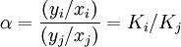

where:
α is the relative volatility of the more volatile component i to the less volatile component j,
y_{i} is the vapor-liquid equilibrium concentration of component i in the vapor phase,
x_{i} is the vapor-liquid equilibrium concentration of component i in the liquid phase,
y_{j} is the vapor-liquid equilibrium concentration of component j in the vapor phase and
x_{j} is the vapor-liquid equilibrium concentration of component j in the liquid phase

The vapor-liquid equilibrium was found from The Perry's Chemical Engineers' Handbook:

At 91,2 ⁰C:

y_{i} = 0,304
x_{i}= 0,06
y_{j}=0,696
x_{j}=0,94

Thus the relative volatility was calculated to be 6,84

For the distillate:
X_{LK}=0,999
X_{HK}=0,001

For the bottoms:
X_{LK}= 0,001
X_{HK}=0,999

From the Fenske equation the minimum number of stages was calculate to be 7,2. A factor of three was assumed to get the real number of stages. Thus the number of stages became 22.

A.2 SHORTCUT METHOD USING UNISIM

Using the shortcut module in UniSim and the specifications given in table A.1 the number of stages was calculated for COL-2. Assuming a stage efficiency of 60% the real number of stages was calculated. The result of the calculation is given in table A.2. The number of stages in COL-1 was calculated by using the distillation column module in UniSim. The flow molar flow rate from the reboiler was specified to be 0,997 of the total amount of methanol + water in the feed. The temperature in the condenser was set to 18 °C. The number of stages and feed stage was found using trial and error until the CO₂ mole fraction was near zero in the bottom stream and until the recycle ratio was reasonable.

Table A.1 - Specifications used in the short cut column
 | COL-2
Water in distillate [mole fraction] | 0,001
Methanol in Bottoms[mole fraction] | 0,001
Condenser pressure[kPa] | 100
Reboiler pressure [kPa] | 200
External reflux ratio | 0,68*

*Set to 1,2 times the minimum reflux ratio (IA1)

Table A.2 – Result of calculation
 | COL-1 | COL-2
Number of stages –reboiler | 27 | 6
Number of stages with 60 % Efficiency | 45 | 10
Feed stage (from the top) | 11 | Reboiler

A.3 DIMENSIONS OF COLUMN

The columns was sized using a procedure described by Sinnot.

Procedure from Sinnot:
The plate spacing was set to 0,5 m.
The column diameter was calculated according to the following equations:

Where is the maximum allowable vapor velocity, based on the gross (total) column cross sectional area, m/s, and l_{t} is the plate spacing in meters.

Where D_{c} is the column diameter in meters, is the maximum vapor rate in kg/s.

APPENDIX B: CALCULATION OF T_{carnot}

The temperature where the reaction changes from being non-spontaneous to spontaneous is called T_{Carnot}. T_{Carnot} was calculated using the relation:

At equilibrium the equation above is equal to zero, and the T_{carnot} could be calculated:

Thermodynamic data for different pressures and temperatures was obtained from UniSIM and SI-chemical data. The data are listed in table B.1.

The thermodynamic data in from table B.1 was used to calculate ΔH_{RX} and ΔS_{RX} for reaction B.1. The results are shown in table B.2.

(B.1)

Table B.1. Thermodynamic data collected at different temperatures and pressures.
 | 298 K and 1 bar |  | 200 C and 40 bar |  | 800C and 40 bar
Components | H [kJ/kgmol) | S [kJ/kgmolC] | H [kJ/kgmol) | S [kJ/kgmolC] | H [kJ/kgmol) | S [kJ/kgmolC]
CH₄(g) | -74920,00 | 183,60 | -68193,94 | 170,74 | -31150,49 | 219,65
CO(g) | -110600,00 | 159,20 | -105531,10 | 141,82 | -86367,16 | 167,79
H₂(g) | -0,11 | 123,10 | 5038,69 | 105,62 | 22920,71 | 129,93
H₂O(g) | -245550,00 | 189,00 | -272048,48 | 90,71 | -213118,89 | 189,76

Table B.2. T_{carnot} for different temperatures and pressures
 | 298 K and 1 bar | 200 C and 40 bar | 800C and 40 bar
ΔH_{RX} [kJ/kgmol] | 209870 | 249827 | 226664
ΔS_{RX} [kJ/kgmolC] | 156 | 197 | 148
T_{carnot} [C] | 1073 | 994 | 1257

It would seem that the temperature have to above 1257 ⁰ Celsius to make the reaction spontaneous. The T_{carnot} seemed to vary quite a lot, which is a bit distubing, since one could expect that the T_{carnot} should be relative constant because there are no phase transitions present. UniSIM are probably not be best tool to use, when collection thermodynamic data, but was used because of the simplicity. In the literature (S. Lee, 1997) thermodynamic calculations were done for the same reaction. The result was a T_{carnot} temperature of 950K. The temperature in the steam was chosen to be 1000 °C to be sure that the reaction actually is above T_{carnot,} and to ensure that reaction would give good conversion. The latter is especially important for the process described in this report, because of the lack of a secondary reformer.
APPENDIC C: AMOUNT OF NATURAL GAS FEED

This appendix shows the calculation of the amount of natural gas feed needed for the process to produce 2500 tonne pr day methanol assuming 100% conversion,

By combining the equations C.1 and C.2, equation can be formed:

(C.1)

(C.2)

(C.3)

From this equation it is easy to see that 1 mole of methanol is equivalent to 1 mole of methane. Using a molar mass of 32,0418 kg/kgmole methanol, the amount of methane required to make 2500 tonne/day methanol was found to be 3251kgmole/h. This value was used as an approximation of the amount of natural gas needed in the methanol production.

APPENDIX D: SIZING OF THE METHANOL REACTOR

The reaction of syngas to methanol is highly exothermic. Heat released from the reaction needs to be removed to keep the reactor isothermal. To be able to cool the reactor sufficient, the catalytic mass has to be divided into small enough pieces that heat efficiently can be removed. Tjeldbergodden has similar reactor and reaction, which is carried out at a similar temperature. The tube dimensions used at Tjeldbergodden were used as an estimate for the catalytic tubes size estimation. The reactor length was also assumed to be the same as used at Tjeldbergodden.

In the industry, a 4:1 recycle ratio is commonly used (Aasberg-Petersen, 2001). The number of tubes needed in the reactor are based this recycle ratio, a single tube diameter of 4 cm (O7) and a maximum flow velocity of 5m/s (O4).

A flow rate of 13199 kgmole/h incoming feed from the reformer section would result in a allowed recycle of 65995 kgmole/h. Which is equivalent to a volume flow rate of 16,88 m³/s when using a molar density of 1,09 kgmol/m³. A maximum allowable flow rate in the reactor lead to a cross section area of 6,75 m² ,when assuming a catalyst void fraction of 0,5. This will lead to a total number of 5373 tubes inside the reactor shell.

The outer diameter of the shell was calculated by assuming a triangular pitch of 1,25 times the outer tube diameter (Smith, 2005) and a wall thickness of 0,5 cm. A single tube in a triangular pitch arrangement was reported by the literature (Smith, 2005) to be contained in an area of 0,866 times the pitch squared. From this, the area and the diameter were calculated. The total diameter was found to be 4,8 m.

APPENDIX E: SIZING OF SEPARATORS

The size of the separators was calculated using the procedure described by Sinnot et. al (Sinnot, 2009). Sizing data from UniSIM was compared with the data from the procedure above. It was assumed that demister pads were used for both separators.

The procedure from Sinnot et al goes as the following:

Equation E.1 can be used to calculated the settling velocity (u_{t}) :

(E.1)

whereis the liquid density andis the vapor density.

Minimum vessel diameter:

(E.2)

Where V_{v} is the volumetric flow rate in m³/s, u_{s} =u_{t} since demister pads were used.
Required liquid level was calculated by assuming a 10 min hold up time.
The height were calculated according to figure 10,67 page 638 in Sinnot et. al (Sinnot, 2009).
Key data are given in table E.1
Table E.1 – Key data
Variable | SEP-1 | SEP-2
u_{t} [m/s] | 0,67 | 0,39
ρ_{L}[kg/m³] | 1004,6 | 821,4
ρ_{v} [kg/m³] | 10,9 | 25,0
V_{v}[m/s] | 3,10 | 9,33
D_{v} | 2,43 | 5,49
Liquid height [m] | 2,32 | 1,22
Liquid level to inlet (min(d/2,0.6m)) [m] | 1,21 | 1,22
Inlet to demister pad (min(d,1m)) [m] | 2,43 | 5,49
Demister pad to vapor outlet (min0.4m) [m] | 0,40 | 0,40
Total height [m] | 6,36 | 9,85

APPENDIX F: SIZING OF HEAT EXCHAGERS, CONDENSERS AND REBOILERS
This appendix describes the sizing of the heat exchangers, condensers and reboilers. Heat transfer coefficients for the fluids used in the model are given in table F.1.
Table F.1 – Heat transfer coefficients (Skogestad, 2003)
Fluids | Heat transfer coefficients  [W/m² K]
High pressure process stream- water | 570
High pressure process stream –vaporizing water (assumed) | 500
High pressure process stream –high pressure vapor | 450
High pressure process stream- High pressure process stream | 450
Low pressure process stream – Water | 140
Boiling liquid- condensing vapor | 800
Boiling liquid- Cooling of super heated steam (assumed) | 800
The exchanger area was calculated by using the duty given from UniSIM. The log mean temperature difference was calculated for each heat exchanger. If one or both of the fluids experienced phase transitions, the exchanger was split into appropriate pieces such that correct heat transfer coefficients could be used. All heat exchangers are assumed to be counter-current heat exchangers.
Example:
Duty: Q (given from UniSIM)
LMTD (log mean temperature difference) =
Where is the temperature difference between the hot inlet stream and cold outlet is is stream and is the difference between the hot outlet stream and the cold inlet stream.
Using the relation:

The heat exchanger area could then be calculated. The results are shown in table F.2.

Table F.2 – Key heat exchanger data
 | Duty [kW] | Surface area [m²] | Type
Heat exchanger (HE-1) | 28673 | - | Included in heat recovery unit on  the steam reformer
Heat exchanger (HE-2) | 20360 | - | Included in heat recovery unit on  the steam reformer
Heat exchanger (HE-3) | 121776 | - | Included in heat recovery unit on  the steam reformer
Heat exchanger (HE-4) | 61583 | 1321 | U-tube
Heat exchanger (HE-5) | 137072 | 13087 | Flat plate
Heat exchanger (HE-6) | 74205 | 2934 | U-tube
Heat exchanger (E-105) | 133129 | 894 | Falling film evaporator
Reboiler (REB-1) | 9434 | 99 | Kettle
Reboiler (REB-2) | 59945 | 473 | Kettle
Condenser (CON-1) | 262 | 163 | Shell and tube
Condenser (CON-2) | 60620 | 7508 | Shell and tube

APPENDIX G: Heat Exchanger Network Design

- The synthesis gas (H1) from the steam reformer is to be cooled from 1000°C to 30°C.
- The product out from the methanol reactor (H2) is to be cooled from 260°C to 30°C.
- Flue gas from the steam reformer (H3) should be cooled from 1000°C to below 150°C
- The natural gas feed (C1) is to be heated from -0,26°C to 455°C.
- The methane rich gas from the prereformer (C2) is to be heated from 448,25°C to 650°C
- The methanol reactor feed (C3) is to be heated from 46,03°C to 260°C.

Table G.1 summarizes the flow rate, heat capacity and temperature intervals for the six streams.

Table G.1 – Properties for the hot and cold streams
 | Stream | Flow rate, m | Cp (average) | ΔT | Q = mCpΔT
 | # | (kg/s) | (kJ/kg°C) | °C | MW
C1 | Natural Gas | 15,21 | 3,047 | 455,26 | 21,10
C2 | Methane from PR | 51,74 | 2,744 | 201,75 | 28,64
C3 | Reactor feed | 286,49 | 2,648 | 213,97 | 162,32
H1 | Exhaust gas | 157,24 | 1,255 | 850 | 177,53
H2 | Syngas | 51,74 | 3,440 | 970,00 | 172,66
H3 | Methanol | 273,70 | 2,677 | 230,00 | 168,53

G.1 HEAT EXCHANGERS HE-1, HE-2 AND HE-3

To ease the start-up of the plant, the flue gas (H3) is only heat integrated with the process streams before the steam reformer (C1 and C2). It should also be ckecked if there is enough heat in the flue gas to generate the amount of MP Steam needed in process. The dew point for water at 30 bar (pressure for MP steam) is 234,6°C. The heat of vaporization is 1822,70 kJ/kg. Generating MP steam with a flowrate of 36,351 kg/s and target temperature of 455°C requires a duty of

The total required duty is then

Q = Q_{C1} + Q_{C2} + Q_{MP} = 21,10 MW + 28,64 MW + 123,94 MW = 173,68 MW.

Assuming an outlet temperature of 150°C for the flue gas, the c_{p} is found to be 1,153 kJ/kg°C. At 1000°C the c_{p} is 1,370 kJ/kg°C, and the average c_{p} is then 1,262 kJ/kg°C. The outlet temperature of the flue gas becomes

At 125,8°C the c_{p} is 1,147 kJ/kg°C, and the average c_{p} is then 1,259 kJ/kg°C. The exit temperature then becomes 122,7°C which is an acceptable exit temperature. Further in the calculations, if nothing else is stated, c_{p} is assumed to not change cignificantly for smaller temperature intervals.

The outlet temperature of H3 out of HE-1 becomes

The outlet temperature of H3 out of HE-2 becomes

G.2 HEAT EXCHANGERS HE-4 AND HE-5

The synthesis gas from the steam reformer could possibly be used to generate HP steam. The dew point for water at 40 bar (HP steam) is 251,3°C. The heat of vaporization is 1741,17 kJ/kg. Generating HP steam with a flowrate of 38,671 kg/s and target temperature of 510°C requires a duty of

The excess heat for the syngas is (172,66-142,79) MW = 29,87 MW. The outlet temperature of the syngas becomes

To reach the target temperature of 30°C cooling water (duty = 29,87 MW) could be used
(HE-5). Because there will be a phase transition, the heat exchanger will have a larger duty.

G.3 HEAT EXCHANGERS HE-6 AND HE-7

The feed to the methanol reactor (C3) could be heat integrated with the methanol stream out of the methanol reactor (H3). The methanol stream has a dew point of 110,8°C. To ease the calculations, no phase transition is assumed during the heat exchange with the methanol reactor feed. Assuming a ΔT_{min} equal to 20°C, i.e. the outlet temperature of C3 to be 240°C, the duty for HE-6 becomes

The duty of the cooler (HE-7) becomes (168,53-147,15) MW = 21,38 MW and the outlet temperature H3 becomes

Because there will be a phase transition, the heat exchanger (HE-7) will have a larger duty.

The duty of the heater becomes (assuming c_{p} will not change significantly because of the small temperature difference)

In reality, since phase transition will occure, the outlet temperature of C3 will be lower and the duty of the heater will be higher, and the outlet temperature of H3 will be higher and therefore will also the duty of the cooler be higher.

In figure G.2 below the proposed heat exchanger network is shown. Heat exchanger I represents, HE-1, II represents HE-2 and so on. HE-5 and HE-7 is replaced by the symbol C for cooling.

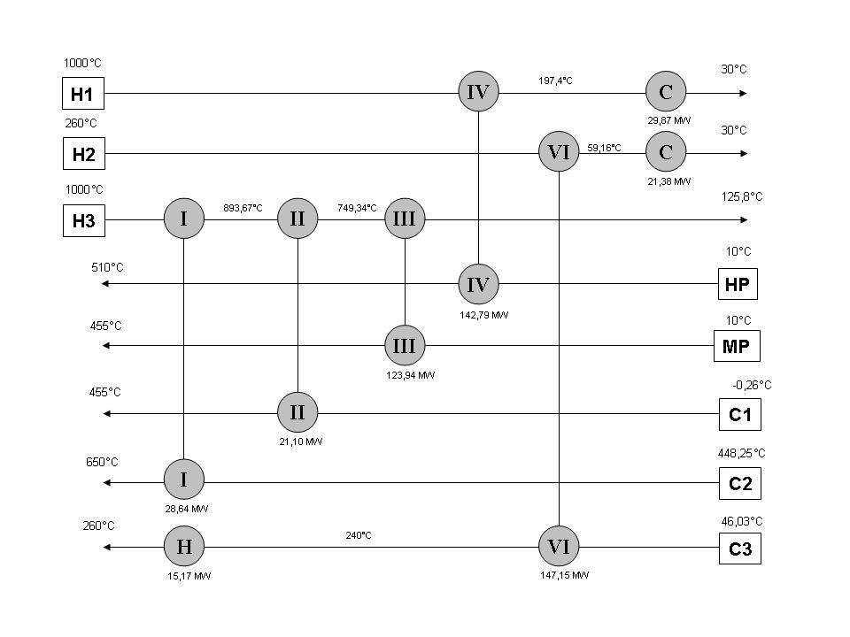
Figure G.2 – Heat Exchanger Network Design

