NTNU Faculty of Natural Sciences and Technology
Norwegian University of Science Department of Chemical Engineering
and Technololy


-

TKP4170 PROCESS DESIGN. PROJECT

Title:  Process Design and Economical Assessment of a Methanol Plant | Keyword:  Synthesis gas, Methanol synthesis, Economical evaluation
Written by:  Silje Kreken Almeland, Knut Åge Meland and  Daniel Greiner Edvardsen | Time of work:  August 26 2009 –  November 20, 2009
Supervisor:  Sigurd Skogestad and Mehdi Panahi | Number of pages:  Main report:  Appendix:
EXTRACT OF WORK AND CONCLUSIONS

This prestudy Design of a methanol plant based on steam reforming and CO₂ injection. Optimization of the simulation in UniSIM. Comparisson of alternative technologies. Economica

Conclusions and recommendations:

- Low carbon conversion
- Capital savings
- Acceptable profitability
- Optimistic future prospects

Date and signature:

CONTENT
PREFACE 4
ABSTRACT 5
1 INTRODUCTION 6
1.1 PROPERTIES AND HISTORY 6
1.2 METHANOL APPLICATIONS 6
1.3 PRODUCTION TECHNOLOGIES 7
1.3.1 Synthesis Gas 7
1.3.2 Methanol Synthesis 9
2 PROJECT BASIS 14
2.1 PRODUCT 14
2.2 PRODUCTION CAPACITY 14
2.3 RAW MATERIALS 14
2.4 LOCATION 15
3 PROCESS DESCRIPTION 17
3.1 Reformer section 17
3.1.1 Choice of technology 17
3.1.2 Structure of Reformer 17
3.1.3 Operating Parameters 18
3.1.4 Modeling 19
3.1.5 Sizing 20
3.1.6 Choice of material 20
3.2 Methanol reactor 20
3.2.1 Choice of Reactor Type 20
3.2.2 Sizing 21
3.2.3 Modeling 21
3.2.4 Challenges and Solutions 22
3.2.5 Choice of material 24
3.3 Other units 24
3.3.1 Prereformer 24
3.3.2 Separators 25
3.3.3 Distillation columns 26
3.3.4 Heat exchangers 27
3.3.5 Compressors 28
3.3.6 Turbine/expander 29
3.4 HEAT EXCHANGER NETWORK AND ENERGY CONSUMPTION 30
3.4.1 Defining hot and cold streams and utilities 30
3.4.2 Minimum number of units 30
3.4.3 Minimum energy consumption 30
3.4.4 Heat Cascade and Grand Composite Curve 31
3.4.5 Forbidden matches 33
3.4.6 Final design 33
3.4.7 Flue Gas Heat Exchange 35
3.4.8 Flow sheet, methanol plant 36
3.5 REFLECTIONS 37
4 SUMMARY OF CALCULATIONS 39
4.1 MAIN EQUIPMENT 39
4.2 MATERIAL BALANCE 40
4.3 HEAT BALANCE 40
4.3.1 Component heat balance 40
4.3.2 Overall Heat Balance 41
4.4 EQUIPMENT COSTS 42
4.5 PROCESS CONTROL 42
5 ECONOMICAL ESTIMATION 43
5.1 CAPITAL INVESTMENT 43
5.1.1 Fixed capital investment 43
5.2.1 Working capital 47
5.2 OPERATING COSTS 47
5.2.1 Variable Operating Costs 48
5.2.2 Fixed Operating Costs 52
6 Investment analysis 53
6.1 Rate of return calculations 53
6.2 Pay-back period 54
6.3 Time value of money 54
6.4 Net present worth 55
6.5 Discounted cash-flow rate of return - DCFRR 55
6.6 Sensibility analysis 55
6.6.1 Worst case scenario of the methanol price 57
6.6.2 Worst case scenario of the raw product price 58
6.6.3 Variation in energy prices 60
6.6.4 CO₂ expences – a question in the future 61
6.6.5 Summary of sensitivity analysis 62
7 CONCLUSIONS AND RECOMMENDATIONS 63
SYMBOL LIST 64
REFERENCES 65

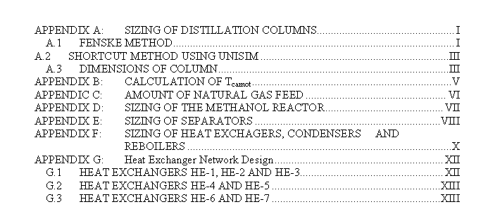

PREFACE

This work was carried out as a project in the course TKP4170 Process Design at Institute of Chemical Engineering at the Norwegian University of Sciency and Technology (NTNU) in Trondheim, Norway, during the fall semester of 2009.

We would like to thank Sigurd Skogestad and Mehdi Panahi for serving as our supervisors. Special thanks go to Medhdi for being very patient and helpful when we experienced problems with the simulations.

We will also like thank Margrete Hånes Wesenberg, Principal Researcher in Statoil ASA at the Research Centre in Trondheim and Nina Enaasen, Engineer O&M in Statoil ASA at Tjeldbergodden for being very helpful with answering questions from curios students.

______________________ ______________________ _________________________
Silje Kreken Almeland Knut Åge Meland Daniel Greiner Edvardsen

NTNU
November 20, 2009

ABSTRACT

Because of an increase in the methanol demand the past decades, energy efficient and innovative solutions for methanol production are highly valuable. Today’s technology is mainly based on the ICI and the Lurgi Methanol Technology. This study looks on the possibility of reinjecting carbon dioxide in the process, and by so reducing the investment and operating costs and the expenses associated with the CO₂ emissions. In addition, this solution is environmental friendly.

The case is a natural gas field in the Norwegian Sea with a given spesification (0,955 methane, 0,03 ethane, 0,005 propane, 0,004 n-butane and 0,006 nitrogen, all mole fractions). The proposed plant location is close to Kollsnes process plant in west Bergen. The production capacity of the plant is approximately 2700 tonne methanol per day. High pressure steam is also produced and sold (3817 tonne/day).

With today’s prices on natural gas, electricity and methanol, the total annual operating costs are 2 billion NOK and total capital investment is also approximaty 2 billion NOK. The annual value of the products are about 2,6 billion NOK, which results in a pay back period of 4,9 years. This corresponds to a rate of interest of 40,21%, assuming the life time of the plant is 10 years.

The investment analysis showed an acceptable perfermance of the project with the current assumptions. Neverthless the sensibility analysis indicated a relatively large sensibility to alternations in the product price as well as in the prices for the raw material.

1 INTRODUCTION

1.1 PROPERTIES AND HISTORY

Methanol is a colourless, water-soluble liquid also called methyl alcohol or wood spirit. Its freezing point is at -97.6°C and its boiling point 64.6°C at atmospheric pressure. It has a density of 0,791 at 20°C.

Robert Boyle was the first to produce methanol. He did so through the distillation of boxwood in 1661 and called his product “spirit of the box”. Jean-Baptiste Dumas and Eugene Peligot described its chemical identity, CH₃OH, in 1834 and called it methylene; from Greek meaning wine (methu) and wood (hyle). From methyl the name methyl alcohol arrived and later the systematic name methanol. Coal largely replaced wood during the industrial revolution. Fritz Haber and Carl Bosch contributed to the development of the chemical processing of methanol synthesis. In 1905 Paul Sabatier suggested the synthetic route to methanol production, by reacting carbon monoxide with hydrogen.

The first large scale methanol plant was operated by BASF in 1923 in Germany. A few years later DuPomt company began to produce methanol using synthesis gas produced from coal. Based on the developments in the 1930’s, steam reforming of natural gas began in the United States. From then on, natural gas largely replaced coal as a feedstock for synthesis gas (Olah, 2006).

1.2 METHANOL APPLICATIONS

Methanol is one of the most important chemical materials that are produced. Worldwide, about 90% is used in the chemical industry and the remaining 10% for energy use. The world capacity for methanol synthesis was in 2000 about 40 million tonnes per year (Olah, 2006). About 35% of the methanol produced is used as a feed in the production of formaldehyde and further 27% is used in the production of MTBE (Methyl tert-butyl ether) and TAME (Tert-Amyl Methyl Ether). It is used in the production of other chemicals and solvents, acetic acid, single-cell protein and oxygenated compounds as well (I1). It can also be dehydrated over ZSM-5, an aluminosilicate zeolite, to produce gasoline (I2). Table 1.1 summarizes the methanol demand in both 1988 and 1999.

Table 1.1 – Use of methanol (in %) (Olah, 2006)
Product | World |  | USA |  | Western Europe |  | Japan
 | 1988 | 1999 | 1988 | 1998 | 1988 | 1998 | 1988 | 1998
Formalaldehyd | 39 | 35 | 27 | 24 | 44 | 46 | 43 | 32
Acetic acid | 6 | 10 | 14 | 12 | 7 | 7 | 8 | 10
Methyl halides | 7 | 7 | 6 | 3 | 7 | 8 | 5 | 8
MTBE | 12 | 27 | 24 | 40 | 10 | 17 | 5 | 7
DMT | 3 | 2 | 4 | 2 | 3 | 1 | 1 | 1
Methylamines | 4 | 4 | 3 | 2 | 4 | 5 | 4 | 4
MMA | 3 | 3 | 4 | 3 | 4 | 3 | 8 | 7
Solvents | 9 | 4 | 7 | 6 | 1 | 1 | 4 | 3
Others | 17 | 8 | 11 | 8 | 15 | 12 | 22 | 28
Total (10⁶ tonnes) | 17.3 | 26.7 | 5.0 | 8.3 | 4.5 | 6.3 | 1.6 | 1.9

Methanol has a large potential in many areas, for instance as a motor fuel, energy source, raw material for synthesis and a basis for protein. Therefore it has and will have for a long time a key position in the chemical industry.

1.3 PRODUCTION TECHNOLOGIES

The main steps in producing methanol are the following:

- Production of synthesis gas
- Synthesis gas compression
- Conversion of the synthesis gas into methanol
- Distillation
Each step will now be explained.

1.3.1 Synthesis Gas

Synthesis gas, or syngas, denotes mainly CO/H₂ mixtures in different proportions. Raw materials for synthesis gas generation can be coal, natural gas or mineral oil fractions. Due to the high H₂ content, natural gas and light oil fractions are best suited for synthesis gas. Since the methanol production in this study is based on natural gas as raw material, production methods of synthesis gas from natural gas will be explored. These methods are usually divided into three types (C.-J. Lee, 2009);

- Steam reforming
- Oxyreforming
- CO₂ reforming

The selection of the production method for syngas generation depends on the price and composition of the natural gas, acceptance of energy export and the plant capacity (I1).

Steam reforming

A majority of the methanol plants operating today are based on steam reforming of natural gas (I1). The reaction is described as follows:

∆H(298K) = 247kJ/mol

The equation shows that there is an excess of hydrogen. This means that there are more hydrogen obtained than is required to convert the carbon oxides to methanol. The reaction in the steam reformer is endothermic, which means that it prefers high temperatures. Nevertheless, a limitation for the reformer temperature is to make the material of the reformer withstand the high temperatures. Today new tube materials make it possible to design tubular reformers for tube wall temperatures up to 1050°C. Reactor simulations and experiments have shown that the reformer exit temperature can indeed be reduced to below 700°C while maintaining the same conversion (Aasberg-Petersen, 2001). Process data for the steam reforming section are as follows:

The synthetic ratio of the syngas from the steam reformer can be adjusted by lowering the hydrogen concentration through the reverse water-gas shift reaction shown below:

∆H(298K) = -47kJ/mol

This can be achieved by addition of carbondioxide. CO₂ is added to match the excess hydrogen, thereby producing a syngas containing carbon oxides and hydrogen in stoichiometric proportions. This would reduce the feed and fuel requirement per ton methanol (I1). Taking into account the CO₂ politics of today one would actually be paid for using CO₂, so adding CO₂ could be an economical gain. The hydrogen-carbon ratio in the syngas can also be adjusted by a secondary reforming reaction, such as oxyreforming or autothermal reforming (C.-J. Lee, 2009).

Autothermal reforming

Autothermal reforming (ATR) is the combination of steam reforming and oxyreforming. Oxyreforming uses oxygen as a reactant to produce syngas and is generally used to adjust the synthetic ratio. Oxygen, or air with high concentration of oxygen, is fed into the reformer where it reacts with methane from the natural gas trough the following reaction:

∆H(298K) = -36kJ/mol

This reaction is exoterm which makes it thermodynamically preferable compared to the steam reforming process. Oxyreforming also gives syngas with the synthetic ratio 2, which is the stoichiometric ratio for methanol production from carbonmonoxide (C.-J. Lee, 2009). A drawback with this method is that one has to separate oxygen from the air to avoid large amounts of nitrogen as an inert in the system. The air separation can be a cost intensive operation.

Carbon dioxide reforming

This process uses CO₂ as a reactant to produce syngas through the following reaction

∆H(298K) = 206kJ/mol

As can be seen from the equation that the synthetic ratio for carbondioxide reforming is 1, and the maximum yield for syngas can be obtained when the feed gas is supplied with a CO₂/CH₄ ration of 1. The reaction is endothermic which means that the conversion increases as the reaction temperature rises (S. Lee, 2009). It may be argued that CO₂ reforming would be better than steam reforming to meet the required gas compositions, but CO₂ reforming is rarely feasible. At the economic pressure of the synthesis gas plant, stoichiometric reforming will result in incomplete conversion of CH₄ due to thermodynamics, and further the process economy depends strongly on the pressure and the cost of the CO₂ available. An option can be combined steam and CO₂ reforming. This may be feasible with natural gas containing CO₂ and with cheap CO₂ available (Aasberg-Petersen, 2001). The production economics of CO₂ reforming is known to be similar to the steam reforming process (C.-J. Lee, 2009).

1.3.2 Methanol Synthesis

Methanol is produced from synthesis gas through the following equations:

∆H(298K) = -91kJ/mol
∆H(298K) = -50kJ/mol

In addition the water gas shift reaction occurs over the copper-catalyst:

∆H(298K)= -47kJ/mol

There are three common processes for methanol production existing today. These are the BASF high pressure process, the UK-Wessling high pressure process and the ICI low pressure process. Their characterizations are given below.

BASF is a German chemical company, founded in 1865. The BASF process, also known as the high pressure process, for production of methanol is conducted at 320-380°C and approximately 340 bar (Olah, 2006). The process uses the ZnO-Cr₂O₃ catalyst. To avoid high temperatures (exothermic reaction) cold gas is injected in the catalyst bed. Short residence time (1 to 2 seconds) is used to prevent equilibrium from taking place. Conversions of 12-15% for a single pass through the reactor are typical for this process. Another similar process was developed by UK Wesseling. This process operates at low CO partial pressure (≈13 bar in gas recycle) and reaction conditions at 300 bar and 350°C (Olah, 2006).

To be able to operate at lower pressures, more active Cu-based catalysts were introduced. In 2003 about 65% of the methanol production in the world was based on the ICI low pressure process (Olah, 2006). This process is characterized by lower investment and process costs. The operating conditions in the converter are 50-100 bar and 240-260°C. The ICI process uses a CuO-ZnO/Al₂O₃ catalyst.

An elegant method for methanol production is partial oxidation of methane, known as the direct route. The reaction mecanishm is

The problem with this method is that k₂ is much larger than k₁ and thus methanol production is not profitable with today’s technology. However, there is currently being put a lot of research on this field (Lødeng, 1991)

Methanol Reactors

The most important section of the methanol synthesis process is the methanol reactor. As the synthesis reaction is strongly exothermic, heat removal is an important process (Tijm, 2001). High average heat flux leads to fewer tubes, smaller furnances and thus reduced costs (Aasberg-Petersen, 2001).

The methanol reaction is exothermic, so the primary task of the reactor is to control the temperature. The reactor technologies that have been used extensively in commercial settings fall into two categories; multiple catalyst bed reactors and single bed converters.

Multiple bed reactors
The multiple catalyst bed reactors controls the reaction temperature by separating the catalyst mass into several sections with cooling devices placed between the sections. Bed sizes are generally designed to allow the reaction to go to equilibrium. In the following, three different multiple bed reactors will be presented (Tijm, 2001).

Haldor Topsoe collect, mix, distribute converter: This reactor have catalyst beds separated by support beams. The gas that is leaving the upstream catalyst is then collected and mixed with a quench gas for cooling. The mixed gas stream is evenly spread over the downstream catalyst bed. The reaction temperature is lowered and the conversion per pass rate is increased.

Kellog, Brown and Root’s adiabatic reactors in series: In these reactors, which are in series, each catalyst layer is accommodated in a separate reactor vessel with intercoolers between each reactor. The feed gas is fed directly into the first reactor which increases the kinetic driving force for the reaction. This leads to a reduced catalyst volume compared to a quench-type reactor.

Toyo Engineering Corporation’s MRF-Z reactor: This reactor is a multi-stage radial flow reactor with intermediate cooling. This indirect cooling keeps the temperature close to the path of the maximum reaction rate curve (when the methanol concentration is plotted against temperature). Maximum, or close to maximum, conversion per pass is then achieved.

Single bed reactors
In single bed reactors, heat is continuously removed from the reactor by transfer to a heat-removing medium. The reactor runs effectively as a heat exchanger.

In most commercial methanol production today the gas phase reactor technology, which is a two-phase gas-solid reactor, is in use. Recently a three phase, gas-solid-liquid, technology has been introduced. These liquid phase technologies are contributing to cost reduction in the methanol industry through the simplicity of their converter design.

In the following three different single bed reactors will be presented (Tijm, 2001).

Linde isothermal reactor: In this reactor design helically-coiled tubes are embedded in the catalyst bed. It is very much similar to LNG (liquefied natural gas heat enchangers) with catalyst around the tubes. The Linde isothermal reactor allows for up to 50% more catalyst loading per unit of reactor volume. Compared to reactors with the catalyst inside the tubes, the heat transfer on the catalyst side is significant higher for a Linde isothermal reactor. As a result, material costs are saved since less cooling area is required.

Lurgi Methanol Reactor: The Lurgi Methanol Reactor is much like a heat exchanger; it has a vertical shell and tube heat exchanger with fixed tube sheets. The catalyst in the tubes rests on a bed of inert material. Steam is generated by the heat of reaction and drawn off below the upper tube sheet. To achieve presice control of the reaction temperature, steam pressure control is applied. Operating at isothermal conditions enables high yields at low recycles. In addition the amount of by-products produces is minimized (I3)

For plant capacities above 3000 tonnes per day, a two-stage converter system using two Lurgi methanol reactors in combination has been developed. As it needs to achieve only partial conversion of synthesis gas to methanol, the first converter can operate at higher space velocities and temperatures than a single-stage converter. Operating at higher temperatures enable the production of high-pressure steam. Also, the converter can be made smaller. The exit gas is led into the second converter, which operates at a lower reaction rate.

Mitsubishi Gas Chemical/Mitsubishi Heavy Industri superconverter
This superconverter has double-tubes with the catalyst packed between the inner and the outer tubes. The feed enters the inner tubes and is heated when flowing through the tubes. The gas then enters the space between the inner and the outer tubes and flows through the catalyst bed. In addition to being cooled by the gas in the inner tubes, the catalyst is also cooled by boiler water outside the double-tube. Since the catalyst bed temperature is higher near the inlet of the reactor, then lowers towards the outlet, the gas proceeds along the maximum reaction rate line. This means that a higher conversion per pass rate is achieved.

Catalysts

A good catalyst should remain active for several years, so as to sustain high plant output. Over time catalysts may be poisoned by inpurities or deactivated by thermal sintering or carbon deposition. Reasearch findings have suggested that carbon dioxide-rich conditions may cause irreversible damage to the catalysts (Tijm, 2001). The current catalysts used in low pressure methanol synthesis are composed of copper oxide and zinc oxide on a carrier of aluminium oxide; Cu/ZnO/Al₂O₃. This catalyst is proven to have a high activity, particularly at lower temperatures, and it perform well in both adiabatic and isothermal reactor systems. However, the catalyst is very sensitive to sulfur and the synthesis gas should be free of both sulfur and clorine. This catalyst is known as a second-generation catalyst. (Olah, 2006)

ZnO-Cr₂O₃ is known as a first-generation catalyst. The catalyst has a maximum activity when the Zn/Cr ratio is about 70:30 (Weissermer, 2003). Because the catalyst is very resistant to typical catalyst poisons, the catalyst can be used for several years.

The metal catalysts active for steam reforming are the group VIII metals, and usually nickel. Drawbacks with the other metal groups are that the iron rapidly oxidizes and the cobalt cannot withstand the partial pressure of steam. Also, rhodium, ruthenium, platinum and palladium are too expensive for commercial operation. A typical nickel catalyst is made from 15-25 wt% nickel that is dispersed onto the suppert material. As for the Cu/ZnO/Al₂O₃ catalyst, also the nickel catalyst is highly sensitive to poisioning by sulphur compounds (S. Lee, 1997).

Conversion
Commercial methanol production based on synthesis gas has typically a conversion per pass at 50% (Aasberg-Petersen, 2001). Many commercial processes today take place at low pressure. As the conversion favors high pressures, low pressure processes tend to result in only a low fraction of the synthesis gas being converted in each pass, typically some 10 %. Therefore, the process uses a recycle loop to achieve adequate yields, with a purge to remove impurities that would otherwise build up over time. The amount of purge depends on the stoichiometric ratio of the reactants in the synthesis gas. If the gas is too rich in carbon oxides, it may be necessary to remove the excess through absorption or adsorption in the form of CO₂. If the gas is too rich in hydrogen, rejection via water is required. In other cases CO₂ injection can be carried out to adjust the carbon-hydrogen ratio (Tijm, 2001).

Optimalization
The aim in methanol production is to achieve a relatively high carbon efficiency so as to minimize the amount of synthesis gas to be processed. The efficiency is defined as the percentage of carbon oxides in the syngas that is converted to crude methanol. The efficiency increases as the

- pressure increases
- molar CO:CO₂ ratio in the syngas increases
- content of inerts in the syngas decreases
- conversion rate decreases

Synthesis optimization aims at minimizing the purge gas rate for a given feed and primarily depends on the selection of an adequate synthesis pressure and conversion rate. A low purge rate and high carbon efficiency are favored by a higher synthesis pressure and a lower conversion rate. Both the conversion rate and the pressure variables vary with the plant capacity. Larger plants operate at higher pressure and conversion rates. Although carbon efficiency increases as the conversion rate are reduced, lower conversion rates would result in an increased recycle rate and then a larger compressor duty is needed for the recycle stream (I1). Commercial MeOH production based on synthesis gas has typically a recycle ratio of four (Aasberg-Petersen, 2001).

Distillation

Methanol is mainly produced as chemical grade or grade AA, with a purity of 99,9 wt% of the methanol product (Tijm, 2001). The design of the methanol distillation section can consist of two or three columns, depending on the energy situation in the front end. The two-column distillation unit represents the low cost unit, and the three column unit the low-energy system. The components present in raw methanol are shown in figure 1.1 below.

CO  CO₂  H₂  CH₄  N₂  Dimethylester  Formiates  Aldehydes  Ketones | Light ends
Methanol | Product  .
Ethanol  Higher alcohols  Water | Heavy ends
Figure 1.1: The components present in raw methanol

2 PROJECT BASIS

In the following the project basis will be described. The methanol product, production capasity, raw materials and location will be described.

2.1 PRODUCT

Grade AA methanol is methanol which fulfills certain federally prescribed tests. Grade A methanol may contain more contaminants than Grade AA methanol. The specifications for Grade AA methanol is presented in Table 2.1 below (I1).

Table 2.1 – Grade AA Methanol, specification
Component | Value
Dissolved gases | None
Acetone and aldehyde | Max. 30 wt-ppm
Acetone | Max. 10 wt-ppm
Ethanol | Max. 10 wt-ppm
Higher alcohols | None
Hydrocarbons | Clear product
Water | Max. 1000 wt-ppm

2.2 PRODUCTION CAPACITY

The production capacity of the plant is approximately 2714 tonne methanol/day. The regularity of the plant is assumed to be 98,6%, which means the number of operating days is 360 days per year. The annual production capacity is the approximately
977040 tonne methanol/year.

2.3 RAW MATERIALS

The raw materials used in the process are natural gas, air, make-up water and carbondioxide. Their properties and compositions are summarized in Table 2.2.

Table 2.2 – Properties and compositions of raw materials
Property | Natural Gas | Make-up water | Air | CO₂
Temperature [°C] | 50 | 10 | 30 | 50
Pressure [bar] | 70 | 1,013 | 1 | 50
Mass flow [tonne/day] | 2076 | - | 12823 | 1207
Volume flow [m³/h] | 1759 | - | 466574 | 469,4
Density [kg/m^{3]} | 49,18 | 1019 | 1,145 | 107,1
Heat Capacity [kJ/kg°C] | 2,676 | 4,318 | 1,013 | 1,307
Component (mole%)
Methane | 0,955 | - | - | -
H₂O | - | 1,00 | - | -
CO₂ | - | - | - | 1,00
Ethane | 0,03 | - | - | -
Propane | 0,005 | - | - | -
n-Butane | 0,004 | - | - | -
Nitrogen | 0,006 | - | 0,79 | -
Oxygen | - | - | 0,21 | -

Catalysators used are a zeolite-based catalyst for the prereformer, NiO catalyst for the steamreformer and Cu/ZnO/Al₂ for the methanol synthesis.

2.4 LOCATION

The location of the methanol plant could be anywhere in the world where natural gas is available as an energy source. It is also preferable to have methanol costumers within certain proximity. The largest costumers in Western-Europe are Germany, Scandinavia, Poland and Great Britain (I4).

Possible locations could be at the west coast of Norway, integrating the methanol plant with the gas treatment facilities at Kollsnes or Kårstø. Another possibility is locating the methanol plant at the gas receiving terminals in Emden or Dornum in Germany. Since there is already one methanol producer close to these receiving terminals (Honeywell Specialty Chemicals Seelze GmbH, located in Seelze), this option is neglected. It should also be mentioned that Statoil ASA is producing methanol at Tjeldbergodden in Møre og Romsdal.

Because large area is available and a gas pipeline network already exists, the methanol plant is assumed to be located at Kollsnes west of Bergen, Norway. It is assumed that new ground has to be prepared. Also, sea water is widely available at the site for cooling purposes. Figure 2.1 shows the graphical location of the site.

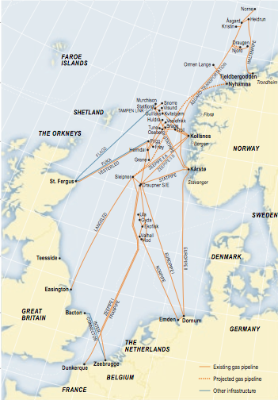
Methanol plant
Figure 2.1 – Methanol Plant Location (I7)

3 PROCESS DESCRIPTION

As described in the introduction part, the process consists of two separate processes, the synthesis gas production and the conversion of synthesis gas to methanol. For the synthesis gas production, the reformer is the main unit. The main unit in the methanol production is the methanol reactor. These two units will be described first, and the rest of the units afterwards. Finally, the heat exchanger network design will be described.

3.1 REFORMER SECTION

3.1.1 Choice of technology

The choice of technology for manufacturing of synthesis gas depends on the scale of operation. For capacitys below 1000-1500 tonne/day steam reforming would be cheapest, whereas autothermal reforming (ATR) would be cheapest at capacities around 6000 tonne/day. For the intermediate range, a combination would be the optimal solution (Assberg-Petersen, 2001).

Nevertheless, steam reforming was chosen as the technology to produce the synthesis gas. The reaction in a steam reformer is carried out according to equation (1.1). The idea of using this method was that this would be more economical viable compared to a combination, because of the reduction of capital costs. ATR requires pure oxygen, and not using an ATR in the process reduces the plant capital cost, because an expensive oxygen enriching plant is no longer needed. The problem of using only steam reforming is the hydrogen/carbon ratio (H/C). There is currently no method which will give the ideal H/C ratio for conversion of syngas to methanol. Steam reforming will produce an H/C of approximate 3. ATR on the other hand will produce an H/C of approximate 1,8 (O7). If the H/C ratio is too low H₂ can be injected to adjust this ratio up. If the H/C ratio is too high CO₂ or CO can be injected to adjust this ratio down. It was assumed that CO₂ injection would be simplest solution, thus steam reforming would be the recommended technology. To be able to consume CO₂, which often is considered to be a problem gas because of its relation to the greenhouse effect, would be very favorable. Stricter restrictions regarding emissions of CO₂ will also in the future most likely be more prominent.

The combination of the two methods described above (combined steam reforming and ATR) is today very well known methods, and the potential for major improvements would be limited. Therefore, the investigation of the solution with a steam reformer and CO₂ injection is very interesting. It was assumed that the CO₂ is available at the plant location.

3.1.2 Structure of Reformer

A steam reformer is similar to a big furnace, with vertical tubes loaded with catalyst, see figure 3.1. The feed of natural gas and steam is mixed in a manifold at the inlet. The feed is then injected into the catalyst filled tubes. The reformer is heated by burners, usually located at the top or at the sides of the reformer. The reformer can be divided into a radiant section, convective section and stack section. Heat transferred into the catalytic tubes is mostly done in the radiant section, with radiation. Approximate 50 % of the heat created by the burners is transferred into the tubes (O7). The simulation in UniSIM showed that 58% of the heat was transferred to the process gas and the rest to the tubes into the tubes, which is close to the approximate percentage. The convective section consists of horizontal tubes and coils which goal is to recover heat from the flue gas. The heat recovery is described in more details in the Chapter 3.4. The burners are assumed to be fueled by natural gas.

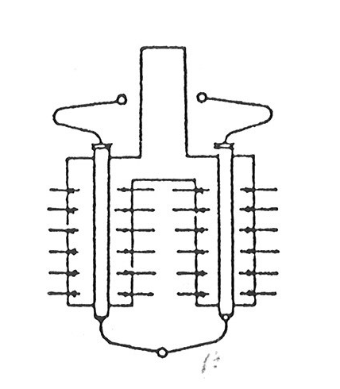
Figure 3.1 – Side-fired (radiant wall) steam reformer (S. Lee, 1997)

3.1.3 Operating Parameters

The temperature of the steam reformer is assumed to be around 1000°C. UHDE reported an outlet temperature of 740-880C at 40 bar (I1). It was shown with thermodynamic calculations (appendix B) that the reaction of methane to syngas, equation (1.1), was spontaneous at approximately 1000°C, at an operating pressure of 30 bar. K. Aasberg-Petersen et.al reported that it is possible to design reformers, using modern materials, which could withstand temperatures up to 1050°C (Aasberg-Petersen, 2001). To ensure good conversion and spontaneous reaction, the steam reformer temperature was set to 1000C. The natural gas and steam feed was preheated to 650°C, which would lead to a reduction of the reformer size (Aasberg-Petersen, 2001). The reformer reactions are favored by low pressures, while the syngas to methanol reaction in the fixed-bed reactor is favored by high pressures. The pressure in the steam reformer is therefore a tradeoff between compression cost and methane conversion. The methanol plant at Tjeldbjergodden uses a pressure of 36 bar in their steam reformer (O3). K. Aasberg-Petersen et.al proposed a pressure in the interval 20-40 bar (Aasberg-Petersen, 2001). In this model the steam reformer pressure was set to 30 bar.

The amount of natural gas needed to produce 2500 tonne/day methanol is calculated in appendix C. From the net reaction given by equation (1.1) and equation (1.5), it is easy to assume that the same amount of steam would be needed. However, data from the literature suggest an ideal steam/carbon ratio (s/c) between 2,2-2,5 (S. Lee, 1997). D.L. Trimm, M.S. Wainwright did suggest that it should be possible to perform coke free operations with s/c ratio as low as 1,3 (Trimm 1996). A case study executed in Unisim showed an increase in productivity with an increase in steam feed, see figure 3.2. This increase in productivity is probably due to a shift to the right of the equilibrium reaction in equation (1.1). Another reason for increasing the s/c ratio is to prevent the formation of coke in the catalyst tubes. This formation of coke will deactivate the catalyst, and decrease the operating time of the catalyst (S. Lee, 1997). To keep the capital cost to a minimum it is also important not to have to high s/c ratio, thus the steam feed rate was chosen where the figure 3.2 starts to level out, at 7000kgmol/h. This corresponds to an s/c ratio of two, which agrees with the literature above.

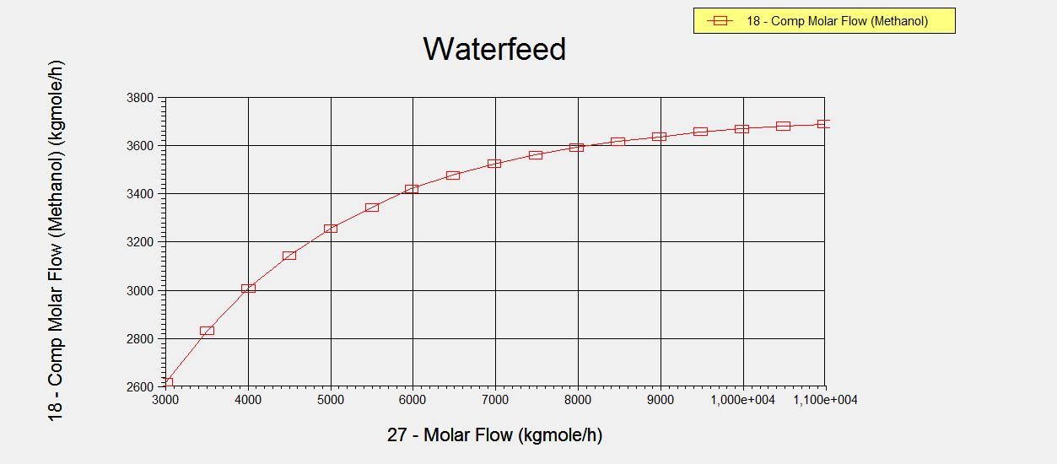
Figure 3.2 – Optimal steamfeed ≈ 7000 kgmole/h

3.1.4 Modeling

The steam reformer was modeled in Unisim using an equilibrium reactor, assuming that the reaction was occurring at equilibrium. It was only assumed that the reactions given in the equations (1.1), (1.6) and (1.2) took place. For the furnace part of the reformer, a conversion reactor was used to model the amount of heat produced in the burners. It was assumed a total combustion of the fuel, which was natural gas at 30 bar. The design parameters for the steam reformer are given in Table 3.1.

Table 3.1 – Design parameters for the steam reformer
 | Equilibrium reactor | Conversion reactor
Hydrocarbon feed [tonne/day] | 1444 | 762
Steam feed [tonne/day] | 3027 | -
Massflow out [tonne/day] | 4471 | 13585
Air feed [tonne/day] | - | 12824
s/c | 2 | -
T_{in} [°C] | 650 | -
T_{out} [°C] | 1000 | 1000
Inlet Pressure [bar] | 30 | -
Pressure drop [bar] | 4 | -
Duty [10⁵ kW] | 2,4 | -2,4

The steam reforming method will produce syngas with an approximate hydrogen/carbon ratio of 3. It is argued by K. Aasberg-Petersen et. al that the syngas ideally should have the same stoichiometry as the final product. This can be expressed by the module, M, equation (1.1), which is equivalent to the H/C ratio. The module should be close to two for the methanol synthesis (Aasberg-Petersen, 2001 & O1). In this model, CO₂ injection has been chosen to adjust the module down to the desired value of two to achieve the largest conversion of natural gas to methane.
(3.1)

3.1.5 Sizing

The steam reformer dimension had to be found to be able to calculate the amount of catalyst needed in the reactor. Since the production rate of the methanol is in the same range as the production rate of the methanol plant at Tjeldbergodden, the size the steam reformer at Tjeldbergodden was used to estimate the dimension of the steam reformer in this model. The catalytic loaded tubes at Tjelbergodden was found to be 12 meters in height and 0,12 meters in diameter. The total number of tubes were 210. These tubes were distributed in two chambers, where each chamber was heated with 180 burners (O7). It was assumed that the steam reformer size a approximate the same as Tjeldbergodden. The total volme was calculated to be 28,5m³. It was used a common nickeloxide catalyst with an assumed void fraction of 0,5. S. Lee reported a typical catalyst loading of 2-7 kg/hr/L (S. Lee, 2001), which would give a total steam reformer volume of approximate 26,7 m³, when assuming a void fraction of 0,5 and 4.5 kg/hr/L as the catalyst loading. This is consistent with the total volume of the steam reformer at Tjeldbergodden, which has a total steam reformer volume of 28,5 m³.

3.1.6 Choice of material

Due to the high temperature levels in the steam reformer, heat resistant stainless steel was chosen to be the material of construction. Stainless steel types like 309 and 310, which contain some nickel and chromium can be used for such high temperature application (Peters, 2003).

3.2 METHANOL REACTOR

3.2.1 Choice of Reactor Type

The choice of the methanol reactor is the Lurgi Methanol Reactor. There are other options that are interesting, but the Lurge reactor is believed to have a high level of temperature control. The choice is also based on the fact that the methanol industry has a very high level of experience with the Lurgi Methanol reactor, among others (Meyers, 2005):
- YPF, Argentina (1999)
- Atlas, Trinidad (2000)
- ZAGROS, Iran (2000)
- Methanex, Chile (2002)
- ZAGROS II, Iran (2004)
- Hainan Methanol, China (2004)
- QAFAC, Qatar (2004)
- Methanex, United States (1992)
- Statoil, Norway (1992)
- CINOPEC, China (1993)
- KIMI, Indonesia (1994)
- NPC, Iran (1995)
- Sastech, South Africa (1996)
- Titan, Trinidad (1997)
- PIC, Kuwait (1998)

3.2.2 Sizing

A fixed bed reactor (FBR) was used as the basis for the methanol reactor. The catalyst used was the common Cu/ZnO on an alumina support. The reactor was dimensioned to match the size of the largest Norwegian methanol plant, Tjeldbergodden. The length was set to 7 m and the number of tubes was calculated to 5374 tubes, each with a diameter of 4 cm (O1). The number of tubes was calculated by setting the maximum velocity to 5 m/s (O4), with an assumed void fraction of 0,5 and recycle ratio of 4:1 (Aasberg-Petersen, 2001). The number of tubes of 5374 is somewhat smaller than the number of tubes used by Tjeldbergodden (O1), which is 14030 tubes with 4 cm diameter that are distributed in two reactor shells. The reason for this is probably that the tolerated maximum space velocity assumed in this report is a bit large. More detailed dimensioning calculations are given in the appendix D.

Figure 3.3 below shows an illustration of the Lurgi Methanol Reactor.

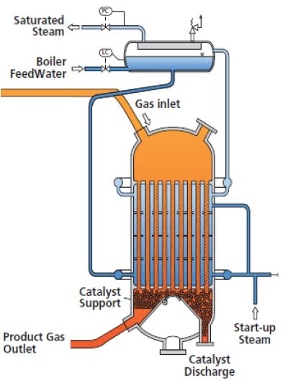
Figure 3.3 - Lurgi Methanol Reactor (I3)

3.2.3 Modeling

The reactor was modeled in Unisim using a plug flow reactor reactor, with kinetic data. The kinetic data used was the data reported by K.M Vanden Bussche and G.F. Froment (Bussche 1996). This kinetic data was only valid from 180°C to 280°C and to pressures up to 51 bar. A case study of the temperature was preformed to ensure the highest conversion possible (see Figure 3.4). Table 3.2 shows some design data for the reactor.

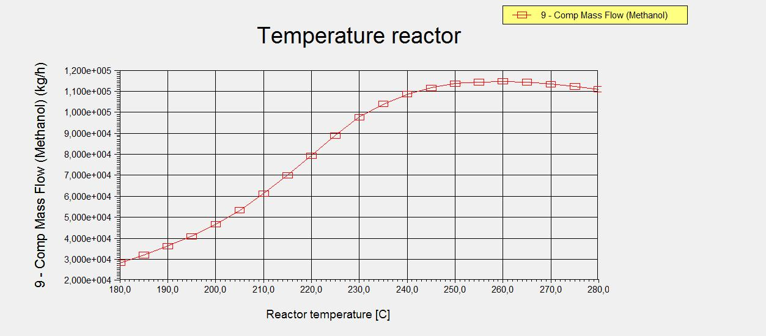
Figure 3.4 – Flow rate of methanol variation with temperature.

Figure 3.4 shows that the optimal temperature was approximately 260°C. Since the reaction is favored at high pressures (Trimm, 1996) the pressure was set to 50 bar which are in the upper range of where the kinetic data is valid.

Table 3.2 – Methanol reactor design data.
Dimension | Value
Number of tubes | 5374
Inner diameter tube, d_{i} [m] | 0,04
Outer diameter tube, d_{o} [m] | 0,05
Total tube volume [m³] | 47,27
Diameter shell [m] | 4,8
Height [m] | 7
Tube wall thickness [m] | 0,005
Pitch [m] | 0,0625
Temperature [°C] | 260
Duty [10⁴ kW] | 6,855

3.2.4 Challenges and Solutions

To ensure good heat recovery, heat from hot reactor outlet was used to preheat the input stream (see Chapter 3.4). However, since the methanol reactor in UniSIM is isothermal, the inlet temperature would be the same as the outlet temp|erature. In reality, the inlet temperature of the reactor would be smaller than the outlet temperature, but since the reaction is exothermic one would experience a rapid increase to the desired temperature by controlling the amount of cooling, and the reactor would be approximately isothermal. In UniSIM this was difficult to simulate since a colder feed in than out would result in a linear temperature profile in the reactor, see figure 3.5. The proposed solution was to add a heater at the reactor inlet, heating the inlet stream to the desired temperature of 260°C. The real heat flow from the reactor to the cooling water would then be the duty of the reactor minus the duty of the heater.

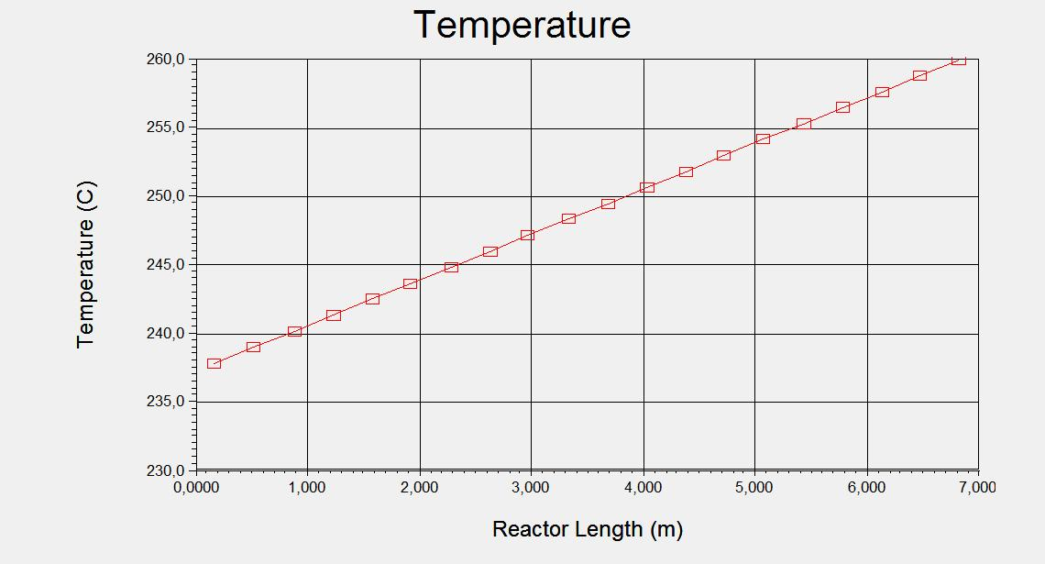
Figure 3.5 – Temperature profile for methanol reactor. T_{feed} = 236,7°C

The graph in figure 3.6 is an illustration of how the temperature profile should roughly look like.

Figure 3.6 – Temperature profile in reality

In figure 3.7 below is the proposed solution for solving the problem in UniSIM.
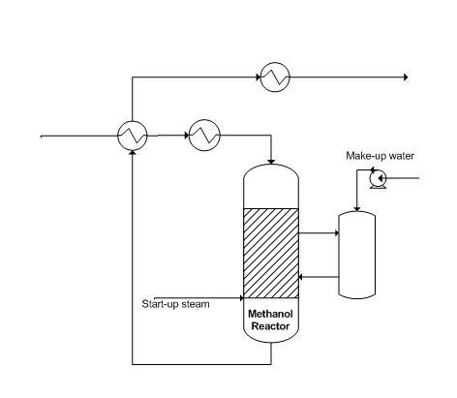
Figure 3.7 – UniSIM configuration

3.2.5 Choice of material

The material for the methanol reactor was chosen to be carbon steel. Since the process streams at this stage are only gasses, corrosion is not believed to be a problem. Due to the temperature conditions at about 250°C, metal dusting not comes into consideration. This leads to a construction material of carbon steel, which is the least expensive material (Peters, 2003).

3.3 OTHER UNITS

3.3.1 Prereformer

Function

It is common to use prereforming because of the natural gas feed usually contains some larger hydrocarbons than methane. The main task of the prereformer is to crack the larger hydrocarbons to methane, but it was also assumed that the syngas reaction (equation 1.1) together with the shift reaction (equation 1.2) could occur in a small extent.

Modeling

The required duty in the tubular reformer may be reduced by increase of the preheat temperature. This involves the problem that the preheater may then work as a steam cracker producing olefins from higher hydrocarbons in the feed. These olefins easily form carbon in the reformer. This problem can be solved by introduction of an adiabatic prereformer on which all the higher hydrocarbons are converted in the temperature range of 350-550°C. After the prereformer it is possible to preheat to temperatures around 650°C, thus reducing the size of the reformer (Aasberg-Petersen, 2001).

The prereformer was modeled in Unisim using one conversion reactor and one equilibrium reactor. Total conversion was assumed for the cracking reactions, and the syngas reaction and the shift reaction was assumed to be in equilibrium. The prereformer was assumed to be adiabatic (Aasberg-Petersen, 2001). The feed was preheated to 455°C using the hot flue gas created by the steam reformer (see section 3.5 for details). This resulted in an outlet temperature of approximate 450°C, which is in the temperature range of 350-550°C reported by K. Aasberg-Petersen et. al (Aasberg-Petersen, 2001). The pressure was kept constant at 30 bar, which is the same as in the steam reformer. Pressure drop was assumed to be negligible.

Synthetisis gas compression

After the steam reforming section the gas has to be cooled and compressed before entering the methanol reactor. The synthesis gas compression is a costly operation and therefore it is preferable that the reformer functions at a pressure as similar to the methanol reactor as possible.

Choice of material

The prereformer is chosed to be constructed in carbon steel, which is the most commonly used engineering material for low to medium temperatures. The main problem with carbon steel is the lack of corrosion resistance, and the material is seldom used above 500°C (Peters, 2003). The temperature in the prereformer is 446°C, which is under the limit for which carbon steel can not be used. The process stream does not contain any CO₂ and metal dusting are not to be of a problem (Chang, 2008).

3.3.2 Separators

Function

A separator is used to separate dispersed liquid in a gas stream. It is important that the dimension of the separator is large enough so that liquid can settle in the bottom of the tank. When designing the separator size, a hold-up time of 10 minutes was assumed (O4). Two separators were used in the plant design, each equiped with demisters, to ensure good separation and to decrease equipment cost. When using a demister the vessel height can be reduced (Peters, 2003). The first separator (SEP-1), located between the reformer section and the methanol reactor, was inserted to separate excess water from the reformer section. The second separator (SEP-2) was inserted to separate the final product (methanol) from the recycle.

The separators where dimensioned using the procedure described by R. Sinnot and G. Towler (Sinnot 2009). Detailed descriptions of the calculations are given in the appendix E.

Choice of material

The construction material of seperator SEP-1 was chosen to carbon steel with nickel-alloy clad. The nickel-alloy clad was added due to the water content in the actual process streams. Nickel exhibits high corrosion resistance to most alkalies and increases toughness and improves low temperature properties and corrosion recistance of the material (Peters, 2005). SEP-2 was chosen to be carbon steel due to the low temperature and low pressure.

3.3.3 Distillation columns

Function

A distillation column is used to separate different components in a fluid, by using their difference in boiling point.

Arrangement

Since the outlet stream from the last separator contains many different components, a minimum of two distillations had to be used to obtain the desired product specification. The column arrangement used was the conventional arrangement described by R. Sinnot et.al known as the stripper and re-run column. This arrangement is illustrated in figure 3.8. The light components are separated in the first column, followed by a separation of mostly methanol and water in the last column.

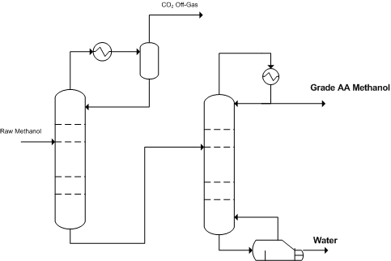

Figure 3.8- Column arrangement (Sinnot, 2009)

Sizing

A plate spacing of 0,5 meters was assumed according to the literature (Sinnot, 2009). This value, along with the described procedure, was used to calculate the column diameter. An alternative procedure was used to confirm the result from the first method (Peters, 2003). To determine the number of trays in the column, a short cut column in Unisim was used. The method described by R.Sinnot et.al was used to confirm the results from Unisim (Sinnot, 2009). A tray efficiency of 60% was assumed to find the real number of trays. For more details about column sizing, see appendixA.

Choice of material

The material of construction used in the distillation columns was assumed to be stainless steel due to the water content in the process stream. Using carbon steel would lead to corrosion.

3.3.4 Heat exchangers

Function

A heat exchanger is a device for making fluids exchange heat without being mixed.

Sizing

Heat exchangers were dimensioned by using the duty and the logarithmic mean temperature difference from Unisim. Appropriate heat transfer coefficients were found and the heat transfer areas were calculated. Heat exchangers which experienced condensation or vaporization were split into multiple heat exchangers for calculation purposes. Some of the exchangers were also modeled using Aspen HTFS+ design system for comparison. Detailed calculations are given in the appendix F.

Application and material of construction

Heat exchangers used for preheating process streams in the reformer section was all assumed to be included in the heat recovery section of the steam reformer, where heat from the hot flue gas were exchanged. This was mostly done to ensure an easy startup after shutdown. More details about this part are found in Chapter 3.4.

For the methanol synthesis part, the preheating of the methanol reactor feed was done using heat from the reactor outlet. It was assumed to be wise to separate the reformer part and the synthesis part to ensure no complications could occur during startup procedure. Because of the relative large exchanger size, a flat plate heat exchanger was used.

Heat exchangers were also used to cool the process gas with cooling water before the separators. U-tube heat exchangers were used, which is better suited for high pressures than a regular shell and tube heat exchangers (Peters, 2003). These heat exchangers were constructed with a shell of carbon steel and tubes of nickel-alloy, due to the seawater used for cooling. Nonferrous metals, like nickel, are often employed in heat exchangers when water is one of the fluids. To reduce costs, the water may be passed through the more expensive tubes and the shell side of the exchanger can be constructed of steel (Peters, 2003).

High pressure steam was produced from the hot outlet process stream from the steam reformer. A forced circulation evaporator was used in this case due to its operating range and its ability to handle the somewhat corrosive seawater conditions (Peters, 2003). Due to the high CO₂ rate combined with high operating pressure in this area, special materials had to be used when designing this heat exchanger, because of the risk of metal dusting. Metal dusting is a high temperaturecorrsion phenomen leading to the disintegration of materials into a dust of fine metal particles, graphite, carbides and oxides. This phenomenon is known to be of catastrophic character. It is generally believed that metal dusting starts to occure in the temperature range of 400–800°C, in an environment involving hydrocarbon or strongly carburising atmosphere. The temperature at the steam reformer outlett, and at the inlet of the heat exchanger the temperature are almost 1000°C, which is far beyond the limit for metal dusting. While increasing Ni content in Fe-Ni alloys, are known to suppress metal dusting. The high alloy, chromia-forming alloys are proved to show minimal extend of metal dusting (Chang, 2008). Based on this information the material in this heat excanger was chosen to be inconel, which is an Ni-Fe-Cr-alloy, known to maintain its strength at elevated temperature and is recistant to furnace gases (Sinnot, 2005).

The condensers and reboilers in the distillation columns were modeled using shell and tube heat exchangers for the condensers and kettle type heat exchangers for the reboilers. The reboiler and the column were chosen to be constructed in stainless steel due to the water content in the process stream. For the condensers the shell and tube were chosen to be constructed in carbonsteel for the shell and stainless steel for the tubes. Since the water content in the the top streams of the column are small, these streams are going through the carbon shells, while the cooling water, assumed to be corrosive seawater, goes through the tubes of stainless steel.

3.3.5 Compressors

Function

Compressors are used to increase the pressure of gases. Compressors are used for high operation from 200 kPa-400MPa. Staged compression is usually employed when the compression ratio is greater than 4 to avoid excessive temp. In multistage compression, the ratio should be about the same in each stage (Peters, 2003).

Sizing

The cost of the compressors was calculated based on the compressor duty given in UniSIM. When modeling the plant in UniSIM no pressure drop was assumed. To be able to calculate the compressor duty, a small expansion valve was inserted before the compressor to compensate for the pressure drop. The pressure drops were based on experience from the industry (O2). A total of two compressors were used in the model. The first compressor (COMP-1) was used to compress the synthesis gas from the reformer section. The pressure drop of the reformer section was assumed to be 4 bar (from 30 to 26 bar). Thus the compressor had to compress the gas from 26 to 50 bar. The second compressor (COMP-2) was used to compress the recycle over the methanol reactor, which had an assumed pressure drop of 2 bar. Both compressors were assumed to be regular centrifugal compressors.

Choice of material

Due to low temperatures and pure vapour phase in both the compressors, the materialof construction was chosen to be carbon steel. A driver was attached to both the compressors.

3.3.6 Turbine/Expander

Function

The function of a turbine/expander is to extract energy from a fluid flow and converts it to useful energy

Sizing

The cost of the expander (EXP-1) was calculated by using the duty found from the UniSIM model. No other sizing calculations was performed for the expander.

Application

It was assumed that the plant would be located nearby a natural gas pipe, which would be feeding the plant with natural gas. The gas was assumed to have a pressure of 70 bar upon arrival. The pressure had to be reduced to 30 bar before the entry into the prereformer. The ability to utilize the energy released by the expansion is discussed later.

The energy released from expanding of the raw methanol stream from 50 to 2,2 bar before the distillation columns, were not assumed to be feasible, and an expander valve was used instead of a turbine.

Choice of material

Due to low temperature conditions and gas stream, material of construction for the heat exchanger was chosen to be the basic carbon steel.

3.4 HEAT EXCHANGER NETWORK AND ENERGY CONSUMPTION

Heat exchanger network (HEN) design is a very important part of the chemical process design; typically 20-30% energy saving can be realised by impoved HEN design (Linnhoff, 1983). In the following the minimum number of heat exchanger units in the process, minimum amount of utility requirement and different heat exchanger networks will be proposed.

3.4.1 Defining hot and cold streams and utilities

It is essentially two hot streams to be cooled and four cold streams to be heated.

- The synthesis gas (H1) from the steam reformer is to be cooled from 1000°C to 30°C.
- The product out from the methanol reactor (H2) is to be cooled from 260°C to 30°C.
- The natural gas feed (C1) is to be heated from -0,26°C to 455°C.
- The methane rich gas from the prereformer (C2) is to be heated from 448,25°C to 650°C
- The methanol reactor feed (C3) is to be heated from 41,32°C to 260°C.

flue gas is essentitally not a process stream since it is not involved in any reactions (apart from the combustion). Therefore it is considered as a utility and not included in the construction of the composite curve and the Grand composite curve. Steam and cooling water are also, of course, utilities available.

3.4.2 Minimum number of units

The minimum number of units, if we aim for some, but not maximum heat recovery, is

U_{min} = N-1

where N is the number of hot and cold streams and utilities (Hohmann, 1971). With two hot streams, three cold streams and three utilities (flue gas, steam and cooling water) available, the minimum number of units become

U_{min} = 2 + 3 + 3 - 1 = 7 units

3.4.3 Minimum energy consumption

To see if there is a process pinch (or if we are dealing with a treshhold problem) and to find the minimum amount of energy consumption needed, composite curves are drawn.

Temperature intervals for the cooling curve are:
-0,26°C | - | 41,32°C | : | C1 is heated | Total mCp = 46,342 kW/°C | Total ΔQ = 1,93 MW
41,32°C | - | 260°C | : | C1 and C3 are heated | Total mCp = 804,822 kW/°C | Total ΔQ = 176,00 MW
260°C | - | 448,25°C | : | C1 is heated | Total mCp = 46,342 kW/°C | Total ΔQ = 8,72 MW
448,25°C | - | 455°C | : | C1 and C2 are heated | Total mCp = 188,304 kW/°C | Total ΔQ = 1,27 MW
455°C | - | 650°C | : | C2 is heated | Total mCp = 141,96 kW/°C | Total ΔQ = 27,68 MW

Temperature intervals for the heating curve are:

1000°C | - | 260°C | : | H1 is cooled | Total mCp = 178,00 kW/°C | Total ΔQ = 131,72 MW
260°C | - | 30°C | : | H1 and H2 are cooled | Total mCp = 910,76 kW/°C | Total ΔQ = 209,47 MW

In figure 3.9 are the composite curves drawn.

Figure 3.9 – Composite curve

From the composite curves it can be seen that a minimum amount of cooling required is 125,59 MW. These utilities can be either cooling water (for the lower temperature part) or steam generated (for the higher temperature part). From these curves it can also be seen that we are dealing with a treshold problem.

3.4.4 Heat Cascade and Grand Composite Curve

To explore how much steam that can be generated, the Heat Cascade (figure 3.10) and the Grand composite curve is constructed.

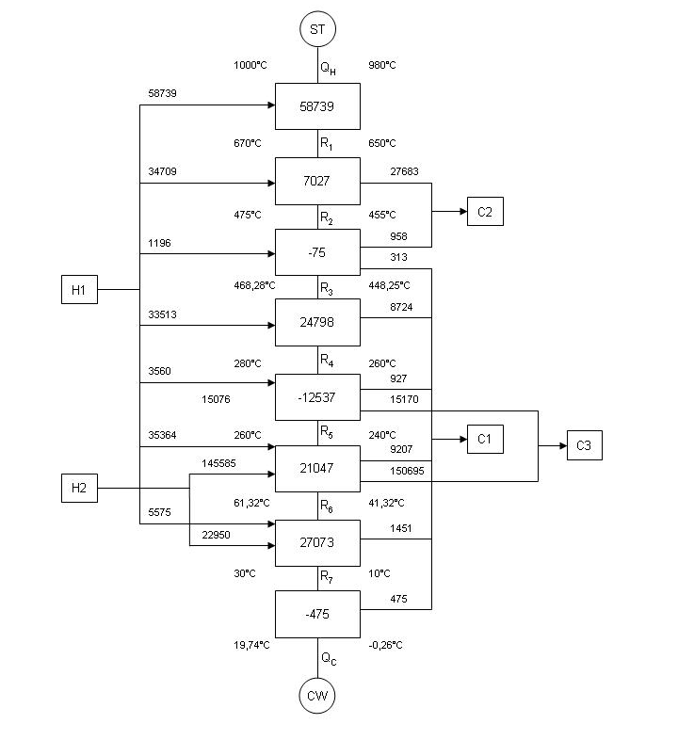
Figure 3.10- Heat cascade

Since the system has a heat surplus, Q_{H} is set to be equal to zero. Calculating the residuals, R_{i}, and the mininmum amount of cooling, Q_{C}, we get R₁ = 587,39 MW, R₂ = 65,77 MW, R₃ = 65,69 MW, R₄ = 90,48 MW, R₅ = 77,94 MW, R₆ = 98,99 MW, R₇ = 126,06 MW and Q_{C} = 125,59 MW.

Below, in figure 3.11, the Grand compostie curve is shown.
HP Steam
Figure 3.11 – Grand Composite Curve

From the Grand composite curve it is seen that high pressure steam at 510°C (Modified temperature = 500°C) can be generated.

3.4.5 Forbidden matches

It is also important to define which streams that should not be matched against eachother, i.e. forbidden matches. It has been decided to divide the process in two; the production of the synthesis gas is one part and the methanol production is one part. Thus, H1 should not be heat integratied with C3 and H2 should not be heat integrated with neither C1 nor C2. In addition, due to start-up considerations, H1 should neither be heat integrated with C1 nor C2. It is then obvious that H1 is a good source for HP steam production and flue gas can be used for heating purposes. Making restrictions like this reduces the number of choices for heat integration. Constructing the full heat cascade (and drawing the Grand composite curve) including all the forbidden matches would be very time consuming and is not done in this study.

3.4.6 Final design

The pinch analysis only states that there is a surplus of heat in the process, but since the heat cascade with forbidden matched is not made, the pinch analysis does not give any explisit suggestions for paring of streams. However, the flue gas is a valuable source for heat integration with the process. Heat integrating the flue gas (from now, H3) with only the process streams before the steam reformer (C1 and C2) would ease the start-up of the plant. H3 can also be sued to produce MP steam. The synthesis gas from the steam reformer is used to make high pressure steam used for heat integration with the methanol reactor product. The methanol reactor product is also heat integrated with the methanol reactor feed. The final heat exchanger network is shown below in figure 3.12. For summary of hand calculations, see appendix G.

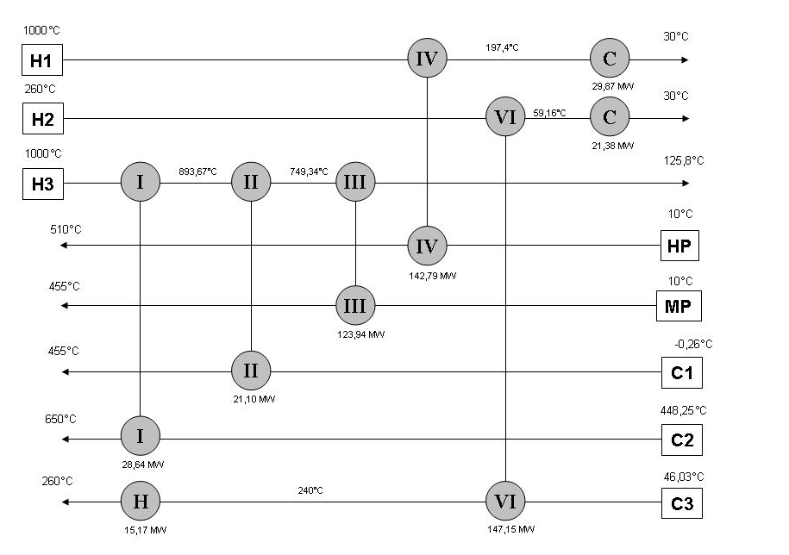
Figure 3.12 – Heat Exchanger Network (Hand calculations)

The proposed heat exchanger network is constructed in the UniSIM flow sheet. Figure 3.13 below shows the actual temperatures and duties calculated by UniSIM.

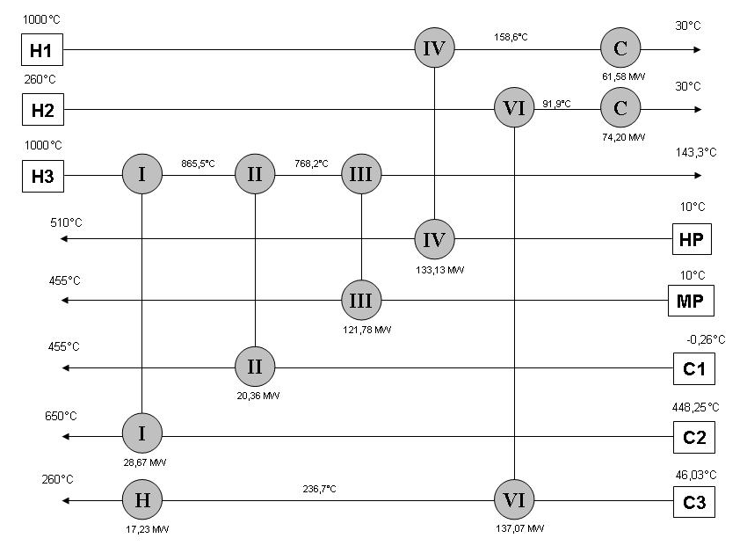
Figure 3.13 – Heat Exchanger Network (UniSIM calculations)

The main differences are in the two coolers (HE-5 and HE-7). This is because there is a phase transition over these coolers. The mC_{p} value will be higher and therefore the duty will be higher in reality.

3.4.7 Flue Gas Heat Exchange

Since a major part of the heat exchange is between process streams and the flue gas, this part is explained. Figure 3.14 below shows a typical terraced-wall reformer from Foster Wheeler. The reactants and the catalyst in the steam reformer tubes are heated by gas burners on the steam reformer inlet walls to reach the desired temperature of 1000°C. The flue gas is sucked by a fan on the top of the steam reformer and sent through the tubes for heat exchange with the process gas.

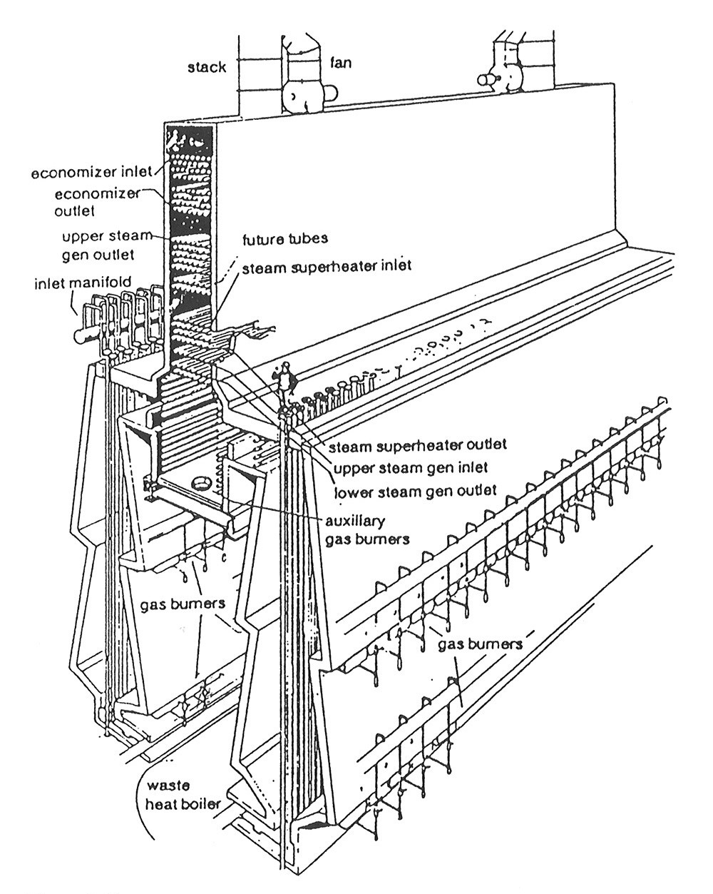
Figure 3.14 – Heat exchange between flue gas and process streams

3.4.8 Flow sheet, methanol plant

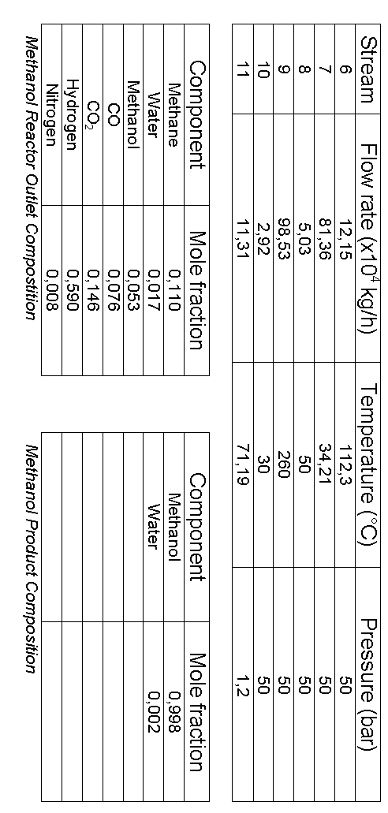
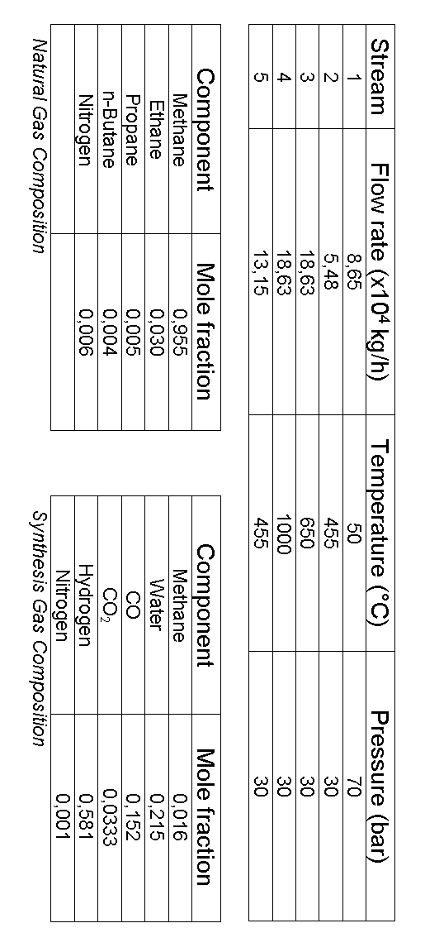
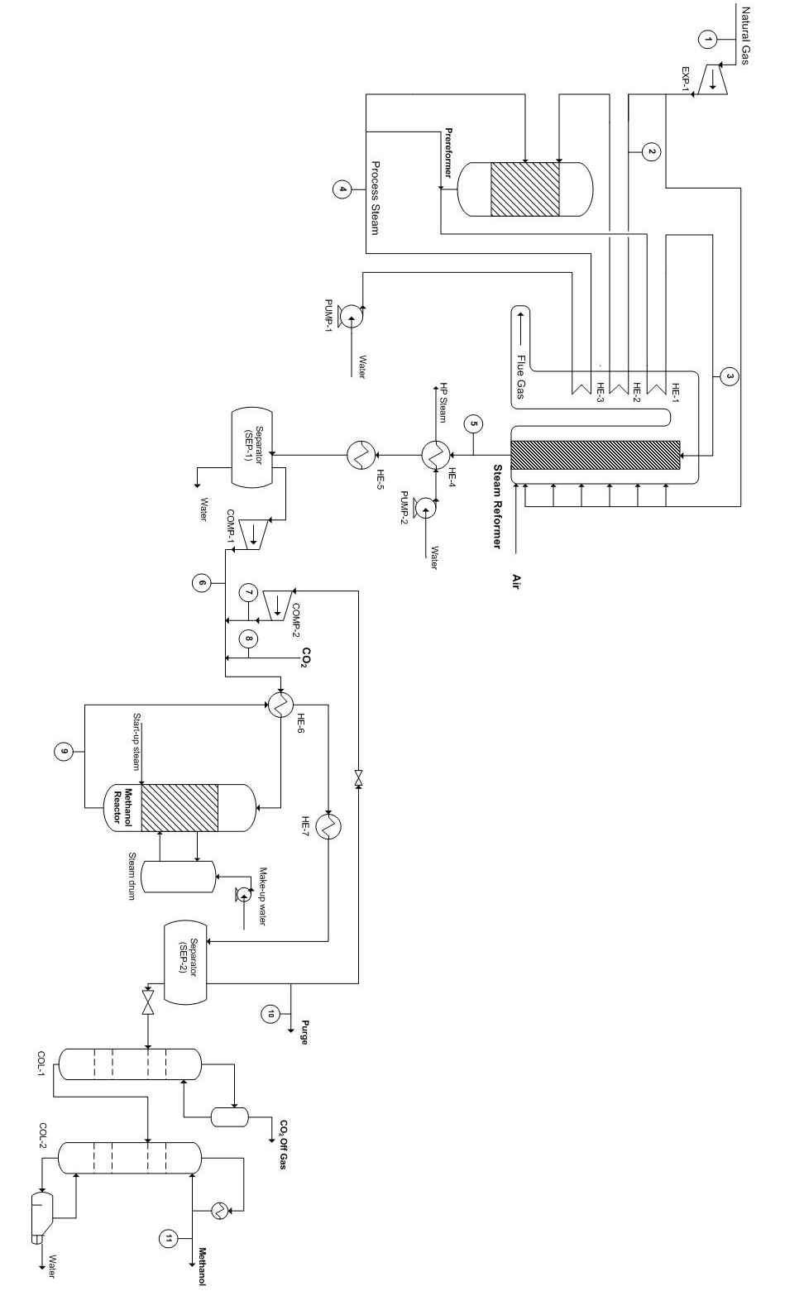
Figure 3.15 – Flow sheet, methanol plant

3.5 REFLECTIONS

One of the elements not taken into consideration in this study is the possibility of sulphur content in the natural gas feed. In fact, there are several other consumables in addition to the catalysts. Among others are acids, sodium hydroxide, phosphate which are added to the boiler water where steam is produced and ammonia to improve the reactions in the sulphur removal section of the process. The sulfur removal is important to avoid poisioning of the catalysts in the steam reformer and the methanol reactor. Nitrogen is used as an inert and for pressurizing the tanks. Different chemicals are used in the waste treatment process such as acids and sodium hydroxide to get the right pH, different nutrients, coagulant, etc. Ion exchanger mass are used for cleaning of the process and boiler water (O2). All these additional consumables are not taken into consideration for the economical analysis.

One possibility of utilizing the energy generated from the turbine (EXP-1) is connecting it to a compressor with a shaft. This unit is called a Turbo-Expander (TEX). Because of friction losses, the duty of the compressor should be approximately 98% lower than the duty of the turbine. The friction losses are minimized by holding the shaft in possision with a magnetic field. The duty of the EXP-1 is 1956 kW and the duty of the compressor should then be 1917 kW. The duty of COMP-2 is 2453 kW. Reduing this duty to 1917 kW requires a lower pressure drop over the recycle, i.e. 1,57 bar which is 0,43 bar lower than the assumed value. If this is feasable such a TEX configuration could be a possibility. The cost savings would be in the costs associated with running the recycle compressor (COMP-2). The investment costs related to a TEX would be in the same order as the total costs for a turbine and a compressor. The operating cost of a TEX is basically only maintenance costs plus a small duty for running the magnet bearing. Investment costs would be in in between 10 to 50 MNOK (O5). Figure 3.9 below shows a sketch of a TEX.

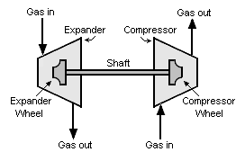
Figure 3.16 – Sketch of a TEX

The carbon conversion of the plant was calculated in appendix I. The total conversion and conversion per pass in the methanol reactor are shown in table 3.3. Compared to Tjelbergodden the conversion in the modeled plant is much lower. This is probably due to that a large part of the methane was not converted in the steam reformer.

The total amount produced was 2714 tonne/day. Natural gas consumed was 2076 tonne/day, of which 36,7% was consumed to pre-heat the steam reformer. Amount CO₂ needed to adjust the hydrogen/carbon ratio was 1207 tonne/day.

Table 3.3 – Carbon conversion of the plant
 | Our model | Tjeldbergodden(O2)
Total carbon conversion]n over the whole plant [%] | 74,1 | 98.5
Conversion per pass over the reactor [%] | 13 | 63

The amount of CO₂ released into the atmosphere was a lot larger than expected. This was mainly due to the large amount of CO₂ released in the flue gas. To avoid these emissions, one could use carbon free fuels, like H₂.Then there would be a net consumption of CO₂ in the process. Another solution would be to install a CO2 capturing plant, but this alternative would probably be costly because of the low pressure and low concentration of CO2 in the flue gas.

The heat integration part could have been done with introducing forbidden matches. Then the Grand Composite Curve would have been more useful in terms of realizing the real process-to-process potential.

4 SUMMARY OF CALCULATIONS

4.1 MAIN EQUIPMENT

The main equipment used in the process is summarized in table 4.1 and table 4.2 For details about the calculation, see Appendix A – F.

Table 4.1 – Main Equipment I
 | Height /length [m] | Inner diameter [m] | #tubes | #trays | Volume [m^3]
Prereformer (PREREF) | 2,8 | 3,5 | - | - | 27,5
Steam reformer tubes (STEAMREF) | 12 | 0,12 | 210 | - | 28,5
Methanol reactor (REACTOR) | 7 | 4,8 |  | - | 126,7
Methanol reactor tubes | 7 | 0,04 | 5374 | - | 0,0088
Separator (SEP1) | 6,4 | 2,4 |  | - | 29,0
Separator (SEP2) | 9,9 | 5,5 |  | - | 235,2
Distillation column (COL-1) | 4,5 | 1,4 |  | 9
Distillation column (COL-2) | 22,5 | 7,1 |  | 45
Storage tank (TANK-1) | 23,2 | 45 |  |  | 36666
Storage tank (TANK-2) | 23,2 | 45 |  |  | 36666
Storage tank (TANK-3) | 23,2 | 45 |  |  | 36666

Table 4.2 – Main Equipment II
 | Duty [kW] | Surface area [m^3] | Type
Compressor (COMP-1) | 8936 | - | Centrifugal
Compressor (COMP-2) | 2453 | - | Centrifugal
Expander (EXP-1) | 1956 | - | Axial gas turbine
Heat exchanger (HE-1) | 28673 | - | -
Heat exchanger (HE-2) | 20360 | - | -
Heat exchanger (HE-3) | 121776 | - | -
Heat exchanger (HE-4) | -61583 | 1321 | U-tube
Heat exchanger (HE-5) | 137072 | 13087 | Flat plate
Heat exchanger (HE-6) | -74205 | 2934 | U-tube
Heat exchanger (E-105) | 133129 | 894 | Evaporator*
Pump (PUMP-1) | 139 | - | Centrifugal
Pump (PUMP-2) | 197 | - | Centrifugal
Pump (PUMP-3) | 3386 | - | Centrifugal
Pump (PUMP-4) | 4080 | - | Centrifugal
Pump(PUMP-5) | 14 | - | Centrifugal
Pump (PUMP-6) | 3333 | - | Centrifugal
Reboiler (REB-1) | 9434 | 99 | Kettle
Reboiler (REB-2) | 59945 | 473 | Kettle
Condenser (CON-1) | 262 | 163 | Shell and tube
Condenser (CON-2) | 60620 | 7508 | Shell and tube

4.2 MATERIAL BALANCE

UniSIM was used to perform the mass balance for the system. The overall mass balance is summarized in table 4.3.

Table 4.3 – Overall Mass Balance
MASS IN |  | MASS OUT
Stream | In (kg/h) | Stream | Out (kg/h)
Natural Gas | 86495 | Flue Gas Exit | 566050
Air | 534320 | SEP-1 (L) | 64820
Process steam | 131510 | Purge | 29147
CO₂ | 50288 | COL-1 (T) | 7772
 |  | COL-2 (B) | 21717
 |  | Methanol Product | 112048
Total | 802614 | Total | 801556
Difference = Mass In - Mass Out = |  | 1058 kg/h
% Error = |  | 0,13 %

The % Error is smaller than 1 %, and thus acceptable.

The component mass balance is summarized in table 4.4.

Table 4.4 – Component Mass Balance
Object | Mass In (kg/h) | Mass Out (kg/h) | Error (kg/h) | % Error
PREREF | 60163,97 | 60164,21 | -0,2464 | -0,0004
PREREF* | 60164,21 | 60164,05 | 0,1614 | 0,0003
COMBUSTION | 566056,11 | 566050,28 | 5,8276 | 0,0010
STEAMREF | 186269,75 | 186272,34 | -2,5893 | -0,0014
REACTOR | 985336,02 | 985332,83 | 3,1959 | 0,0003
SEP-1 | 186272,34 | 186272,34 | 0,0000 | 0,0000
SEP-2 | 985332,83 | 985332,83 | 0,0000 | 0,0000
COL-1 | 142590,42 | 142590,42 | 0,0000 | 0,0000
COL-2 | 134596,36 | 134596,36 | 0,0000 | 0,0000
Total | 3306782,02 | 3306775,67 | 6,3492 | 0,0002

The % Error for each component is much smaller than 0,1%, and thus acceptable.

4.3 HEAT BALANCE

4.3.1 Component heat balance

The heat balance is performed using the properties calculated by UniSIM and a set of equations. For heat exchange systems where no phase transition is occuring, the following equation should be satisfied

(4.1)

Data for the first heat exchanger (HE-1):

Heat Exchanger | Tube/Shell side | Mass flow (kg/s) | Cp (kJ/kg°C) | ΔT (°C)
HE-1 | Tube side | 51,742 | 2,744 | 201,8
HE-1 | Shell side | 157,236 | 1,356 | -134,5

The heat balance for HE-1 becomes

The difference is 0,02 MW, or 0,08%, which is acceptable.

The same procedure is used for HE-2 where no phase transition occurs.

For heat exchange systems where phase transition occure on shell side, the following equation should be satisfied

(4.2)

Phase transition occure on the shell side (where HP Steam is made) for HE-3. Data for the third heat exchanger (HE-3):

Heat Exchanger | Tube/Shell side | Mass flow (kg/s) | Cp1 (kJ/kg°C) | ΔT1 (°C) | Cp2 (kJ/kg°C) | ΔT2 (°C)
HE-3 | Tube side | 36,531 | 4,789 | 224,37 | 2,249 | 220,4
HE-3 | Shell side | 157,236 | 1,236 | -625 | - | -

The heat of vaporization for the stream in the shell side (water/steam) is 1822,70 kJ/kg.

The heat balance for HE-3 becomes:

The difference is 2,49 MW, or 2,03%, which is a bit high, but acceptable. Phase transitions contribute to larger errors.

The same procedure is used for HE-4, HE-5, HE-6 and HE-7 where phase transition occurs.

4.3.2 Overall Heat Balance

The heat flows in to and out of the system are summarized in table 4.3 and table 4.4, respectively.

Table 4.3 – Heat flows in to the system Table 4.4 – Heat flows in to the system
Streams In | Heat Flow  (10⁸ kJ/h) |  | Streams Out | Heat Flow  (10⁸ kJ/h)
Natural Gas | -3,8684 |  | Q-108 | 0,0704
Process Water | -20,9792 |  | Flue Gas Exit | -16,2867
Q-110 | 0,0050 |  | HP Steam | -17,4085
Air | 0,0256 |  | 47 | -1168,2500
Q-118 | 8,7627 |  | SEP-1 (L) | -10,2772
Q-100-3 | -8,7179 |  | Purge | -1,8387
Water 1 | -22,2082 |  | Q-106 | 3,0881
Q-115 | 0,0071 |  | 48 | -1407,7064
Syngas CW | -1170,4669 |  | COL-1 (T) | -0,6827
Q-103 | 0,3217 |  | Q-101 | 0,0096
CO2 | -4,5134 |  | Q-112 | 2,1823
Q-109 | 0,6204 |  | Methanol Product | -8,3571
Methanol CW | -1410,3778 |  | COL-2 (B) | -3,3446
Q-105 | 0,3396
Q-111 | 2,1603
Total | -2628,8895 |  | Total | -2628,8013

Heat flow in – Heat flow out = -2628,8895 x 10⁸ kJ/h – (-2628,8013) x 10⁸ kJ/h
= -0,0882 x 10⁸ kJ/h

The percentage error is 0,0034 %, which is acceptable.

4.4 EQUIPMENT COSTS

The cost of the process equipment is executed in Chapter 5.

4.5 PROCESS CONTROL

There has been a focus on easy start-up in the design of the process. Since the heat exchangers in the synthesis gas part of the process (HE-1, HE-2 and HE-3) are only heat exchanging the process streams with the flue gas, the start-up will be easy for this part. The steam reformer should be fired first, so that the flue gas has the desired temperature of 1000°C when the process natural gas is entering HE-1 and HE-2 and the water is entering HE-3. As indicated in figure 3.16 the methanol reactor should be equipped with an inlet for start-up steam. This ensures that the methanol reactor is preheated and the Cu/ZnO/Al₂O₃ is activated. Also, as mentioned before, the Lurgi reactor ensures good temperature control by exchanging heat with the cooling water. This is done by controlling the flow of the cooling water.

5 ECONOMICAL ESTIMATION

Chemical plants are bulit to make profit, and an estimate of the investment required and the cost of production, are needed before the profitability of a project can be assesed. Since the net profit equals total income minus all expenses, it is essential to be aware of the various types of costs assosiated with each manufacturing step (Peters, 2003). In the economical analysis of a chemical plant, the costs for the plant are devided into investment cost and operating cost. In the following section these costs are considered for the methanol plant.

5.1 CAPITAL INVESTMENT

Before an industrial plant can be put into operation, a large sum of money must be available to purchase and install the required equipment. Land must be obtained, service facilities must be made available, and plant must be erected complete with all piping, controls and services. In addition, funds are required to pay the expenses involved in the plant operation before sales revenue becomes available. The capital needed to supply the required manufacturing and plant facilities is called the fixed-capital investment, FCI, while that needed for the operation of the plant is called working capital, WC. The sum of the fixed capital investment and the working capital is known as the total capital investment, TCI (Peters, 2003).

5.1.1 Fixed capital investment

The fixed capital investment is the total cost of the plant ready for start-up. It is a one time cost that is not recovered at the end of the project life. The fixed capital investment can be subdivided into manufacturing fixed-capital also known as direct cost, and nonmanufacturing fixed capital or indirect cost. The direct costs represent the capital necessary for the installed process equipment with all components that are needed for operation. The indirect costs include the capital required for contruction overhead and for all plant components that are not directly related to the process operation. These plant components include processing such as buildings, offices, laboratories, transportation, shipping, and receiving facilities, and other permanent parts of the plant. The construction overhead cost includes field office and supervision expenses, miscellaneous construction cost, contractors’ fees, and contingencies (Peters, 2003). Table 5.1 below gives a presentation of the direct and indirect cost related to a chemical plant. The right column of Table 5.1 gives typical values of the direct and indirect costs as fractions of of the cost of the delivered equipments.
Table 5.1: An overview of the direct and indirect cost assosiated with building of a chemical plant.
Direct Costs | Typical fraction of delivered equipment
Purchased equipment, E' | 0,10
Delivery, fraction of E'
Subtotal: delivered equipment | 0,47
Purchased equipment installation | 0,36
Instrumentation&Controls(installed) | 0,68
Piping (installed) | 0,11
Electrical systems (installed) | 0,18
Buildings (including services) | 0,10
Yard improvements | 0,70
Service facilities (installed) | 2,60
Indirect costs
Engineering and supervision | 0,33
Construction expenses | 0,41
Legal expenses | 0,04
Contractor's fee | 0,22
Contingency | 0,44

In this project the estimation of the fixed capital investment was based on the module costing technique, which is a common technique to estimate the cost of a new chemical plant (Turton, 2003). This costing technique relates all costs back to the purchased cost of equipment evaluated for some base conditions, which is equipment made of carbon steel and operating at ambient pressure. Deviations from these base conditions are handeled by using multiplying factors that depends on the following:

- The specific equipment type
- The specific system pressure
- The specific materials of construction

The total fixed cost for the purchased equipment is estimated by the total module equipment cost, C_{TM}, which is the sum of the direct and indirect costs, including total concigency and fee costs. The total module cost for each piece of equipment, are based on the bare module cost, through the following equation:

(5.1)

where C_{BM} is a measure of the purchased equipment including indirect and direct costs, but not including concigency and fee. The factor of 1,18 then corrigates for the concigency and fee, which generally are estimated to be 15% and 3% of the bare module, respectively. The bare module cost for a single equipment is calculated according to the following equation:

(5.2)

where F_{BM} are the bare module factor, which is a multiplication factor to account for the direct and indirect cost, as well as the material of construction and the operating pressure assosiated with the equipment. C⁰_{p} are the purchased cost for the base conditions, which is equipment made of carbon steel operating at ambient pressure.

If the plant in question is a completely new facility in which we start the construction on essentially undeveloped land one has to add auxililary facilities costs to the total module. These costs include costs for site development, auxiliary buildings, and off site utilities. In our case these costs are assumed to be 50% of the bare module costs for the base case conditions, which should be an reasonable assumption (Peters, 2003). The fixed cost of a single equipment was then calculated by the following equation:
(5.3)

Data for the purchased equipment cost of, at ambient operating pressure and using carbon steel construction are given by the parameter, C_{p}⁰, were calculated by the following equation given by Turton (Turton, 2003):

(5.4)

where A is the capacity or size parameter for the equipment. Values for the parameters K₁, K₂ and K₃, depends on the equipment type. These values are given in Appendix H. The cost of equipment, increase with increasing operating pressure. The deviation from ambient pressure, are accounted for by the use of pressure factors. To calculate the pressure factors for process vessels and distilation towers the following equation given by Turton was used:

(5.5)

where P are the operating pressure, and D represent the diameter of the vessel. The pressure factor for the remaining process equipment, are given by the following equation [Turton]:

(5.6)

where the unit for pressure are barg. The constants C₁, C₂ , and C₃ depends on the equipment type. These values are given in Appendix H. The bare module factor also depends on the choice of material of construction. This is accounted for by a material factor F_{M}. The way the material factor, F_{M}, as well as the pressure factor, F_{P}, relates to the bare module factor differentiate somewhat according to the equipment in question. The bare module factors for the various equipments are given by the following equation:

(5.7)

where the constant B₁ and B₂ depends on equipment type, these values are given in Appendix?. The material factors F_{M} used were given by Turton. For some kind of equipment only the bare module factor, F_{BM}, are given, and the bare module is calculated directly from this value. The basis for calculating the bare module factor from different equipment, are given in Table 5.2 below. The bare variables used in these equations were given as process condition, or they were found from tables or figures given by Turton (Turton, 2003).

Table 5.3: Equations for bare module cost for various equipment.
Equipment type | Equation for Bare Module Cost
Compressors without drivers
Drivers for compressors
Evaporators and vaporators
Fired heaters and furnances
Power recovery equipment
Sieve trays, valve trays, and demister pads | for N<20 and =1 for N≥20
Tower packing
Heat exchangers, process vessels, and pumps

The resulting total module costs for the various equipments are presented in Table 5.4 below:

Table 5.4: The different equipment and the assosiated construction material, and total cost module in MNOK.
Equipment | Equipment type | Material | CT [NOK] | % of CT
Steam Reformer | Reformer furnance | SS | 566821280 | 0,438865
Prereformer | Process vessel vertical | CS | 3727413,9 | 0,006469
Separator (SEP-1) | Process vessel vertical | CS-Ni-alloy clad | 19337929 | 0,014973
Methanol reactor | fixed tubes | CS | 6446659,8 | 0,004991
Separator (SEP-2) | Process vessel vertical | CS | 54702428 | 0,042354
Column (COL-1) | Tower | SS | 271087,61 | 0,00021
Trays | Sieve | SS | 242652,22 | 0,000188
Reboiler (COL-1) | Kettle reboiler | SS | 4204794,4 | 0,003256
Condenser (COL-1) | fixed-tube | CS/SS | 1138002,9 | 0,000881
Column (COL-2) | Tower | SS | 34688216 | 0,026858
Trays | Sieve | SS | 29236963 | 0,022637
Reboiler (COL-2) | Kettle reboiler | SS | 33188918 | 0,025697
Condenser (COL-2) | fixed-tube | CS/SS | 16091423 | 0,012459
Expander (EXP-1) | axial gas turbine | CS | 6803540 | 0,005268
Compressor (COMP-1) | Centrifugal | CS | 18749049 | 0,014517
Driver for (COMP-1) |  |  | 10044133 | 0,007777
Compressor (COMP-2) | Centrifugal | CS | 6095133 | 0,004719
driver for (COMP-2) |  |  | 3265249,8 | 0,002528
Valve (VLV-100) | relief valve | CS | 172131 | 0,000133
Heat exchanger (HE-4) | U-tube | CS/Ni-alloy | 9646642,9 | 0,007469
Heat exchanger (HE-5) | flat plate | CS/CS | 64901890 | 0,050251
Heat excahanger (HE-6) | U-tube | CS/Ni-alloy | 23686845 | 0,01834
Pump-1 | Centrifugal | CS | 714512,6 | 0,000553
Pump-2 | Centrifugal | CS | 1006790,5 | 0,00078
Pump Recycling Syngas CW | Centrifugal | CS | 6593390,1 | 0,005105
Pump Recycling Methanol CW | Centrifugal | CS | 19806114 | 0,015335
Pump Recycling Cond CW COL-1 | Centrifugal | CS | 96089,01 | 7,44E-05
Pump Recycling Cond CW COL-2 | Centrifugal | CS | 6475963,3 | 0,005014
Expander (K100) | axial gas turbine | CS | 2151087,8 | 0,001665
Evaporator (E-105) | Forced circulation | Ni/Ni | 314069540 | 0,24317
Storage tank 1 | API-floating roof | CS | 7519689,3 | 0,005822
Storage tank 2 | API-floating roof | CS | 7519689,3 | 0,005822
Storage tank 3 | API-floating roof | CS | 7519689,3 | 0,005822

Table 5.4 shows that the the steam reformer and the prereormer are responsible for 44% of the total fixed investment costs. This might be reasonable based on similar plants where the synthesis gas manufacture is reported to be due to 60 % of the investment (Aasberg-Petersen, 2001). Other equipments that are due to a large amount of the equipment costs are the evaporator used to produce high pressure steam after the steam reformer. This evaporator have to be constructed in a special material due to the condition of metal dusting at the given temperature and steamcondition. This equipment are responsible to 24% of the equipment expences. Other equipment that makes a fairly high percent of the total equipment costs are the rest of the heat exchangers, the separators as well as the total costs of the destillation columns.

The values of the different equations used in the total module calculation were normalized to 2001 values. The costs then had to be correted to the current value of money. This was done by the chemical engineering plant cost index, CEPCI. The annual indexes were used, and the costs were updatet to the annual 2008 value by the following equation:

(5.8)

5.2.1 Working capital

The working capital for an industrial plant consist of the total amount of money invested in raw materials and supplies carried in stock, finished products in stock and semifinished products in the process of being manufactured, account receivable, cash kept on hand for monthly payment of operating expenses, accounts payable, and taxes payable.

The ratio of working capital to total capital investment varies with different companies, but most chemical plants use an initial working capital from 10-20 percent of the total capital investment (Peters, 2003). In our analysis the working capital was estimated to be 20 percent of the total capital cost, which equals a value of 25 percent of the total fixed capital cost. The total capital investment (TCI) is the sum of the fixed capital investment end the working capital. Table 5.5 presents the estimate of the obtained total investment cost.

Table 5.5: Estimation of capital investment costs.
Cost | MNOK
Fixed capital investment (FCI) | 1613,992843
Working capital (WC) | 403,4982108
Total capial investment (TCI) | 2017,491054

5.2 OPERATING COSTS

The operating costs can be divided into variable costs of production and fixed costs of production (Peters, 2003).

The variable costs of production include the costs of

- Raw materials
- Utilities
- Consumables
- Effluent disposal
- Shipping

The fixed costs of production include the costs of

- Operating labour
- Supervision
- Direct salary overhead
- Maintenance
- Property taxes and insurance
- Rent of land/buildings
- General plant overhead
- Allocated environmental charges
- Running license fees and royalty payments
- Capital charges
- Sales and marketings costs

5.2.1 Variable Operating Costs

Raw material costs
The raw materials in the process are natural gas, water/steam, air and CO₂.

Natural Gas
Figure 5.1 shows the internal natural gas price for Statoil ASA (I5). In this project a price of 1,4 NOK/Sm³ (natural gas flow at 20°C and 1 atm) will be used for the entire operating period.

With a volume flow of 673,91 MSm³/year natural gas for the process and 390,56 MSm³/year natural gas for combustion, the the annual cost for natural gas consumption becomes

2006
2007
2008
2009
Figure 5.1 – Internal natural gas price, Statoil ASA (I5)

Raw water
Medium pressure steam is produced and consumed by the process. A rough estimate for raw water is 0,26£/tonne. With today’s currency (November 17, 2009), the cost of raw water is approximately 2,50 NOK/tonne.

The water from SEP-1 and COL-2 is assumed to be recycled. The total amount of raw water needed is then

131,51 tonne/h water to prereformer and steam reformer
- 64,82 tonne/h water from SEP-1
- 21,63 tonne/h water from COL-2
= 45,06 tonne/h water needed

With a mass flow of 45,06 tonne/h of water the annual cost of raw water becomes

Air
Air is used in the steam reformer at atmospheric pressure, and therefore assumed freely available.

CO₂
In Norway the industry has to pay a quota to release CO₂ to the atmosphere. The existing methanol plant at Tjeldbergodden can discharge 338.000 tonne CO₂ per year without paying any charges, but for every tonne of CO₂ above this limit they must pay 160 NOK (O2). This is used as a basis for the CO₂ expenses in this study as well.

A mass flow of CO₂ on 2079,87 tonne/day in the flue gas minus the mass flow of CO₂ injected in the process on 1206,91 tonne/day results in a net discharge of CO₂ on:

2079,87 tonne/day – 1206,91 tonne/day = 872,96 tonne/day
= 314.265,64 tonne/year

This is below the limit mentioned above, and therefore it will be assumed no CO₂ expenses. Instead, injecting CO₂ represents a saving in costs of

(2079,87 tonne/day x 360 days/year – 338.000 tonne/year) x 160 NOK/tonne
= 65,72 MNOK/year

compared to if no CO₂ had been injected.

Utilitiy prices
Utilities used by the process are electricity, steam and cooling water.

Electric power
The price of electric power for the industry in Norway is given for the last eleven year in figure 5.2 below. The price is assumed to be constant and equal to 0,30 NOK/kWh throughout the whole period of production. With a total power consumption of 11726 kW the annual cost is

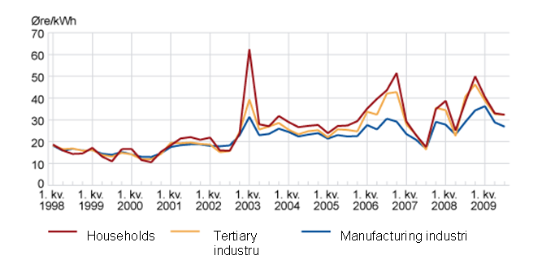
Figure 5.2 – Electric power prices in Norway (Source: Statistics Norway)
HP Steam
High pressure steam at 50 bar is produced in the process and used to heat exchange with the reboilers in the columns. The excess HP Steam is

3341 tonne/day HP Steam produced from heat associated with syngas stream
+ 1720 tonne/day HP Steam produced from heat associated with methanol reactor
- 1244 tonne/day HP Steam consumed by heat associated with column reboilers
= 3817 tonne/day HP Steam

Assuming a HP Steam price of 29,97 $/tonne (Turton, 2009) ≈ 167 NOK/tonne the earnings of selling HP steam is

3817 tonne/day x 360 days/year x 167 NOK/tonne = 229,48 MNOK/year

An alternative is that the HP steam can be used to generate power by expanding it through a turbine. Using UniSIM, expanding a mass flow rate of 3817 tonne/day HP Steam through a turbine, gives a duty of 29097 kW. Assuming a price on electric power of 0,30 NOK/kWh, the annual income becomes

29097 kW x 0,30 NOK/kWh x 24 x 360 h/year = 75,42 MNOK/year.

In this study it will be assumed that all the HP steam can be sold. This is of course dependent on the fact that there is a costumer that wants this amount of steam. Since the project basis is a methanol plant at Kollsnes, it is assumed that heat is needed for the process plant at Kollsnes, possibly in addition other industry in close proximity.

Cooling water
The cost of the cooling water is the cost of pumping the cooling water through the system, costs for water make-up and chemical treatment of the water. The power used in the recirculating cooling water system is assumed to be 0,40 kWh/m³ of circulating water (Sinnot, 2009).

Consumables cost
The consumables in the process are only the catalysts. The cost of the catalysts is dependent on the cost of the catalyst itself and the turnover number (number of molecules of substrate converted by one molecule of catalyst before the catalyst loses its activity) (Sell, 2003). In this study a catalyst cost of 80 NOK/L is assumed (O6). If the catalyst had contained noble metals this price would have been significant higher. A deactivation time of 4 years is assumed.

With a total volume of catalyst being 75,59 m³ and a lifetime of 4 years, the total annual catalyst costs become

75,59 m³ x 80000 NOK/m³ / 4 years = 1,51 MNOK/year

The other consumables discussed in Chapter 3.4 are not taken into consideration for the economical analysis.

Waste-water treatment costs
Since all the water from SEP-1 and COL-2 is reacycled, this cost is assumed to be zero.

Other variable operating costs
Other variable operating costs are (Peters, 2003):

- Operating supervision = 0,15 x Operating labour
- Maintainance and repairs = 0,06 x FCI
- Operating supplies = 0,15 x Maintenance & repair
- Laboratory charges = 0,15 x Operating labour
- Royalties = 0,01 x c_{o} (Total product cost without depreciation)

The costs are summarized in Table 5.6.

5.2.2 Fixed Operating Costs

Labour costs
The number of operators per shift, N, are

where p is the number of processing steps involving the handling of particulate solids and U is the number of main units in the process (Turton, 2009). p is zero and U is 14, and the number of operators is

The number of shifts is assumed to be 5 and the wage for each operator is assumed to be 300.000 NOK/year.

The total labour cost then becomes

Other fixed operating costs
Other fixed operating costs are (Peters, 2003):

- Taxes (property) = 0,02 x FCI
- Insurance = 0,01 x FCI

The costs are summarized in table 5.6.

In addition, plant overhead, administation, distribution & selling and research & development are taken into consideration. These costs are (Peters, 2003):

- Plant overhead = 0,6 x (labour, supervision and maintenance)
- Administration = 0,2 x (labour, supervision and maintenance)
- Distribution & selling = 0,05 x c_{o}
- Research and development = 0,04 x c_{o}

5.2.3 Summarizing operating costs

In Table 5.6 the operating costs are summarized.

Table 5.6 – Summarize of operating costs
Quantity | Annual cost (MNOK/year)
Raw materials | 1744,16
Operating labour | 4,63
Operating supervision | 0,694
Utilities | 58,418
Maintenance and repairs | 3,007
Operating supplies | 0,451
Laboratory charges | 0,694
Royalties | 20,225
Taxes (property) | 1,002
Insurance | 0,501
Plant overhead, general | 4,996
Administration | 1,665
Distribution & selling | 101,123
Research and development | 80,898
Total product cost w/o depreciation, c_{o} | 2022,459

6 INVESTMENT ANALYSIS

As the purpose of investing money in a chemical plant is to earn money, some means of evaluating the economic performance of the project is needed. This can be done by methods that not consider the time value of the money such as rate of return on investment, payback period, or the methods that consider the time value of money involving the discounted cash flow rate of return and net present worth. Cash flows diagrams can be nice tools to illustrate the performance of the project. The yielding investment at this project was analysed at a production rate of 2700 tonne/day, which corresponds to a yearly production rate of approximately 972 000 tonne methanol. The life time of the project was assumed to be 10 years. The depreciation for the plant is estimated to be at 20 percent. The tax to be payed to the government is assumed to be at 28%. The result from the different project performance parameters are shown in Table 6.1 below.

Table 6.1: Performance measurement of the investment.
Rate of return, ROR | 14,4 %
Pay-back period, PBP | 4,9 year
Net present worth, NPW | 670,07
Discounted cash flow rate of return, DCFRR | 21,70 %

6.1 RATE OF RETURN CALCULATIONS

Rate of return, ROR, is the of annual profit to investment, is a simple index of the performance of the money invested. This can be expressed as follows:

(6.1)
Where C_{cum} are the cummulative nat cash flow at the end of the project, N are life of the project, amd C₀ are the original investment in the project.

The rate of return on the methanol project was calculated to be 14,28 %. The minimum acceptable rate of return for a new capacity with established market position are suggested to be somewhere between 8-16% [Peters, 2003]. That means that the calculated rate of return, are inside the acceptable limit. This limit corresponds to the rate of earnings that must be achieved by an investment in order for it to be acceptable for an investor. Since the value of ROR is in the range that is considered to be among the minimum acceptable, the value might be a bit low. That corresponds to a somewhat low annual profit for the investment.

6.2 PAY-BACK PERIOD

Pay back time is another measure of performance of the capital invested. This profitability measure the length of the time nessesary for the total return to equal the capital investment. Figure 6.1 below shows the cash flow diagram for the methanol project.

Figure 6.1 – Cash flow diagram

The cash flow diagram shows the predicted cumulative net cash flow over the life of the project. The annual cash flow corresponds to the money that goes out minus the money that comes in, which means the differnce between the earnings and the expenditure. From the figure the pay back period can be estimated to 4,9 years.

6.3 TIME VALUE OF MONEY

The performance measurement present encounted so far does not take the time value of the money into account. Neverthless the money earned in the early year of the project is more valuable than that earned in later years. This value of money is accounted for by a discount factor. This factor should account for loss of interest, the inflaction as well as the risk connected to the project. In this project we assumed the yearly loss of rent to be 3%, while the annual inflation is assumed to be at 4%. Then the marginal return are at 7,1%, which correstponds to the minimum interest rate an investor can accept to invest in a project. If there are risks attached to the investment, the investor requires larger returns, and this have to be reflected in the discoun factor [Erikson, 2005]. For the methanol project the investment are relatively high, and the there are not accounted for any variation in the marked demand for the product. At the other side there are a well established merket for the product. The risk assosioted with the project can be assumed to be of average size and a risk premium is assumed to be at 6%. This means that the discount factor is estimated to be at 13%.

6.4 NET PRESENT WORTH
One method to evaluate the investment is the net present worth method. In this method the value of cash earned in the future are converted to the present value through the following equation:

(6.2)

Where i is the discount rate and CF₀ are the original investment, CF_{t} are the annual cash flow, and n are the life time of the project. A disadventage with this method is that it is sensitive to the interest rate assumed. By usind an interest rate at 13 %, the net present value over the life time of the project was calculated to be 660 MNOK, ergo a positive net present net worth of the project. A positive net present value means that the capital that is invested gives higher return than if it was not invested. Then there will be a risement of the fortune of the investors and the project should be realized [Erikson, 2005]. A question can be raised whether the assumed discounted rate are too low, considering the risk assosiated with the project. This will have a great influence to the net present worth, and can be considered as a weakness for the method.

6.5 DISCOUNTED CASH-FLOW RATE OF RETURN (DCFRR)

An alternative profitability measurement to the net present worth value is the discounted cash-flow rate of return. The obtained value gives us effective yield of the capital that at a given time is invested in a project. It is determinded as the interest rate at which the total NPW of the project is zero. The value of the discounted cash flow rate of return for the methanol plant was found to be 21,55 % and equals the maximum rate that the project could pay and still break even by the end of the project. If the DCFRR for a project are higher then the discount rate the project should be accepted, if else it shoud not. In our case, the discount rate or the required rate of retur was set to 13 %. This means that DCFRR gives a higher value than the discount rate, and the project should be accepted (Erikson, 2005).

6.6 SENSIBILITY ANALYSIS

To evaluate the robustness of the project a sensibility analysis is made. A sensibility analysis is a way of examining the effects of uncertainties assosiated with a project, by introducing alterations of ±10 per cent for the different variables considered. In the following section the economics of the methanol plant is evaluated at changes in the raw material costs, variation in product prices and variation in energy prices. The responding result is evaluated by the performance measurement evaluated for the methanol at the yielding production rate. The resulting values are shown in Table 6.4.

Table 6.2 – Performance of the project at different scenarios
Profitability measurement | At design conditions | Deviation in product prices +10 % |  | Deviation in raw material prices |  | Deviation in energy prices |  | Accounted for 10 % product loss
 |  | 10 % | -10 % | 10 % | -10 % | 10 % | -10 % | +10%
ROR [%] | 14,40 | 23,47 | 5,27 | 8,12 | 20,68 | 14,4 | 14,4 | 5,27
PBP [year] | 4,9 | 3,5 | 8 | 6,6 | 3,9 | 4,9 | 4,9 | 8
NPW [MNOK] | 670,07 | 1605,13 | -275,35 | 23,1 | 1316,95 | 670,03 | 670,03 | -275,35
DCFRR [%] | 21,7 | 32,58 | 9,05 | 13,32 | 29,33 | 21,7 | 21,7 | 9,05

From the performance metrics in Table 6.4 it is obvious that a 10 percent increase in the product price would lead to a considerable increase in the profit of the project. A negative NPW value and a DCFRR lower than the discount rate, indicate that the project should not be realized. Table 6.4 shows that a decrease by 10 percent in the product price or a 10 percent product loss would make the project unprofitable, considering the NPW values and the DCFRR. Further on the table indicate how the pay back time changes with the applied variations. This is also illustrated in the bar graph in Figure 6.4 below. A decrease in the pay back time would be preferable to the project. An increase in pay back time would lead to a longer periode without profit, which would not be preferable for the project. For the product, increase in the price would be desired, while the opposite is the case for an increase in the energy price or the raw material cost, which are payments for the project.

Figure 6.2 - Pay-back period as functions of ± 10 % deviation from design conditions in product prices, raw materials, energy prices and production loss.

From figure 6.2 it is obvious that deviation in the product price is the one of the parameters considered that has the greatest influence on the pay back time. This also indicates that the project has a great dependens on the obtained sale. A variation in the market demand will probably have a cathastrophical effect on the profitability on the project. The figure also tells that a 10 percent decrease in product prices would have a greater relative negative influence at the payback time than what the corresponding positive effect would be with a 10 percent increase. Further on, Figure 6.2 tells that the raw material also have a somewhat great influence at the pay back time. A decrease in the raw material prices, which means that the payment are decreased, would be profitable for the project, while a raise in the raw material prices would be of negative influence. An increase of 10 percent in the raw material prices will increase the payback time by 1,7 years, while a decrease 10 percent price decrease will lead to a pay back time that is one year less than what is the case at design conditions. Both Table 6.2 and Figure 6.2 shows that the energy prices are of less importance to the project compared to the other factors considered. This can be due to a somewhat small energy consumption of the process. The last column in Figure 7.1 figures the influence at the pay back time for a 10 % production loss. This leads to an increase in the pay back time of 0,37 year. Table 6.2 tells that the NPW are sensitive to production losses.

6.6.1 Worst case scenario of the methanol price

Based on historical costs of methanol a worst case scenario considering the cash flow diagram was abtained. The cost data for methanol are shown in Figure 7.2 below (I8).

Figure 6.3 - Methanol prices every quarter from 2001 to 2009. (I8)

Since methanol is the product in our case, the worst case scenario based on variation in the cost of methanol would be the lowest cost during the period. This scenario corresponds to a value of 1,25 NOK/kg methanol, compared to 2,45 NOK/kg that is the assumed price used in in the evaluation of the methanol project. Figure 6.4 and Table 6.3 below shows the responding change of of the profitability of the project in the worst case scenario for the methanol price.

Figure 6.4 – Cash flow diagram of the worst case scenario for the methanol price based on historical costs.

Table 6.3 – Performance measurement of the investment.
Rate of return, ROR | -41,30124866
Pay-back period, PBP | -
Net present worth, NPW | -5706,7
Discounted cash flow rate of return, DCFRR | -

From Figure 7.2 and Table 7.3 it is obvious that the worst case scenario for the methanol price would be ruinous for the project. The project will never start earning money, and no annual cash flow would be positiv.

6.6.2 Worst case scenario of the raw product price

The robustness of the process toward changes in prices of raw material were considered based on cost data for natural gas during the period from 2000 given in Figure 6.5.

Figure 6.5 – Natural gas prices from 2000 until 2009 and estimated until 2014. (I8)

A high price for the raw material would be of negative characther for the methanol production. The highest price for natural gas is predicted to be around 2010, then the price is estimated to be 2,32 NOK/Sm³, compared to a value of 1,40 NOK/Sm³ that was used in the primary analysis of the methanol plant. This value of 4,90 NOK/Sm³ was used to estimate a worst case scenario according to price changes in natural gas. Figure 6.5 shows the cash flow diagram assosiated with the worst case scenario of the variation in the natural gas prices.

Figure 6.6 – the responding of the cash flow at the worst case scenario assosiated with the raw material prices.

Figure 6.6 shows that the worst case scenario for the material prices, in the same way as for the worst case scenario for the product prices, would be deterious to the project. The annual cash flows do never start to be positve.

6.6.3 Variation in energy prices

The sensitivity analysis in section 7.1 compared the profitability of a ±10 percent variation in the electricity, raw material and product prices for the methanol plant. From this consideration the prices of the electricity seemed to be of litle importance to the performance of the project. To do a closer examination of the imfluence of the electricity prices to the profitability of the project a worst case analysis were performed. Since the process has to buy electricity, a low energy price would be preferable. The analysis was done based on average prices of energy in Norway from 1998 to 2009. The prices during this period are shown in Figure 6.7

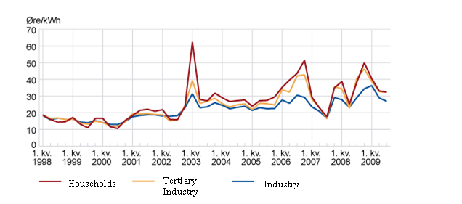
Figure 6.7 – Average electricity prices from 1998 to 2009 (I6).

The highest price for electricity over the period was in 2003. At this time the cost per kWh electricity was at a value of 60 NOK/kWh. This value is used in the worst case scenario to evaluate the sensitivity of variation in energy prices for the methanol process. Figure 6.8 as well as Table 6.4 below presents the profitability of the project at the worst case scenario for the energy price.

Figure 6.8 – Cash flow diagram of the worst case scenario for the methanol price based on historical costs

Table 6.4: Performance measurement of the investmen at the worst scenario for the prices of energy..
Rate of return, ROR | 5,27
Pay-back period, PBP | 8
Net present worth, NPW | -275
Discounted cash flow rate of return, DCFRR | 9,05

From both Figure 6.8 and Table 6.4 it is obvious that at its worst case scenario, the prices of the electricity are of considerable influence to the project. Compared to the design conditions all the performance variables show a relatively large degree of poorer profitability at this scenario. The increase in pay back time is 3,1 year.

6.6.4 CO₂ expences – a question in the future

Lately the CO₂-emission as well as emission of other greenhouse gasses from a contantly growing industraly has gained much attention in the international politics. Prognosis indicates that the climate is in change, and it is generally accepted that the emission of greenhouse gasses must take some of the responsibilty. This has leaded to that the industri have to pay CO₂ expences for the CO₂-emission. Today the CO₂-emission limit for a industrial plant are at a value of 338 000 tonn/year (Source: Mail Tjeldbergodden). The CO₂-balance of the methanol plant shows that the annual net emission from the plant are 314 265 tonn/y, which is under the payment limit. This means that one have to pay for the emission of CO₂ from our plant. It is reasonable to believ that this policity are going to change in the future. Therfore a sensivity analysis is performed to see the effect of a possible CO₂-expense payed for each tonn of discharged CO₂. In the analysis the CO₂ expenses was assumed to be 800 NOK/tonn CO₂ discharged. Figure 6.8 as well as Table 6.5 below shows the response of the profitability of the project at the scenario in question.

Figure 6.8 – Cash flow diagram when the CO₂-expenses are assumed to be 160 NOK/tonn per tonn disharged

Table 6.5 – Performance measurement of the investmen when CO₂-expences have to be payed.
Rate of return, ROR [%] | 3,04
Pay-back period, PBP [year] | 9,2 year
Net present worth, NPW [MNOK] | -512
DCFRR [%] | 5,43

From Figure 6.8 the pay back period can be estimated to be around 9,2 years, this corresponds to an increase of 4,3 compared to the normal case. Table 6.5 shows that all the profitability measurement shows poorer performance. At this scenario the value of DCFRR equals 5,43%. This is less than the discount rate at 13 %, which means that the project should not be realized. The value of NPW is less than zero. This amlify the suggestion about that the project should be rejected at this scenario (Erikson, 2005).

6.6.5 Summary of sensitivity analysis

The sensitivity analysis indicated that the performance of the project is sensitive to alterations in product prices and raw material. The largest influence was found for alterations in the product price, where a 10 percent increase result in a DCFRR from 21,7% to 32,58 %, while a 10 percent decrease made the DCFRR to be as low as 9 % which is lower than the discount rate of the project. The worst case scenario of the product prices and the raw material figured deterious effect on the project performance. The energy prices seemed to be of less importance. A change of ±10% in the energy prices was hardly noticed. Neverthless the worst case scenario of the energy prices showed a relatively large influence of the project profitability.

7 CONCLUSIONS AND RECOMMENDATIONS

The methanol plant described in this report was able to produce methanol of the specified purity (AA grade) and amount of product. The original idea was to design a simple, non-conventional methanol plant consuming more CO₂ than released. However, this was not possible without the installation of a CO₂ capturing plant. Flue gas was the main CO₂ source in the plant. The heat load in the steam reformer was higher than initially anticipated. Thus, the amount of flue gas became larger and therefore also the CO₂ emissions increased.

Total carbon conversion was low compared to other technologies. Similarly, the carbon conversion per pass was lower as well. This was probably mainly because of low conversion of methane to synthesis gas.

The payback time of the investment was found to be 4.9 years. Both the measure of NPW and the value of DCFRR indicated that the project would be profitable. Further on the rate of return was calculated to be 14,28 %. The sensitivity analysis indicated that the performance of the project is sensitive to alterations in product prices and raw material. The largest influence was found for alterations in the product price. The worst case scenario of the product prices and the raw material figured deterious effect on the project performance. The energy prices seemed to be of less importance. A change of ±10% in the energy prices was hardly noticed. Neverthless the worst case scenario of the energy prices showed a relatively large influence of the project profitability.

The main problem is the low carbon conversion compared to other technologies. Our recommendations are to try to increase the conversion in the reformer section, thereby reducing the amount of non-reactive components in the synthesis loop. Savings in the capital investment, stable marked price and demand, and the increasing demand for CO₂ free solutions, could make this technology feasible if the conversion of methane in the reformer section were to be increased

SYMBOL LIST

Symbol | Unit | Description
∆H_{r} | kJ/mol | Heat of reaction
∆H_{vap} | kJ/kg | Mass heat of vaporization
°C | °C | Temperature in celsius
K | K | Temperature in kelvin
c_{p} | kJ/kg°C | Spesific heat capacity
J | Nm | Energy
W | J/s | Watt
t | 1000 kg | Mass, tonne
v | m/s | Fluid velocity
V | m³ | Volume
A | m² | Area
M | kg | Mass
g | 0,001 kg | Gram
E | J | Energy
kWh | J | Energy
M | - | Mega
G | - | Giga
K | - | Kilo
Q | J/s | Heat energy
U | W/m²K | Overall heat transfer coefficient
Pa | N/m² | Pressure, Pascal
k | mol^{1-n}L^{n-1}s⁻¹(n^{th} order) | Reaction rate constant

REFERENCES

Text Books and Scientific Papers

Aasberg-Petersen, K., Hansen., J.-K.B., Christensen, T.S., Dybkjaer, I., Christensen, P. S., Nielsen, C. S., Madsen, S. E. L. W. and Rostrup-Nielsen, J.R.: Technologies for large-scale gas conversion. Applied Catalysis A: General, 221, 379-387, 2001

Bussche, K.M.V. and Froment, G. F.: A Steady-State Kinetic Model for Methanol Synthesis and the Water Gas Shift Reaction on a Commercial Cu/ZnO/Al₂O₃ Catalyst. Journal of Catalysis, 161, 1-10, 1996

Chang, C.-H. and Tsai, W.-T.: “Carburization behavior under the pits induced by metal dusting in
304L and 347 stainless steels”, Department of Materials Engineering and Science, National Cheng Kung University, Taiwan, 2008

Erikson, T., “Teknologiledelse, Økonomiske betraktninger”, Gyldendal Norsk Forlag AS, Oslo, 2005.

Hohmann, E.C.: “Optimum Networks for Heat Exchange”, Ph.D. Thesis, University of Southern California,1971

Lee, C.-J., Youngsub, L. Kim, H.S. and Han C.: Optimal Gas-To-Liquid Product Selection from Natural Gas under Uncertain Price Scenerios. Ind. Eng. Chem. Res., 48, 794-800, 2009

Lee, S.: Methane and its Derivatives, Marcel Dekker Inc., New York, 1997

Linnhoff, B and Hindmarsh, E: “The Pinch Design Method for Heat Exchanger Networks”, 38,5 , 745-763, 1983

Lødeng, R.: “A Kinetic Model for Methane Directly to Methanol”, Ph.D. Thesis, NTNU, 1991

Meyers, R.A.: “Handbook of Petrochemicals Production Processes”, RR Donneley, USA, 2005

Olah, G.A., Goeppert, A. and Prakash, G.K.: Beyond Oil and Gas: The Methanol Economy, Wiley-VCH, Darmstad, 2006

Peters, M.S., Timmerhaus, K.D. and West, RE.: Plant Design and Economics for Chemical Engineers”, 5th ed., McGraw-Hill, New York, 2003

Sell, C.S.: “A Fragnant Introduction to Terpenoid Chemistry”, TJ International Ltd, Cornwall, 2003

Sinnot, R. and Towler, G.: Chemical Engineering Design, 5th ed., Elsevier Ltd., UK, 2009

Skogestad, S.: “Prosessteknikk, Masse- og energibalanser”, 2nd ed., Tapir Akademisk Forlag, Trondheim, 2003

Smith, R.: “Chemical Process Design and Integration”, John Wiley and Sons Ltd., Chippenham, 2005

Tijm, P.J.A., Waller, F. J. and Brown, D.M.: Methanol technology developments for the new millnium. Applied Catalysis A: General, 221, 275-282, 2001

Trimm, D.L. and Wainwright, M.S.: “Steam Reforming and Methanol Synthesis”, Catalysis today, 6, 261-278, 1996

Turton, R., Bailie, R.C., Whiting, W.B. and Shaeiwitz, J.A.: “Analysis, Synthesis, and Design of Chemical Processes”, Prentice Hall, Massachusetts, 2009

Weissermel, K. and Arpe, H.-J.: Industrial Organic Chemistry, 4th ed., Wiley-VCH, Darmstad, 2003

"Carburization behavior under the pits induced by metal dusting in
304L and 347 stainless steels"
Chia-Hao Chang,Wen-Ta Tsai

Internet Adresses

(I1) http://www.uhde.eu/archive/upload/uhde_brochures_pdf_en_6.00.pdf
(I2) http://chemelab.ucsd.edu/methanol/memos/ZSM-5.html
(I3) http://www.lurgi.com/website/fileadmin/pdfs/brochures/Br_MegaMethanol.pdf
(I4) http://www.statoil.com/en/OurOperations/TradingProducts/Methanol/Pages/default.aspx
(I5) http://www.statoil.com/en/InvestorCentre/AnalyticalInformation/InternalGasPrice/Pages/default.aspx
(I6) http://www.ssb.no/emner/10/08/10/elkraftpris/
(I7) http://maps.google.com/
(I8) http://www.ineosparaform.com/55-Methanol_price.htm

(IA1) http://people.clarkson.edu/~wilcox/Design/heurist.pdf

Other References

(O1) Slides fra Tjeldbergodden
(O2) E-mail from Nina Enaasen (O&M in Statoil ASA, Tjeldbergodden), 14.11.2009
(O3) E-mail from Margrete Hånes Wesenberg (Principal Researcher in Statoil ASA, Rotvoll), 13.11.2009
(O4) Personal conversation with supervisors
(O5) E-mail from Peter Aardal (Senior Engineer in Statoil ASA, Kollsnes), 14.11.2009
(O6) Lecture notes from TKP4165 Prosessutforming (Spring 2008): “E_Driftskostnader[1].pdf”
(O7) Guest lecture TPK4120 Prosessteknikk, NTN: ”Methanol and synthesis gas produtcion at the Tjeldbergodden methanol plant”, Margrete Hånes Wesenberg, October 30, 2009

