Helge Smedsrud

DYNAMIC MODEL AND CONTROL OF HEAT EXCHANGER NETWORKS

5th YEAR PROJECT WORK
FALL 2007



Norwegian University of Science and Technology
Department of Chemical Engineering

Abstract

The task of this project has been to model and control the heat exchanger network at Brobekk waste incineration plant in Oslo, which is run by the City of Oslo’s Waste Recycling Department. The plant sells their produced energy to Viken Fjernvarme AS, a company which runs a district heating network in Oslo city. The two furnaces at Brobekk are capable of producing 32 MW of energy combined, yet at certain periods of the day, typically in the morning and in the late afternoon, Viken’s energy demand is greater than this. When this happens, Viken has to use its own gas and electrically operated heaters as well, in order to achieve the necessary temperature.

The problem is that during these peak loads Viken also tends to take out more energy than just 32 MW from the Brobekk plant, leading to the latter being temporarily cooled down. This is rather critical, since the flows that return to the furnaces have very strict temperature demands due to the risk of acids in the flue gas condensing on the pipes. The solution seems to be to reduce the flow on the secondary side of the heat exchangers, so that less energy is taken out. However, by doing so we also increase the pressure drop across the heat exchangers, only leading to Viken’s pumps working harder and, thus, maintaining the flow.

The activities of the project have been to understand the current control structure, investigate the feasibility of the plant, and, finally, create a dynamic Simulink model of the entire plant. The control structure implemented in the model successfully manages to control the furnace return temperatures, but does not control the temperature in the flow towards Viken quite well enough.

Acknowledgements

The following people deserve thanks for valuable help during the course of the project:

Johannes Jäschke, co-supervisor and Ph.D. student at NTNU, for valuable help and discussions, and for lending me his 10-cell Simulink heat exchanger and cooling unit models

Helge Mordt, senior consultant at Prediktor AS, for information and discussions concerning the Brobekk plant

Sigurd Skogestad, supervisor and professor at NTNU, for discussions concerning the controller tuning

Shridharakumar Narasimhan, post-doctoral research fellow at NTNU, for help with early project activities

Contents

1 Introduction 6
2 Background 6
2.1 Heat exchangers 6
2.1.1 Steady-state energy balance 6
2.1.2 Dynamic multi-cell heat exchanger model 8
2.2 The Brobekk plant and its control structure 9
2.2.1 The Brobekk side 11
2.2.2 The Viken side 12
2.2.3 Security mechanisms 14
2.2.4 Current issues 14
2.2.5 Degree of freedom analysis 17
3 MATLAB calculations on the Brobekk plant 17
3.1 Simulation of a heat exchanger using the fsolve routine 17
4 Modeling and control in Simulink 20
4.1 Creating a dynamic model of the plant 20
4.2 Controller tuning 21
4.2.1 Linearization of the model 21
4.2.2 Calculation of tuning parameters 24
5 Simulations 25
6 Discussion 30
6.1 The Brobekk plant and its current issues 30
6.2 The Simulink model 30
6.3 Controller tuning 30
6.4 Simulations 31
7 Conclusion 32
References 34
Appendix 35
A Symbols and abbreviations 35
A.1 Symbols 35
A.2 Abbreviations 37
B Flow sheets of the Brobekk plant 38
B.1 Overview of the Brobekk plant and the Viken side control structure 38
B.2 The control structure on the Brobekk side 39
B.3 The control structure on the Viken side 40
B.4 Modified control structure on the Brobekk side 41
B.5 Modified control structure on the Viken side 42
C Structure of the Simulink model 43
C.1 Splitter units 43
C.2 Mixer units 44
C.3 Heat exchanger and cooling units 45
D Step responses 47
E Overview of constraints and operational parameters at Brobekk 50

1 Introduction

At the Brobekk incineration plant in Oslo waste from the surrounding area is burned in two furnaces. The resulting energy is used to heat pressurized water, which is in turn heat exchanged with cold water from a district heating network operated by Viken Fjernvarme AS. To avoid corrosion on the pipes in the furnaces it is crucial to keep the return temperature of the hot water under tight control. This is possible through the use of either a hot water bypass or an air cooler, depending on how much energy Viken takes. On the secondary side – if the temperature gets too high – cold water may be added through a bypass.

A crucial aspect of the plant is the water flow through the secondary side of the heat exchangers. Reducing this leads to less heat transfer, and vice versa. However, experience has shown that controlling this flow is not an easy task, and subsequently this may cause the Brobekk plant to get temporarily cooled down, i.e. the furnace return temperature gets lower than its nominal value. This usually happens in the morning and late afternoon, where Viken has an increased demand of hot water.

Today the control structure is divided between Energigjenvinningsetaten (EGE), which is the owner of the Brobekk plant, and Viken Fjernvarme AS, in such that they each control their respective side of the heat exchangers. Intuitively, this does not seem like an ideal way to design the control structure, and it would therefore be advisable to let one of the parties operate the entire control structure.

In the following we will look briefly at basic energy calculations for heat exchangers, as well as how heat exchangers can be modeled. Afterwards the control structure at Brobekk will be presented in detail, and we will also discuss the plant’s degrees of freedom. In the end we look into how the plant was modeled in Simulink, how the controller tuning parameters were obtained, and, finally, how the control structure responds to disturbances.

2 Background

2.1 Heat exchangers

2.1.1 Steady-state energy balance

For an adiabatic heat exchanger one can set up the following energy balance:

(2.1)

where Q is heat duty; superscripts h and c indicate hot and cold side, respectively; mass flow rate; c_{p} specific heat capacity; U overall heat transfer coefficient; A heat exchange area; and F a correction factor related to the flow effectiveness of the heat exchanger.
For a shell and tube heat exchanger with one tube, the overall heat transfer coefficient can be calculated as below, assuming that the wall thickness of the tube is so small that the inner and outer tube areas are almost equal:

(2.2)

Here, h is heat transfer coefficient; k thermal conductivity; and Δr tube thickness. If the tube thickness is made even smaller (i.e. vanishingly small), or if there is a very low heat resistance in the tube wall (i.e. k is large), then Eq. (2.2) may be rewritten as

(2.3)

Eqs. (2.2) and (2.3) are valid only for ideal conditions and must usually be modified in order to account for fouling (e.g., salt precipitation, metal oxidation) of the tube [Couper et al., 2005]:

(2.4)

where R_{f} is a combined fouling factor for the internal and external surface of the tube.

The overall temperature driving force of the heat exchanger, ΔT_{HE}, depends on flow configuration, and is for a counter-flow heat exchanger expressed as

(2.5)

where the subscripts i and o represent inlets and outlets, respectively. The correction factor F is dependent on flow configuration as well, and is found from a nomogram after first calculating two temperature factors, P and R. For a counter-flow shell-and-tube heat exchanger with one shell (hot side) pass and two tube (cold side) passes these are defined as [Skogestad, 2003]:

(2.6)

(2.7)

where the subscripts t and s represent tube and shell side, respectively. These factors are then used in combination with a suited nomogram; see e.g. [Kays and London, 1984], to find the correction factor.

2.1.2 Dynamic multi-cell heat exchanger model

In multi-cell or lumped compartment models the heat exchanger is modeled as N ideally mixed interconnected tanks, as shown in Fig. 2.1. Mathematically, these models are very simple, yet at the same time they closely resemble a real shell-and-tube heat exchanger with baffles.

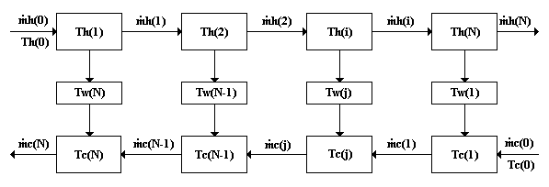

Figure 2.1 Cell model of a heat exchanger. Fluid temperatures, wall temperatures, and fluid pressures are state variables. Flow rates are computed from pressure drops. After [Mathisen et al., 1993].

In such models, distributed model behavior may be achieved by using a large number of cells (i.e. a pure lumped model), preferably at least equal to the number of baffles (N_{B}) plus one, or by using the logarithmic mean temperature difference (LMTD) as the temperature driving force (i.e. a hybrid model). Table 2.1 presents the recommendations by Mathisen et al. [Mathisen et al., 1993] regarding the cell number in these models.

Table 2.1 Recommended number of cells in models of shell-and-tube heat exchangers.
N_{B} is the number of baffles; N_{P} is the number of tube passes.
 | Min. from steady-state | Min. from dynamics | Max.
Pure lumped model | N_{TU} | 2 | (N_{B} + 1)N_{P}
Hybrid model | 1 | 3 | (N_{B} + 1)N_{P}

In addition to ideal mixing assumptions it is customary to assume negligible heat loss, constant heat capacity, and an even distribution of heat exchange area A and volume V across the N cells. For liquid heat exchangers fluid densities are also assumed constant, while pressure drop is neglected. For gas heat exchangers the densities could be computed from ideal gas law, and flow rates from pressure drop. Below are presented the resulting ordinary differential equations (ODEs) for a liquid heat exchanger with wall capacitance. For a complete derivation the reader is referred to Mathisen et al.

(2.8)
(2.9)
(2.10)

All symbols are explained in App. A.1.

2.2 The Brobekk plant and its control structure

The Brobekk plant (Fig. 2.2) operates with several constraints related to temperature and flow rate, and which will be discussed in detail below. The flow rate on the primary side of each line (i.e. the Brobekk side) is maintained at 250 t/h and the pressure at 15 bar, while the flow rate through the hot water bypasses should not exceed 80 t/h each. It is also important that the temperatures out of the furnaces do not get higher than 180 °C because of the risk of boiling in the pipes. This may happen if the furnace inlet temperature goes above 126 °C.

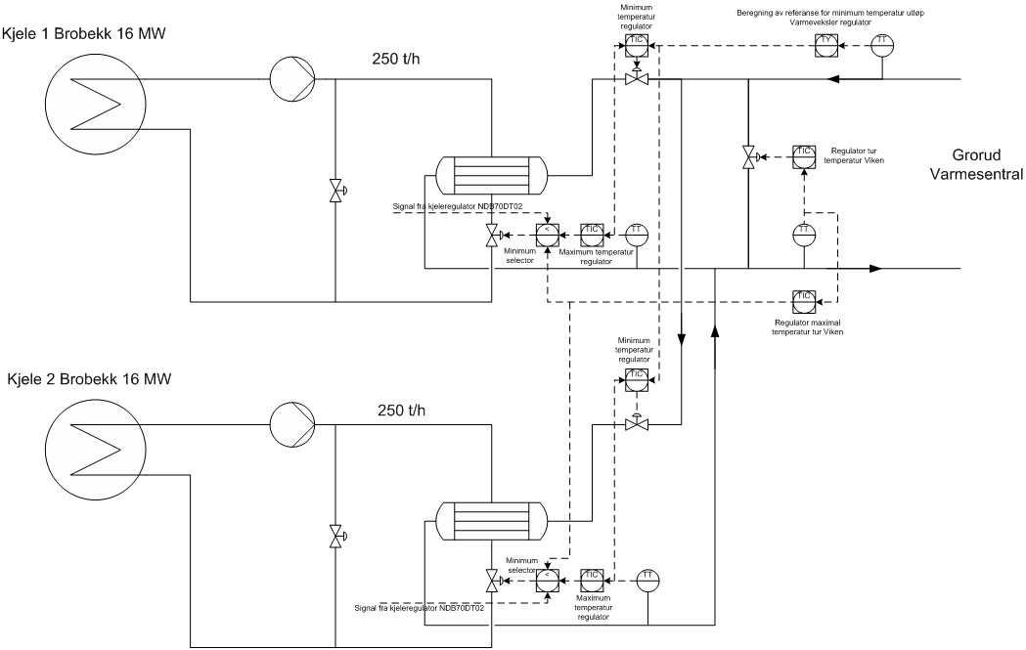

Figure 2.2 Overview of the Brobekk plant, showing its two heat exchanger lines, as well as the Viken side control structure (Grorud Varmesentral). From [Mordt, 2007]. A higher resolution version is given in App. B.1.

There are also some limitations regarding valve openings: In order to minimize pump resistance the heat exchanger primary side valves must always be at least 55 % open. Also, the two secondary side inlet valves must be at least 22-25 % open due to the risk of boiling at low flow rate. There is also a limitation in the cold water bypass of 540-600 t/h. For a complete list of limitations and operational parameters, the reader is referred to App. E.

The control structure at Brobekk (including the Viken side) consists of numerous PI and PID controllers, some of which use split-range control. Also, it features some logic in the form of maximum and minimum signal selectors. It serves the following five purposes [Mordt, 2007]:

- to maintain a constant temperature in the flows towards the furnaces
- to limit the heat duty exchanged with Viken
- to maintain a constant temperature in the flow towards Viken
- to maintain a constant flow in the Brobekk cycles
- to limit the outlet temperature on the secondary side of the heat exchangers

The main idea, and challenge, of the current control structure is that one wants to have a constant heat transfer of 16 MW per heat exchanger line regardless of the inlet temperature on the secondary side, and with both primary side temperatures fixed. This is equal to keeping ΔT_{LM} in Eq. (2.5) constant, which is possible by altering the secondary side outlet temperature. This temperature may in turn be altered by varying the flow rate through the secondary side. However, for instance throttling the valve for this flow (e.g., valve V-2 in Fig. 2.3) leads to an increased pressure drop across the heat exchanger, which is in turn quickly combated by the Viken pumps increasing their rotational speed. Thus the flow rate is maintained.

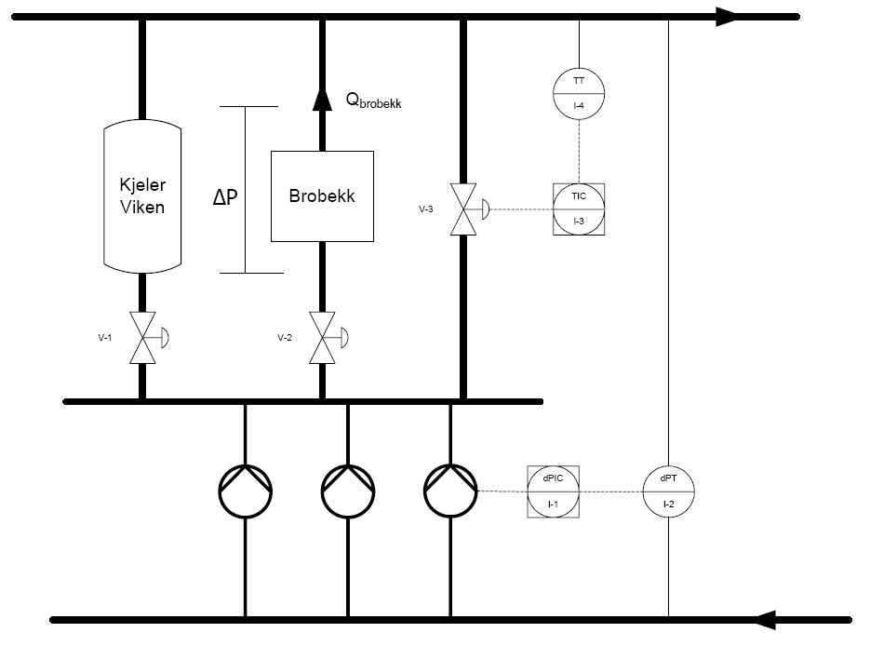

Figure 2.3 A part of the Viken side control structure with pumps and furnaces, as well as the heat exchangers at Brobekk. From [Mordt, 2007].

2.2.1 The Brobekk side

Table 2.2 shows the three different Brobekk side temperature controllers and their controlled and manipulated variables (CVs and MVs). The reader should note that there are a total of six controllers divided between the two heat exchanger lines. The table is meant to give a summary of the flow sheet in Fig. 2.4. In the section after the table the control structure is described in closer detail.

Table 2.2 Overview of the Brobekk side temperature controllers [Mordt, 2007].
Controller | Controlled variable | Manipulated variable(s) | Physical meaning
NDB40DT1 | NDB40CT1 | M | cooling unit fan speed
NDB70DT1ª | NDB70CT1 | NDA35AA2 | hot water bypass valve
NDB70DT1ª | NDB70CT1 | NDB30AA3 | heat exchanger p.s. valve
NDB70DT2 | NDB70CT1 | NDB30AA3 | heat exchanger p.s. valve
NDB70DT2 | NDB70CT1 | NDB40AA3 | cooling unit valve
a) These two controllers are the only PID controllers; all others are PI.

Controller NDB40DT1 controls the temperature in the flow after the cooling unit by adjusting the speed of the cooling fan (M). This controller uses a sort of feedforward control called decoupling: The fan speed is dependent on the sum of the output from the controller, as well as the opening in valve NDB40AA3, which governs the water flow through the cooling unit. The strategy behind this decision is that an increase in valve opening would imply an increased need for cooled water towards the furnace, which in turn can be handled by increasing the fan speed and removing more heat. The set point for NDB40DT1 is calculated as a function of the opening in valve NDB40AA3, the total flow, and the set point for the temperature in the flow towards the furnace:

where _{HE} is mass flow rate through the primary side of the heat exchanger; and _{CU} is the mass flow rate through the primary side of the cooling unit.

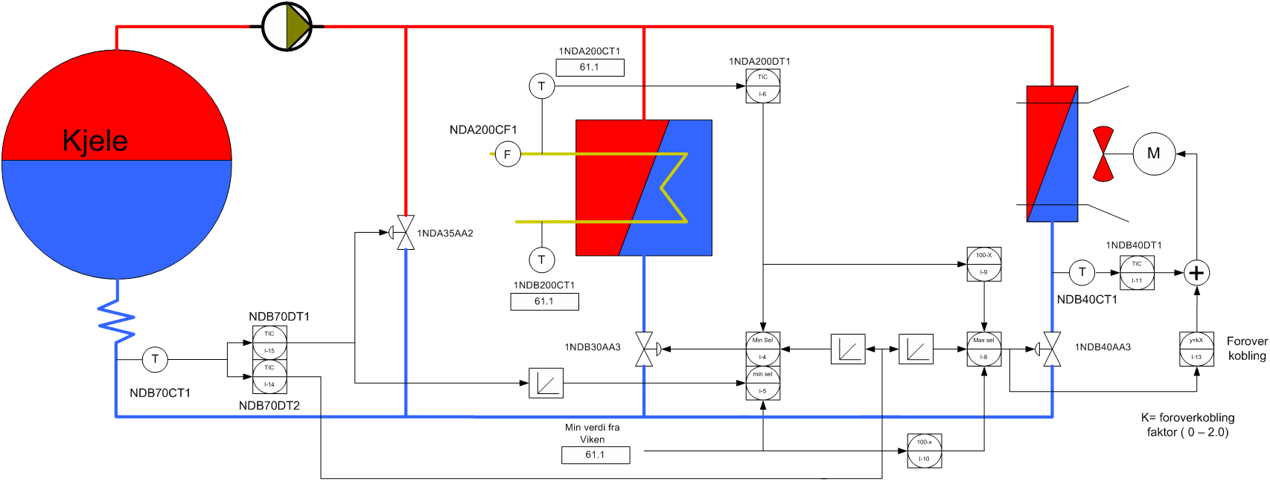

Figure 2.4 Flow sheet of the control structure on the Brobekk side of the Brobekk plant. From [Mordt, 2007].
A higher resolution version is given in App. B.2.
The second and third controllers, NDB70DT1 and NDB70DT2, share the same goal, namely to maintain the temperature in the flow entering the furnace at 126 °C. If the inlet temperature on the secondary side of the heat exchanger would drop, or if the flow from Viken increases, the outlet temperature on the primary side of the heat exchanger will drop. In order to compensate for this, controller NDB70DT1 starts opening valve NDA35AA2 – which governs the hot water bypass – and starts closing valve NDB30AA3, which governs the primary side flow in the heat exchanger. Similarly, if the flow from Viken decreases or the secondary side inlet temperature increases, the primary side outlet temperature will also increase. In order to prevent this disturbance from affecting the temperature in the flow entering the furnace, controller NDB70DT2 starts closing valve NDB30AA3 and simultaneously opens NDB40AA3 equivalently much. The temperature in the primary side outlet flow should be kept at 126 °C, but may go as low as 110 °C if hot water is subsequently added through the bypass.

From what has been discussed so far it is clear that the plant may experience either of three operational cases:

- Viken requires too much heat, which leads to the plant being cooled down. This may for instance happen if Viken wants a ΔT of 28 °C (i.e. from minimum inlet temperature to minimum outlet temperature) or more at a flow rate of more than 973,8 t/h.

- Viken requires exactly the 32 MW of heat Brobekk can deliver. This happens with a flow rate of exactly 973,8 t/h and a ΔT of 28 °C.

- Viken requires too little heat, which leads to the plant being heated. This is however not a problem, since any excess heat is simply removed in the cooling units. For the example above this happens with a flow rate of less than 973,8 t/h.

2.2.2 The Viken side

On the secondary side of the heat exchangers there are a total of eight temperature controllers divided between the two heat exchanger lines. Controllers from one of the two lines, as well as shared controllers, are presented in the table below. Controller NDA200DT1 is governed by EGE, while the others are governed by Viken. A flow sheet of this control structure is shown in Fig. 2.5.

Table 2.3 Overview of the Viken side temperature controllers [Mordt, 2007].
Controller | Controlled variable | Manipulated variable(s) | Physical meaning
NDA200DT1 | NDA200CT1 | NDB30AA3 | heat exchanger p.s. valve
NDA200DT1 | NDA200CT1 | NDB40AA3 | cooling unit valve
TC66A | TT66 | NDB200AA1 | cold inlet valve
TC66B | TT66 | NDB30AA3 | heat exchanger p.s. valve
TC66B | TT66 | NDB40AA3 | cooling unit valve
TC68A^{b} | TT68 | NDB100AA1 | cold water bypass valve
TC68B^{b} | TT68 | NDB30AA3 | heat exchanger p.s. valve
TC68B^{b} | TT68 | NDB40AA3 | cooling unit valve
b) Controllers shared by the two heat exchanger lines.

Controller NDA200DT1 controls the outlet temperature on the secondary side of the heat exchanger by manipulating the valve on the primary side of the heat exchanger and the valve after the cooling unit, simultaneously. If valve NDB30AA3 closes by a certain amount, then valve NDB40AA3 opens equivalently much, and vice versa. The set point for NDA200DT1 should be approximately 5 °C higher than the set point for TC66A/TC67A (see below).

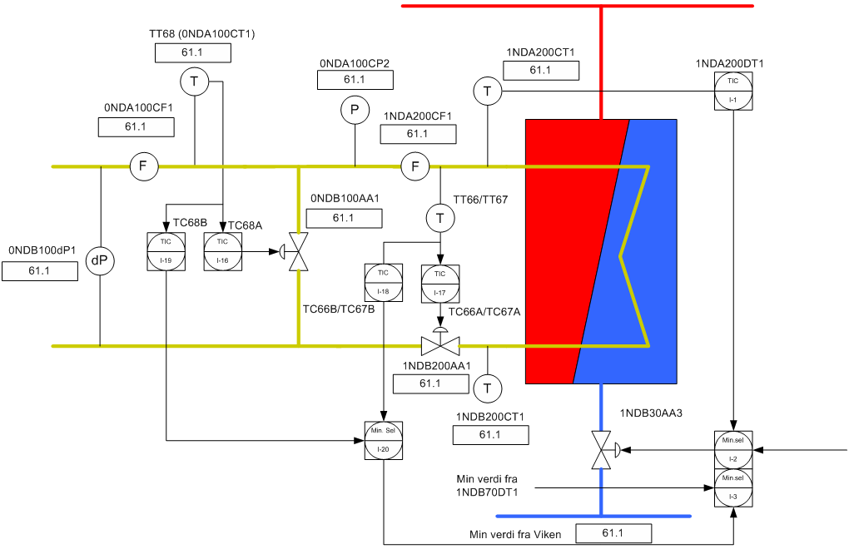

Figure 2.5 Flow sheet of the control structure on the Viken side of the Brobekk plant. From [Mordt, 2007].
A higher resolution version is given in App. B.3.

TC66A/TC67A is tasked with controlling the minimum temperature on the secondary side of the heat exchanger by manipulating the secondary side inflow through valve NDB200AA1. This controller’s reference is calculated from the secondary side inlet temperature with the intention of keeping ΔT_{LM} constant at 40 °C.

TC66B/TC67B controls the maximum temperature on the secondary side of the heat exchanger by manipulating the heat exchanger valve NDB30AA3 and cooling unit valve NDB40AA3, simultaneously. Since this controller functions in the same way as NDA200DT1, we get a duplicate control function for the secondary side outlet maximum temperature. The set point for TC66B/TC67B should obviously be the same as for NDA200DT1.

Controller TC68A controls the minimum temperature in the flow towards Viken, and manipulates the cold water bypass valve if the temperature is higher than a set point dictated by Viken’s system control center. Controller TC68B controls the same temperature, but this controller’s task is to control the maximum temperature in the flow. Because of this, its set point is 5-8 °C higher than that of controller TC68A. TC68B can manipulate valves NDB30AA3 and NDB40AA3.

2.2.3 Security mechanisms

On Viken’s side several trip functions have been implemented in the PLCs (programmable logic controllers) as a security precaution. These include [Mordt, 2007]:

- high temperature after heat exchanger 1
- high temperature after heat exchanger 2
- high temperature towards Viken
- low pressure after heat exchanger 1
- low pressure after heat exchanger 2
- low flow from Viken

In any of these situations, valve NDB30AA3 will shut completely and valve NDB40AA3 open completely, i.e. all produced energy will be removed in the cooling units. The limit for the high temperature is set to 150 °C. The reason for this is the risk of thermal tension in the pipes causing fissures. The low pressure and low flow limits are both implemented due to the risk of boiling, and thus a risk of bending in the pipes.

2.2.4 Current issues

According to Mordt [Mordt, 2007] the current issue is that Viken, in certain periods of the day, requests more energy than Brobekk can deliver. As mentioned earlier, this typically happens between 6:30 and 8:30 AM, and between 15:30 and 16:30 PM. During these periods the Brobekk plant tends to get cooled down, i.e. Viken takes both the 32 MW of produced energy and also some of the remaining energy in the hot water flow. This makes Brobekk temporarily unable to maintain the desired furnace inlet temperature of 126 °C. This is, of course, only a transient effect; the rest of the day and night Brobekk is able to operate within its desired limits. If Brobekk is not able to raise the temperature in the cold water flow sufficiently Viken use their own electric and gas operated heaters to supply the remaining heat. Fig. 2.6 shows the maximum flow rate of cold water as a function of cold water temperature increase for three different Brobekk furnace scenarios. Feasible operation points are located below the curves.

Figure 2.6 Maximum cold water flow rate as a function of cold water temperature increase. See also Fig. 2.8.

A novel solution to this problem could be to temporarily utilize the heat capacity in the water and pipes at Brobekk. This could be achieved by increasing the hot water temperature, say, ten degrees during the morning and afternoon. The mass of water in each of the lines at Brobekk is between 30 and 35 metric tons, and for now we assume the latter. Under the assumption that we have a total of 200 m of steel pipe, as well as two steel heat exchangers of 2035 kg each [Mordt, 2007] we find that this equals 3080 MJ. Per hour this is roughly equal to 0,86 MW, which is only slightly more than 5 % of what Brobekk normally delivers. Judging from the current situation, this is not enough to meet Viken’s demands. In this calculation the heat capacity in the metal in the two air coolers has been neglected, but this contribution would most likely be smaller than the one from the main heat exchangers. These are of course neither in use when Viken takes all the produced energy, and could thus be considered not being a part of the system. Regarding these calculations, a final comment should be added: This idea assumes that it is both possible and safe to increase the hot water temperature to 190 °C. As has been discussed, due to the boiling risk, this may not be true.

In Fig. 2.7 we see how much energy is needed to heat a flow with a temperature of 62 °C and a certain flow rate to various temperatures. This figure can thus be used to see how much short Brobekk is in energy for varying conditions on the Viken side.

Figure 2.7 Heat required by Viken as a function of flow rate at constant T^{c}_{in} and varying T^{c}_{out}.
The cyan line represents the 32 MW capacity limit at Brobekk.

As an example, if the cold water flow rate is, say, 1100 t/h and the temperature 62 °C, then it takes about 36,1 MW to heat this flow to 90 °C. This makes Brobekk 4,1 MW short, and Viken thus has to use its own heaters. The next question of interest is then: In what case is it possible for Brobekk to provide enough energy? The answer is partially given in the figure above, but this figure is, however, based on a cold water inlet temperature of 62 °C (i.e. the worst case). During the night, for instance, this temperature will likely be higher. Therefore a plot was made with maximum flow rate as a function of desired outlet temperature at various inlet temperatures. This is shown in Fig. 2.8.

Figure 2.8 Maximum cold water flow rate as a function of desired cold water outlet temperature at various cold water inlet temperatures. All curves are calculated based on Q = 32 MW.
If we return to the example in the previous paragraph, we see that since the 1100 t/h flow rate is located above the blue 62 °C isotherm’s intersection point on the ordinate, it is not possible to heat this flow to 90 °C or higher. The highest temperature Brobekk may achieve in this example is only 86,8 °C.

2.2.5 Degree of freedom analysis

As we saw in Ch. 2.2.1, the Brobekk plant has three operational regions or points. Depending on which of these regions or points are active the plant’s degrees of freedom will change. For example when Viken takes exactly 32 MW there are zero degrees of freedom available for control. Since the goal of the plant is to heat exchange a constant 32 MW, this implies that ΔT_{LM} for the heat exchangers must be kept at 40 °C, which is a design specification. This automatically fixes the secondary side outlet temperature, which will then be proper for just one set of valve positions. For this scenario the primary side valves at the heat exchangers will be fully open, while the other valves on the Brobekk side are fully closed. On the Viken side there must be a certain ratio between the flow rate through the heat exchangers and through the cold water bypass in order to achieve the proper temperature towards Viken. Thus, there will be no degrees of freedom left.

The situation is however different when Viken requires less energy than 32 MW. Now there are two possibilities; either the extra energy is sent to the cooling units (which is the proper thing to do), or it is used to raise the secondary side outlet temperature in the heat exchangers to more than needed, only leading to subsequent addition of cold water through the Viken side bypass. Because of this it is evident that there several degrees of freedom available. Actually, the cold water bypass, the two cooling unit bypasses, and the two heat exchanger primary side valves can be considered degrees of freedom, which is in agreement with the mass balances on either side.

3 MATLAB calculations on the Brobekk plant

One of the first tasks of this project was to develop a basic MATLAB model of the plant and do some simulations on this in order to investigate the plant’s feasibility. For teaching purposes, and for ease, a linear programming (LP) problem formulation was chosen. According to theory, the solution to the optimization problem would then lie at the constraints. The guidelines proposed by Lersbamrungsuk et al. [Lersbamrungsuk et al., 2006] were used. Of course, for a complex plant like Brobekk, the relevance of this type of formulation is questionable, and the results of this activity should thus be considered as mere learning, and will consequently not be discussed any further here.

3.1 Simulation of a heat exchanger using the fsolve routine

In order to obtain a temperature profile for the hot and cold flows in the heat exchangers, a MATLAB script using the fsolve routine was created. fsolve solves a system of nonlinear equations of several variables – in this case equations obtained by applying the three identities in Eq. (1.1) on a 10-cell heat exchanger model as shown in Fig. 2.1, only with the wall capacitance neglected.

In the beginning, constant heat capacity was assumed, but later the heat capacity was made temperature dependent in order to give a more realistic model. This was accomplished by curve fitting data from the Handbook of Chemistry and Physics [Lide (ed.), 2005] to a standard heat capacity model on the form

(3.1)

and then using this equation to calculate the heat capacities. The experimental data from the literature were valid for water in the range of 0,04 to 179,91 °C at 1 MPa or 10 bar. The experimental and curve fitted data are shown as smooth curves in Fig. 3.1.

Figure 3.1 Experimental and curve fitted data for heat capacities of water
at p = 10 bar, and T = 0,04 to 179,91 °C.

In Figs. 3.2 and 3.3, and the subsequent text, we will look into a couple of different heat exchange situations. In both cases the primary side flow rate and inlet temperature are 250 t/h and 180 °C, respectively. In Figs. 3.2A and B the secondary side inlet flow is 250 t/h and its temperature is 62 °C; in Figs. 3.3A and B, while keeping the temperature constant, the flow rate is increased to 450 t/h. In both cases exactly 16 MW is transferred.

Figure 3.2 Temperature responses and transferred heat in a lumped 10-cell model of a Brobekk heat exchanger. The red line represents the primary side; the blue line the secondary side. Note that the cell numbers on the abscissa per definition refer to the hot side; for the cold side the numbers should be reversed, as shown in Fig. 2.1. The graphs are explained in detail in the text.

In Figs. 3.2A and B the flow rates are equal, which would – if the heat capacities in both flows were equal – give a situation were the cold flow is heated equally much as the hot flow is cooled. These calculations are however based on temperature dependent heat capacities, but for water this effect is rather small, as can be seen from Fig. 3.1. Because of this it seems as if the two temperature profiles are equidistant. This is also why Q_{i}, the amount of transferred heat per cell, is only increasing slightly throughout the heat exchanger; ranging only from 1,585 to 1,615 MW.

Figure 3.3 Temperature responses and transferred heat in a lumped 10-cell model of a Brobekk heat exchanger. The graphs are explained in detail in the text.

In Figs. 3.3A and B the cold water flow is 80 % greater than the hot water flow. Thus the amount of transferred heat per cell is no longer enough to heat the cold water as much as previously and thus the slope of the cold water temperature profile is less steep. Naturally, the cold water outlet temperature is also lower. Contrary to the first example, Q_{i} now decreases throughout the heat exchanger, ranging from 1,83 to 1,39 MW.

4 Modeling and control in Simulink

4.1 Creating a dynamic model of the plant

To be able to implement a control structure and to take disturbances into account, a dynamic Simulink model of the plant was created. This is shown in Fig. 4.1. The model consisted of the following main components:

- two heat exchangers (red)
- two cooling units (blue)
- two hot flow splitters (light green)
- one cold flow splitter (light green, middle)
- two hot flow mixers (cyan)
- one cold flow mixer (cyan, middle)
- thirteen PI controllers (orange)

In addition, the yellow blocks represent constants (i.e. model parameters and controller set points); while the olive green and brown blocks are scopes (i.e. graph plotters). In short, the upper part of Fig. 4.1 represents the first heat exchanger line, while the lower part represents heat exchanger line two. The upper left part of the figure shows a structure used to make steps (i.e. disturbances) in the cold water inlet temperature and cold water flow rate. Detailed flow sheets of the main components of the model can be found in App. C. During the design of the model the following assumptions were made:

- All four heat exchangers were modeled as lumped 10-cell units.

- The cooling unit valves v_{CU1} and v_{CU2} were replaced with (1 – v_{HE1}) and (1 – v_{HE2}) expressions, respectively. Because of this, the signal selection structure that is usually used for these two valves was removed.

- Controllers TC66A and TC67A, which control the cold water flow to the heat exchangers, were removed. Instead they were replaced with 0,5(1 – v_{CB}) expressions.

- The two controllers 1NDB70DT1 and 2DNB70DT1, which are normally PID controllers, were modeled as PI controllers instead.

- Constant heat capacity and density was assumed for all flows and for the heat exchanger steel.

- The fact that an increased furnace inlet temperature would yield an increased outlet temperature was not taken into account; the latter temperature was fixed at 180 °C.

- No time delay was implemented explicitly into the model. However, as will be discussed later, a ten second time delay was used during the controller tuning.

Based on some of these assumptions, updated control diagrams had to be made. These are given in App. B.4 and B.5.

Figure 4.1 Overview of the Simulink model of the Brobekk incineration plant.
A description of the model units is given in the text and in App. C.

Briefly explained, the model works as follows: In the three splitter units the two hot flows (180 °C) and the cold flow (60 – 90 °C) are split into theoretically three flows each. For each hot flow this gives one bypass flow, one “heat exchanger” flow, and one “cooling unit” flow. Due to the nature of the plant and its control structure, only two of these flows are active at the same time; either the heat exchanger and the bypass, or the heat exchanger and the cooling unit. The last splitter, for the cold flow, gives two heat exchanger flows, as well as one bypass flow.

In the heat exchangers, heat is transferred from the hot flow to the cold flow. The now cooled hot flow is then mixed with either a cooled flow from the cooling unit, or with a hot flow from the hot bypass. This mixing should then yield a flow with T equal 126 °C, as has been previously discussed. Similarly, the now heated cold flow is mixed with the similar flow from the other heat exchanger line. If the temperature in this mixed flow is higher than its set point, Viken has the ability to mix in cold water through the use of the cold bypass.

4.2 Controller tuning

4.2.1 Linearization of the model

As we have seen, the Brobekk plant consists of numerous controllers, and it was chosen to tune these on the basis of transfer functions (TFs) obtained from the steady-state Simulink model. First, linearization points were appended to the input (MV) and output (CV) of interest (see Table 4.1 for numerical steady-state values), and then the Control and Estimation Tools Manager was launched. Here, under the menu Linearization Task, an operating point (i.e. time) where the process was at steady-state was chosen. The model was then linearized at this point, and the generated TF was subsequently exported to MATLAB’s workspace in state-space form. Here, the TF was inspected and reduced with the MATLAB routine hankelmr, which performs an optimal Hankel model approximation on a state-space model. When executed, this command first produces a histogram as shown in Fig. 4.2,

Table 4.1 Steady-state values of manipulated and controlled variables, as well as process parameters, in the Simulink model. All values are the same for both heat exchanger lines.
Parameter | Value | Unit | Parameter | Value | Unit
T_{cold, in} | 70 | °C | _{cold water} | 600 | t/h
T_{hot, in} | 180 | °C | _{air} | 179,4 | t/h
T_{cold, out} | 95 | °C | v_{HB} | 0 | -
T_{hot, out} | 126 | °C | v_{HE} | 0,556 | -
T_{air, in} | 10 | °C | v_{CU} | 0,444 | -
T_{Viken} | 95 | °C | v_{CB} | 0 | -
T_{furnace} | 126 | °C | v_{CI} | 0,5 | -
_{hot water} | 250 | t/h

and then prompts the user to chose the desired model order. This order should be greater than or equal to the number of dominant singular values in the histogram. For the example in Fig. 4.2 the adequate model order would be three.

Figure 4.2 Typical histogram produced by the MATLAB routines hankelmr and hankelsv.
In this case we see an analysis of the transfer function between v_{HE} and T_{f}.

Below are shown, in gain/time constant form, the reduced transfer functions between the inputs and outputs of interest from a control perspective. Step responses for the linearized, non-reduced models can be found in App. D.

From NDA35AA2 (hot water bypass valve) to NDB70CT1 (temperature before furnace):

(4.1)

From NDB30AA3 (HE primary side valve) to NDB70CT1 (temperature before furnace):

(4.2)

From NDB40AA3 (CU primary side valve) to NDB70CT1 (temperature before furnace):

(4.3)

From M (CU cooling fan speed; in the model: air flow rate) to NDB40CT1 (primary side temperature after CU):

(4.4)

From NDB30AA3 (HE primary side valve) to NDA200CT1 (HE secondary side temp.), and from NDB30AA3 (HE primary side valve) to TT68 (temperature towards Viken):

(4.5)

From NDB100AA1 (cold water bypass valve) to TT68 (temperature towards Viken):

(4.6)

From NDB40AA3 (the CU primary side valve) to NDA200CT1, TT66 (HE secondary side temperature), and TT68 there was simply a stationary gain of 0.

To get some perspective of what impact this model reduction method has on the model characteristics we compare a step response in the reduced transfer function in Eq. (4.2) (of third order) with its non-reduced form (of sixtieth order, not shown):

Figure 4.3 Step response in the non-reduced (green) and reduced (blue) transfer function
from NDB30AA3 to NDB70CT1.

As we see, these two responses are fairly identical, although the reduced one has a slightly lower steady-state gain.

4.2.2 Calculation of tuning parameters

Because the transfer functions obtained in the previous chapter are relatively difficult to reduce to first order plus time delay (FOPTD) expressions analytically, it was therefore decided to obtain these through trial-and-error by comparison with the non-reduced ones. An example of this is shown in Fig. 4.4. Because we will assume a time delay of ten seconds in the subsequent controller tuning (because of the valves), it does not matter if our FOPTD model is unable to mimic the fast dynamics of the original transfer function, since, after all, this region is beyond our control.

In the controller tuning, τ_{c} was for robustness chosen equal to θ, and the SIMC tuning rules [Skogestad, 2002] were used to obtain K_{c}, and τ_{I}. The time delay was, as already mentioned, assumed to be ten seconds, regardless of what time delay that was obtained during the FOPTD approximation. Table 4.2 summarizes the controller parameters.

Figure 4.4 Step response in the TF in Eq. (4.2) (blue), and how it is approximated as
the first order plus time delay transfer function g(s) = -10,82exp(-3s)/(17s+1) (green).

Table 4.2 Controller parameters for the temperature controllers in the Simulink model of the Brobekk plant. K is decoupling gain.
Controller | K_{c}  [°C⁻¹] | K  [kg/s] | τ_{I}  [s] | Controller | K_{c}  [°C⁻¹] | K  [kg/s] | τ_{I}  [s]
1NDA200DT1 | 0,03 | - | 8 | 1NDB40DT1^{c} | -0,87 | 2 | 12
2NDA200DT1 | 0,03 | - | 8 | 2NDB40DT1^{c} | -0,87 | 2 | 12
1NDB70DT1 | 0,1 | - | 7 | TC66B | 0,03 | - | 8
2NDB70DT1 | 0,1 | - | 7 | TC67B | 0,03 | - | 8
1NDB70DT2 | -0,08 | - | 17 | TC68A | -0,07 | - | 4
2NDB70DT2 | -0,08 | - | 17 | TC68B | 0,03 | - | 8
c) K_{c} for these controllers has the unit s/kg.

5 Simulations

In the simulations that will be presented below steps were made in the cold water inlet temperature. To make the steps more realistic they were first passed through a first order TF with τ₁ = 300 seconds. In all the simulations the decoupling gains of the controllers 1NDB40DT1 and 2NDB40DT1 were set to 2.

In Figs. 5.1A and B a step from 70 to 62 °C has been made in the cold water temperature at t = 500 seconds. As we see in A, the return temperature to the furnace is almost constant at 126 °C, dropping only to 129,5 °C, and then rather quickly regains its set point. The temperature towards Viken, shown in B, drops from 95 to 88,7 °C, but is not able to reach its set point again, despite the fact that there is enough energy in the system to lift it to 107 °C.

Figure 5.1A Return temperature to the furnace after a step from 70 to 62 °C in the cold water inflow.
The cold water flow rate was constantly 600 t/h.

Figure 5.1B Temperature towards Viken after a step from 70 to 62 °C in the cold water inflow.
The cold water flow rate was constantly 600 t/h.

A step from 70 to 80 °C was done in the cold water temperature in Figs. 5.2A and B. The return temperature to the furnace now peaks at 129,2 °C and does not reach its steady state value until about 2500 seconds later. However, it reaches 126,1 °C after only 1400 seconds, indicating that this response is rather satisfactory. The temperature towards Viken peaks at 96,8 °C, far below its maximum limit of 135 °C, and departs from its steady state value of 95 °C for a total of only 250 seconds.

Figure 5.2A Return temperature to the furnace after a step from 70 to 80 °C in the cold water inflow.
The cold water flow rate was constantly 600 t/h.

Figure 5.2B Temperature towards Viken after a step from 70 to 80 °C in the cold water inflow.
The cold water flow rate was constantly 600 t/h.

In the final simulation a step was made from 70 to 90 °C. This is shown in Figs. 5.3A and B. In A we see that the furnace inlet temperature experiences a peak at nearly 130 °C, then oscillates slowly, and finally decreases, however slowly, to a new set point of 127,6 °C (not shown).

Figure 5.3A Return temperature to the furnace after a step from 70 to 90 °C in the cold water inflow.
The cold water flow rate was constantly 600 t/h.

The temperature towards Viken peaks at 97,5 °C, and quickly regains it steady state value, as can be seen from Fig. 5.3B.

Figure 5.3B Temperature towards Viken after a step from 70 to 90 °C in the cold water inflow.
The cold water flow rate was constantly 600 t/h.

Simulations were also run were the cold water flow rate experienced disturbances. For example the simulation in Figs. 5.1A and B was also run with _{Viken} changing from 600 t/h to 900 t/h at the same time as the temperature disturbance occurred. This situation would be the worst situation the Brobekk plant could possibly be in, with maximum flow rate from Viken as well as the lowest possible cold water inlet temperature. Yet, the controllers nicely regulate the furnace inlet temperature, as seen in Fig. 5.4A.

Figure 5.4A Return temperature to the furnace after a step from 70 to 90 °C in the cold water inflow, and a step from 600 t/h to 900 t/h in the cold water flow rate.

The temperature in the flow towards Viken is unfortunately not as good (Fig. 5.4B). Since the maximum temperature in that flow for this scenario is 92 °C, an offset would be expected. However, it turns out to stabilize at 80,5 °C, which is almost ten degrees lower than the wanted minimum value. The air coolers (not shown) reveal that these actually transfer more than 6 MW each, energy that could be used to heat the cold water instead.

Figure 5.4B Temperature towards Viken after a step from 70 to 90 °C in the cold water inflow, and a step from 600 t/h to 900 t/h in the cold water flow rate.
6 Discussion

6.1 The Brobekk plant and its current issues

An inherent problem with the plant and its control structure is that two seemingly competing parties – EGE and Viken Fjernvarme AS – both try to control the process. Ideally only one party should have been responsible for the operation of the entire control structure, both on the Brobekk and the Viken side. It also seems weird that it takes fourteen temperature controllers to control a process with a lot less degrees of freedom. Due to the amount of time available simpler control structure proposals have not been investigated, but it seems evident that an ideal control structure could be a lot simpler than the one implemented. However, this assumes that either of the parties is left in charge of the entire control structure.

Given the fact that the Brobekk plant is highly constrained, MPC might seem like a tempting solution to the control problems. Since our plant is already stabilized by a control structure of PI controllers, implementing MPC on top of this layer should be fully possible. This will likely be part of the future work on the plant.

As a way to combat the transient cooling of the plant it was investigated if temporarily raising the hot water temperature ten degrees could provide enough energy to satisfy Viken’s demand. Calculations showed that this provides only about 0,86 MW, which is not enough. In addition the risk of boiling in the pipes is now increased. Another novel solution could be to install a shunt at the end of the pipeline network in Oslo. During the night this would allow Viken to circulate hot water and warm up the network, thereby preparing for the increased energy demand in the morning. Of course, two important aspects need to be sorted out: First, for how long can we take the network out of operation in order to install a shunt? And to what cost? And second, regarding the safety of the users of the hot water, what temperature is safe to have in the water in the shunt? Except for these details, this solution seems to be promising.

6.2 The Simulink model

In the Simulink model there were numerous constraints related to flow and valve positions that needed to be handled properly. For this purpose the blocks Saturation, MinMax, and Switch were used. Earlier in the project these blocks caused a lot of problems by causing the model to diverge, but this was fixed when the initial values for all the temperatures in the four heat exchangers were improved.

Apart from the controllers, which will be discussed in detail in the next chapter, the model exhibited realistic dynamics, as can be seen from the step responses in App. D. This is due to the fact that the heat exchangers both incorporate wall capacitance and that they are modeled with multiple cells.

6.3 Controller tuning

The challenge of the tuning process was the approximation of the model transfer functions as simple first order plus time delay expressions. Due to the nature of the transfer functions it was decided to do this graphically. An alternative way could have been to approximate some of the TFs simply as gains, and with a proper filter inserted into the controllers to handle the zeros. During the controller tuning a ten second time delay was assumed, regardless of what time delay might have arisen from the approximation of the transfer functions. This assumption should deal with the fast dynamics linked to the complex conjugate poles and zeros.

For any future work one should perhaps see if it is possible to obtain even better tuning parameters than what have been done, still using traditional methods. Alternatively, one could also investigate the possibility of changing some of the controllers from PI to a better suited type.

6.4 Simulations

The simulations in the previous chapter gave mostly good results for the furnace inlet temperature. Since this is perhaps the single most important variable in the plant, these results are satisfactory. For the disturbances tested here, it never went outside its interval of 124 to 132 °C.

On the other hand, the temperature towards Viken has a tendency of suffering from an offset. This indicates that one or more of the model assumptions have made it difficult for the controllers to maintain this temperature at its set point. This is likely the assumption regarding the signal selection structure for the primary side valve in the air coolers. In the model these are given by the valve opening on the primary side in the main heat exchangers, whereas in reality they are chosen from three different signals through a maximum selector. Obviously, this simplification has resulted in one less manipulated variable for the controllers from which these signals originated.

During the first disturbance, where the cold water inlet temperature dropped from 70 to 62 °C, the temperature towards Viken should have been able to come back to 95 °C, but instead stabilizes at 88,7 °C. Instead the extra energy on the Brobekk side, a total of 13 MW, is sent to the air coolers. What should have happened is that the cooling unit valves should have closed, more energy transferred in the heat exchangers, and the hot water bypass valves should have opened. An interesting fact is that when the cold water inlet temperature rises the controllers associated with controlling the temperature towards Viken are able to do their job. This is clear evidence that these controllers are able to lower this temperature, but, as we have seen, not raise it.

Another unpredicted result is when the cold water inlet temperature is raised from 70 to 90 °C. The temperature towards Viken is nicely regulated, but the furnace return temperature exhibits a very bad behavior. First of all, it never regains 126 °C, and second, this new steady state is not reach until after several thousand seconds. Why this happens will be investigated in the diploma work in the coming spring. Theoretically the solution would be to open the cold water bypass more, as well as start closing the heat exchanger primary side valve and sending the energy to the air coolers instead. What is observed in the model is actually that the cold water bypass opens to 80 %, and almost all the energy is sent to the air coolers. However, the heat exchanger primary side valves are static (i.e. saturated), and both the hot and cold exit temperatures in the heat exchangers are much higher than what they are allowed to be. This problem may be due to the fact that the valve position for the primary side valve at the heat exchangers is chosen from four signals through a minimum selector. For such a structure to work we must be absolutely sure that all the input signals are “correct”, i.e. not faulty due to bad tuning etc. Obviously, if one signal is always very negative (the MinMax blocks do not use absolute values), this signal will always be chosen, and the others could just as well not be present.

7 Conclusion

It is evident that the control structure at Brobekk is overly complicated as it is. In the point where Viken takes exactly 32 MW all valve positions are actually given, and one does not have any degrees of freedom left. However, if Viken needs less energy than 32 MW there are multiple degrees of freedom available for control.

The Brobekk plant experiences two major problems today. First, two different parties both have control over the plant. Instead only one should be in charge of the entire control structure. Second, the control structure tries to do more than what is possible from a degree of freedom point of view. Thus, the structure should either have some MVs removed or combined, or the input/output pairing should be changed. Future work on the plant will look into this.

It was suggested to temporarily utilize the heat capacity in the system at Brobekk to take care of the peak loads in the morning and late afternoon. The results from this investigation turned out negative. The heat capacity at Brobekk is way too small to make a change in these periods, and Viken will therefore have to use its own heaters. On the other hand, the possibility of installing a shunt in the pipeline network in Oslo city looks promising, and should be considered in more detail.

The Simulink model turned out satisfactory. All of the four heat exchangers in the system were modeled with ten cells, and the heat exchanger dynamics should thus have been well captured. Also, all of the heat exchangers featured wall capacitance. The control problems present are most likely related to the controller parameters and the signal selection simplifications for some of the valves.

The temperature towards the furnaces is controlled as wanted, and stays well above its lower limit for all the disturbances that were tested here. It does however go somewhat too high when the temperature from Viken increases, signifying that the cooling units and heat exchanger primary side valves could perform better. The temperature towards Viken is also controlled rather well, although there are situations were it experiences an offset which should not, theoretically, be present or be as large as it is.

The omission of pressure in the model, which in turn led to the exclusion of controllers TC67A and TC66A, is a major simplification. In the real plant pressure has a large impact on the temperature control, and should in the future be implemented in the model. In addition, some effort should be spent on the tuning process in order to obtain better performance from the controllers. Concerning the control structure itself, a decision must be made on whether to pursue the modeling of an ideal, most likely better performing, plant, or to simply try to optimize the control structure currently in use.

Trondheim, November 26th 2007

Helge Smedsrud
References

Couper, J.R.; Fair, J.R.; Penney, W.R.; Walas, S.M. (2005). Chemical Process Equipment: Selection and Design. Gulf Professional Publishing, 2nd Ed.

Kays, W.M.; London, A.L. (1984). Compact Heat Exchangers. McGraw-Hill.

Lersbamrungsuk, V.; Skogestad, S.; Srinophakun, T. (2006). A Simple Strategy for Optimal Operation of Heat Exchanger Networks. CBES 2006, Bangkok, Thailand, October.

Lide, D.R. (ed.) (2005). Handbook of Chemistry and Physics. CRC Press, 85th Ed.

Mathisen, K.W.; Morari, M.; Skogestad, S. (1993). Dynamic Models for Heat Exchangers and Heat Exchanger Networks. ESCAPE 3, Graz, Austria, July.

Mordt, H. (2007). Private correspondence.

Skogestad, S. (2003). Prosessteknikk. Tapir Akademisk Forlag, 2nd Ed.

Skogestad, S. (2002). Simple analytic rules for model reduction and PID controller tuning. J. Proc. Cont., 13 (2003), 291-309.

Spirax-Sarco (2007). http://www.spiraxsarco.com/no/. November 9th.

Appendix

A Symbols and abbreviations

A.1 Symbols

Latin | Description | Unit
A | heat transfer area | m²
c_{p} | specific heat capacity | J kg⁻¹ °C⁻¹
F | heat exchanger effectiveness correction factor | -
h | heat transfer coefficient | J s⁻¹ m⁻² °C ⁻¹
k | thermal conductivity,  valve opening | J s⁻¹ m⁻¹ °C ⁻¹  -
K | decoupling gain | kg s⁻¹
K_{c} | controller gain | °C ⁻¹, s kg⁻¹
 | mass flow rate | kg s⁻¹
N | number of cells,  number of [indicated by subscript] | -  -
P | temperature factor | °C
Q | heat duty | J s⁻¹
r | radius | m
R | temperature factor | °C
R_{f} | overall fouling factor | J s⁻¹ m⁻² °C ⁻¹
t | time | s
T | temperature | °C
U | overall heat transfer coefficient | J s⁻¹ m⁻² °C ⁻¹
v | valve opening | -
V | volume | m³
w | mass flow rate | kg s⁻¹
Greek | Description | Unit
α | first heat capacity coefficient | J kg⁻¹ °C ⁻¹
β | second heat capacity coefficient | J kg⁻¹ °C ⁻²
γ | third heat capacity coefficient | J kg⁻¹ °C ⁻³
Δr | radius difference | m
ΔT | temperature difference | °C
θ | time delay | s
ρ | density | kg m⁻³
τ | time | s
Superscripts | Description
c | cold (side)
h | hot (side)
w | wall
Subscripts | Description
B | baffles
c | controller
CB | cold bypass
CU | cooling unit
D | derivative
 | fouling, furnace
HB | hot bypass
HE | heat exchanger
i | inlet, [index]
I | integral
id | ideal
in | inlet
LM | logarithmic mean
o | outlet
out | outlet
p | at constant pressure
P | tube passes
s | shell side
sp | set point
t | tube side
TU | transfer units
ut | utility (exchanger)

A.2 Abbreviations

Brobekk | Brobekk forbrenningsanlegg (Brobekk incineration plant)
CB | Cold (water) Bypass
CU | Cooling Unit
CV | Controlled Variable
DOF | Degrees Of Freedom
EGE | Energigjenvinningsetaten, Oslo Kommune  (The Waste Recycling Department, The City of Oslo)
FOPTD | First Order Plus Time Delay
HB | Hot (water) Bypass
HE | Heat Exchanger
LMTD | Logarithmic Mean Temperature Difference
LP | Linear Programming
MV | Manipulated Variable
MW | Megawatt(s)
ODE | Ordinary Differential Equation
p.s. | primary side
PI | Proportional-Integral
PIC | Pressure Indicator and Controller
PID | Proportional-Integral-Derivative
PLC | Programmable Logic Controller
s.s. | secondary side
TF | Transfer Function
TIC | Temperature Indicator and Controller
Viken | Viken Fjernvarme AS

B Flow sheets of the Brobekk plant

B.1 Overview of the Brobekk plant and the Viken side control structure

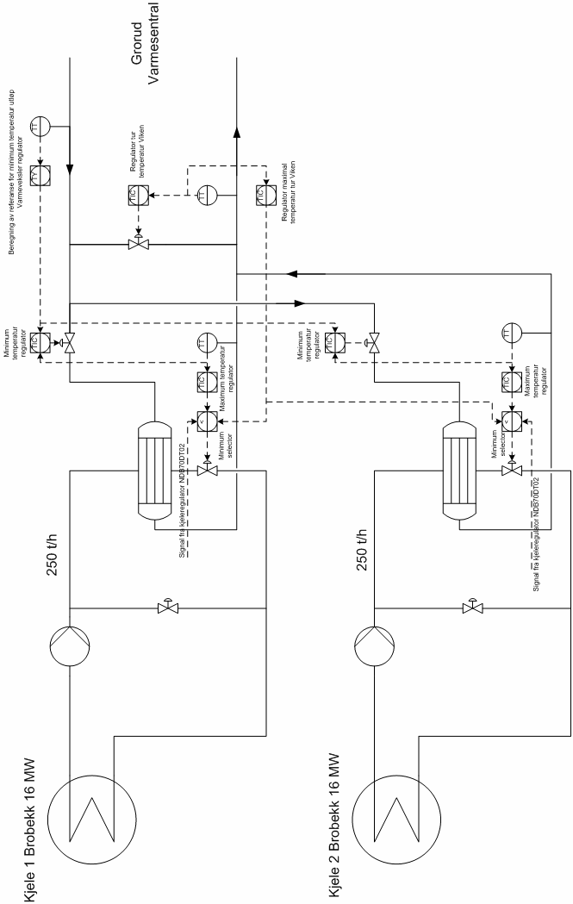

B.2 The control structure on the Brobekk side

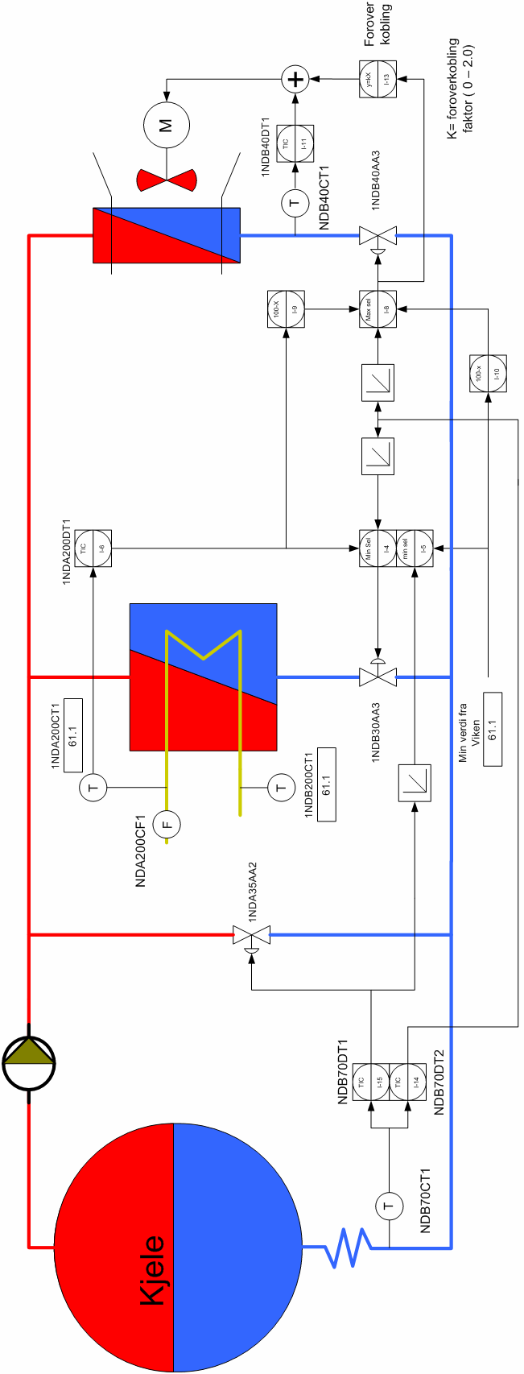

B.3 The control structure on the Viken side

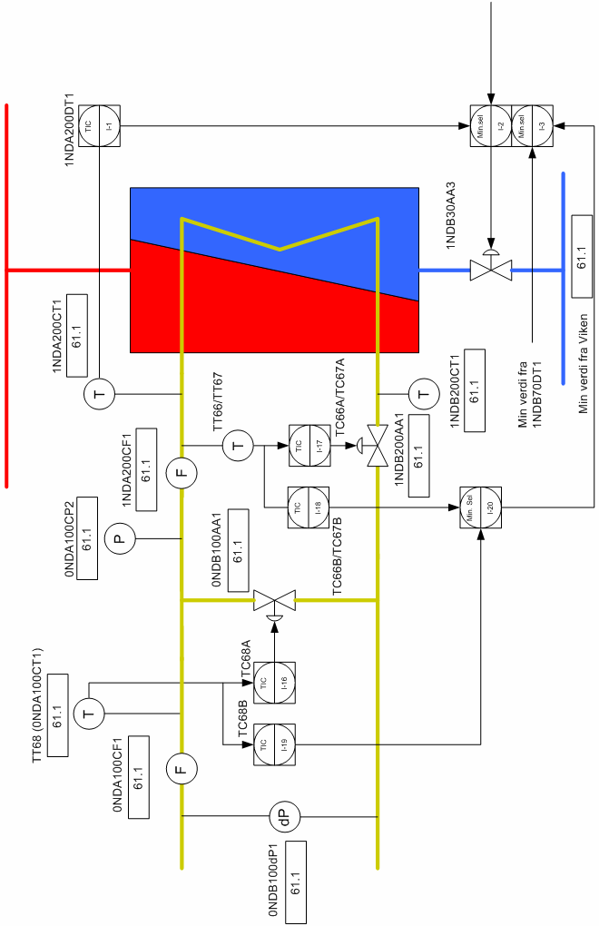

B.4 Modified control structure on the Brobekk side

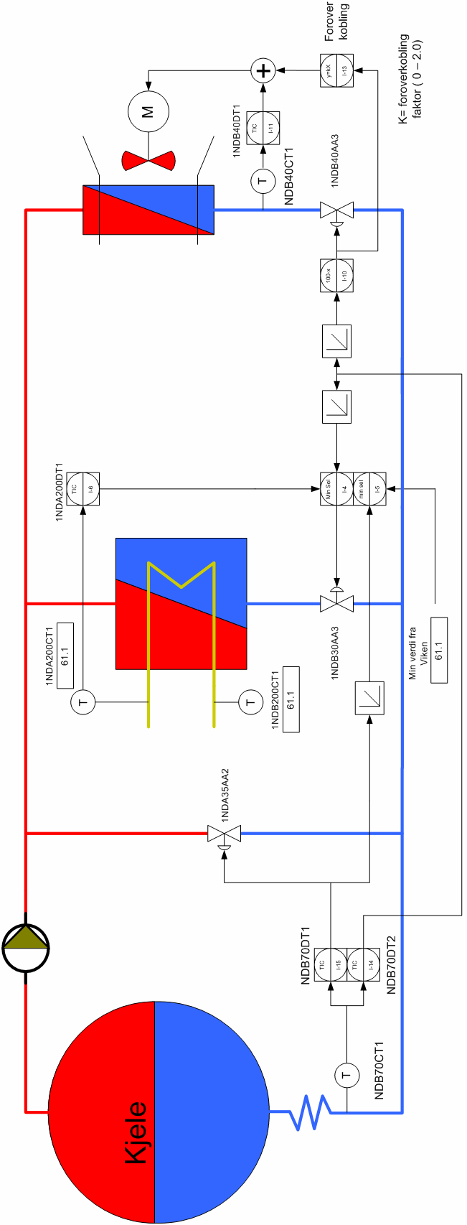

B.5 Modified control structure on the Viken side

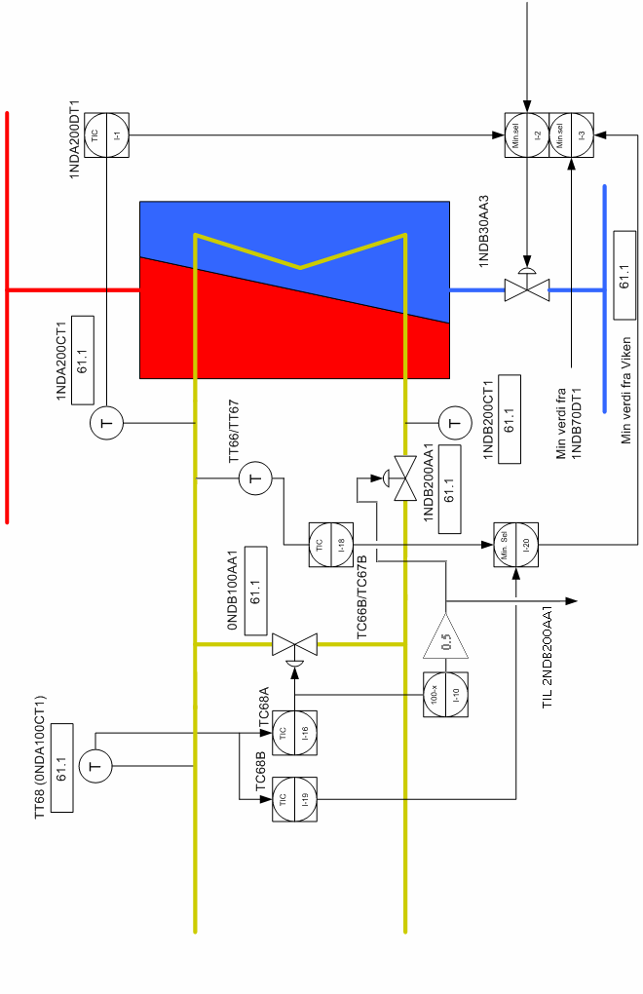

C Structure of the Simulink model

C.1 Splitter units

The two hot flow splitters are modeled as this;

where the -K- gain block serves to limit the flow in the hot water bypass to maximum 80 t/h; and the constant block sees to that the heat exchanger valve and cooling unit valve open inversely proportional to each other. Further, the cold flow splitter is modeled as

This flow sheet functions in the same way as the one above, with the only exception that here there is no limit regarding the flow through the cold water bypass.

C.2 Mixer units

The two hot flow mixers are modeled as

The -K- gain is used to divide the sum of the temperature-mass products by the total flow, which is necessary for the mixing calculation. The black bar at the top of the figure, called a Mux, is used to create a vector signal from any number of input signals. In this case the resulting signal is sent to an outside subunit for set point calculation for the cooling unit controller, NDB40DT1. For the cold flow, the mixer is modeled as below. The exception here is that the mixing calculation is slightly different, because we may have disturbances in the cold water flow rate (i.e. during a flow rate disturbance the total flow continuously changes).

C.3 Heat exchanger and cooling units

Structurally, the heat exchangers and cooling units are identical. Due to visual reasons, one of the cooling units has been chosen for display:

As we see, the model is built of ten vertical and identical cells, each one containing a hot side element (top), a wall element (middle), and a cold side element (bottom). In the lower part of the figure we see a calculation of the total amount of transferred heat duty. A closer look at one of the cells reveals the following structure:

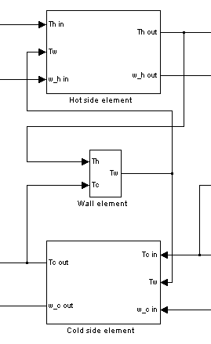
On double-clicking the hot side element the user is met with the following screen:

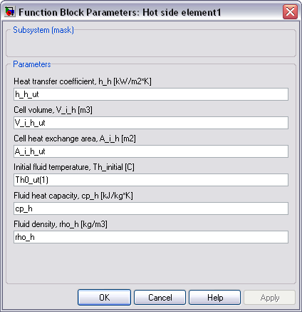

The parameters in the white fields must the same as in the MATLAB parameter script run prior to the Simulink simulation (not shown in this report). Similar boxes also appear when double-clicking on the wall and cold side elements. If we look under the mask of the hot side element we see the following structure;

which represents the energy balance on the hot side. Similarly, the structures in the wall and cold side elements (not shown) represent their energy balances.

D Step responses

Figure D.1 Step response from hot water bypass valve (NDA35AA2) to temperature
towards furnace (NDB70CT1).

Figure D.2 Step response from heat exchanger primary side valve (NDB30AA3) to
temperature towards furnace (NDB70CT1).

Figure D.3 Step response from cooling unit primary side valve (NDB40AA3) to
temperature towards furnace (NDB70CT1).

Figure D.4 Step response from heat exchanger primary side valve (NDB30AA3)
to heat exchanger secondary side outlet temperature (NDA200CT1), and from heat
exchanger primary side valve (NDB30AA3) to temperature towards Viken (TT68).

Figure D.5 Step response from cold water bypass valve (NDB100AA1)
to temperature towards Viken (TT68).

Figure D.6 Step response from cooling unit secondary side air flow ()
to primary side water outlet temperature (NDB40CT1).

E Overview of constraints and operational parameters at Brobekk

Heat duty
Q 16 MW 2x

Controller set points
NDA200DT1 TC66A/TC67A + 5 °C 2x
NDB70DT1 126 °C 2x
NDB70DT2 126 °C 2x
NDB40DT1 calculated 2x
TC66A/TC67A calculated 2x
TC66B/TC67B TC66A/TC67A + 5 °C 2x
TC68A set by Viken Fjernvarme AS 1x
TC68B TC68A + 5-8 °C 1x

Decoupling gain
NDB40DT1 0 ≤ K ≤ 2

Flow rates
_{Brobekk side} 230 t/h ≤ ≤ 260 t/h (_{sp} = 250 t/h)
_{Viken side} ≤ 900 t/h
_{bypass, hot} ≤ 80 t/h
_{bypass, cold} ≤ 540-600 t/h (at Δp = 1 bar)

Temperatures
T_{primary side, in} 180 °C ≤ T ≤ 185 °C
T_{primary side, out} 110 °C ≤ T ≤ 126 °C
T_{secondary side, in} 60 °C ≤ T ≤ 90 °C
T_{secondary side, out} 90 °C ≤ T ≤ 135 °C (149 °C absolute maximum)
T_{furnace, entrance} 124 °C ≤ T ≤ 132 °C (120 °C minimum, 126 °C set point)

Pressure and pressure drops
dP_{primary side, HE} ≤ 0,5 – 0,75 bar
dP_{secondary side, HE} ≤ 0,2 bar
P_{primary side} 15 bar
P_{secondary side} 14 - 20 bar

Valves
NDA35AA2 0 ≤ k ≤ 1 2x
NDB30AA3 0,55 (0) ≤ k ≤ 1 2x
NDB40AA3 0 ≤ k ≤ 0,45 (1) 2x
NDB100AA1 0 ≤ k ≤ 1 1x
NDB200AA1 0,22-0,25 ≤ k ≤ 1 2x

At 10 bar absolute pressure water boils at 179,916 °C. However, since the operational pressure in the Brobekk lines is 15 bar, there is a safety margin of about 18,4 °C [Spirax-Sarco, 2007].

