README
Brage Master Project Data

For any aspen files, all assumptions are made inside the model. It is easily navigable through the Aspen GUI.

Aspen_Column_Bidir
Aspen V14
- Steady-state/model definition: sim1.apwz
- Dynamic model: sim1_SIMPLE_13_1.dynf

Aspen_Column_Ratio
Aspen V14
DYCOPS paper 2025 simulation
- Steady-state definition: sim1.apwz
- Dynamic model: sim1_DYCOPS_B{1-4}.dynf

Aspen_EthylBenzene
EthylBenzene model from Nithin & Aayush: EB.apwz
EB4_17.dynf is the latest dynamic model revision used in the thesis.

Figures
All formatted figures
BIDIR is bidirectional control for a single distillation column
EB is bidirectional control for an ethyl benzene plant
Sim1_B1-B4 are simple control schemes for a distillation column (ifac paper)

Simulation_data
Raw data from the simulations
File_dict.py: reads all file names and corresponding variable names, and stores as dictionaries.
Parse_clc.py: extracts data from the .clc (table) files from Aspen dynamics (form: show as table)
Plot_results.py: plots the files specified on line 355 that matches the “handles” input. It is possible to add a list of strings here.
- Input name handle and press “Ctrl+S”
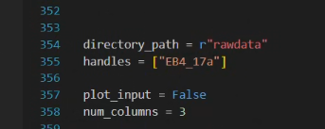

- Check if the handle matches with file names (marked in red)
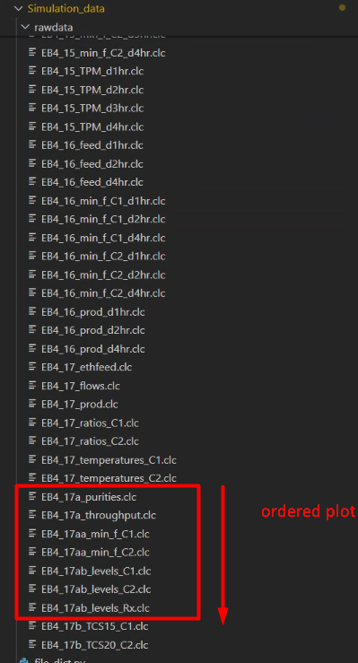
- Run file
