Introduction to automated drilling

The drilling process is controlled by machines mainly operated manually by drillers. The task is to drill fast and safe while keeping within a set of boundaries and handle upsets. It is a challenge to coordinate the hardware tools involved in drilling (top drive, pumps, chokes, etc). There is a great potential by increased automization and optimization. Statoil alone drills for appr 50 MRD NOK/year and the drilling industry operates with a 20-25% non-productive time in average. The main objective is to maximize the drilling efficiency, e.g. represented by the rate of penetration (ROP) and time spent to perform standard operations such as connections. Other parameters are drill bit wear, wellbore pressure, cuttings removal, drill string
torque load, pump flow rates, and choke opening (MPD). Advanced PDE models have been developed mainly for planning and these have also been used in real time during drilling in some operations.

1) The drilling process: A plantwide control approach for optimization

The task is to study the drilling process and to make a simple model for control.
A starting point can be the pressure-model (Kaasa-model). A task is to make a simple model for rate of penetration (ROP). Both the Kaasa-model and the model for ROP should be used to do a systematic analysis to find the controlled variables and manipulated variables. Further, the best way to pair the variables.

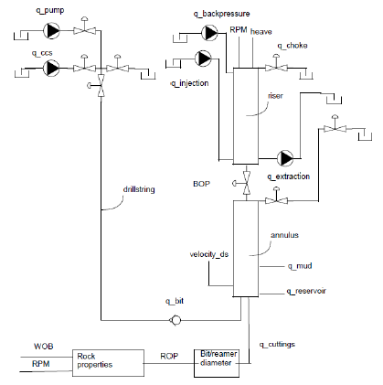
Picture from Nygaard.

Supervisor: Sigurd Skogestad
Co-supervisor: John-Morten Godhavn (Statoil)

2) Simulation and control of the drilling process: Feedback or feedforward?

A high fidelity Matlab model of a well is available from IRIS. In this project we want to study the application of such a model for control or if it is sufficent to use feedback control from measurements.
Controller analysis of poles, zeros, time constants, deadtimes.

Supervisor: Sigurd Skogestad
Co-supervisor: John-Morten Godhavn (Statoil)

