NTNU Faculty of natural science and technology
Norwegian university of science Depertement of chemestry engineering
and technology

Master thesis 2008

Use of dynamic degrees of freedom for tighter bottleneck control

Théogène Uwarwema

Abstract

This thesis deals with obtaining tighter bottleneck control by using dynamic degrees of freedom. We consider a part of a gas processing plant with four distillation columns in series. The process is simulated in Matlab/simulink. The control objective is to obtain maximum throughput within feasible operation in spite of disturbances. The bottleneck is fixed to the last unit whereas the throughput is manipulated at the feed rate. The large effective delay between the throughput manipulator and the bottleneck unit makes tight bottleneck control difficult. To overcome this, dynamic degrees of freedom which are holdup volumes upstream the bottleneck unit are used to obtain tighter bottleneck control.

Three control structures were implemented on the simulated process and tested for four different disturbances in order to compare their performance on disturbance rejection. The three control schemes were single loop control, single-loop control with bias adjustment and model predictive control. The disturbance scenarios were disturbances in the feed rate, feed composition, feed liquid fraction and the flow rate setpoint to the bottleneck unit.

The results showed that model predictive control and ratio control performed well on disturbance in the feed rate. Single loop control performed poorly compared to the two other control schemes. Concerning disturbances in the feed composition and the feed liquid fraction, these had no major impact on the bottleneck flow rate and all control structures responded nearly likewise. For a setpoint change in the flow rate to the bottleneck unit, single loop control with bias adjustment and model predictive control gave fast setpoint tracking, while single loop control was sluggish.

Using inventories as dynamic degrees of freedom has been demonstrated to be an effective method to achieve tight bottleneck without relocating the throughput manipulator. Although for model predictive control there is still scope for improvement in performance, its tuning parameters are mostly a matter of “rules of thumb”, based largely on experience gained from simulation of typical problems.

Acknowledgements

This work is the culmination of my studies at the Norwegian University of Science and Technology (NTNU); and was written as part of my master’s degree at the department of chemical engineering. The time of two years studies I passed at NTNU has been an interesting and hard working experience.

I want to thank my supervisor professor Sigurd Skogestad at the Department of Chemical Engineering for his guidance and co-supervisor PhD-student Elvira Marie B. Aske for her valuable guidance, hints and support; first on the specialization project and later on this master thesis.

I would also like to express my gratitude to PhD-student Henrik Manum for his help with Matlab/Simulink and especial a discussion on S-function.

I declare that this is an independent work according to the exam regulations of the Norwegian University of Science and Technology

Date and signature: .......................................................

Contents

Abstract 2
Acknowledgements 3
Contents 4
1. Introduction 5
2. Control strategies for implementing dynamic degrees of freedom 7
3. Case study 9
3.1. Process description 9
3.2. Model development in Matlab 11
3.2.1. Model assumptions in Matlab 11
3.2.2. Model data 11
3.3. Distillation column 14
3.3.1. Regulatory Control structure 14
3.3.2. Tuning of regulatory control 15
3.4. Evaluated control schemes for tight bottleneck control 16
3.4.1. Single loop control “manual control” 16
3.4.2. Adding bias directly to the level controller outputs 18
3.4.3. MPC 20
4. Results for case study 24
4.1. Disturbance scenario 1: 8 % increase in the feed rate 24
4.2. Disturbance scenario 2: 5 % increase in the bottleneck flow rate setpoint 26
4.3. Disturbance scenario 3: 5 % increase in the feed liquid fraction 28
4.4. Disturbance scenario 4: 5 % decrease in the feed composition components and 29
4.5. Summary of the results 31
5. Discussion 33
5.1. Model assumptions 33
5.2. Single loop control 34
5.3. Single loop control with bias adjustment 34
5.4. Model predictive control 35
6. Conclusion 36
Literature 37
Appendix A: Basic equations 38
Appendix B: Temperature and composition 40
Appendix C: Manipulated variables 44
Appendix D: Attached files 47

Introduction

The plant optimum can in many cases be simplified to maximum throughput. Given sufficiently high product prices, low feed and utilities cost; the maximum throughput is realized with maximum flow through the bottleneck (Aske et al., 2007). When the bottleneck flow is not at its maximum then is considered as a loss in productivity. Therefore tight bottleneck control is required to maximize the throughput, thus avoid the loss in production.

A good performance of a throughput control lies in its ability of propagating a production rate change throughout the process plant so that such a change produces changes in the flow rates of all main feed and product flows (Price et al., 1994). Furthermore its performance depends on where in the plant the throughput manipulator (TPM) is located (Aske et al., 2007, Narraway and Perkins, 1993). The TPM is commonly set at the inlet to the plant with inventory control in the direction flow. An important reason of this choice is probably that most of the control structure decisions are done at the design stage where one usually fixes the feed rate (Skogestad, 2004). Still, to achieve maximum throughput requires tight bottleneck control, and this implies that the TPM is located near the bottleneck. Near bottleneck means a short effective delay. Price et al. (1994) stated that the inventory control structure must be radiating around the location of the TPM to ensure self-consistency. They further decided the basic inventory control into three schemes, namely:

1. Inventory control in the direction of flow: feed as throughput manipulator
2. Inventory control in the direction opposite to flow: product as throughput manipulator
3. Process internal throughput manipulator with radiating inventory control

The first named control scheme is also called “conventional structure”. This configuration is usually used when the feed rate is given or limited. Whereas radiating inventory control structure can be suitable when it is optimal to maximize the throughput which is limited by some conditions inherent in the process. Thus, moving the TPM requires reassignment of the inventory loops to ensure a self-consistent inventory control. However reassignment of inventory loops is not always desired (or even possible). Compared to inventory control in the direction of flow, Luyben (1999) points out several problems due to the on- demand control structures. Among the problems identified by Luyben are: the difficulties of tuning level controllers due to dynamics lags, interaction between level and composition loops and the propagation of disturbances in this control structures is more complex than that in the conventional control.

The logical corollary is that the relocation of the TPM is rarely desired. However, when the TPM is located at the feed, it may lead to a large effective delay; hence difficult to obtain tight bottleneck control. Thus, large back off is necessary in order to ensure the plant operational feasibility. To shorten the long loop and minimize the back off without relocating the TPM, dynamic degrees of freedom like inventories can be used.

The dynamic degrees of freedom mentioned above are for example liquid levels and buffer tank level. A buffer tank is a unit where the holdup volume is exploited to provide smoother operation (Faanes and Skogestad, 2003). Note that buffer tanks have many different names and different purpose in industry, such as storage vessels, surge drums and holdup tanks. Here we focus on buffer volumes for liquid, using these as dynamic degrees of freedom can attenuate the disturbances effect on the bottleneck flow by minimizing the crucial back off, thus maximum throughput.

In order to implement maximum throughput, Aske et al. (2007) propose three fundamental factors, and these are:

1) Identify the bottleneck unit(s) in the process plant,

2) Implement maximum throughput in the identified unit,

3) Minimize the back off from active constraints.

As mentioned above the feed is commonly used as the TPM. Further, the feed rate is usually a degree of freedom while operating a process plant, and very often the economic conditions impose to maximize the production rate; that imply an increase of the feed rate. Conversely as the feed rate increases one will eventually reach a constraint F_{max} of a flow variable F, which becomes a bottleneck for the further increase in the feed rate. Consequently, maximum flow through the bottleneck can usually not be achieved in practice due to hard constraints, which cannot be violated freely. Subsequently to ensure the plant operational feasibility one needs to reduce the feed rate and “back off”. Moreover under the presence of disturbances, uncertainties, measurement errors and other sources of imperfect control, a back off is needed to satisfy hard constraints and thus feasible operation (Narraway and Perkins, 1993; Govtsmark and Skogestad, 2005).

On the other hand, large back off gives an economic loss; therefore this needs to be minimized. It is obviously that operating the plant closer to the bottleneck constraints, with small back off, improves the plant throughput and thus the profit. Nonetheless, this can lead to infeasible operation when large disturbances occur.
In this thesis a case study on distillation columns in series with fixed bottleneck control is considered. We want to use the holdup volumes in the columns as dynamics degrees of freedom to minimize the back off subject to the plant operation constraints; and thus achieve tighter bottleneck control. Three approaches for control are considered:

- Single loop control: using a single proportional integrator (PI) controller on the TPM;
- Single loop control with bias adjustment: Adding bias directly to the level controllers outputs which are situated upstream the bottleneck
- Model predictive control: Using MPC to manipulate at the feed rate and on the level controller set-points;

The organization of this thesis is as follows. First we consider bottleneck control and alternatives for control structures including dynamic degrees of freedom in chapter 2. A case study and a closer look to the control structure alternatives used follows in chapter 3. In chapter the obtained results are presented, whereas the performance of the studied control schemes are discussed and compare in chapter 5 and 6.

Control strategies for implementing dynamic degrees of freedom

In this chapter different control strategies for using inventories as dynamic degrees of freedom are explained.

1. Traditional configuration (manual control); Figure 2-1 shows an inventory control structure where the bottleneck is located in the last unit, with bottleneck throughput manipulated at the feed rate. This control structure has an inherent weakness of using inventories as dynamic degrees of freedom due to the long loop in the process. This long loop follows to a large effective delay and makes tight bottleneck control difficult.

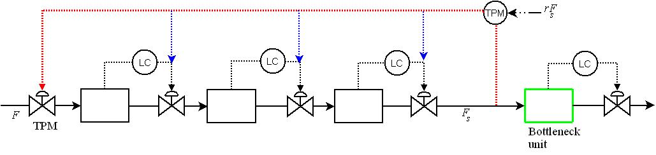
Figure 2-1: Conventional structure

To shorten the long loop in the control scheme above, we evaluate two alternatives control in the following.

2. Adding bias directly to the level controller outputs upstream the bottleneck or “single loop with bias adjustment”; using this control scheme, we obtain a short closed loop and the volumes in the process plant can optimally be exploited to dampen disturbances, as a result preventing the propagation of the disturbance effects to downstream units. As shown in Figure 2-1, the error (bias) from the TPM is added directly to the level controllers situated upstream the bottleneck unit; this allows a fast and efficient controller response when disturbances occur. In doing so, significant improvement on tighter bottleneck control can be achieved using this control scheme. The static gain Kr in figure 2-2 is the nominal ratio R (see more on this ratio in chapter 3.4.2).

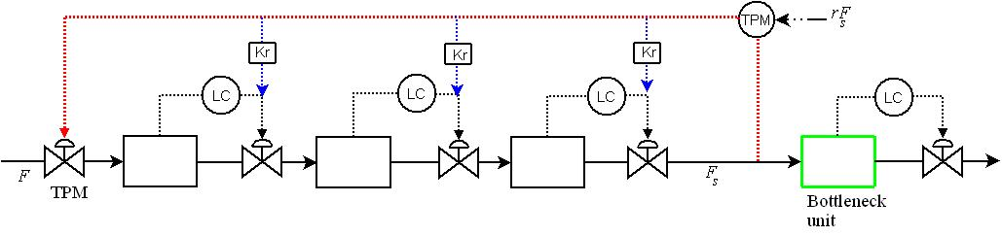
Figure 2-2 : Single loop with bias adjustment: inventory control in the direction of flow with the feed rate as TPM; with bias directly added to the level controllers.

3. Using MPC to manipulate at the feed rate and on the level controller set-points; this control structure is suitable for constrained problems. The presence of buffer tanks in many processes and the ability of being able to take account of constraints make MPC to be attractive for industries. The level of liquid in such a buffer tank has to be controlled; this is to ensure that it does not become empty or full, but within these limits it can be allowed to vary. In fact, the whole point of having such a tank is for the level to vary, because that is the means by which it absorbs the effects of disturbances.

In this study, MPC controller is implemented on the top of the regulatory layer (Figure 2-1) and uses levels in the unit upstream bottleneck as dynamic degrees of freedom by manipulating on their controllers set points; as well as the TPM setpoint. This means that MPC outputs are inputs to the regulatory layer controllers; see Figure 2-3.

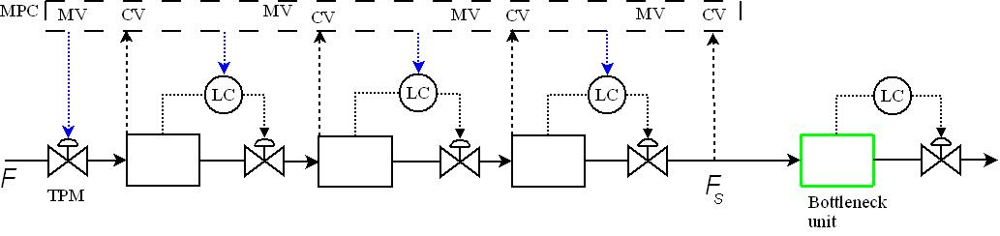
Figure 2-3: MPC control structure with the feed rate and inventories setpoints as manipulated variables (MVs) .

Note that the previously evaluated control schemes can only be used in cases with fixed bottleneck because it is unwanted to reassign the loops each time the bottleneck moves. Given that the bottleneck is included in the control problem as a controlled variable (CV) in the MPC controller object, MPC can also be used for moving bottleneck.
If one has to use single loop control on moving bottlenecks, the reassignment of inventory loops at each time the bottleneck moves is then unavoidable; this likely seems to be impractical. In the case study presented in the following chapter we consider fixed bottleneck in all three approaches of control investigated here.

Case study

A part of gas processing plant is used as an example of how tight bottleneck control can be achieved using inventories as dynamic degrees of freedom.

Process description

We consider a part of a gas processing plant which separate ethane (), propane (), isobutane () normal butane (), and naphta. These components are separated by four distillation columns in series as illustrated in Figure 3-1. A description of each of the four distillation columns follows:

The Deethanizer column separates the feed into ethane as the distillate product, whereas the heavier components ( ,, and ) are the feed to the depropanizer.
The Depropanizer column has propane as distillate and the remaining components as bottoms which are the feed to the debutanizer. In the debutanizer we have naphta as the bottoms and and as distillate. Butanesplitter separates isobutane as distillate and normal butane as bottoms; note that the feed to butansplitter is the distillate (not bottoms) from debutanizer; contrarily to the previous distillation columns.

Each of the columns in Figure 3-1 has configuration for level control and a fast temperature loop for composition control. The control structure is discussed further in chapter 3.3.1

The process presented in Figure 3-1 has four main feed flows with () as the overall feed into the process through deethanizer, the feed to depropanizer column, the feed to debutanizer and as the feed to the bottleneck unit butansplitter.

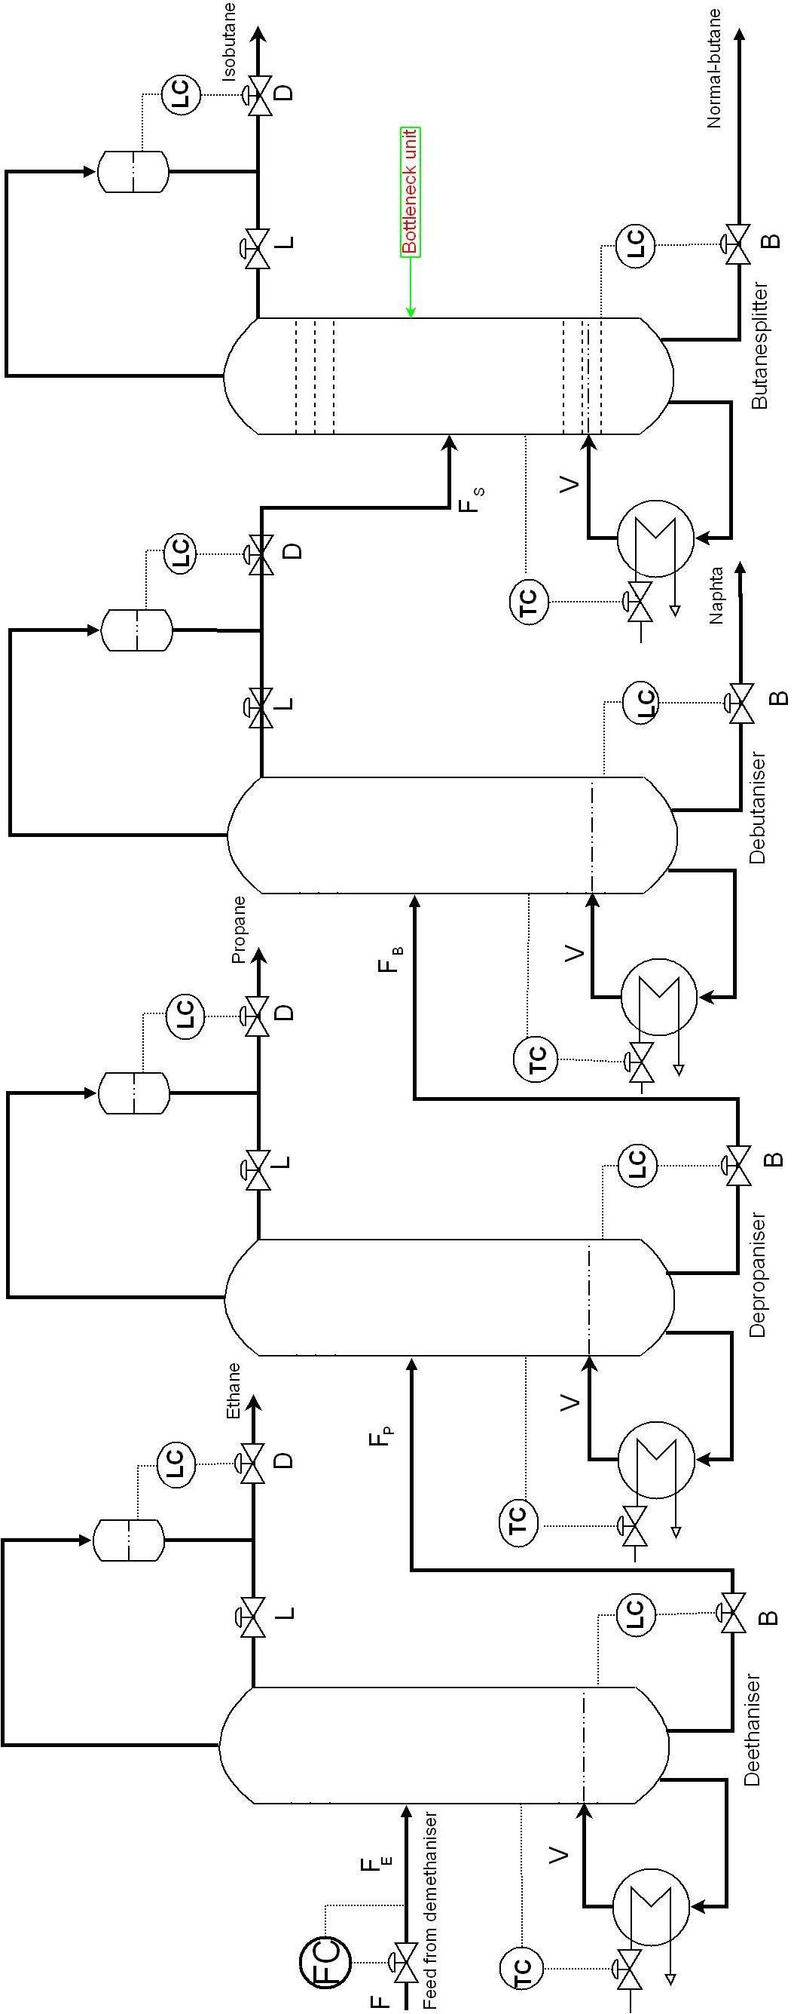
Figure 3-4: The process plant flowsheet with -configuration and temperature loops

Model development in Matlab

The model used in this thesis is based on column A (Skogestad and Postlethwaite, 1996). The matlab model of this column was first described for binary mixture and later extended to multicomponent mixture (http://www.nt.ntnu.no/users/skoge/book/matlab_m/cola/cola.html).
In this thesis we use the model for multicomponent mixtures.

Model assumptions in Matlab

The model has states; with components number in the multicomponent mixture and trays number in the actual distillation column. The assumptions considered in this model are:

- Multicomponent mixture with components
- is the heavy component,
- Constant pressure
- Constant relative volatility
- Constant molar flows
- No vapour holdup
- Total condenser
- Linear liquid dynamics
- Liquid flow dynamics modelled by Francis weir formula
- Equilibrium on all stages.

Furthermore due to the assumption of constant molar flow, we assume that the temperature on stage is directly given by the mole fraction. That means linear combination of composition and boiling temperature for pure component (see Equation 2).

Model data

To be able to simulate the process model in Figure 3-1, we need first to find an initial steady state. These steady state data serves as initial data for simulations in Matlab and later on in Simulink. There are different ways to calculate the initial steady state data. Some of the used tools are Matlab using dynamic simulation and run it to steady state; or any other of the simulation software. A dynamic simulator from the existing plant was used to obtain initial steady – state data. Some of the important steady – state data are presented in Figure 3-1

Table 3-1: Nominal values of the feed, feed compositions, reflux, boilup, distillate, the bottoms, the liquid fraction, and the condenser and the reboiler liquid hold up used in the process presented in Figure
 |  | Distillation columns
Parameters | Deethanizer(D1) | Depropanizer(D2) | Debutanizer(D3) | Butanesplitter(D4)
[] | 0.4057 | 0.0182 | 0.0000 | 0.0000
[] | 0.3538 | 0.5798 | 0.0021 | 0.0030
[] | 0.0564 | 0.0943 | 0.2200 | 0.3170
[] | 0.1134 | 0.1895 | 0.4784 | 0.6760
[] | 0.0707 | 0.1183 | 0.2995 | 0.0040
[] | 30.320 | 17.800 | 8.1000 | 2.5000
[] | 45.320 | 11.600 | 3.5000 | 5.6000
[] | 75.640 | 29.480 | 11.600 | 8.1000
[] | 63.500 | 27.100 | 8.6000 | 32.000
[] | 88.620 | 33.870 | 11.850 | 34.500
[%] | 0.9300 | 0.6400 | 0.5790 | 1.0000
[] | 226.00 | 227.00 | 62.000 | 88.100
[] | 121.00 | 38.000 | 18.000 | 66.400

In addition, to perform the simulation in Matlab, we need to find the relative volatility and boiling point at operating pressure of each component for temperature calculation. This is due to the model assumptions used here; otherwise one can obtain these data from a simulator like HYSYS.

Calculation of relative volatilities

The pressure at the key separation in the different distillation columns, as well as the DePriester charts were used to calculate the relative volatility used in the matlab models for the four columns in series displayed in Figure 3-1. As already mentioned above in the assumptions (section 3.2.1), we assume constant relative volatility alpha (α) which is obtained using the following formula

(1)

Where is any component and is an arbitrarily selected reference component in the definition of relative volatilities. While and are mol fractions in the vapour phase and liquid phase respectively. Values used in (1) are obtained from DePriester charts (Perry and Green, 1999).

The obtained alpha values are stated in Table 3-2.

Table 3-2: Alpha obtained using K_values from DePriester charts
 |  | _Values |  |  |  | alpha =
Components | D1 | D2 | D3 | D4 | D1 | D2 | D3 | D4
 | 1.49 | 3.90 | 18.1 | 12.0 | 2.98 | 5.57 | 11.38 | 10.9
 | 0.50 | 1.50 | 8.10 | 5.10 | 1.00 | 2.14 | 5.09 | 4.63
 | 0.23 | 0.70 | 4.40 | 2.70 | 0.46 | 1.00 | 2.76 | 2.45
 | 0.15 | 0.51 | 3.80 | 2.15 | 0.30 | 0.72 | 2.38 | 1.95
 | 0.07 | 0.24 | 1.59 | 1.10 | 0.14 | 0.34 | 1.00 | 1.00
 | 0.06 | 0.19 | 1.56 | 0.89 | 0.11 | 0.27 | 0.98 | 0.80
 | *_D1= | _D2= |  | _D3= |  | _D4=

Temperature calculations

The Soave–Redlich–Kwong (SRK) fluid package in Aspen HYSYS was used to calculate the boiling temperature of the pure components at operating pressure. This was done by specifying separately the pressure at which, each of the four columns was operated at; the obtained temperatures were then used in

(2)

to calculate the temperature at each tray in the different columns used in this study. The calculated boiling temperatures at different pressure are presented in Table 3-3; the pressures at which the distillation columns were operated are stated in this table too.

Table 3-3: The calculated boiling temperature for pure component and the pressures at which the columns were operated
 | Deethanizer | Depropanizer | Debutanizer | Butansplitter
Components | 26.1 bar | 12.0 bar | 3.67 bar | 5.17 bar
 | 276.26 | 246.76 | 212.30 | 221.20
 | 342.88 | 307.00 | 264.97 | 275.83
 | 387.65 | 347.10 | 299.55 | 311.84
 | 401.88 | 360.48 | 311.92 | 324.48
 | 443.95 | 398.75 | 345.43 | 359.22
 | 452.15 | 406.55 | 352.67 | 366.61

For more data and basic equations used in this model, see appendix A

Distillation column

Regulatory Control structure

In this thesis we use -configuration combined with a fast temperature loop as recommended by Skogestad (2007), this configuration is illustrated in Figure 3-2.

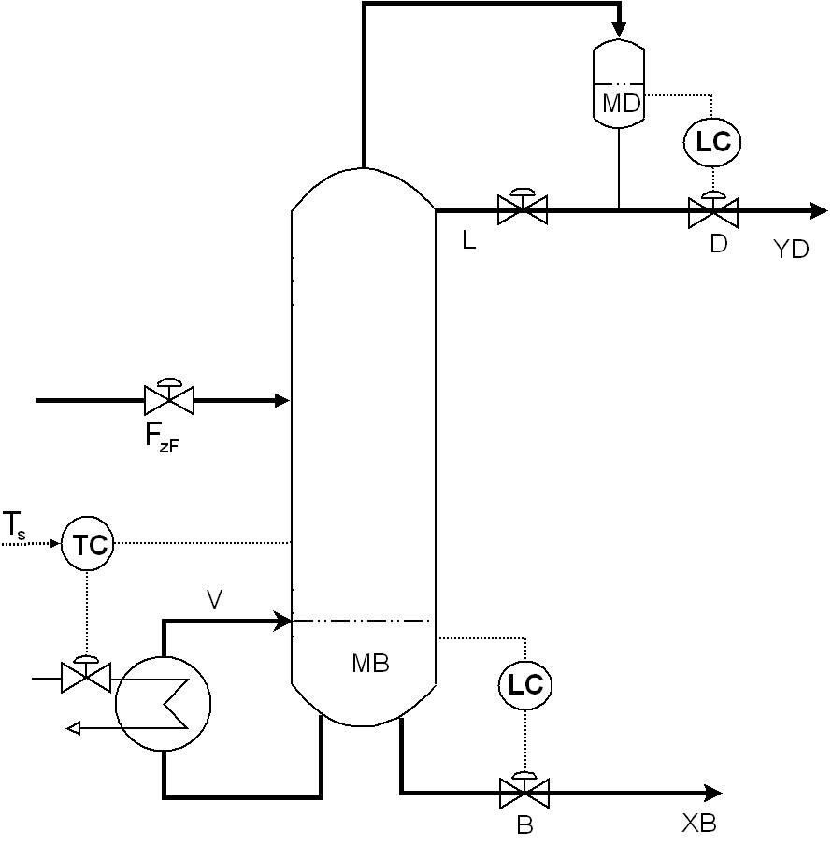
Figure 3-5: Distillation column controlled with - configuration and regulatory temperature loop in the bottom section

Before any control action, it is critical that we stabilize the distillation column by controlling the two integrating modes associated to levels in the reboiler and condenser. We choose here to control the liquid holdup in the condenser () and reboiler () with distillate () and bottom () flows, respectively as shown in Figure 3-2. In addition we need to control the composition profile in the column, because the composition dynamics can work like integrator with a large time constant. A temperature measurement inside the column is simple and a good alternative for the control of the composition profile (Skogestad 2007). As we have now closed the two level loops using and; the remaining degrees of freedom for the temperature control are boilup and reflux . To measure the temperature inside the column and thus stabilize the composition profile, we choose here to use the boilup (see Figure 3-2).
In chapter 3 it was emphasised that the temperature is directly given by the mole fraction and calculated using Equation (3).

Tuning of regulatory control

We use here Skogestad’s tuning rules (SIMC) with the closed loop time constant as tuning parameter (Skogestad, 2003). For levels we need slow control “smooth control” subject to having acceptable disturbance rejection, while for temperature and later bottleneck control we need “tight control”. To achieve smooth or tight control one have to select a suitable closed loop time constant

Level control

A single proportional (P) controller is used for each of the level controllers in Figure 3-1. We want smooth control rather than tight control of levels in and; this is important because we want to attenuate disturbance effects using these levels, before they affect the output controlled variable.

Assuming nominal volume such that the holdup time is where is the effective time constant. The required volume is given by:
(3)
Where is the proportional controller tuning parameter and is given by:
(4)
The values of the tuning parameter are stated in Table 3-4.

Table 3-4: - values for the proportional controllers in the model presented in figure 3-1
Parameters | deethanizer | depropanizer | debutanizer | butansplitter

In addition to (3) and (4) the values in Table 3-4 were decided (by testing different disturbances) according to how these were suitable to dampen disturbances as well as taking account of the hold up volumes capacity.

Temperature control

PI controllers are used to control the desired temperature inside the different columns in Figure 3-1.
The dominant time constant and process gain for each PI controller were obtained by using model approximation as described by Skogestad (2003). While for a fast control of the temperature loops, the closed loop time constant was selected to 0.5 min.

Table 3-5 shows the temperature controlled trays in the four different columns and the PI tuning parameters values used.

Table 3-5: PI-parameters values and the tray number for temperature control
Parameters | deethanizer | depropanizer | debutanizer | butansplitter
Controlled tray

Evaluated control schemes for tight bottleneck control

In this section the used control schemes as well as their tuning are discussed. The inventory control configuration in Figure 2-2 and 2-3 are considered for single loop with bias adjustment and MPC. For single loop control, the conventional structure in Figure 2-1 is used.

Single loop control “manual control”

In Figure 3-3, we use the conventional structure for tighter bottleneck; the feed rate is used as TPM, whereas the bottleneck is located on butansplitter unit. A single PI controller is used on the TPM to manipulate the feed rate. The control objective is to maximize the primary controlled variable. Contrary to level control, for tight bottleneck control we need “fast control”. The SIMC tuning rules was used to tune the used PI controller in Figure 3-3. The process had a small effective delay, so choosing for tight control gave aggressive and oscillating responses, in order to get a smoother control; the closed loop response time was selected to (Skogestad, 2007.b). The parameters obtained using are stated in Table 3-6, whereas the used tuning parameters values are stated in table 3-7. Levels and temperatures in Figure 3-3 were controlled as described in chapter 3.3 (Table 3.4 and 3.5).

After implementing all the required controllers, the simulink model of the process displayed in Figure 3-3; was simulated at steady – state. When the model was satisfactory stable, the actual implemented control structure was investigated for different disturbance scenarios. The simulated disturbance scenarios are explained in details in chapter 4.

Table 3-6: PI tuning parameters for
parameters | values
 | 5.60
 | 31.9
 | 94.7

Table 3-7: PI tuning parameters for
parameters | values
 | 65.9
 | 31.9
 | 94.7
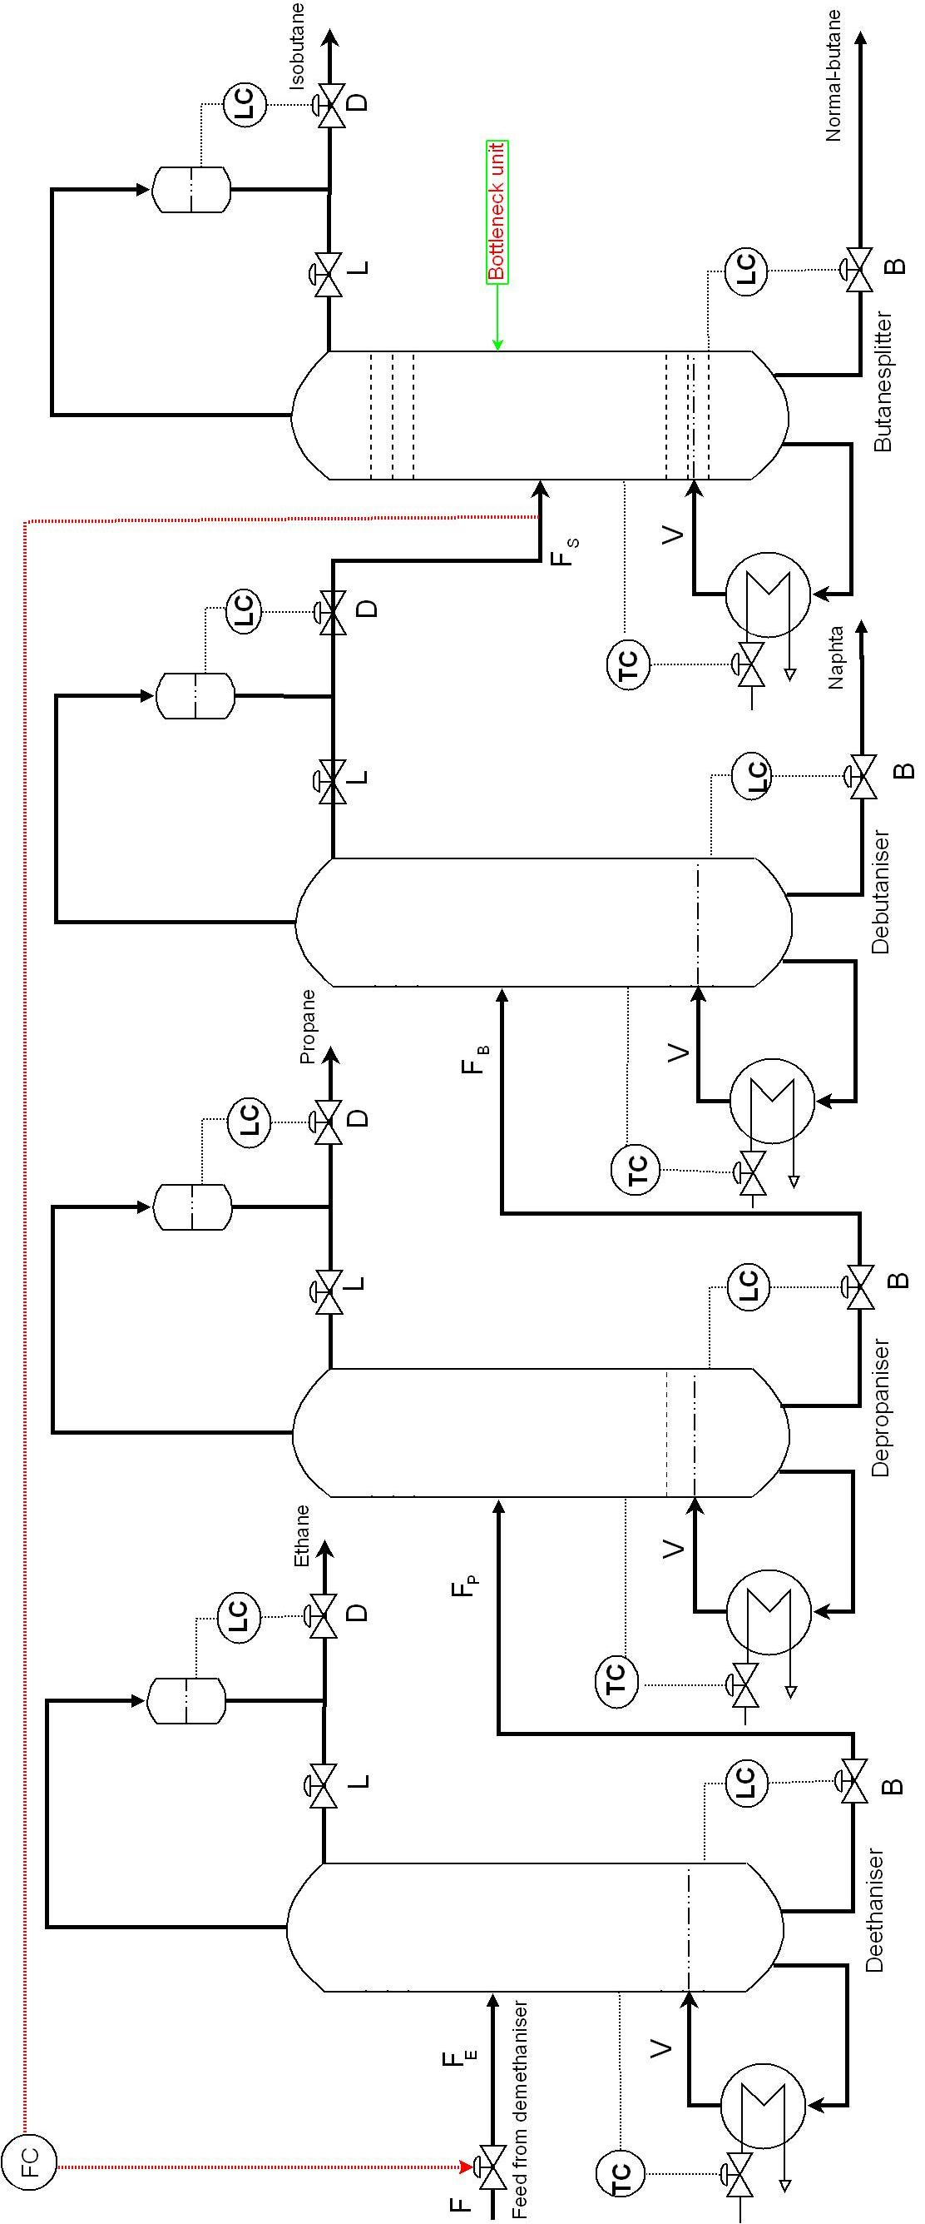
Figure 3-6: The studied process with single loop control scheme.

Adding bias directly to the level controller outputs

Figure 3-4 shows the studied process with single loop control with bias adjustment structure. As for the single loop control, the bottleneck is situated on the last unit and controlled by manipulating the feed rate. However, in this control structure bias are added directly to the level controller outputs. In Figure 3-4 the long loop is illustrated by a red line, whereas the bias is illustrated by blues lines. It is significant to note how much the long loop is shortened according to inventories. This gives a short and effective time to respond on eventual disturbances by an optimal exploitation of levels, which can damp disturbances before they reach the controlled output flow, hence tight bottleneck control.
Using single loop with bias adjustment we add the error from the TPM direct to the level controller outputs, and maintain the ratio “R” of two process variables at a specified value. These variables are usually flow rates, a manipulated variable u and a disturbance variable. Thus, the ratio is controlled rather than the individual variables. Note that u and are physical variable and not deviation variables (Seborg et al., 2004). For the process in Figure 3-4, u is

[]

while is so for R_{1,} R₂ and R₃ in Figure 3-4 we used the followings static ratio

[] ^{T}, respectively.

For the flow control on the bottleneck, a typical flow PI controller with min. and as tuning parameters is used on the TPM in Figure 3-4 (Skogestad, 2007.b). Whereas levels in the columns are tuned as for single loop control as described in chapter 3.3. Note that the inventory loops are not relocated compared to the “conventional structure”.

Same disturbances simulation scenarios as these investigated for single loop control were simulated for the process model in Figure 3-4.

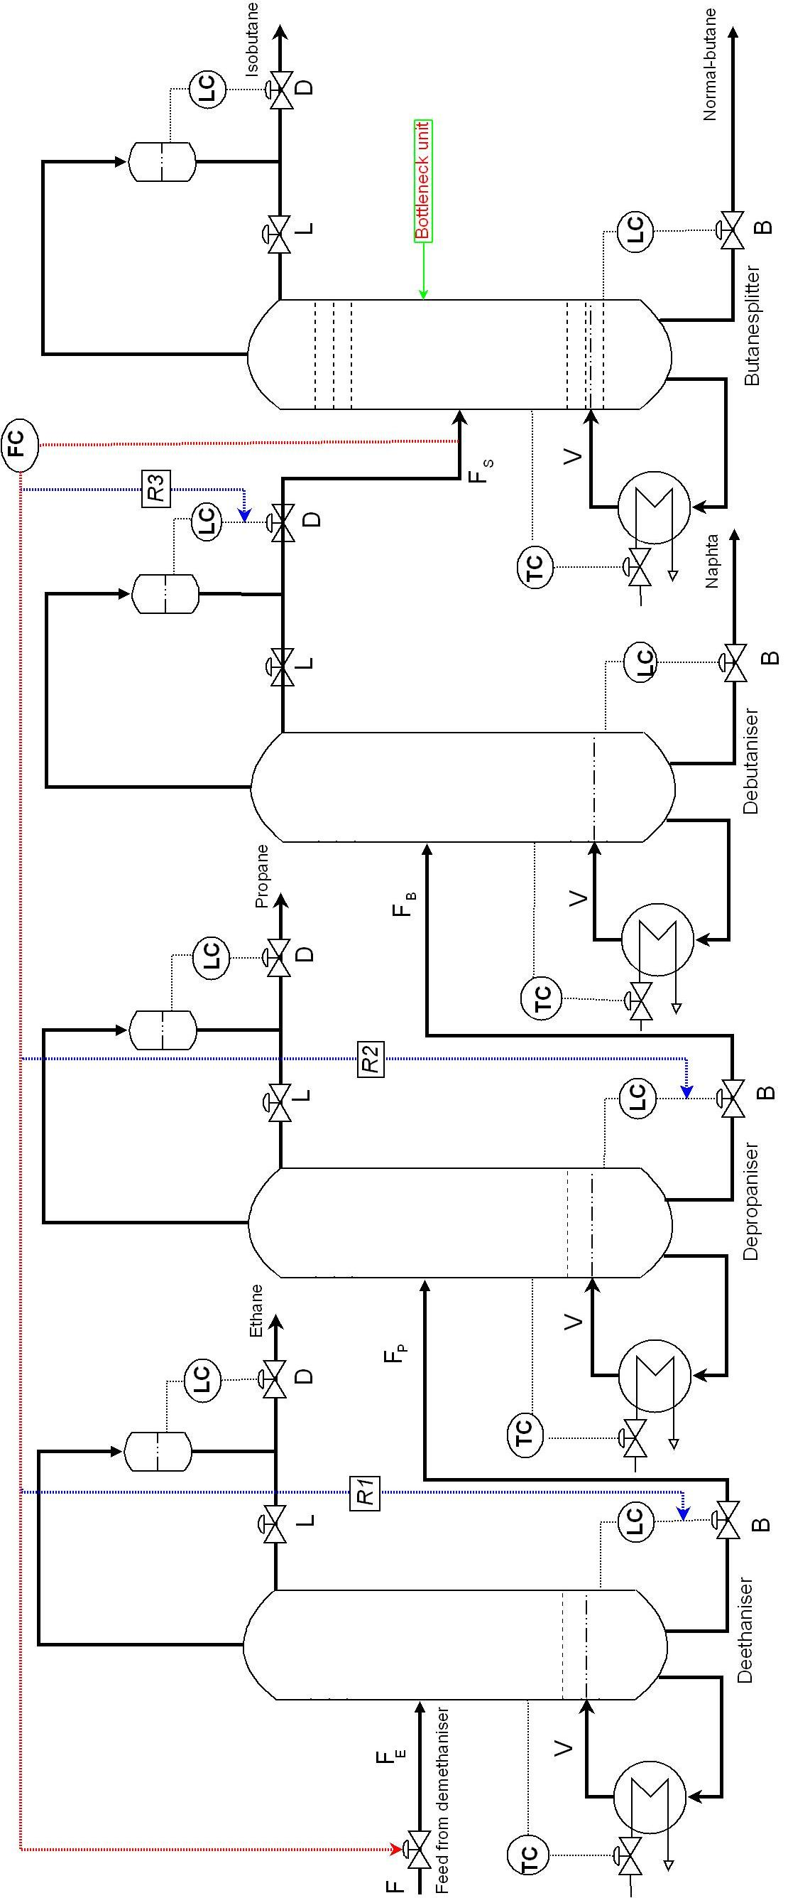
Figure 3-7: The process flowsheet with single loop with bias adjustment configuration

MPC

In this thesis the inbuilt MPC toolbox within Matlab/Simulink library with a linear MPC is used here. Linear MPC uses linear models in a model predictive control framework to choose control action. The MPC controller chooses the future control moves that minimize an objective function subject to constraints on manipulated, controlled and state variables (Maciejowski, 2002).

Implementing MPC

In this thesis MPC was implemented by setting up the control problem as a quadratic programming problem and solve it over the prediction horizon. The MPC toolbox in the inbuilt MPC Simulink library within Matlab was used to linearize the nonlinear model from Figure 3-3 and create the MPC object. For more details on the use of MPC toolbox please see uwarwema (2007).
Figure 3-5 shows the process model with MPC control scheme; this is implemented on the top of the regulatory control layer (single loop control) in Figure 3-3. The MPC controller block (light blue) receives the current measured output

reference (ref) signal

and outputs the optimal manipulated variables

by solving a quadratic program. The MPC controller block outputs are obviously the setpoints of and controllers for the regulatory control layer.

Selection of tuning parameters

The tuning parameters that have a significant effect on the plant behaviour and the predictive controller performance for the process model presented in Figure 3-5 are the control horizon, prediction horizon, sampling interval, penalty weight matrices and move suppression factors. Principally the weights may be dictated by the economic objectives of the control system, but usually they are in effect tuning parameters which are adjusted to give satisfactory dynamic performance.

Figure 3-8: The process model with MPC

Once again, our goal is to use dynamic degrees of freedom, to damp potential disturbances effects, before they reach the controlled output flow; these degrees of freedom are the volumes upstream the bottleneck unit . Having in mind this objective, follows a discussion of the tuning parameters used for the tuning of MPC controller “MPC” considered in this thesis:

The control interval or simple time was set at 1 min., which was found to provide good control performance. The prediction horizon was set at 30 samples by comparing control performance. The choice of control horizon has a large impact on the computational load on the controller algorithm.
As the control horizon increase, the MPC controller tends to become more aggressive and the required computational effort increases. However we can reduce this computational effort by inputs blocking (see Table 3-10). On the other hand using a lower value of tends to make the controller more aggressive. The prediction horizon was selected by using a thumb rule to be so that the full effect of the last input move is taken into account. We suppose that the plant includes a pure time delay equivalent to D sampling instants.

The weight matrices were selected to provide a greater weighting on outputs variables than manipulated variables; furthermore the output flow of the debutanizer where the bottleneck is located was largely weighted than the three remaining controlled variables which are volume levels in the deethanizer, depropanizer and debutanizer

The constraints used on manipulated and controlled variables in the process model presented in Figure 3-5 are shown in Table 3-8.

Table 3-8: Constraints on manipulated and controlled variables in Figure 3-5
Variables | Nominal values | Constraints | Max up and max down rate

Table 3-9, shows the weights values used on different manipulated and controlled variables in the process model with MPC controller shown in Figure 3-5.

Table 3-9: Weights on manipulated and controlled variables in Figure 3-5
Variables | weights | weights rate
 | 1e9
 | 9e7
 | 1e8
 | 9e7
 |  | 1e8
 |  | 9e7
 |  | 1e8
 |  | 9e7

In order to speed up the required computational effort, simulating the model with MPC control, we had to use the inputs blocking technique, which means non-uniform intervals between control decision (Maciejowski; 2002), see Table 3-10

Table 3-10: Sample time, control and prediction horizon for MPC controller
Variables | Values
Sample time [min]
Prediction horizon
Control horizon [blocking]

For comparison reason this control schemes was investigated using the same disturbance simulation scenarios as for the traditional control and single loop with bias adjustment.

Results for case study

A number of simulations were run in order to investigate the performance of the different control schemes on tight bottleneck control. The keys parameters here are the feed flow to the bottleneck unit “butansplitter”, the dynamic degrees of freedom: volume levels in the columns upstream butansplitter, which are deethanizer, depropanizer and debutanizer. Furthermore, the temperature and composition profile in the actual units are also of interest for the performance evaluation.
The simulations were performed in Matlab/Simulink. Matalab was used to create initial condition; thereafter the simulations were carried out in Simulink with a help of Simulink interfaces created in Matlab. The simulation in Simulink is trivial, because it makes the controller implementation and modification easier as well as parameters change.

Four different disturbance scenarios were run by introducing disturbances in the given cases. The tested scenarios were:

- A step in the overall feed from to
- A change in the bottleneck feed flow setpoint from to
- A step in the feed liquid fraction in the feed from to
- A step in the feed composition in the feed , a decrease of in and

Disturbance scenario 1: 8 % increase in the feed rate

The process was allowed to run until it was completely stabilized, before the disturbance was introduced. To facilitate the comparison one disturbance was introduced in all three control setup studied here. Figure 4-1 and 4-2 show the process responses to an increase of 8 % in the overall feed flow rate F.

Single loop

Figure 4-1 shows the response of the step change in and its effect on the bottleneck flow rate . Using (1) the back off in (green dashed) was calculated to; while the resettling time from when disturbances occur is 500 min. Figure 4-2 shows the variation of levels (green dashed) in the columns upstream bottleneck, in order to counter the disturbances effect on the downstream flow.

Adding bias directly to the level controllers upstream the bottleneck

As the objective of our case study is to tightly control the bottleneck, it is obviously to see if other control structures can give lower back off than that obtained using single loop control structure. Figure 4-1 shows the response (blue dotted) obtained using single loop control with bias adjustment. The resulted back off was , whereas the resettling time was . Compared to the results obtained from single loop control; this is a significant improvement on disturbance rejection.
This is explained by the short loop in single loop control structure with bias adjustment, the effect of adding bias directly to level controllers, and that the controller takes action before the deviation in the controlled variable occurs as it was emphasized in chapter 3.4.2. The variations of the actual levels displayed in Figure 4-2 (blue dotted responses). Compared to single loop and MPC levels responses, we have an offset in single loop control with bias adjustment levels responses; this is due to the static ratio “R” (see section 3.4.2) and that there was used a single P-controller on levels in the distillation columns. A little integrator action should bring the level at their setpoints. However the levels in the buffer volumes do not have to be controlled at their setpoints, since their use is to vary and dampen disturbances. As long as these variations respect the constraints (or tank capacity) there is no need of controlling levels at their setpoints.

Figure 4-9 Step change response in and its effect on the controlled flow with control structures: Single loop control (SL), single loop with bias adjustment (SL_{w}bias) and MPC.

Using MPC to manipulate on the level controller set points

MPC is know for its ability of handling constrained problems, that’s why it’s of interest to investigate how it respond to the introduced disturbances in compared to the two previous control structures. The key idea is to use volumes as dynamic degrees of freedom, with constrains on manipulated and controlled variables (see Table 3-8).
The response of obtained using MPC is displayed in Figure. The resulted back off was this result is both better than these obtained using single loop control and single loop with bias adjustment. The resettling time was about .
Figure 4-10: Responses of controlled levels on disturbances in the feed rate

The use of the holdup volumes responses in the columns are displayed in Figure 4-2. The variations in the controlled levels (red solid) show that MPC uses less volume than these used by the other investigated control structures. An explication to this is the use of MVs, when disturbances occur MPC controller outputs optimal MV as well as. This gives large variation in MVs, thus minimum variations in the CVs compared to single loop control and single loop with bias adjustment. The MV responses obtained using MPC are displayed in appendix C. Some of the important measurement of composition and temperature are discussed in appendix B.

For comparison reasons, in the following disturbance scenarios the responses ware plotted and described (legend) similarly to the actual disturbance scenario.

Disturbance scenario 2: 5 % increase in the bottleneck flow rate setpoint

Figure 4-3 and 4-4 show the responses obtained from the simulation with a setpoint change in the bottleneck flow rate. Figure 4-3 shows an increase of 5 % in rF_{S} and its effect on the primary controlled flow rate F_{S} . The results show that single loop control with bias adjustment and MPC was significantly fast to reach the new bottleneck setpoint than single loop control. From single loop control with bias adjustment and MPC responses, we observed a back off of 0.020 kmol/min and 0.006 kmol/min, respectively.
Figure 4-11 step change in and its effect on the controlled flow

Figure 4-12: Responses of controlled levels on setpoint change in the bottleneck flow rate

The uses of inventory in this simulation scenario are displayed in Figure 4-4. The discussion made on the use of hold up volumes in disturbance scenario 1 yield for this scenario also. The MVs responses obtained from simulation using MPC are displayed in appendix C. And some important responses of temperature and composition from this simulation scenario are presented in appendix B

Disturbance scenario 3: 5 % increase in the feed liquid fraction

Figure 4-5 and 4-6 show the process responses to an increase of in the feed liquid fraction for all three control schemes.
Figure 4-5 shows the response of the step change in and its effect in the feed flow rate . The obtained responses showed that there was not a significant effect on the bottleneck flow rate. However there were observed some minor oscillations in the bottleneck flow using single loop control and MPC controllers, this is probably due to a tuning problem which leads to a lost opportunity of about 0.14 % under the bottleneck nominal flow rate value. The obtained response using single loop with bias adjustment seems to be insensitive to disturbance in the feed liquid fraction see Figure 4-5.
Figure 4-13: Responses obtained using disturbance in the feed liquid fraction

The back off obtained here was for single loop, while there was not observed back off from single loop control with bias adjustment and MPC simulations with disturbance in the feed liquid fraction.

The responses in the controlled levels , showed minor variation or no variation at all. The variations in the actual levels are displayed in Figure 4-6.
Having in mind that the nominal values for the controlled levels were 121, 49 and 62 successively; Figure 4-6 shows that the process was stabilized to other values than nominal values for single loop control and single loop with bias adjustment. This is probably due to the use of single P-controller on levels. However this is not a problem as we do not want to hold the levels at their setpoints; their means is to vary. Note that MPC responses are at their nominal values.
The MV responses resulted under the simulation with disturbances in the feed liquid fraction using MPC are displayed in appendix C. Other important measurement like composition and temperature profile are presented in appendix B
Figure 4-14: Responses of controlled levels on disturbances in the feed liquid fraction

Disturbance scenario 4: 5 % decrease in the feed composition components and

As for the disturbance in the feed liquid fraction, the disturbance in the feed composition did not have any significant impact on the bottleneck flow rate. Figure and show the process responses resulted from simulation with a decrease of in the feed composition components and (see Table 4.1). Figure shows the response of the step change in ( and ) and how it affects the controlled flow.
The comments made on the behaviours of and controlled levels in disturbance scenario 2 yields here too. Figure 4-8 shows the responses of the controlled levels. From Figure 4-7, we have a lost opportunity of under the bottleneck flow rate nominal value using MPC and using single loop control. As it can be seen from the same figure, there was not observed back off in for all three control structures; while simulating with disturbance in the feed composition .

Using this scenario, the obtained results are similar to these obtained in scenario 3 where the disturbances were introduced in the feed liquid fraction. Namely, that these disturbances do not significantly affect the bottleneck flow rate as the disturbance in the feed rate (Figure 4-1)
Figure 4-15: Step change response in and the resulted responses

Table 4-11: 5 % decrease in and
component
 | 0.4057 | 0.4057
 | 0.3537 | 0.3622
 | 0.0564 | 0.0536
 | 0.1134 | 0.1077
 | 0.0707 | 0.0707

Figure 4-16: Responses of controlled levels on disturbances in the feed composition

Summary of the results

Figure 4-9 shows responses of the primary controlled variable for all four simulated disturbance scenarios. MPC controller gave a good disturbances rejection when these occurred in the overall feed flow rate . Single loop control (green dashed) performs poorly compare to both MPC and ratio control, the large back off occurred using this control structure; further it has a quite large resettling time about 400 min. more than the two other control structures. From Figure 4-9 the obtained results show also that single loop control with bias adjustment achieved the best results in disturbance scenarios 3 and 4. And as one can see from the same figure, its response in disturbance scenario 2 is not fall from the one obtained using MPC. Table 4-2 shows an overview of the back off resulted from each control structure.

Table 4-12: The back off from simulated scenarios
control scheme | back off
 | Disturbance 1 | Disturbance 2 | Disturbance 3 | Disturbance 4
Single loop control | 0.600(7.40%) | 0.000 | 0.000 | 0.001(0.012%)
Single loop control with bias adjustment | 0.042(0.64%) | 0.020(0.24%) | 0.000 | 0.000
Model predictive control | 0.003(0.04%) | 0.006(0.07%) | -0.011(0.14%) | -0.019(0.23%)

Figure 4-17: responses from all simulated scenarios.

Discussion

The results have been commented on throughout the results section; however, a more thorough assessment is needed and the used control structure should be discussed and compared for their performance on the obtained results.

Model assumptions

Two of the assumptions used in the Matlab column model require a particular attention.

1. Linear liquid dynamics. Liquid flow dynamics was modeled by Francis weir formula in the Matlab model used for our study; the initial steady state data used in this model were obtained by utilization of D-Spice dynamic simulation tool. Simulating the Matlab column model with these data gave different steady state data on the flows and especial low purity in composition both in top and bottom composition. Consequently, fewer adjustments of the reflux and reboiler values were needed to get satisfactory initial steady state values, before the model was tested for different disturbance scenarios. A reason for this mismatching can probably be that the simulation in D-spice model was performed on other assumptions than the ones used in the matlab model.

2. Constant molar flow. With this assumption, the molar flows of the liquid and vapour along the column do not change from one stage to the next. Then at steady state

As a sequel from constant molar flow assumption, we assumed that the temperature on stage is directly given by the mole fraction; and was calculated using (3). The issue of where to place the temperature sensor (controller) along the distillation column was questioned here. Skogestad (2007) give a clear discussion of the criteria listed by Luyben (2006) on this issue and present some recommendations. One of the recommendations which should be used for dynamic purposes is to select the tray where there are large changes in temperature from tray to tray. This criterion was used to choose which tray to control in this thesis. For deethanizer and butanesplitter other tray numbers than these used in D-spice model were used in the Matlab/Simulink model, in order to satisfy the criterion named above. The temperature profiles for the four different columns are displayed in appendix B.

Concerning composition and columns product quality, it should be emphasized that the main focus in this thesis was on the throughput control; however we did not completely ignored the product quality. An example on how the disturbance scenarios affect the composition in the different columns is presented in appendix B. The obtained results showed that the assumption of controlling the composition profile using temperature performed suitable, Skogestad (2007).

Single loop control

When compare to the other control structures studied in this thesis, single loop control gave poor disturbances rejection. For the first disturbance scenario, where an increase of 8 % in the overall feed rate was introduced into the plant; the back off in the primary variable was, thusof the bottleneck flow rate nominal value. This is and higher than the back off resulted when the process was simulated with MPC and single loop control with bias adjustment. Disturbances in the feed composition and feed liquid fraction seemed to do not have a significant impact on the bottleneck flow rate. The setpoint change response in the bottleneck flow rate was sluggish to reach the new setpoint compared to the remaining control schemes. This is due to the large loop inherent to single loop control scheme.

In summary for single loop control scheme, the disturbances thus seemed to have a significant effect on the bottleneck flow control, are these in the overall feed flow rate and the bottleneck flow rate setpoint change. Having in mind that the TPM is situated on the feed rate and-that single loop – PI controller is used; we can say that the poor disturbance rejection observed in these two disturbance scenarios was due to the long loop in the process. The reason for the long loop is that the controller is placed far from the bottleneck unit and thus no immediate corrective action is taken before the deviation in the controlled variable occurs. Further, the volumes in the columns between the TPM and the bottleneck can increase the effective delay; hence tight bottleneck control becomes more difficult. However, a solution to this problem should be to relocate the TPM closer the bottleneck unit; though this is unwanted for men reasons (see chapter), such as permanent reassignment of level loops. In the following we discuss two alternatives control thus can reduce the long loop or handle moving bottleneck without needing the reassignment of the loops.

Single loop control with bias adjustment

Most of the results discussions for this control structure were taken above while discussing single loop control. However, there is something remarkable from this control structure that requires a special consideration; that is the use of dynamic degrees of freedom. Contrary to single loop control, in this control scheme inventories were optimally used by adding the signal from the TPM “bias” directly to level controller outputs situated upstream the bottleneck. In this manner, the long loop observed in single loop became considerably reduced; and thus facilitated tight bottleneck control.
Summing up, for single loop with bias adjustment, the use of inventories as dynamic degrees of freedom improved significantly the results on tight bottleneck control compared to single loop control.

Model predictive control

Under the linearization of the simulink model displayed in figure, we faced a problem of singular value decomposition (SVD) and further step required to complete the linearization could not be performed. Disabling temperature PI-controllers under linearization and then enabling these after the linearization of the process model solved the problem. However, it cannot be confirmed, because we do not know if this has had an impact on MPC controller performance. Although, the results obtained from MPC were better than these obtained using single loop control and single loop with bias adjustment in disturbance scenarios 1 and 2. It should be emphasized that these result are in accordance with the results obtained in the specialization project, uwarwema (2007).
The temperature in the column was calculated using a simple function in Matlab and controlled in Simulink via S-function; as a solution to the SVD problem it have been thought to include the temperature calculation in the Matlab column model but this was not done here. Note that, including the temperature calculation in the Matlab column model will increase number of states.

Taking a look at the results obtained using this control structure, even if the actual structure performed better on disturbance in the feed flow rate compared to the two previously discussed control structures; Figure 4-5 and 4-7 shows that single loop control with bias adjustment performed better on both disturbances in the feed composition and the feed liquid fraction.

Concerning MPC in general, as noted earlier it handles in a good manner constrained problems. In addition as a solution to the problem of moving bottleneck and reassignment of levels loops, MPC has the advantages of automatically tracking the moving constraints and reassigning control task in an optimal manner. Being able to take account of constrained problems in the presence of buffer volumes in the process plant makes this control structure attractive for industry. On the contrary, model predictive control is more complex, and after its implementation it gives little access to the user, its failures and sensitivity to errors are almost unpredictable (Skogestad, 2004). That explains why MPC is often placed on the top of the regulatory layer; and if it starts to malfunction, it is usually possible to disable it, and let the local loop controllers hold the plant at the last set-points they received from a higher layer. This was implemented in this project by enabling the input port for externally manipulated variables to the plant in the MPC controller block (see Figure 3-5).

Another challenge encountered in this thesis, when using model predictive control was the tuning parameters. The reason is that there are many adjustable parameters in the predictive control (section ) that affect the plant behaviours and those are mostly based on ‘rule of thumb’ gained from experience (Maciejowski, 2002).

Conclusion

The location of throughput manipulator and inventory control structures has a significant impact on the overall performance of plantwide control systems. Three control structures have been investigated for tighter bottleneck control using dynamic degrees of freedom. In the control structures where the inventories were exploited to handle disturbances, the results were superior to that obtained using the control structure that did not take account (exploit) of inventories see Figure 4-1.

Based on the results obtained from the case study, it should be noted that single loop control with bias adjustment was as good as MPC if not better for the case with fixed bottleneck, thus recommended for cases like this. Single loop with bias adjustment is preferred here for two main reasons, namely:

1. It performed nearly like MPC on bottleneck flow rate setpoint change and even better on disturbances in the feed composition and feed liquid fraction (see Figure 4-5 and 4-7).

2. It is easy to implement and be understood by operators compare to MPC by the day today.

However, for moving bottlenecks MPC control should be used, because the use of single loop with ratio control would require the reassignment of inventory loops. On the basis of the forgoing analysis, the use of dynamic degrees of freedom has been demonstrated to be an effective method for tight bottleneck control, notwithstanding the fact that this is for control structures that are designed for (or can) the purpose of using inventories as degrees of freedom (see Figure 2-1 and 2-2).

Literature

Aske, E.M.B., Skogestad, S., & Strand, S. (2007). Throughput maximization by improved bottleneck control. In 8th International symposium on Dynamics and control of process systems (DYCOPS), vol. 1, Cancun, Mexico, pp.63-68.

Faanes, A. and S. Skogestad (2003). Buffer tank design for acceptable control performance. Ind. Eng. Chem. Res. 42, 2189–2208.

Govatsmark, M.S. and S. Skogestad (2005). Selection of controlled variables and robust setpoints. Ind. Eng. Chem. Res. 44, 2207–2217.

Luyben, W.L. (1999). Inherent dynamic problems with on-demand control structures.
Ind. Eng. Chem. Res. 38(6), 2315–2329.

Luyben, W.L., 2006, Evaluation of criteria for selecting temperature control trays in distillation columns, J Proc Control, 16: 115–134.

Maciejowski, Jan Marian (2002). Predictive control with constraints. Printice Hall

Narraway, L.T. and J.D. Perkins (1993). Selection of process control structure based on linear dynamic economics. Ind. Eng. Chem. Res. 32(11), 2681–2692.

Price, Randel M. and Philip R. Lyman and Christos Georgakis (1994). Throughpout manipulation in plantwide control structures. Ind. Eng. Chem. Res. 33, 1197-1207

Perry, R. H. and D. W. Green (1999). Chemical Engineers’ Handbook. 7th ed.. McGraw-Hill.

Seborg, E.D., Edgar,F.T., Mellichamp, A.D (2004) Process Dynamics and Control, 2. ed., John Wiley & sons, Inc.

Skogestad, S. (2003). Simple analytic rules for model reduction and PID controller tuning. J. Proc. Control 13, 291–309.

Skogestad, S. (2004). Control structure design for complete chemical plants. Computers and Chemical Engineering, 28, 219–234.

Skogestad, S., Postlethwaite, I. (2005). Multivariable Feedback Control: Analysis
and Design. John Wiley & Son

Skogestad, S. (2007.a). The dos and don’ts of distillation column control. Trans.
IChemE, Part A 85(A1), 13–23.

Skogestad, S. (2007.b). Lecture notes. http://www.nt.ntnu.no/users/skoge/vgprosessregulering/part2_tuning/ October 2007.

Uwarwema, T. (2007), Comparison of control structures for maximizing throughput. http://www.nt.ntnu.no/users/skoge/diplom/prosjekt07/theogene/Project%20report.pdf

Appendix A: Basic equations

The equations system in the model

Here, we give a short summary of the basic equations used in the Matlab model used in this thesis

The overall material balance

On the equilibrium-stage concept basis, a distillation column section is modelled as shown in Figure A-1. The stages are numbered starting from the bottom of the column. From Figure A-1 and are total vapour and liquid molar flow rates leaving stage and entering successively stages and .
Assuming perfect mixing in both phases inside a stage; the mole fraction of species in the vapour leaving the stage with is and the mole fraction in is .
The total masse balance on stage then is:

A.1

Component material balance

The material balance of the light component on each stage is given by

A.2

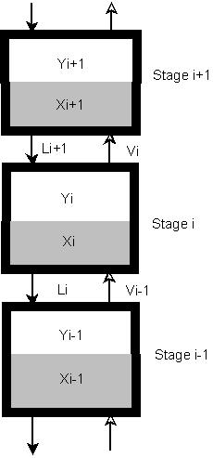
Figure A-18 distillation column section modelled as a set of connected equilibrium stages

Algebraic equation

The liquid composition and the vapour composition on the same stage are related to each other by the algebraic vapour –liquid equilibrium equation:

A.3

Where alpha is the relative volatility. The liquid flow depends only on the holdup over the weir; in this thesis the liquid flow dynamic are given by Francis Weir Formula:

A.4

Where is a constant. The total holdup is the sum of the holdup under weir and the holdup over weir. The total condenser and reboiler are given respectively by:

A.5

and

A.6

Energy balance

Under the assumption of constant molar flow; we can neglect the heat balance, provided the mixture is relatively ideal so that the assumption of constant molar flows holds.
For simplicity in this thesis we assume that the temperature on stage is directly given by the mole fraction (Skogestad and postlethwaite, 2005).

A.7

Where is the number of the components in the mixture and the boiling temperatures of the pure components.
The boiling temperatures of the pure components were obtained using SRK fluid package in Aspen HYSYS.

The relative volatility

As already mentioned above in the assumptions part, we assume constant relative volatility alpha (α) which is obtained using the following formula:

A.8

Where is any component and is an arbitrarily selected reference component in the definition of relative volatilities. (perry’s s.1276_13-35, 1999).
Values are obtained from DePriester charts reading at the pressure where the key separation it was in the actual distillation column.

Appendix B: Temperature and composition

Temperature

Figure to show temperature profiles in the four distillation columns for the case study in chapter before implementation of temperature controllers. Table shows the controlled trays in the D-spice model and used trays in the Matlab/Simulink model. For more on temperature results of all the simulated cases, see the matlab files at Skogestad home page (http://www.nt.ntnu.no/users/skoge/diplom/diplom08/)

Table B-13: Controlled column trays
 | Controlled trays
column | D-spice | Matlab/simulink
deethanizer | 1 | 5
depropanizer | 5 | 5
debutanizer | 5 | 5
butansplitter | 19 | 5

Figure B-1: Temperature profile in the deethanizer column

Figure B-2: Temperature profile in the depropanizer column
Figure B-3: Temperature profile in the debutanizer column

Figure B-4: Temperature profile in the butanesplitter column
Composition

In figure we present an example of how the disturbances affect the composition in the different columns. The obtained results showed that only disturbances in the feed flow rate had a significant effect on composition. That is why the results obtained from this simulation scenario are presented here.
If one is interested in the composition profile for each component or the obtained results for all four simulated scenarios, these are available at Skogestad home page (http://www.nt.ntnu.no/users/skoge/diplom/diplom08/)

Figure B-5: Reponses of top composition in the four distillation columns (butansplitter (a), debutanizer (b), depropanizer(c) and deethanizer (d)) obtained simulating with disturbance in the feed flow. Single loop control responses are green dashed, red solid for MPC and blue dotted for ratio control.

For comparison reason, figure shows top composition responses obtained using disturbance in the feed liquid fraction as simulation scenario.
Figure B-6: Reponses of top composition in the four distillation columns (butansplitter (a), debutanizer (b), depropanizer(c) and deethanizer (d)) obtained simulating with disturbance in the feed liquid fraction qF. Single loop control responses are green dashed, red solid for MPC and blue dotted for ratio control.

Appendix C: Manipulated variables

Figure C.1 to C.4 show the manipulated variables responses obtained from the four disturbance scenarios simulated in this thesis for the process model with MPC.

Figure 0-19: Variations in manipulated variables a) deethanizer, b) depropanizer, c) debutanizer and d) flow. (from disturbance scenario 1)

Figure 0-20: variations in manipulated variables a) deethanizer, b) depropanizer, c) debutanizer and d) flow.( from disturbance scenario 2)

Figure 0-21: Variations in manipulated variables a) deethanizer, b) depropanizer, c) debutanizer and d) flow.(f from disturbance scenario 3)
Figure 0-22: Variations in manipulated variables a) deethanizer, b) depropanizer, c) debutanizer and d) flow.( from disturbance scenario 4)

Appendix D: Attached files

H_process_RC_SL folder:

This folder has Matlab files and simulink models for:
- Single loop control (MulticompModel_SL.mdl)
- Single loop control with bias adjustments (MulticompModel_bias.mdl )
“simresults_SL .m” run the single loop model, whereas, “simresults_bias.m” run the single loop with bias adjustment model.

H_process_MPC folder:

This folder has Matlab and simulink model used for MPC

“MulticompModelMPC.mdl” is the simulink model and run by “simresults_MPC.m”

For a closer description of the Matlab models see (http://www.nt.ntnu.no/users/skoge/book/matlab_m/cola/cola.html).

Data folder:

Single loop control
multicomp_sep_Single_F.mat % data disturbance scenario 1
multicomp_sep_Single_FS.mat % data disturbance scenario 2
multicomp_sep_Single_qF.mat % data disturbance scenario 3
multicomp_sep_Single_zF.mat % data disturbance scenario 4

Single loop control with bias adjustments
multicomp_sep_Bias_F.mat % data disturbance scenario 1
multicomp_sep_Bias_FS.mat % data disturbance scenario 2
multicomp_sep_Bias_qF.mat % data disturbance scenario 3
multicomp_sep_Bias_zF.mat % data disturbance scenario 4

MPC
multicomp_sep_MPC_F.mat % data disturbance scenario 1
multicomp_sep_MPC_FS.mat % data disturbance scenario 2
multicomp_sep_MPC_qF.mat % data disturbance scenario 3
multicomp_sep_MPC_zF.mat % data disturbance scenario 4

