Procedure for extending the EOP Oil and Gas library.

1. Open the exisiting library by double-clicking the EOP_Oil_and_Gas_Simulink_Library.mdl located as shown below.
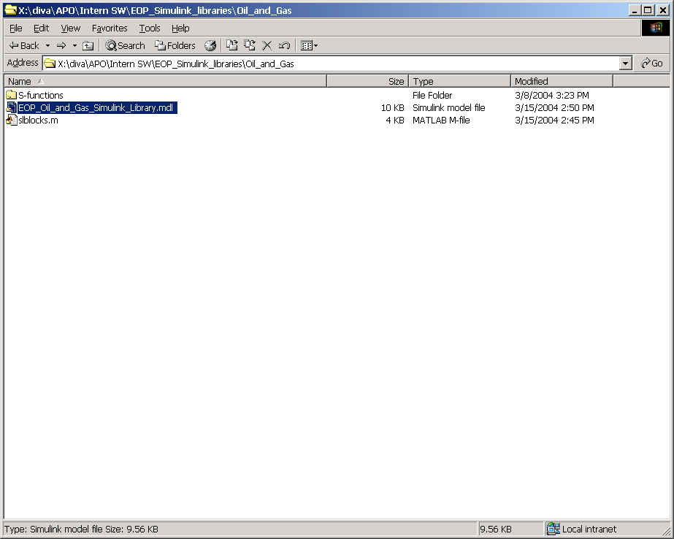

2. You will now see the simulink file representing the library. Note the “Library:” preceding the filename. This is differing a Simulink library from a ordinary simulink file. The content will be something like in the figure below.
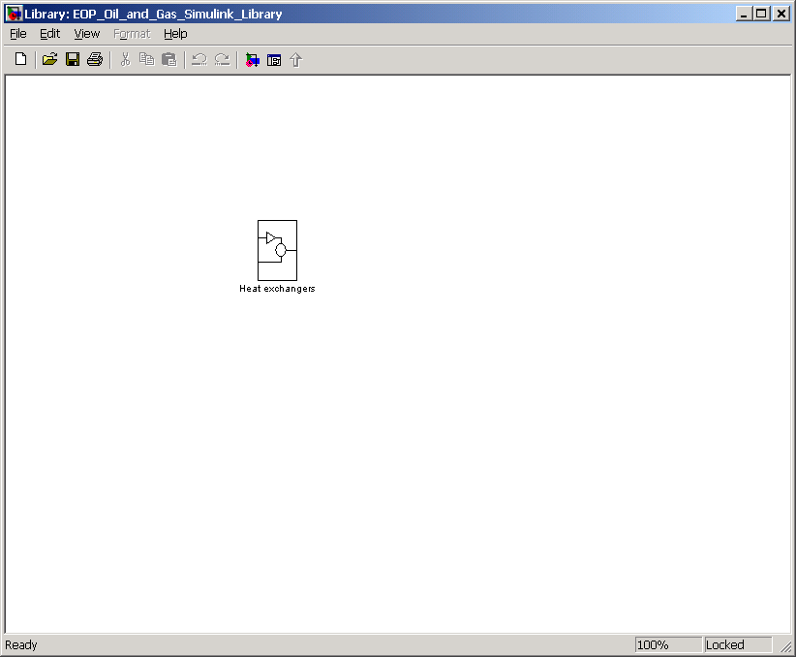

In the version of the library used for creating this procedure, there exists only one sub-class of models, namely the one for heat-exchangers.

If you want to add a new type of heat exchanger, proceed as follows.
- double click the Heat Exchanger subsystem block and get the following window
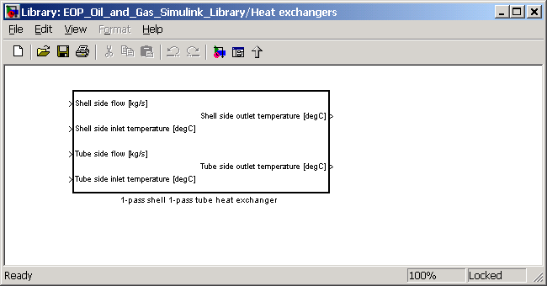
- Unlock the library to enable editing it

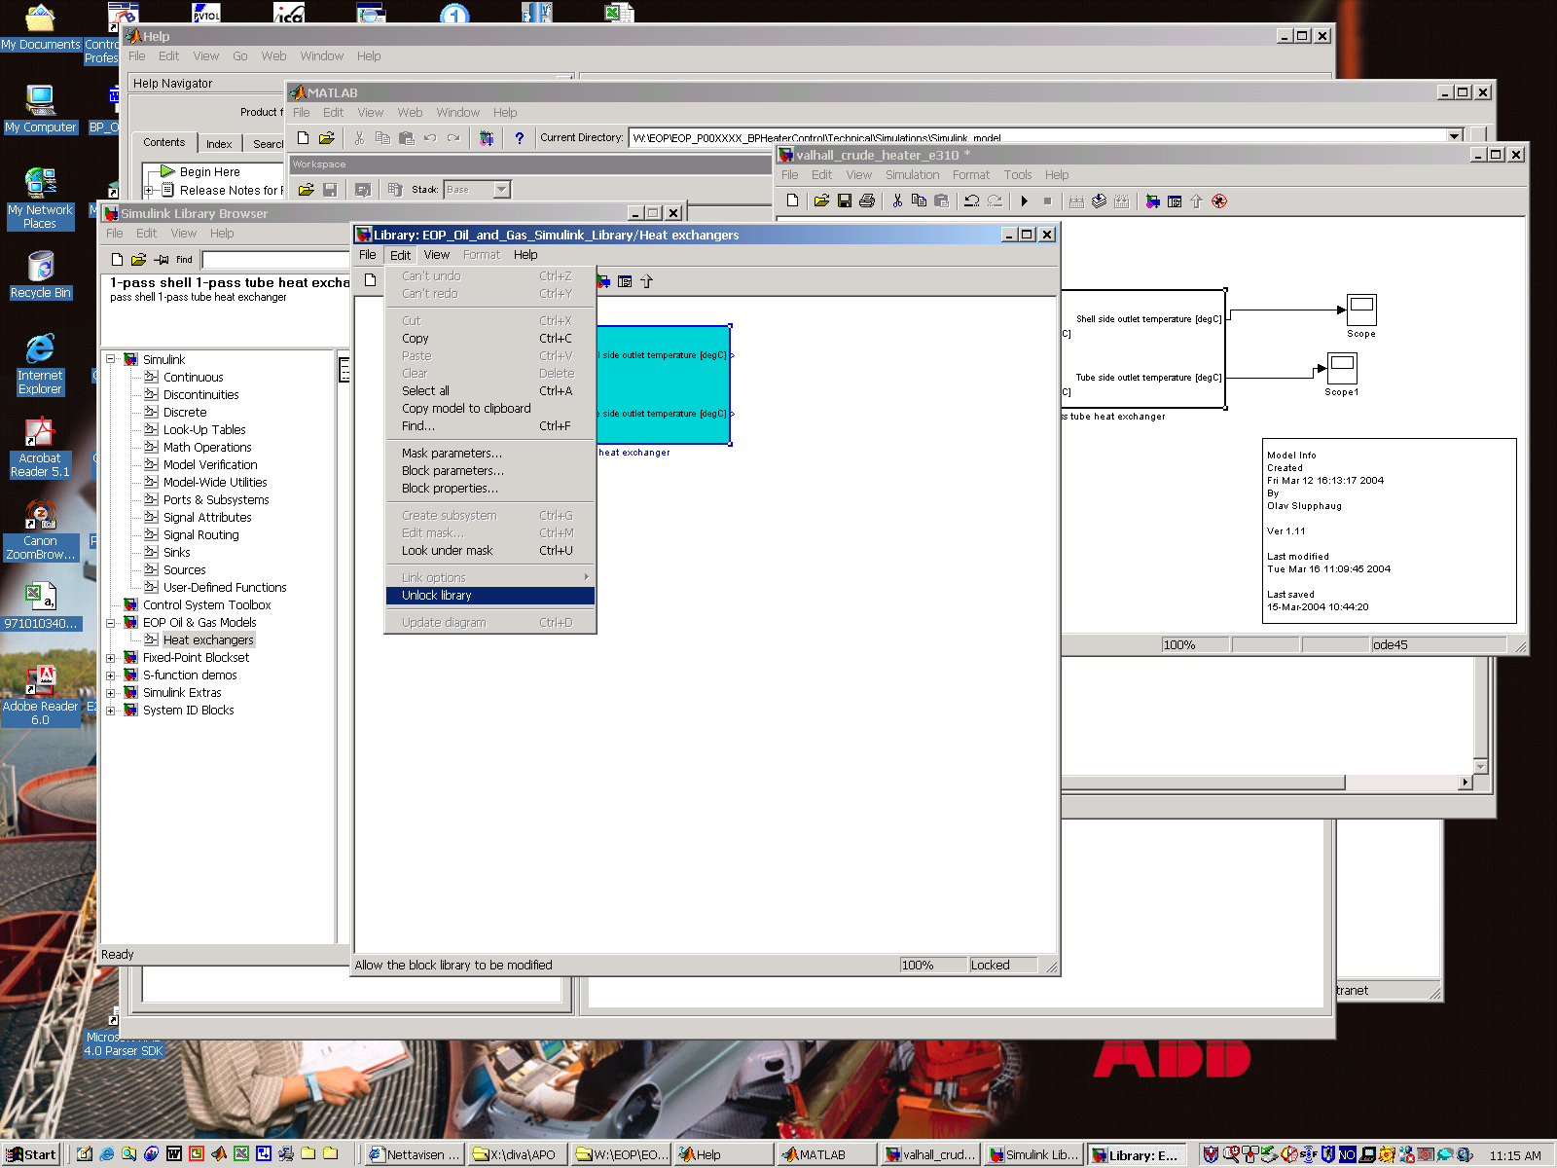

- create the functionality defining the new heat exchanger and get something like this (do not add any inputs or output gates). NOTE: If you want to paste in functionality defined in another simulink model, you must have started the EOP_oil_and_gas_simulink_library.m in the same Matlab session (command window) as the simulink one you want copy the functionality from.
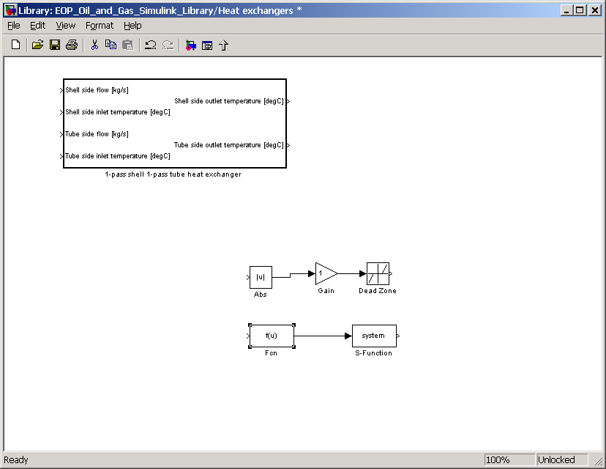

- mark all new compononents and Create Subsystem and get this view
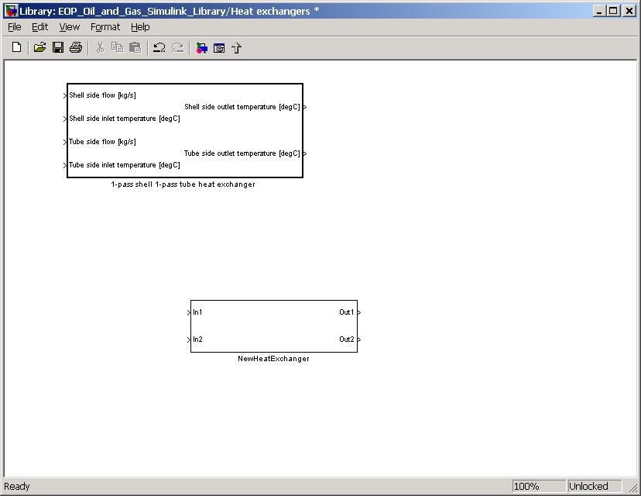

- change the names of the input and output gates to relevant names.

- mask the subsystem and add relevant parameters, and you will get this view
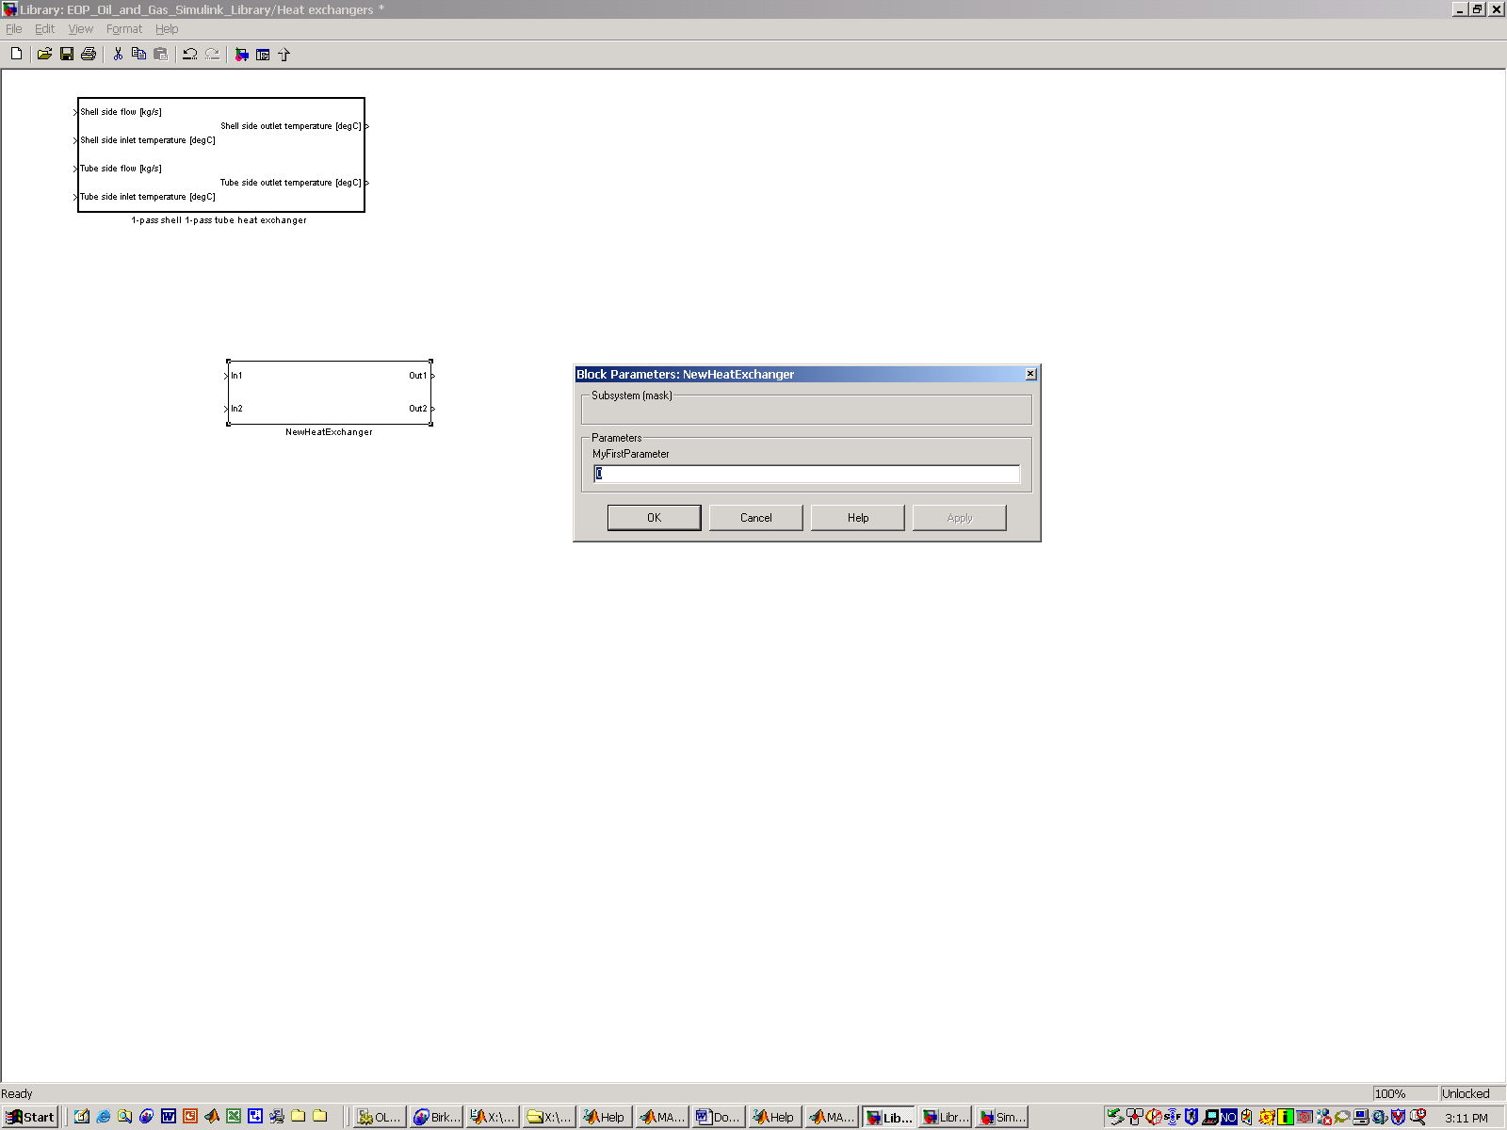

- save the library, close the simulink library browser, and open it again and you will get the new heat exchanger included in the EOP library as shown below.
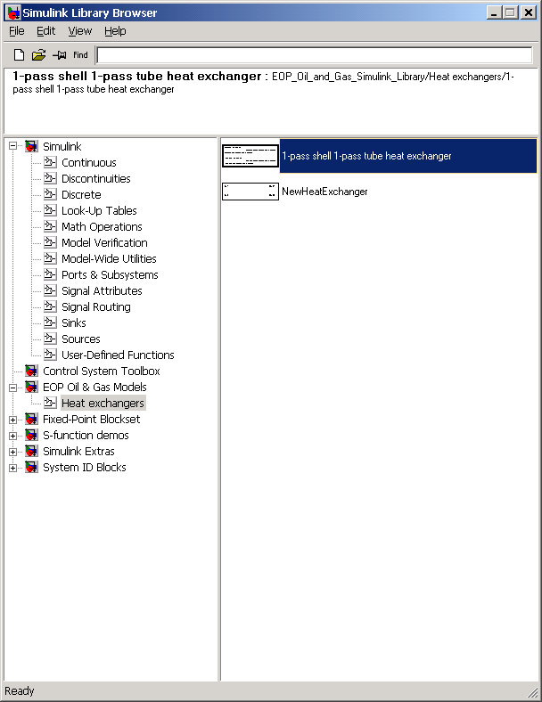

If you want to include a new class of models, say separators, do as follows
- compose the new model at the same level as the heat exchanger sub-system, and get something like this
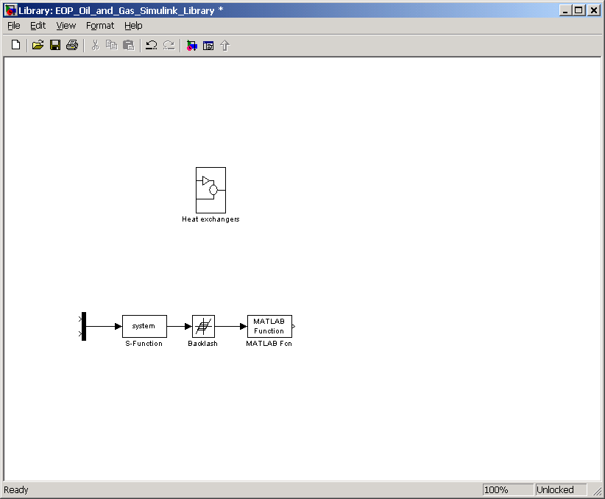

- make the new model a subsystem, and get this view
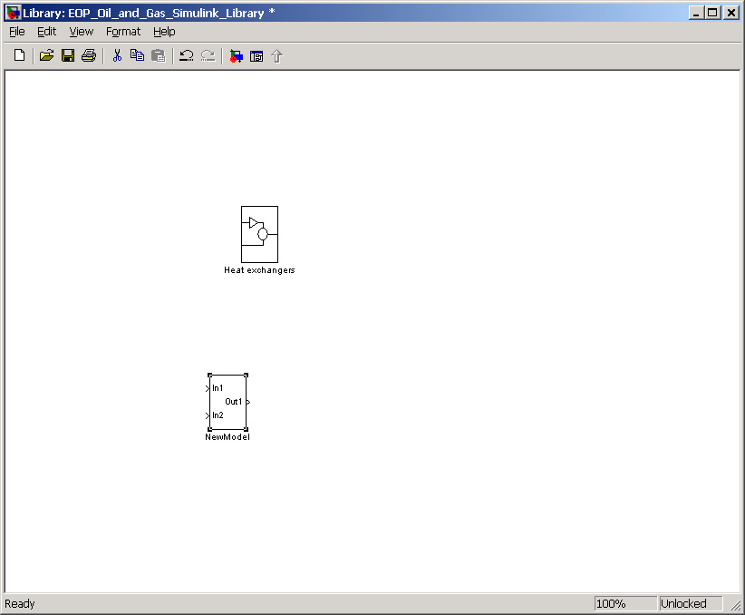

- mask the subsystem, include the relevant parameters, and get something like this when double clicking the NewModel.
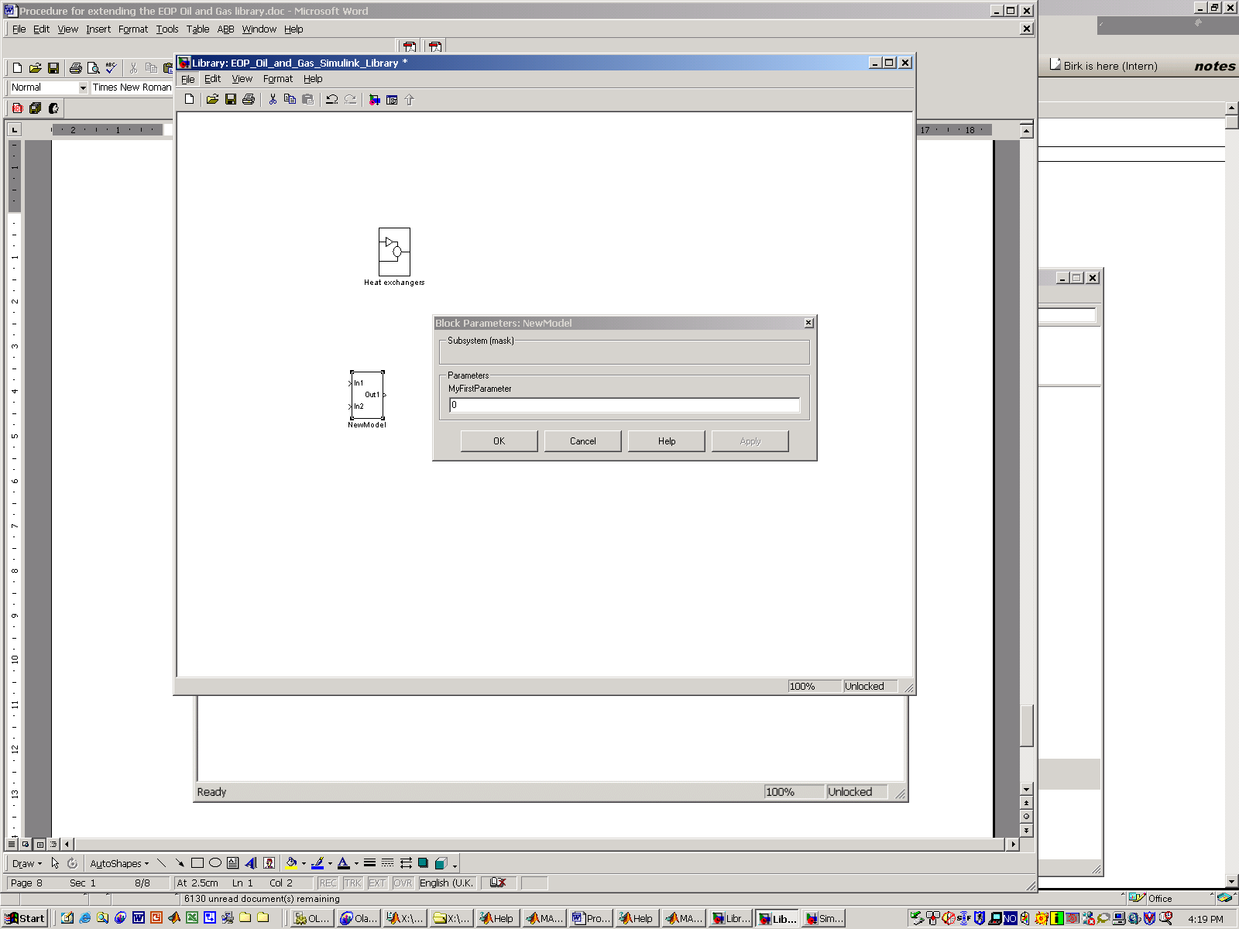

- choose the masked model and make it a subsystem. Double click the new subsystem (containing the masked subsystem NewModel) and get this view
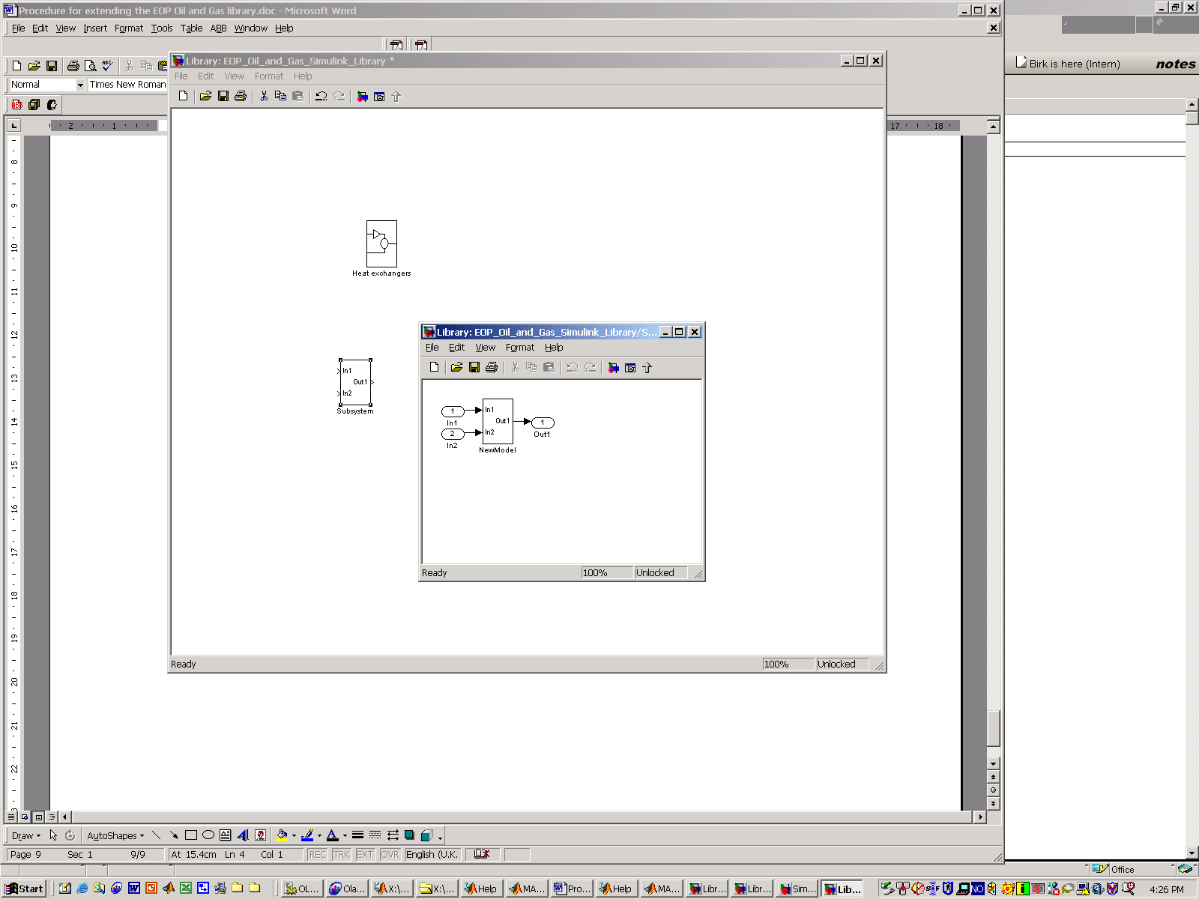

- delete the input- and output ports and associated connections, close the NewModel window, and get this view after having named the new subsystem Separators.
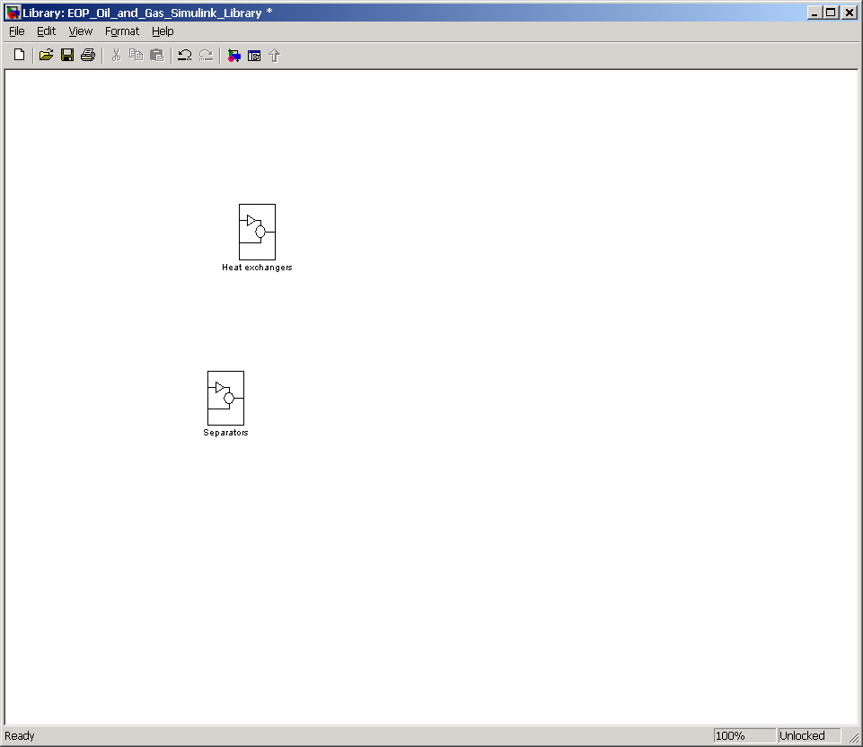

- Save the library file, and you are done with extending the library with a new class of models containing one member. Close the Simulink library browser and open it again, and you should get these views

