A. The model
The model provided using Simulink is found on a separate disc attached to the original thesis. In this section a short introduction on how to put the model to use will be provided.

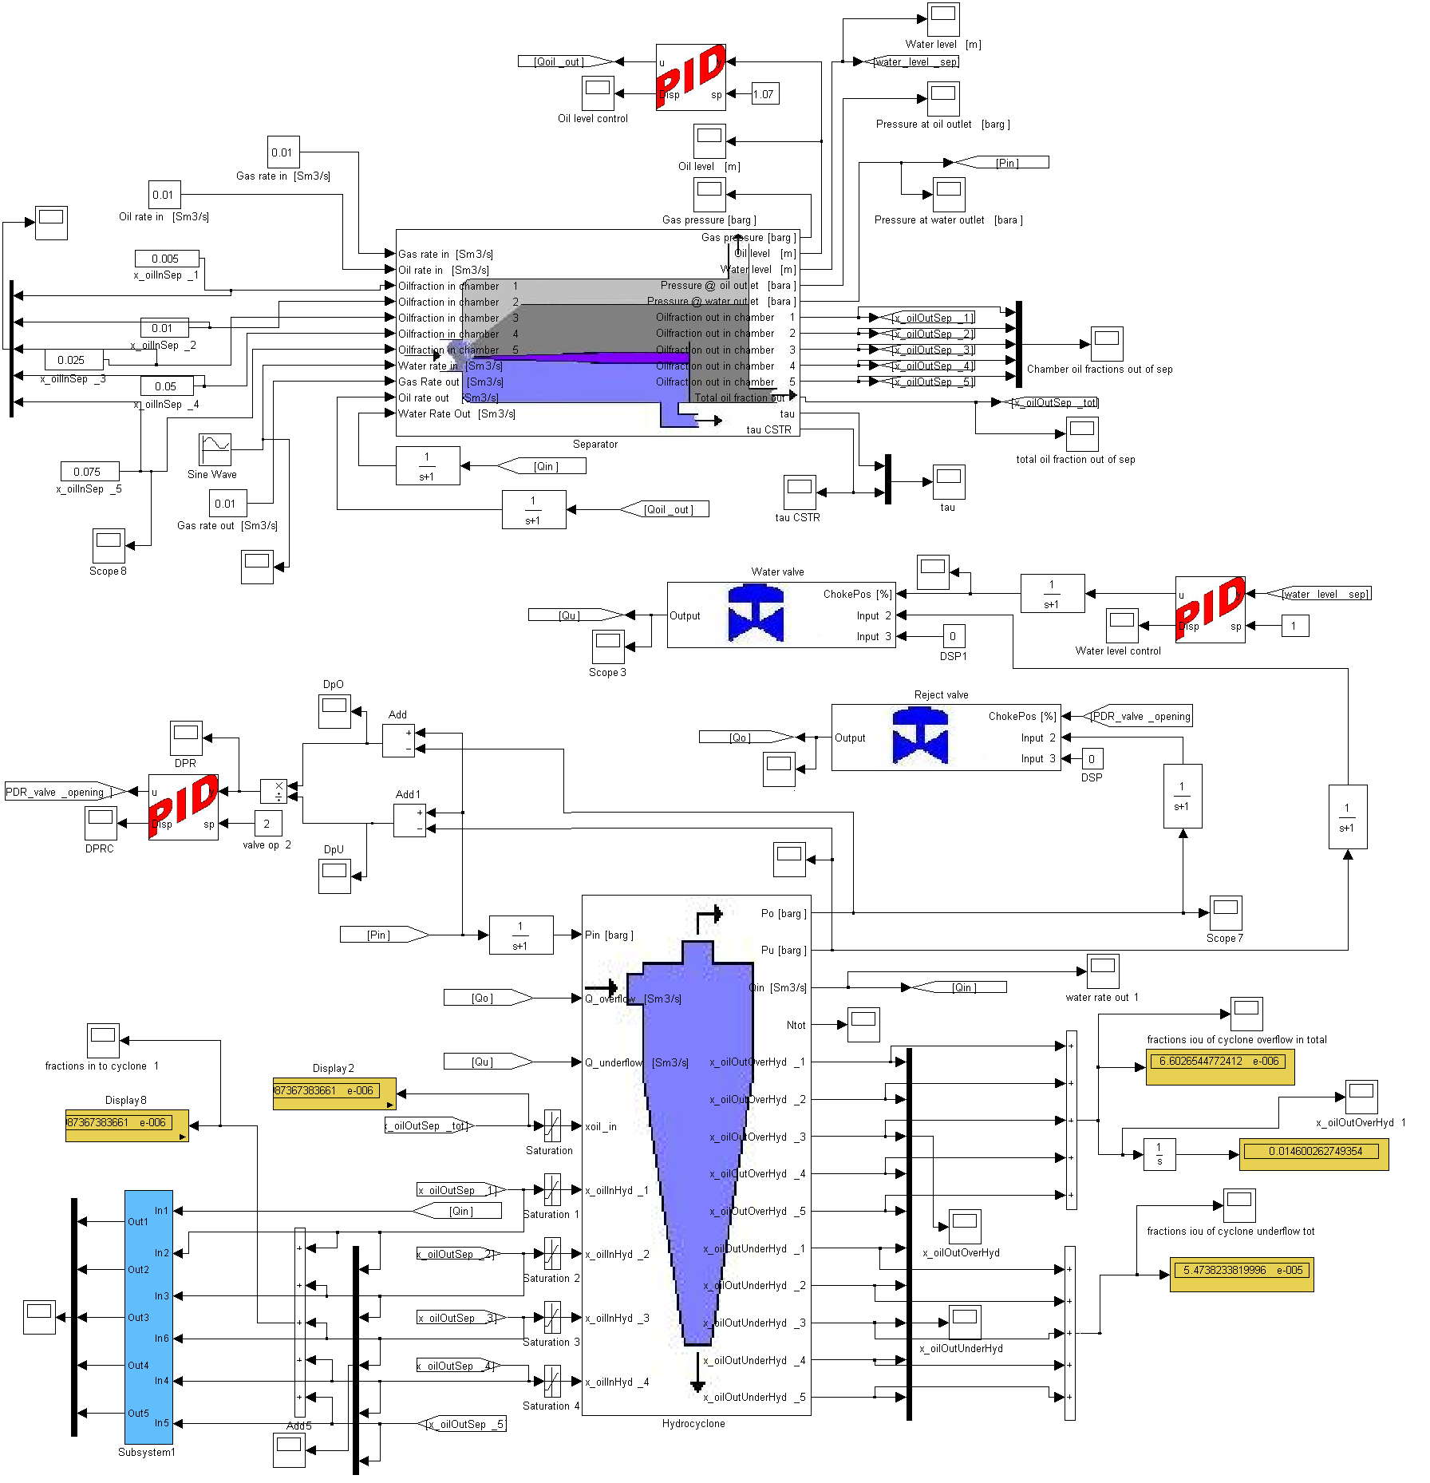
Figure A.1. The model

The modelling was done using Matlab R2007b but hopefully there are not any problems implementing the model also using other versions.

On the attached disc to the original thesis the following items are found:
- The Simulink model is found in the file Model.mdl.
- The s-functions providing the separator and the hydrocyclone coding resulting from this thesis are found in the files sSeparator and sHydrocyclone respectively.
- Picture representations in Simulink of the hydrocyclone and the separator are found in the files hydrocyclonesim.JPG and Separatorpic.JPG respectively.
- ABB’s department of Enhanced Operation and Production’s Simulink library, providing the coding for the additional equipment consisting of valves and controllers is found in the folder EOP_Oil_and_Gas_Simulink_Library.
- A copy of this text file is also attached.

Putting the model to work:
- Place all the files in the same Matlab workspace.
- Add the EOP_Oil_and_Gas_Simulink_Library folder to the workspace path.
- Open the model and choose the fixed-step solver: ode3 (Bogacki-Shampine) with a fixed-step size of 0.1 and a tasking mode for periodic sample times set to auto. The fixed step size can be changed if required, but remembering to provide the same change also to the sampling time for the flow measurement in the separator mask. The solver can also be chosen as a variable step one, as the commonly used ode45(Dormand-Prince) but as plug flow is assumed for the flow through the separator the accuracy may be limited and a problem with the model drifting off may occur and it is therefore not recommended.
- All the constant parameters can be changed within the application masks.
- The model should now be ready for use in running simulations.

