DIPLOMA THESIS 2002

DESIGN AND IMPLEMENTATION OF

MULTIVARIABLE CONTROL STRUCTURE
FOR A PRESSURE TANK

BY:
KJETIL MEYER
FACULTY OF CHEMISTRY AND BIOLOGY
DEPARTMENT OF CHEMICAL ENGINEERING
NTNU

ADVISOR: PROFESSOR SIGURD SKOGESTAD

CO-ADVISOR: Ph.D STUDENT VIDAR ALSTAD

TRONDHEIM 7. JUNE 2002
NTNU Faculty of Chemistry and Biology
Norwegian University of Science Department of Chemical Engineering
and Technology



DIPLOMA WORK 2002

Title:  Design and implementation of multivariable  control structure for a pressure tank. | Subject (3-4 words):  process control, MPC, experimental pressure tank
Author:  Kjetil Meyer | Carried out through:  Spring 2002
Advisor:Sigurd Skogestad  Co-advisor:Vidar Alstad  External advisor: | Number of pages: 78  Hovedrapport:46  Bilag:32
ABSTRACT

Goal of work (key words):

Two control structures for an experimental pressure tank have been implemented. The control structures are desentralized PI-control and linear MPC. A control program has been made for both controllers to make them easy to use. The two controllers have been tuned, and then compared based on physical experiments.

Conclusions and recommendations (key words):

The control program is working properly, but several improvements can be made. Data storage and data plotting are the main areas where it can be improved.

MPC control will be a better alternative than PID control if one has enough time to tune the controller properly.

The largest uncertainty lies in the modelling of the interactions between the pressure output and the liquid valve input for the pressure tank.

I declare that this is an independent work according to the exam regulations
of the Norwegian University of Science and Technology

Date and signature: .......................................................

Summary

This diploma thesis was about implementing two new control structures to a pressure tank. And then to tune and compare the controllers. The pressure tank is an experimental tank at the chemical engineering department at the Norwegian University of Science and Technology.

The tank was connected to a new data acqusition card. A control program was made using Matlab/simulink and a third party software made by N. L. Ricker at the University of Washington. A desentralized PI-control structure was implemented to the program. An other program was made with a linear MPC control structure implemented. To make the programs easier to use, graphical user interfaces were made for both the control programs.

The controllers were tuned and compared based on physical experiments. Setpoint changes and disturbances were imposed to the process to test the controllers.

The control program is working properly, but several improvements can be made. Data storage and data plotting are the main areas where it can be improved.

Using Matlab/Simulink with Rickers program to control the process worked fine. It was stable and easy to set up, and the sample time was not a problem.

The MPC controller worked better than the PID controller. The MPC was a lot more stable and just as fast or faster than the PID controller. The MPC controller took the strong interactions of the system into account. The tuning of the PID controller was a lot easier and faster however. The MPC controller was cumbersome and time consuming to tune properly.

The largest uncertainty lies in the modelling of the interactions between the pressure output and the liquid valve input for the pressure tank.

MPC control will be a better alternative than PID control if one has enough time to tune the controller properly.

Summary 3
1 Introduction 6
1.1 Background 6
1.2 Purpose 6
1.3 Outline of report 6
2. Theory 7
2.1 PID-controller 7
2.2 Skogestad IMC- PID-rules 7
2.2.1 Deduction of the model 7
2.2.2 Tuning of the PID-controller 8
2.3 MPC-control 9
2.3.1 General MPC theory 9
2.3.2 The process model 9
2.3.3 The object function 10
2.3.4 Prediction and control horizon 10
2.3.5 Weights on the output and input 11
2.3.6 Constraints on the output and input 11
3 Experimental 12
3.1 Process description 12
3.2 The Data acquisition card 12
3.3 The control programs 13
3.3.1 Software connection 13
3.3.2 The Simulink diagram for the PI-controller 14
3.3.3 The graphical user interface for the PID-controller 16
3.3.4 The Simulink diagram for the MPC-controller 16
3.3.5 The graphical user interface for the MPC controller 17
4. Results 19
4.1 Tuning of the PI-controllers 19
4.1.1 System identification and controller tuning for the liquid valve 19
4.1.2 System identification and controller tuning for the pressure valve 20
4.2 Tuning of the MPC controller 20
4.2.1 System identification 20
4.3 Choice of MPC parameters 22
4.3.1 Weights of inputs and outputs 22
5. Discussion 30
5.1 Comparison of PI- and MPC control 30
5.1.1 A PID- and MPC controller 30
5.1.2 Two MPC controllers with different models 34
5.1.3 MPC with a model error 38
5.1.4 Summary 41
5.2 Model discussion 41
5.3 Software discussion 42
5.4 Further work 42
6. Conclusion 44
References 44
List of symbols 46
A1: The Data Acqusition Card 47
A2: Calibration of level and pressure 48
Tabel A2.2 Pressure and voltage values 49
A3 Manual for the control programs 50
A3.1 The PID-control program 50
A3.1.1 Startup 50
A3.1.2 Controlling the process manually 50
A3.1.3 Controlling the process automatically 51
A3.1.4 Adjusting the setpoints 51
A3.1.5 Data logging 51
A3.1.6 Safety measures 52
A3.1.7 Quit 52
A3.2 The MPC program 52
A3.2.1 Startup 52
A3.2.2 The transfer functions 53
A3.2.3 The weights and horizons 54
A3.2.4 Controlling the process manually 54
A3.2.5 Controlling the process automatically 54
A3.2.6 Adjusting the setpoints 54
A3.2.7 Data logging 54
A3.2.8 Safety measures 55
A3.2.9 Quit 55
A4: System identification and PI-tuning 56
A4.1 Liquid valve controller 56
A4.2 Pressure valve controller 57
A4.3 System identification of the interactions 58
A4.4 System identification for a new model 59
A5: Matlab code 63
A5.1 The PID control program 63
A5.2 The MPC controlprogram 69

1 Introduction

Background

The Institute for chemical process engineering at NTNU has a pressure tank that is being used as a controllab experiment for undergraduate students. The pressure tank has water and air inlets and outlets and is supposed to simulate an oil/gas separator. The control system consist of a IBM-386 computer running the Paragon control software. The process has heavy interactions between the pressure and level, but the control structure used is desentralized PID-control.

A MPC control structure will be added to the process. MPC is today the far most common multivariable control structure in the industries. The pressure tank is a good system to use MPC-control on since it is fairly easy to identify a model.

This thesis was carried out at the department of chemical engeineering, Norwegian Institute of Science and Technology. Supervisors have been professor Sigurd Skogestad and PhD student Vidar Alstad.

Purpose

The purpose of this project was to implement a new control structure and software in the pressure tank. The new control program will be based on Matlab/Simulink and a third party software to connect Simulink to a DAQ device. Two new control structures have been implemented.
1. A linear MPC control structure based on step-respons models. The MPC controller will be based on Mathworks inhouse MPC controller to ensure compatibility with Simulink.
2. A decentralized PID controller
The following changes have been implemented.

- The process has been connected to a new data acqusition card.
- A new program has been made for both PID and MPC control.
- A graphical user interface has been made to ensure an easy use for the students

The PID- and MPC-controller are compared based on physical experiments.

Outline of report

This report is diveded into 6 chapters and additional appendixes. The 1. chapter gives a brief introduction to the background and purpose of this project. Chapter 2 discusses the theory around PID and MPC control. Chapter 3 treats the experimental procedures. Chapter 4 describes the tuning of the controllers. Chapter 5 contains a general discussion of the work. Chapter 6 summaries and concludes the works. Then there are references and list of symbols. The appendixes are divided into information about the DAQ card, calibration of level and pressure, manual for the control program, system identification and Matlab code.

2. Theory

2.1 PID-controller

PID-control is by far the most common control method used in the industry today. It is divided into three parts. The proportional part (P) changes the input directly proportional to the error. The integral part (I) changes the input proportional to the integrated error. And the derivate part (D) changes the input proportional to the derivate of the controlled variable. The ideal PID algorithm is given by the equation: see Seborg^{/6/}:

$u\left(t\right)=u_{0}−K_{C}^{'}\left(e\left(t\right)+\frac{1}{τ_{I}^{'}}\int{e\left(t\right)}+τ_{D}^{'}\frac{\text{de}\left(t\right)}{\text{dt}}\right)\text{dt}$ (2.1)

Where u is the input, Kc the gain, τ_{I} is the integral time, τ_{D} the derivate time and e is the difference between the measured variable and the setpoint. This equation gives the ideal PID-controller in transformed Laplace space:

$K\left(s\right)=K_{C}^{'}\left(1+\frac{1}{τ_{I}^{'}s}+τ_{D}^{'}s\right)$ (2.2)

It is most common in chemical engineering practice to us a PI-controller.

$K\left(s\right)=K_{C}\left(1+\frac{1}{τ_{I}s}\right)$ (2.3)

The PI-controller used in this assignment is a decentralised controller.

2.2 Skogestad IMC- PID-rules

2.2.1 Deduction of the model

For more information about the Skogestad PID-rules see Skogestad^{/1/}.

The Skogestad PID-rules are based upon the IMC PID tuning rules of Morari et. al. It consists of finding a 1. or 2. order transfer function for the process using the “half-method”. For a PI-controller the most common will be to use a 1. order transfer function. To obtain this function information is needed about the process gain, k, the integral time, τ and the dead-time θ.

$f=\frac{k⋅e^{−θs}}{τs+1}$ (2.4)

One way of obtaining this information is to make experimental step-responses for the process. Figure 2.1 show an example of such a step-respons.

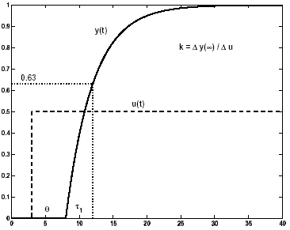
Figure 2.1: Step-respons

The gain, k, is found from the change in the steady-state value of the process output $k=\frac{Δy(t=∞)}{Δu}$. The process dead-time, θ , is the time from the input change until the output starts to change. The dominant time-constant, τ₁, is the time from the output starts to change until it has reached 63% of its final value.

For an integrating process the exact values of k and τ₁ are not so easy to find, so Skogestad recommends that the initial slope k’=k/τ should be used instead.

2.2.2 Tuning of the PID-controller

Skogestad recommends the following tuning parameters for the controller gain and time constant for an ideal PI-controller.

$K_{C}=\frac{1}{k}\frac{τ_{1}}{τ_{C}+θ}$ (2.5)
$τ_{I}=\text{min}(τ_{1},\frac{4}{K_{C}k}τ_{1})$ (2.6)

For an integrating process the following tuning parameters are recommended.

$K_{C}=\frac{1}{k'}\frac{1}{τ_{C}+θ}$ (2.7)
$τ_{I}=\text{min}(τ_{1},4\left(τ_{C}+θ\right))$ (2.8)

For robust tuning it is best to use $τ_{C}≥θ$. This choice will often be a trade-off between speed of respons and disturbance rejection, stability, robustness and input usage.

These rules are based on SISO systems, and do not take into account MIMO system with strong interactions

2.3 MPC-control

2.3.1 General MPC theory

MPC, or modelbased predictive control, has over the last years become more and more popular both for academic and industrial use, Maciejowski^{/5/}. The concept of MPC is that the controller solves an optimizing problem in real time. The optimizing problem uses an explisit formulated process model to predict the future behaviour of the process. This predication takes into account constraints on both the inputs and outputs of the process. An optimal input sequence is then calculated, and the first input is used on the process. The measurments are then sent back to the controller, and a new optimizing problem is solved. Figure 2.2 shows how a MPC controller is structured.

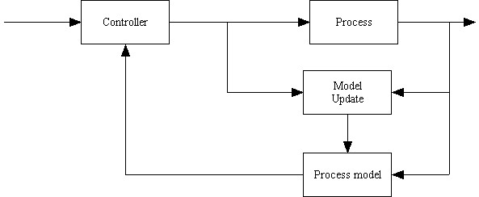
Figure 2.2 Structure of MPC controller

2.3.2 The process model

There are several ways for modelling the process. One is to use a state-space model. This way has become most popular in academic circles because it uses a small number of parameters and can guarantee stability. For this project however the step-respons model was used.

The step-response model makes steps in the inputs of the process. From the behaviour of the system, linear transfer functions are found. For a system with two inputs and two outputs the process model will be on the form.

$y=\left[\begin{matrix}g_{\text{11}} & g_{\text{12}} \\ g_{\text{21}} & g_{\text{22}}\end{matrix}\right]u$ (2.9)

Where y is the measurements, u is the process inputs and g is the transfer functions from step-responses. This model can be made into a step-respons model with help from the Matlab command tfd2step. The final discrete step-respons model will be on the form:

$y_{k+1}=\sum_{i=1}^{R−1}{a_{i}{Δu}_{k−i+1}+a_{R}u_{k−R+1}+y^{0}}$ (2.10)

where y_{k+1} is the output at time k+1, a is step-response coefficient, y⁰ is the outputs initial conditions and R is a constant. If it is assumed that the step-response for a stable process reaches a steady state value after M time steps, R is chosen so that $R≥M$.

The big advantage with using step-respons models is that the model is fairly easy to obtain. One does not need any information about the process apart from what the step-responses give. This makes it intuitive for students to use for a lab assignment.

The disadvantage is that the process model is only valid in a small area around the steady-state values. Estimating models from step responses gives a lot of emphasis to low frequencies. For feedback control higher frequencies are usually more important^{/5/}. For an unstable process it is also necessary to model the plant as an integrator, which will cause a structural error in the model^{/3/}.

2.3.3 The object function

The MPC controller works by trying to minimize a quadratic object functions.

$\underset{u_{k}^{N}}{\text{min}}φ_{k}=\sum_{i=0}^{P}{\left({\left(y_{k+i}−y^{r}\right)}^{T}Q\left(y_{k+i}−y^{r}\right)+{\left(u_{k+i}−u^{r}\right)}^{T}R\left(u_{k+i}−u^{r}\right)\right)}$ (2.11)
s.t. C$ΔU≥c_{k+1}$ (2.12)

Where P is the prediction horizon, N is the control horizon, y is the output of the process, y^{r} is the reference output, u is the input to the process, u^{r} is the reference input, Q is the weights on the outputs and R is the weights on the inputs.

This function is solved using a quadratic solver to ensure fast optimizing.

2.3.4 Prediction and control horizon

The prediction horizon (P) tells the controller how many sample steps ahead should be used when minimizing the object function. The control horizon (N) tells the controller how many control steps should be used when minimizing (2.10).

The larger N is compared to P, the bigger the chance is that the controller will find an input sequence to minizime 2.11. But that may lead to an aggressive use of input and an unstable system. The values of these parameters will be a trade-off between good performance and time limits. Gjerstad^{/2/} recommends that $P≥M+N−1$ where M is the length of the step-respons. But he warns that those values could give too large P.

2.3.5 Weights on the output and input

The weights in the object function tells the controller which of the variables that should be emphasised more than others. A high weight on one of the outputs will force the controller to keep that value closer to the referance than the value of the other outputs. A high weight on one of the inputs will reduce the input activity. If the weight on the input is increased indefinitely, the activity will be reduced to zero, and there will no longer be any feedback action.

The most common way of tuning the weights is to use them to scale all the inputs and outputs of the object function. This ensures that the controller will take all parts in to equal consideration. From there on the weights need to be adjusted to best fit the particular process.

2.3.6 Constraints on the output and input

A MPC-controller can handle constraints both for the inputs and outputs. The constraints will be formulated like

$u_{k+1}^{\text{min}}≤u_{k+1}≤u_{k+1}^{\text{max}}$ (2.13)
$y_{k+1}^{\text{min}}≤y_{k+1}≤y_{k+1}^{\text{max}}$ (2.14)

These limitations can lead to an infeasible solution set for the controller. It can also give a very aggressive controller. To solve that problem it is often possible to either soften the constraints or move the constraint window to later times.

3 Experimental

3.1 Process description

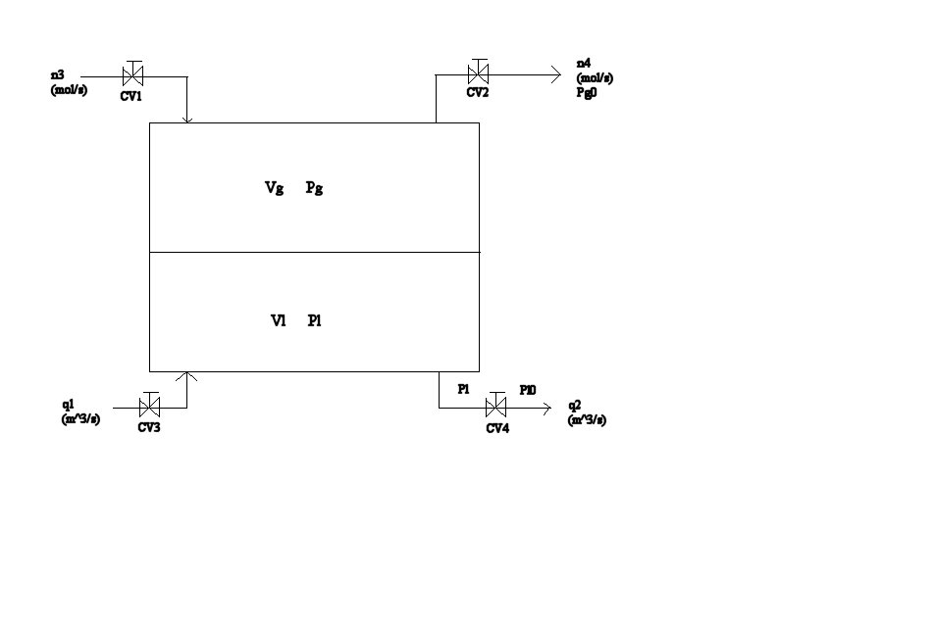
Figure 3.1 Sketch of the pressure tank

The process which was controlled was a pressure tank. A sketch is shown in figure 3.1. Air flows through valve CV1 and water flows through valve CV3. The outputs that are controlled are the tank pressure Pg and water level. The inputs are valve CV2 which controls the air outlet flow and CV4 which controls the water outlet flow.

3.2 The Data acquisition card

The Data Acquisition card used for this project is NI-DAQ 6036E, se Appendix A1. This card has a sampling rate of 200 kS/s, with 16 bits resolution on 16 analouge inputs.

The connection scheme for the NI-DAQ 6036E is shown in figure 3.2.
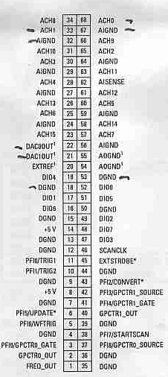
Figure 3.2 Connection scheme for NI-DAQ 6036E

The level indicator is connected to AC1 (33) and AIGND (32). The pressure indicator is connected to AC0 (68) and AIGND (67). The pressure valve (CV2) is connected to DAC0OUT (22) and DGND (18). The liquid valve (CV4) is connected to DAC1OUT (21) and DGN (53).

To avoid noise in the measurements, the card takes the average value of 500 samples for each sample time.

3.3 The control programs

The software used to make the control programs was Windows 2000 with Matlab 6.1 and Simulink 2.1 running on an IBM computer with PIII 850 MHz processor and 256 MB of RAM.

3.3.1 Software connection

To make the controller communicate with the actual process some sort of external program is needed. This program must receive the output measurements from the process, send them to the controller, and send the new inputs calculated by the controller back to the process. Examples of such programs are NIs Labview or Mathworks xPC Target.

For this project Matlab/Simulink was used with a third party software to connect to Data Acquisition toolbox. The software is developed by N. L. Ricker^{/4/} from the University of Washington and is freely available form the author for academic use.

Data Acquisition toolbox (DAQ) is a tool released by Mathworks in 1999 to collect and send out signals. DAQ uses high-level Matlab and object oriented programming skills. To make it easier to use DAQ, Ricker packed all the commandos as Simulink blocks. Thereby the commands could be configured graphically.

Simulink is a simulation platform consisting of interconnected blocks. Each block can be modelled as a continuous system, a discrete operation, or a hybrid of the two. The blocks are connected together by signals that represents time depended variables and parameters. During a simulation the blocks are called repeatedly to get the information needed to calculate the signals. The problem is that there is no connection between the simulated time for each time a block is called, and the real time. The real time will depend upon the complexity of the block and the CPU power available. It is therefore impossible to predict the real time usage to calculate a sequence of blocks. This is incompatible with DAQ needs.

The software solves this problem by slowing down Simulink. That means every time a DAQ-block is calculated, the CPU clock is checked. Then the block pause the simulation until real time catches up. When real time is the same as simulated time, the block collects the data, and continues the simulation.

Ricker reports that the sample time for the program should be kept at 1 second or higher. This will be tested out in the experimental part of this project.

3.3.2 The Simulink diagram for the PI-controller

Figure 3.3 shows the simulink diagram for the PI-controller.
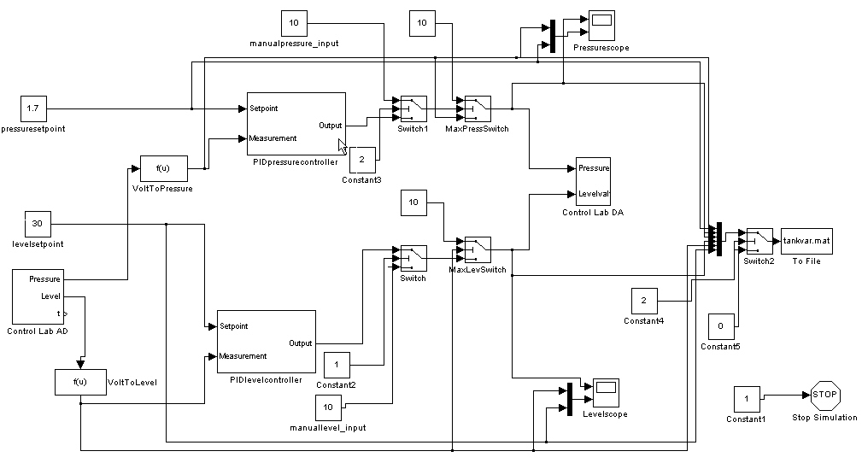
Figure 3.3 The Simulink diagram for the PI-controller program

The two blocks named Control Lab AD and Control Lab DA are from Ricker. The AD block get the volt signals from the output ports of the DAQ card and converts them into values Simulink can use. The sampling time is the one thing the user can decide. The signals are then converted from volt to pressure and bar in the blocks named VoltToPressure and VoltToLevel. The calibration of these blocks can be found in appendix A2. Then they are sent to the PI-controllers together with the setpoint values. The PI-controllers are built as shown in figure 3.4.

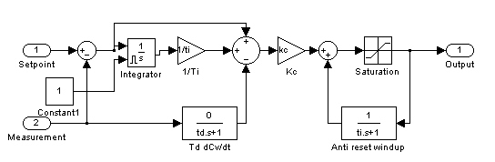
Figure 3.4 The PI-controller.

This PI-controller is built like an ideal controller. The block named Constant1 ensures that the integrator is zeroed out every time the PI-controller jumps in. This prevents windup of the controller. The parameters that the user controlls are Kc, τ_{I}, τ_{D} and the upper and lower limits for the input signals.

The signals calculated from the PI-controller are then sent to the Control Lab DA block. Here the signals sent back to the DAQ card. The switches that can be seen after the PI-controllers are there to ensure that the process can be controlled manually. Whenever the manual switch is turned on, the signals sent to the DA blocks comes from the manual blocks. The next switches, names MaxLevSwich and MaxPressSwitch are safety switches. Whenever the level or pressure value reaches a treshold, currently 3 bar and 50 cm, the program switches to manual mode and opens the valves. This ensures that the pressure and level values never will become critically high.

All the signals are also sent to the block named “to file”. Here the signals are stored in a file called tankvar.mat. The switch in front of the block ensures that the user can decide whether to store the signals or just zeros. This ensures that the matrixes do not become too large and difficult to handle for the user when analyzing the data.

3.3.3 The graphical user interface for the PID-controller

To make the program easier to use a graphical user interface (GUI) was made. There the important parameters in the Simulink diagram could be controlled using intuitive sliders and text boxes. Figure 3.5 shows the GUI for the PI-control program.

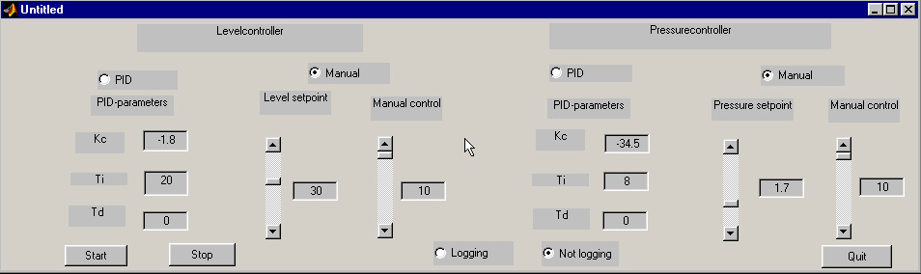
Figure 3.5 The GUI for the PI-control program

The Matlab code for this program is shown in appendix A5. The manual for the program is shown in appendix A3.

This program proved to be very time-consuming to make. In the end several shortcuts had to be made to ensure that the program would be finished in time. The plots used are taken directly from the Simulink plots instead of making the plots inside the GUI. The name of the file where the data is stored can not be decided inside the GUI, but must be set externally.

The setpoint-sliders are connect directly to the setpoint boxes in the Simulink diagram. This makes it easy and intuitive to control the process both manually and automatic.

3.3.4 The Simulink diagram for the MPC-controller

Figure 3.6 shows the Simulink diagram for the MPC-controller.
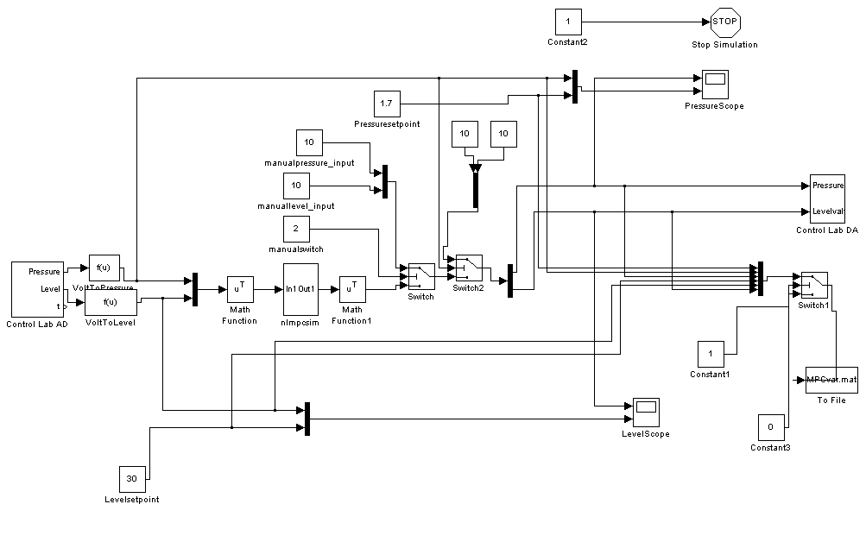
Figure 3.6 The Simulink diagram for the MPC-controller

This diagram is built in almost the same way as the diagram for the PID-controller. The Control Lab AD and Control Lab DA works exactly the same way. The only difference is the controller itself. The controller uses the Matlab program nlmpcsim to calculate the inputs. The user defined variables are the step-response model, the weights on inputs and outputs, the setpoints, the constraints on the inputs and outputs and the initial values of the inputs.

The block nameed Switch2 is the safety function. It ensures that the whenever the pressure value reaches 3 bar, the program opens all valves on the tank.

All signals are also here sent to the block named “To File”, and are stored as a file named MPCvar.mat.

3.3.5 The graphical user interface for the MPC controller

A GUI was made for this program as well. The Matlab code for the GUI is found in appendix A5. The manual for the GUI is found in appendix A3. Figure 3.7 shows the GUI for the MPC program.

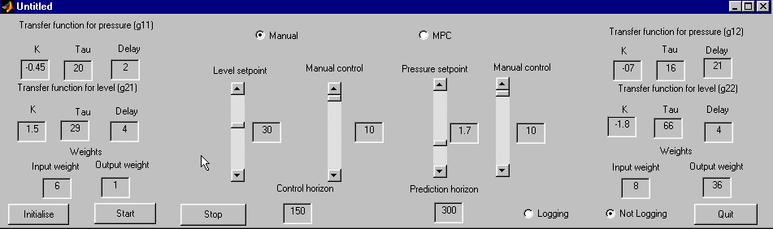
Figure 3.7 The GUI for the MPC program

This program works in the same way as the PID-program. The setpoints and manual control sliders are conncted directly to the Simulink diagram. The only major problem is that the process model and weights can not be changed on-line. The program needs to be stopped and restarted for the changes to take effect.

4. Results

4.1 Tuning of the PI-controllers

The pressure tank was controlled with two PI-controllers to have a comparison with the MPC-controller. The PI-controllers were not decoupled and did not take the systems interactions into account. Skogestads PI-tuning rules^{/1/} was used to tune the controller. All calculations are shown in appendix A4.

4.1.1 System identification and controller tuning for the liquid valve

The process was runned to steady-state values at 1.7 bar pressure and 30 cm liquid height. The controllers were put in manual and a step in the liquid valve of 0.5 V was performed. The plot is shown in figure 4.1.

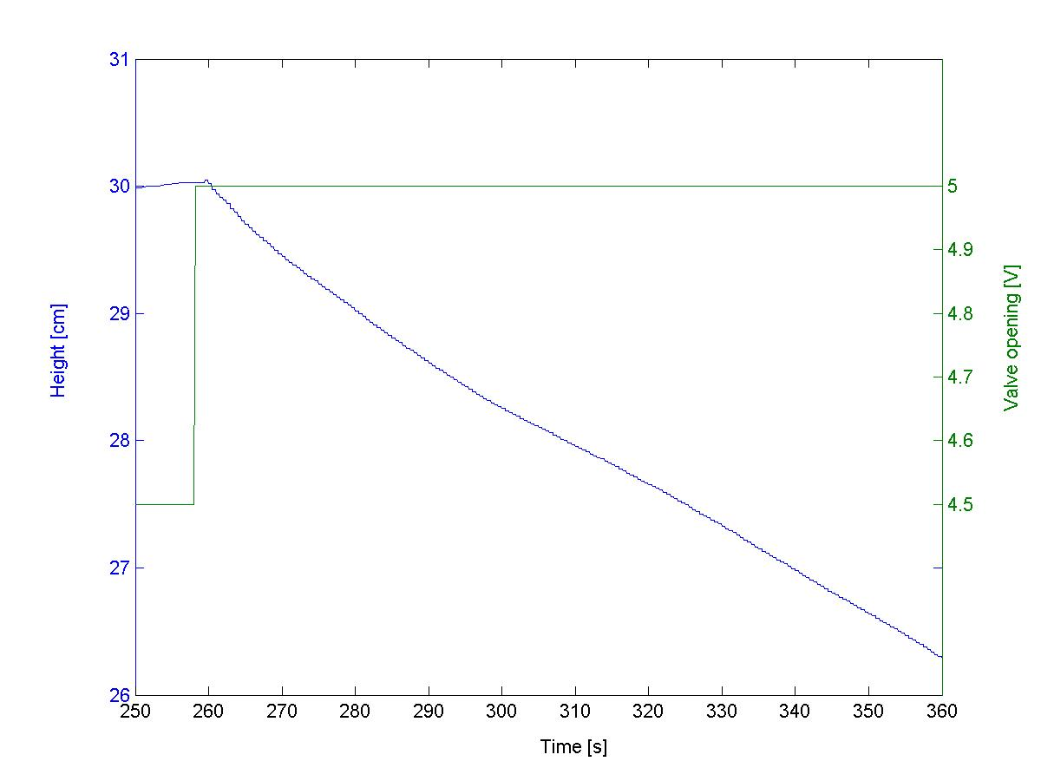
Figure 4.1 Liquid level for 0.5 volt change in the liquid valve input

As can be seen from the plot, this is an integrating process. Using Skogestads rules for integrating process the tuning parameters were found as follows.

Tabel 4.1 Tuning parameters for the PI-controller of the liquid valve
K_{C} [Volt/cm] | Τ_{I} [s]
-3.29 | 16

4.1.2 System identification and controller tuning for the pressure valve

The process was runned to steady-state values at 1.7 bar pressure and 30 cm liquid height. The controllers were put in manual and a step in the pressure valve at 0.5 Volt were performed. The plot is shown in figure 4.2.

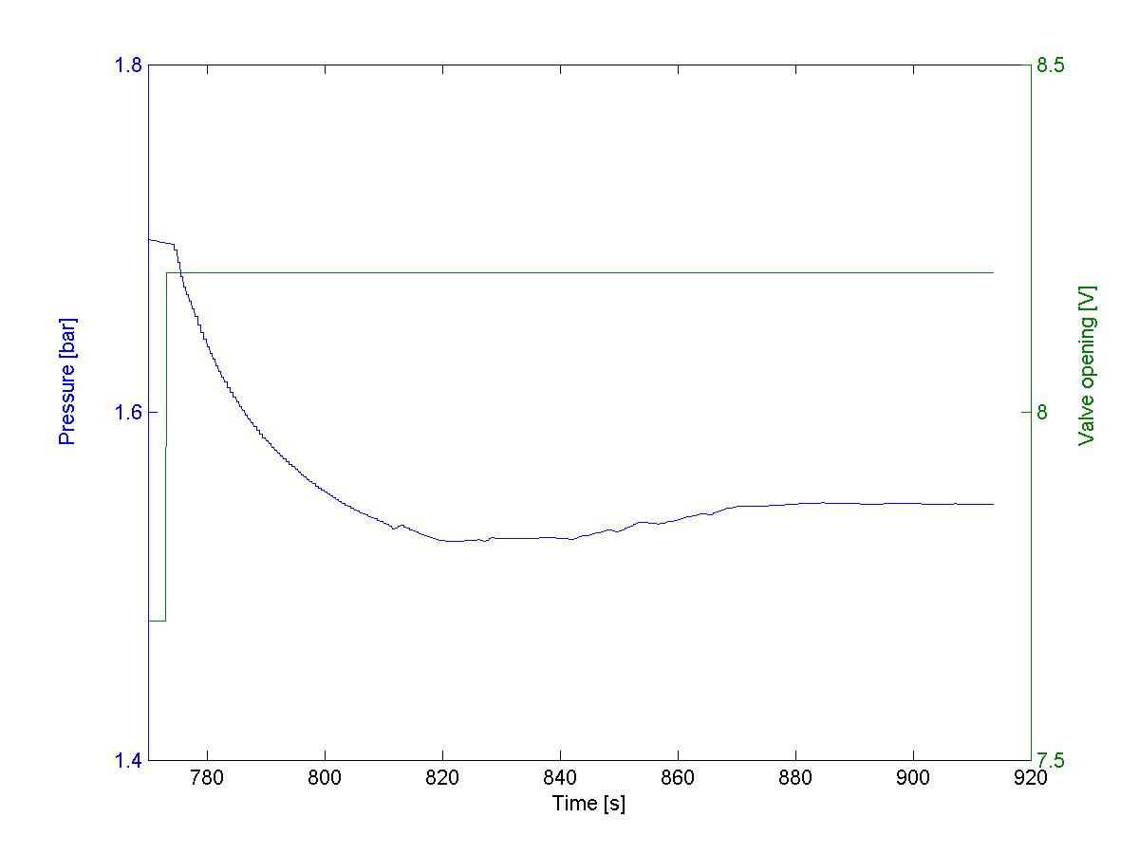
Figure 4.2 Pressure values for 0.5 Volt change in the pressure valve

A first order transfer function was estimated from this plot with a process gain of –0.298 bar/V, a time constant of 12 seconds and a dead-time of 1 second. Using Skogestads rules the tuning parameters for the controller was found to be.

Tabel 4.2 Tuning parameters for the PI-controller of the pressure valve
K_{C} [Volt/bar] | τ_{I} [s]
-20.14 | 12

4.2 Tuning of the MPC controller

4.2.1 System identification

All the calculations can be found in appendix A4.

To identify the model a 2x2 matrix with transfer functions deducted from step responses was used. The model was then on the form:

$y=\left[\begin{matrix}g_{\text{11}} & g_{\text{12}} \\ g_{\text{21}} & g_{\text{22}}\end{matrix}\right]u$ (4.1)

where $y=\left[\begin{matrix}\text{pressure} \text{measurment} [\text{bar}] \\ \text{liquid} \text{measurment} [\text{cm}]\end{matrix}\right]$, $u=\left[\begin{matrix}\text{pressure} \text{valve} [\text{Volt}] \\ \text{liquid} \text{valve} [\text{Volt}]\end{matrix}\right]$and g are the transfer functions for the model. To find the model input, steps of 0.5 Volt was made for the valves. The complete model becomes:

$y=\left[\begin{matrix}\frac{−0\text{.}\text{298}e^{−s}}{\text{12}s+1} & \frac{−0\text{.}\text{092}e^{−s}}{\text{13}s+1} \\ \frac{0\text{.}\text{091}e^{−2s}}{s} & \frac{−0\text{.}\text{076}e^{−2s}}{s}\end{matrix}\right]u$ (4.2)

The step respons model was then calculated by the Matlab command tfd2step with a sampling time of 0.3 seconds and a step-respons length of 100 seconds. Figure 4.3 shows the plots for the step responses.

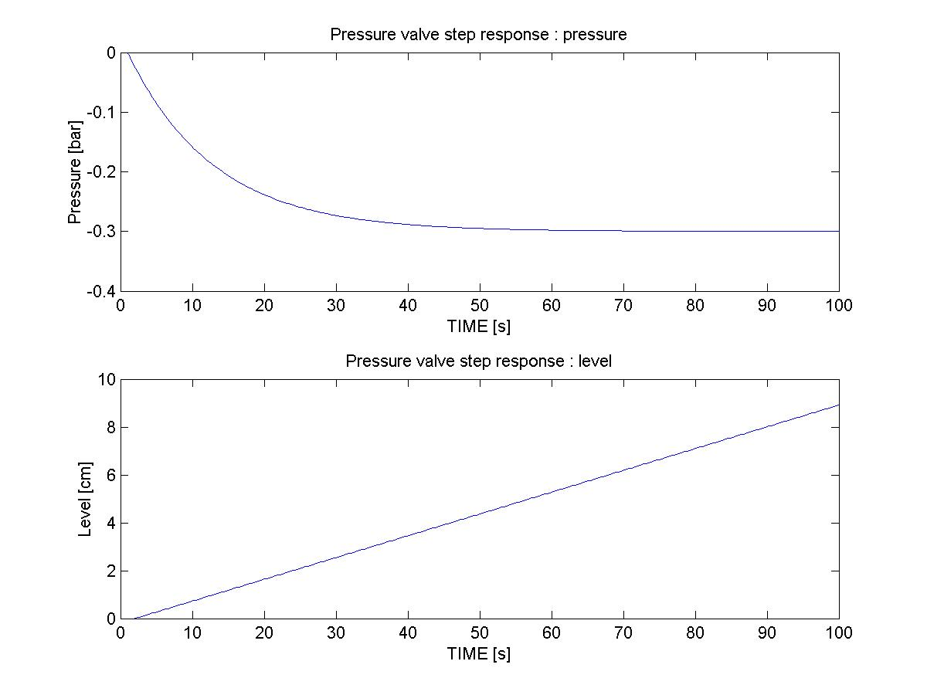
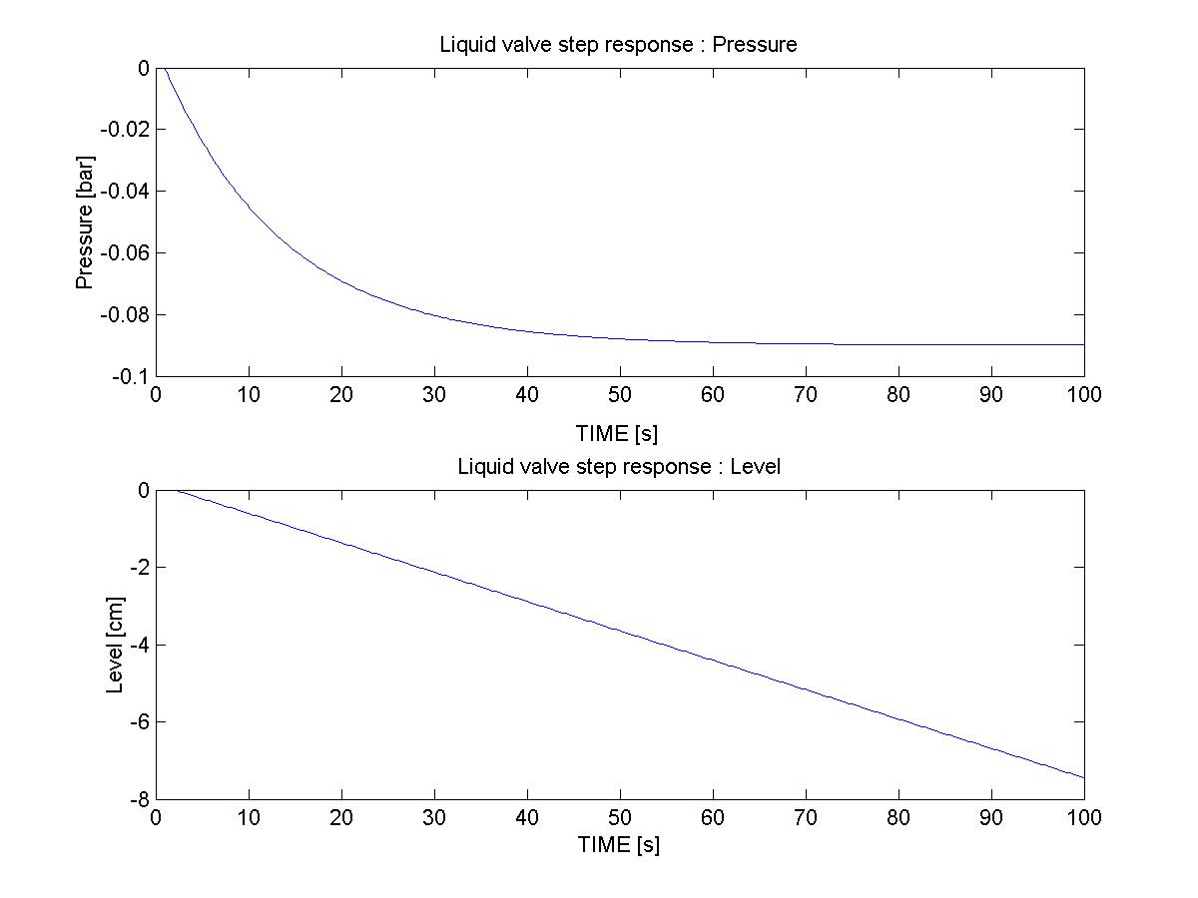
Figure 4.3 Step responses for changes in the inputs.

To have a comparison a different model was found using the same procedure. The new model was on the form:

$y=\left[\begin{matrix}\frac{−0\text{.}\text{21}e^{−s}}{\text{14}\text{.}5s+1} & \frac{−0\text{.}\text{12}e^{−2s}}{\text{18}s+1} \\ \frac{0\text{.}\text{052}e^{−7s}}{s} & \frac{−0\text{.}\text{11}e^{−2\text{.}5s}}{s}\end{matrix}\right]u$ (4.3)

The step responses for this model are shown in figure 4.4.
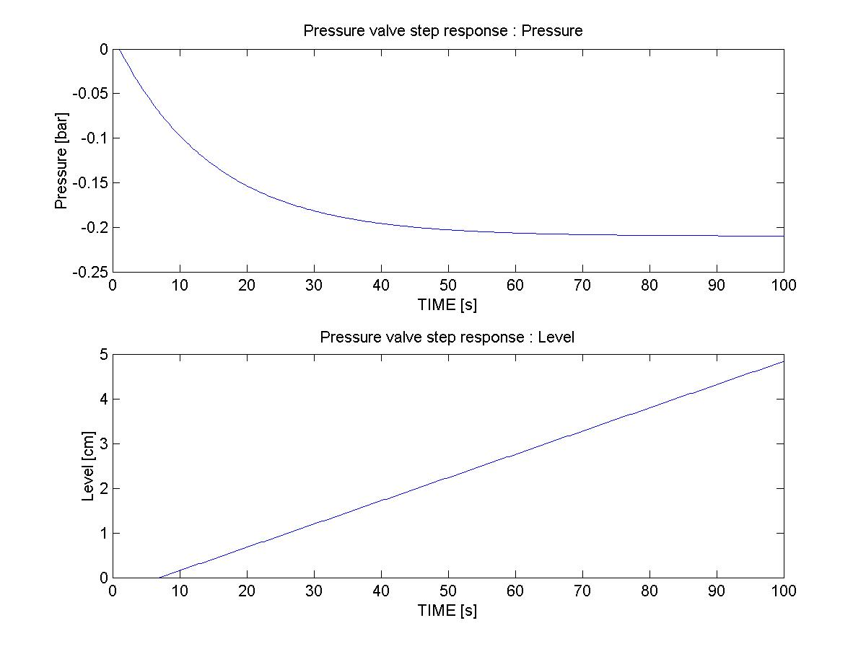
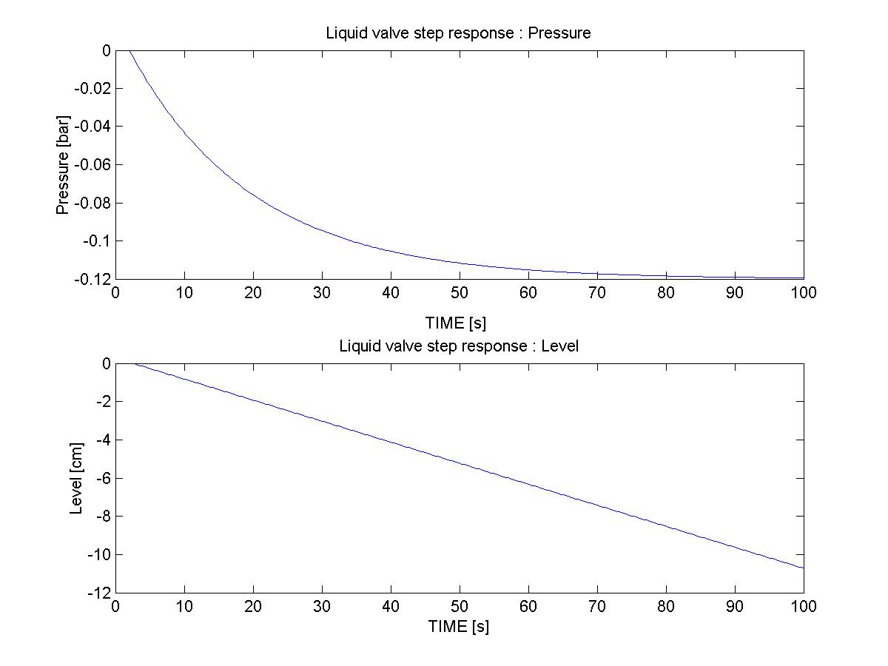
Figure 4.4 Step responses for the model in (4.3).

4.3 Choice of MPC parameters

4.3.1 Weights of inputs and outputs

The model from (4.2) was used first. To have a good starting point for the weights, they were scaled to even out the object function at steady-state values. This would ensure that the optimizer paid equal amount of attention to all the inputs and outputs. The values were chosen as

$w_{I}=\left[\begin{matrix}\text{pressurevalve} \text{input} \text{weight} \\ \text{liquidvalve} \text{input} \text{weigth}\end{matrix}\right]=\left[\begin{matrix}8 \\ \text{10}\end{matrix}\right]$ and $w_{O}=\left[\begin{matrix}\text{pressure} \text{output} \text{weight} \\ \text{liquid} \text{ouput} \text{weight}\end{matrix} \right]=\left[\begin{matrix}\text{18} \\ 1\end{matrix}\right]$. In addition the prediction horizon (P) and control horizon (C) were chosen randomly as 100 and 50.

Figure 4.5 shows the plot for a level setpoint change fra 30 cm to 25 cm at 110 seconds and a pressure setpoint change from 1.7 bar to 1.9 bar at 320 seconds.

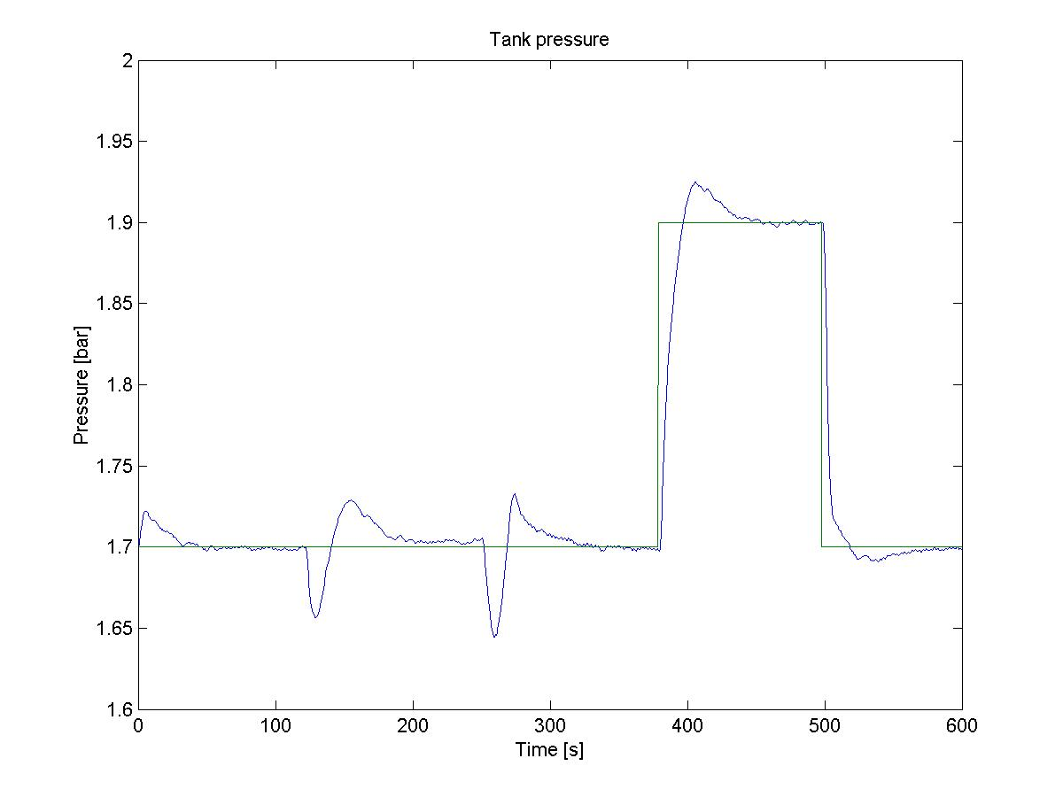

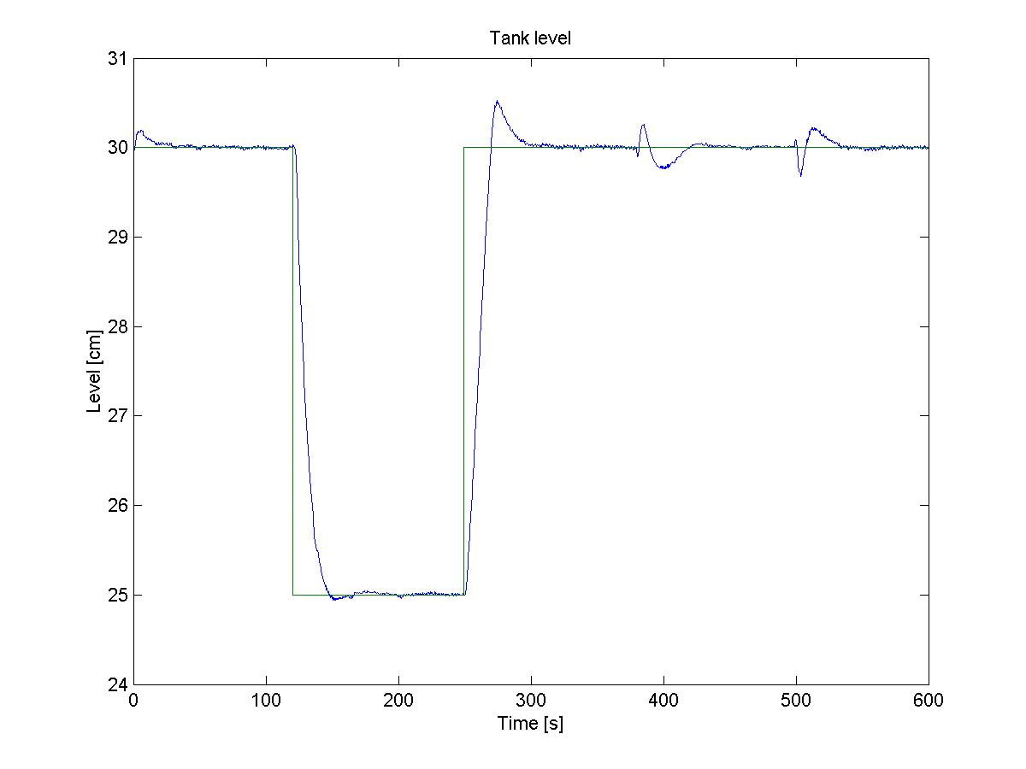
Figure 4.5 Level and pressure measurments for various setpoint changes and disturbances.

To compare this result an experiments with different weights were carried out. Figure 4.6 shows the plot for $w_{I}=\left[\begin{matrix}8 \\ \text{10}\end{matrix}\right]$, $w_{O}=\left[\begin{matrix}\text{72} \\ 1\end{matrix}\right]$, P=100 and C=50. A setpoint change for the liquid level was imposed at 110 seconds and a setpoint change for the pressure was imposed at 320 seconds.

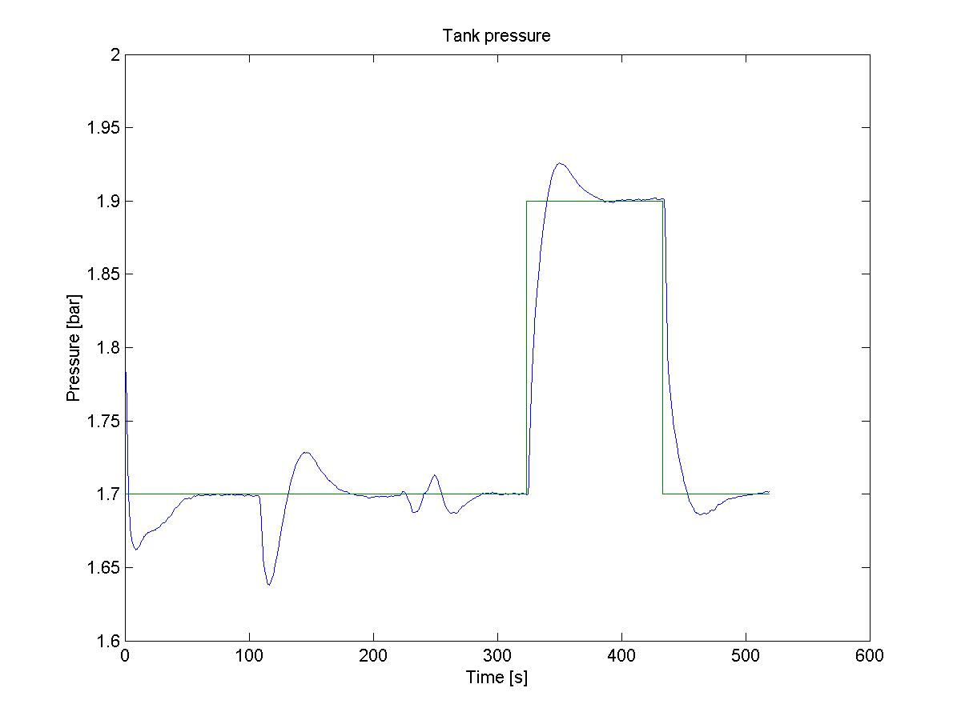
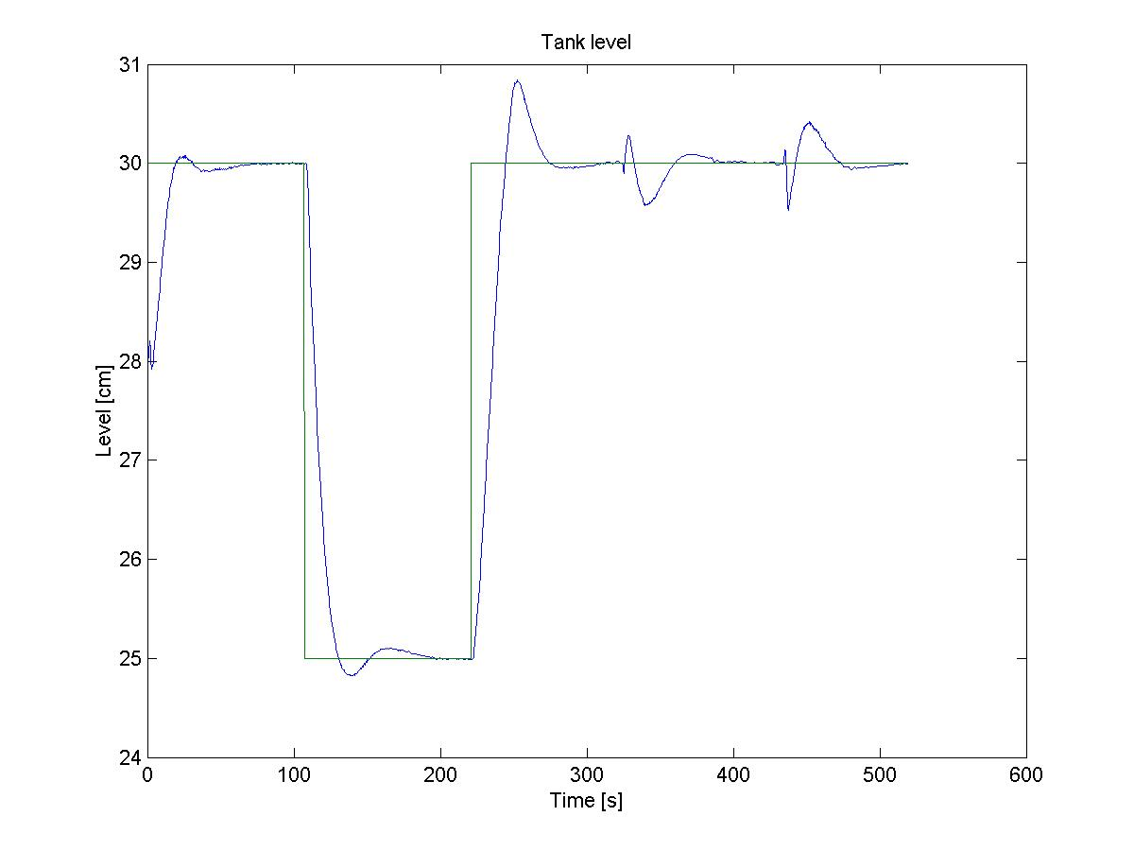
Figure 4.6 Level and pressure measurments for setpoint changes.

The plot shows that the pressure is now controlled a lot better. However the liquid level is now controlled somewhat worse, especially after the setpoint change from 25 cm to 30 cm.

Figure 4.7 shows the plot for $w_{I}=\left[\begin{matrix}8 \\ \text{10}\end{matrix}\right]$,$w_{O}=\left[\begin{matrix}\text{18} \\ 1\end{matrix}\right]$, P=100 and C=50 and a sample time of 0.2 seconds. A setpoint change in the level was performed at 100 seconds and a setpoint change in the pressure at 320 seconds.
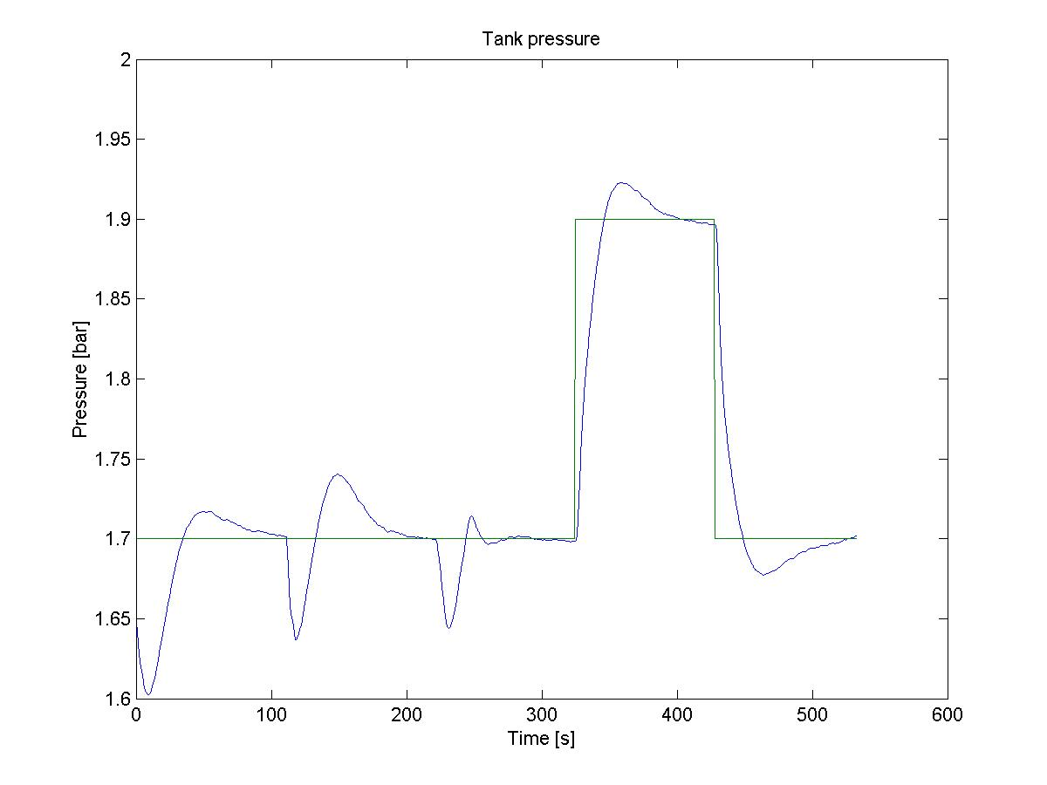
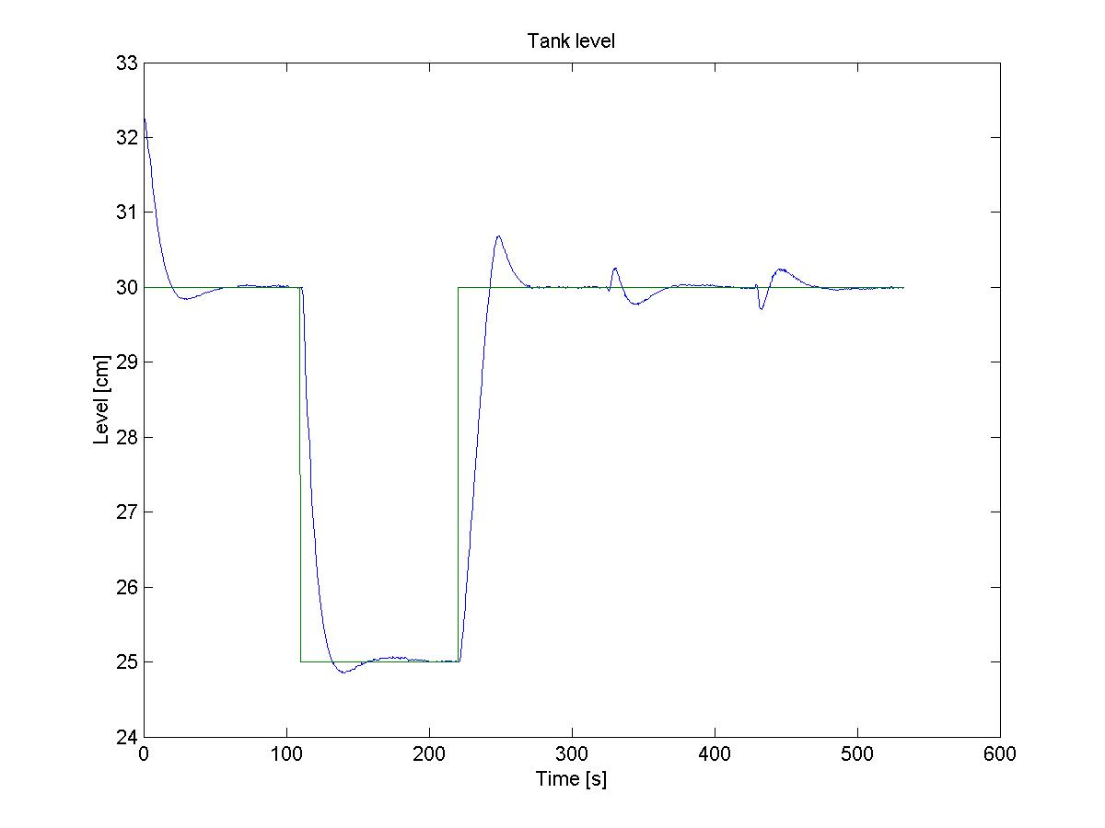
Figure 4.7 Level and pressure measurments for different setpoint changes

Surprisingly the change in the sample time made the controller worse. The pressure controller now has larger deviations from the setpoint than with the previous parameters. This probably has to do with the prediction horizon becoming smaller in real seconds when the sample time was shortened.

The sample time was put back to 0.3 seconds and the prediction and control horizon was increased. At the same time the weights on the inputs were decreased to allow more aggressive control.

Figure 4.8 show the plot for $w_{I}=\left[\begin{matrix}6 \\ 8\end{matrix}\right]$, $w_{O}=\left[\begin{matrix}\text{18} \\ 1\end{matrix}\right]$, P=300 and C=150. A setpoint change for the level at 60 seconds and a setpoint change for the pressure at 260 seconds were performed.

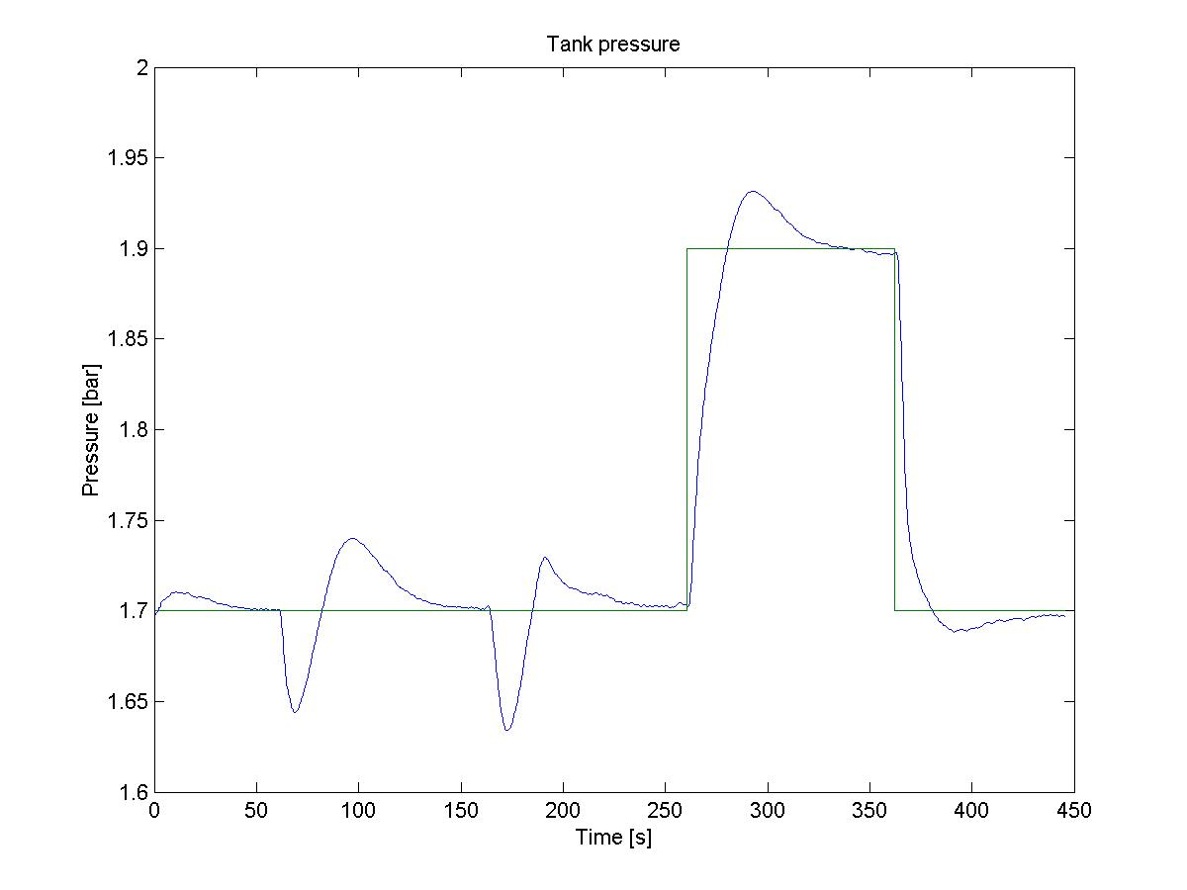
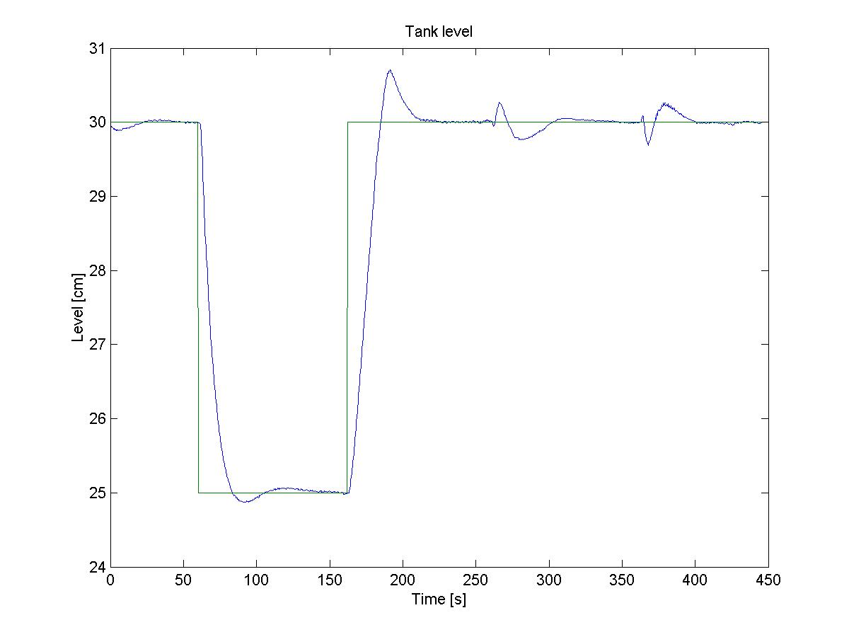
Figure 4.8 Level and pressure measurments for different setpoint changes.

This did not improve the situation for the pressure output. The deviations from the setpoints are still clearly worse than before. To improve the situations the weight on the pressure output was increased.

Figure 4.9 shows the plot for $w_{I}=\left[\begin{matrix}6 \\ 8\end{matrix}\right]$, $w_{O}=\left[\begin{matrix}\text{72} \\ 1\end{matrix}\right]$, P=300 and C=150. A setpoint change for the level at 60 seconds and a setpoint change for the pressure at 260 seconds.

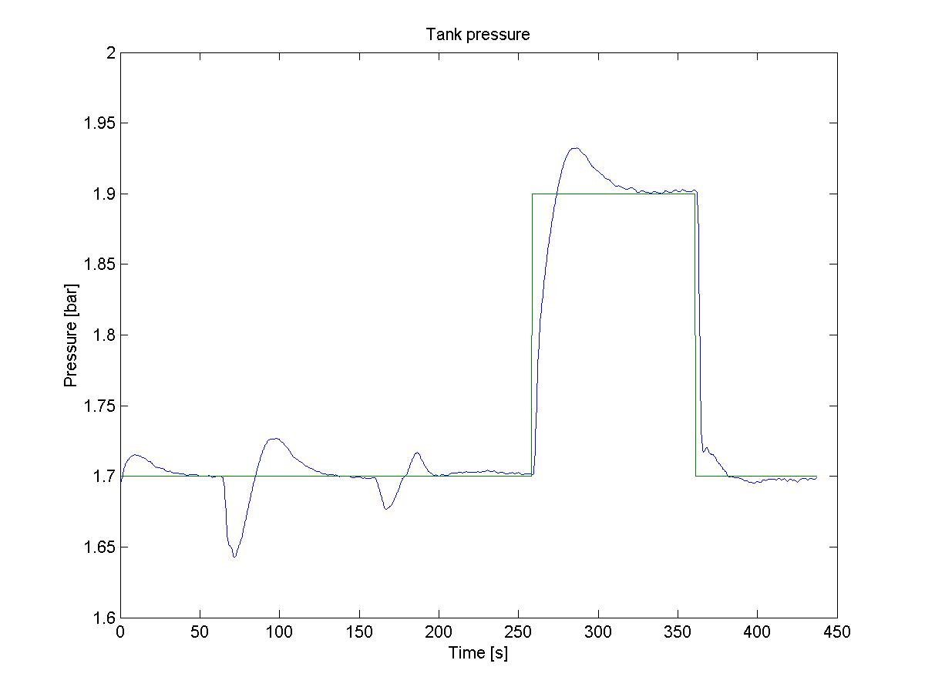
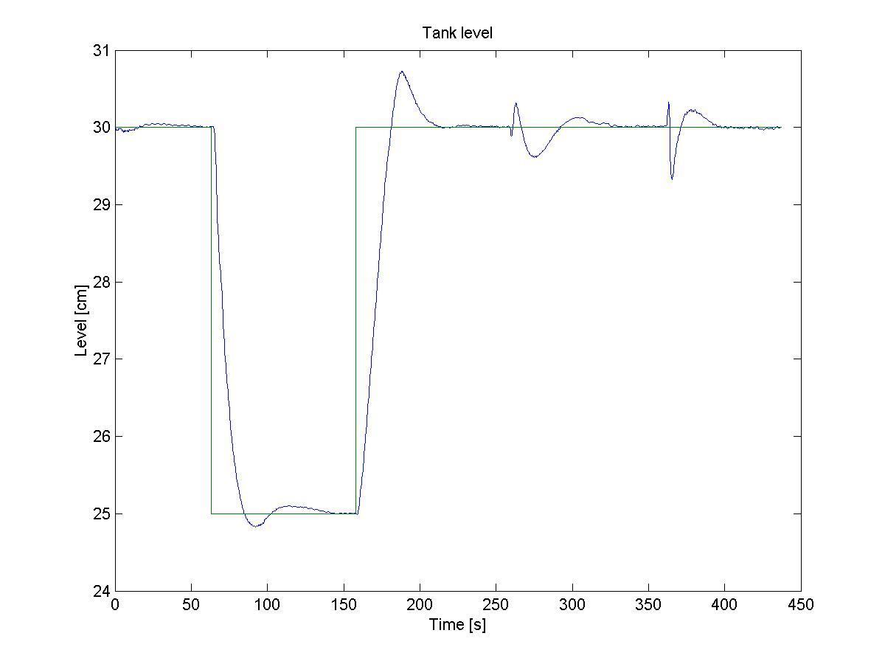
Figure 4.9 Level and pressure measurments for different setpoint changes and disturbances.

This clearly improved the pressure control. The trade-off is a slightly worse control of the level.

In an attempt to make the controller more aggressive, the input weights were decreased. Figure 4.10 shows the plot for $w_{I}=\left[\begin{matrix}4 \\ 5\end{matrix}\right]$, $w_{O}=\left[\begin{matrix}\text{72} \\ 1\end{matrix}\right]$, P=330 and C=250. A setpoint change for the level at 60 seconds and a setpoint change for the pressure at 210 seconds.

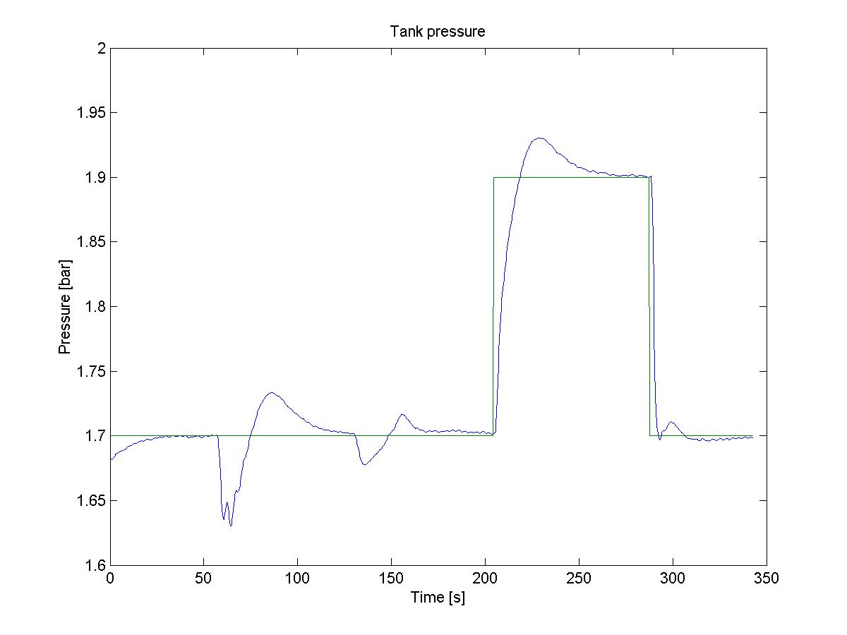

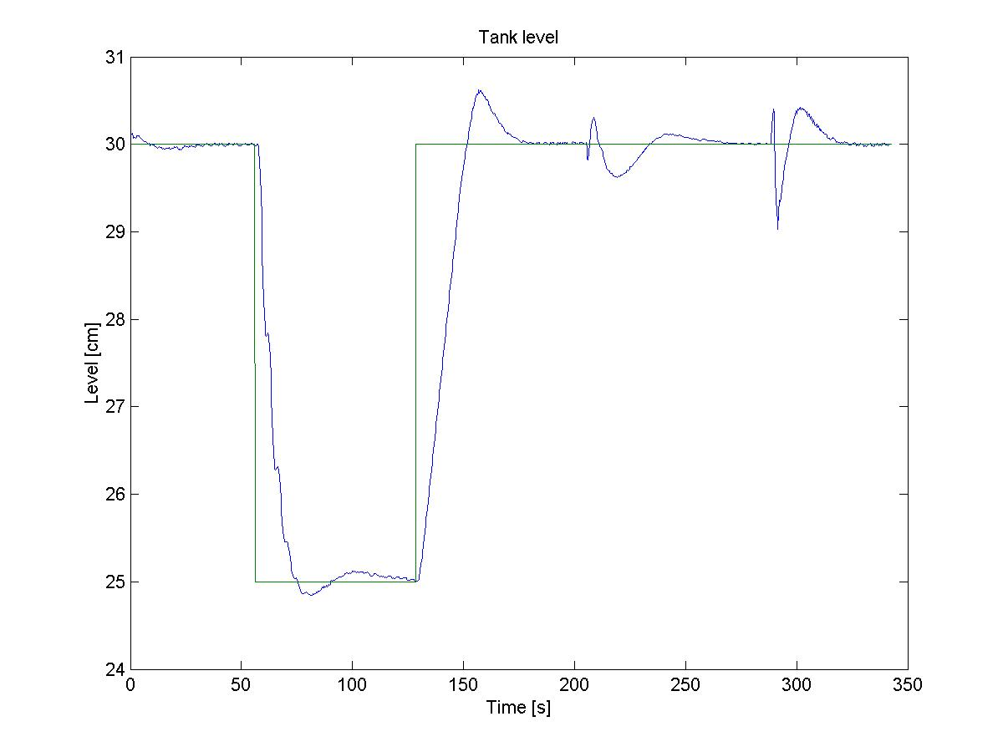
Figure 4.10 Level and pressure measurments for different setpoint changes and disturbances.

This was not much different for the last tuning, but looks to be a bit worse overall.

To see if the tuning improved with a different model, the model from (4.3) was tried out. With this model a new experment was performed. Figure 4.11 shows the plot for $w_{I}=\left[\begin{matrix}6 \\ \text{10}\end{matrix}\right]$, $w_{O}=\left[\begin{matrix}\text{72} \\ 1\end{matrix}\right]$, P=330 and C=150. A setpoint change for the level at 60 seconds and a setpoint change for the pressure at 210 seconds.

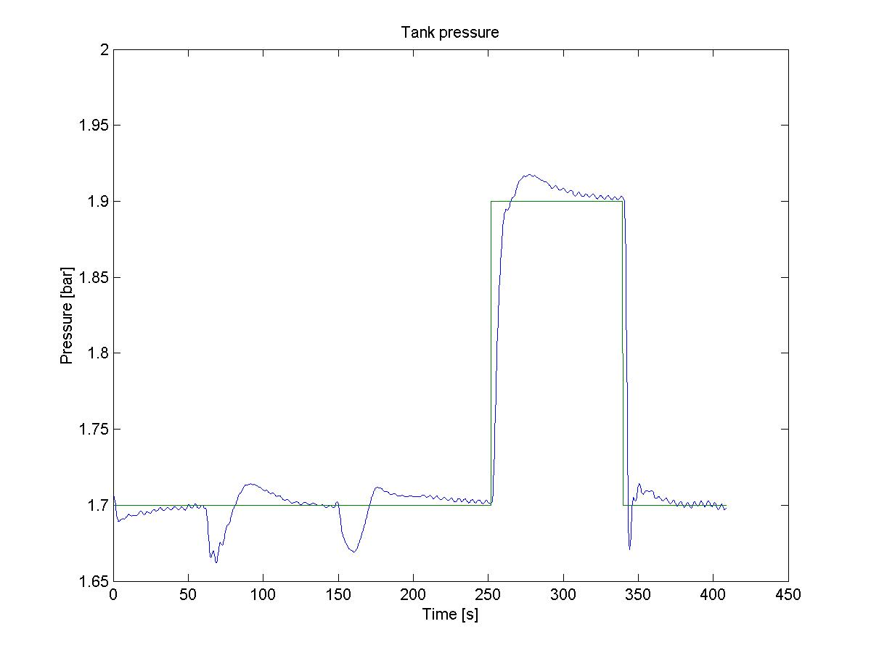
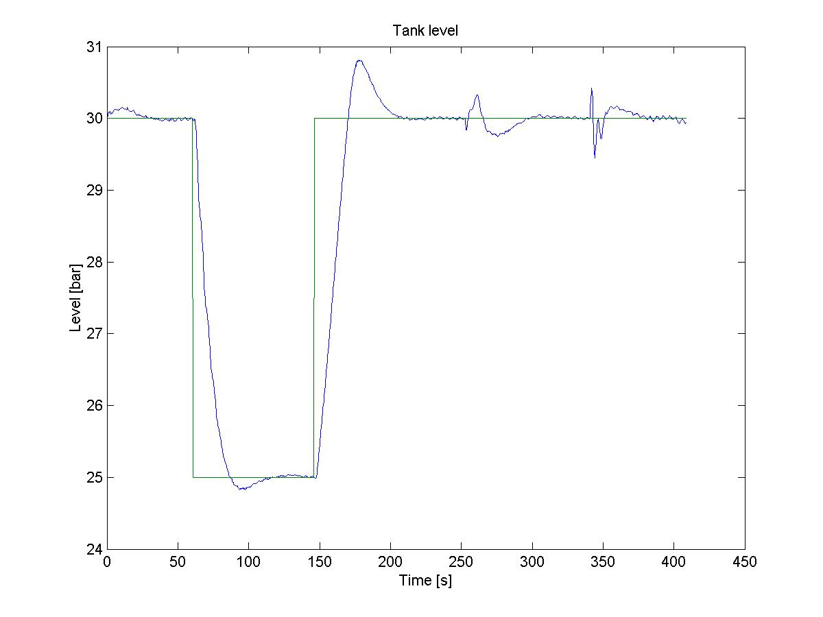
Figure 4.11 Level and pressure measurments for different setpoint changes and disturbances.

This tuning was a bit more erratic than before, but also faster, especially for the pressure controller. Which of the controller tunings to be chosen will then have to be a trade-off between fast and aggressive controller, or slower but more stabel control.

5. Discussion

5.1 Comparison of PI- and MPC control

One of the purposes of this diploma thesis was to compare the performance of a PI and MPC controller. This was achieved by running several experiments with setpoint changes and disturbances. The plots containg the inputs and measurements for the experiments are shown below.

5.1.1 A PID- and MPC controller

The PI-controller is tuned as shown in tabel 4.1. The MPC controller is tuned as shown in figure 4.9 with $w_{I}=\left[\begin{matrix}6 \\ 8\end{matrix}\right]$, $w_{O}=\left[\begin{matrix}\text{72} \\ 1\end{matrix}\right]$, P=300 and C=150.

Figure 5.1 shows the level and pressure measurements for the PI and MPC controller a for level setpoint change from 30 cm to 25 cm.

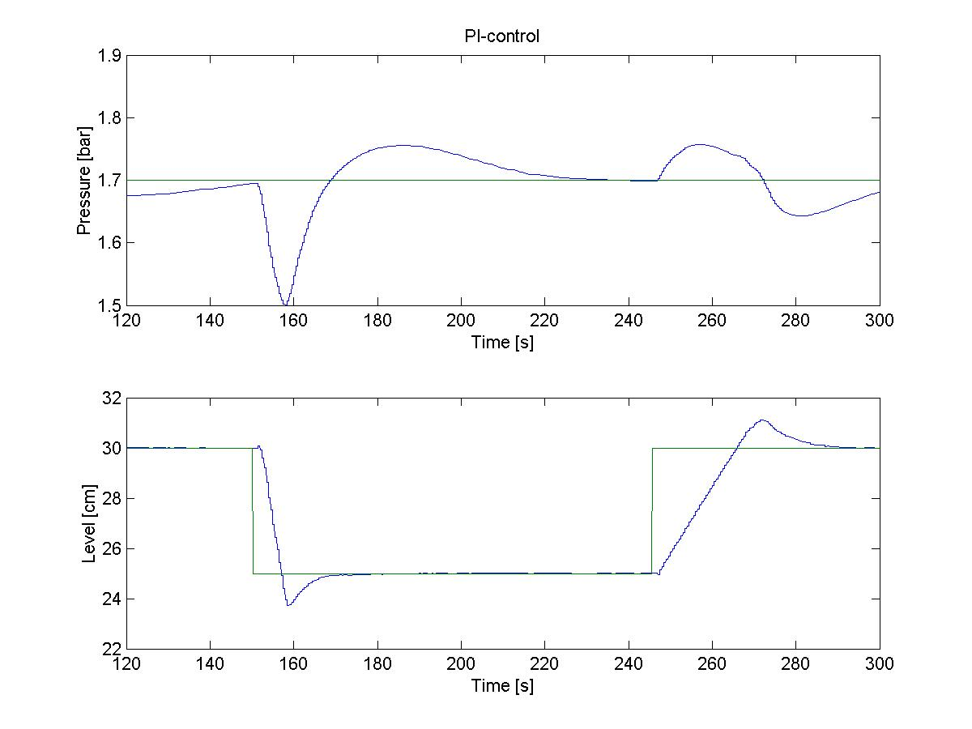 | 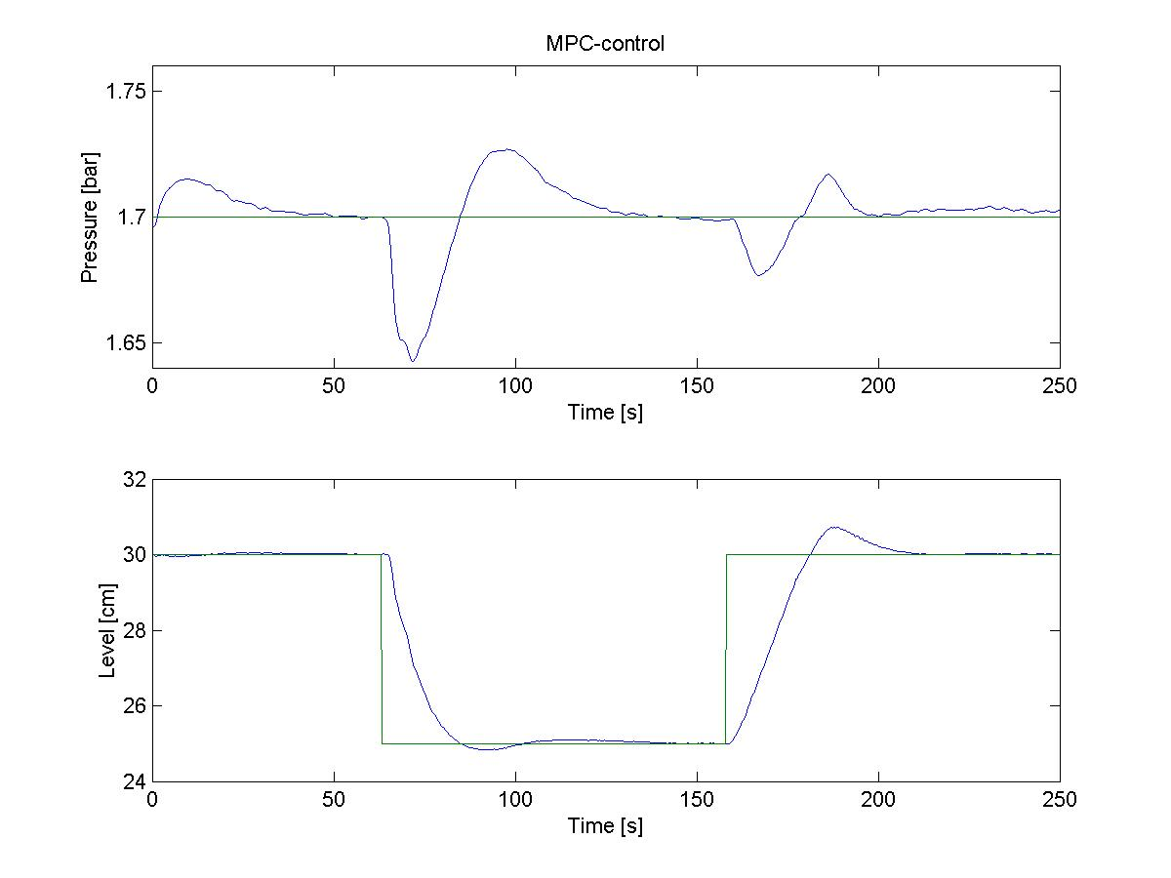
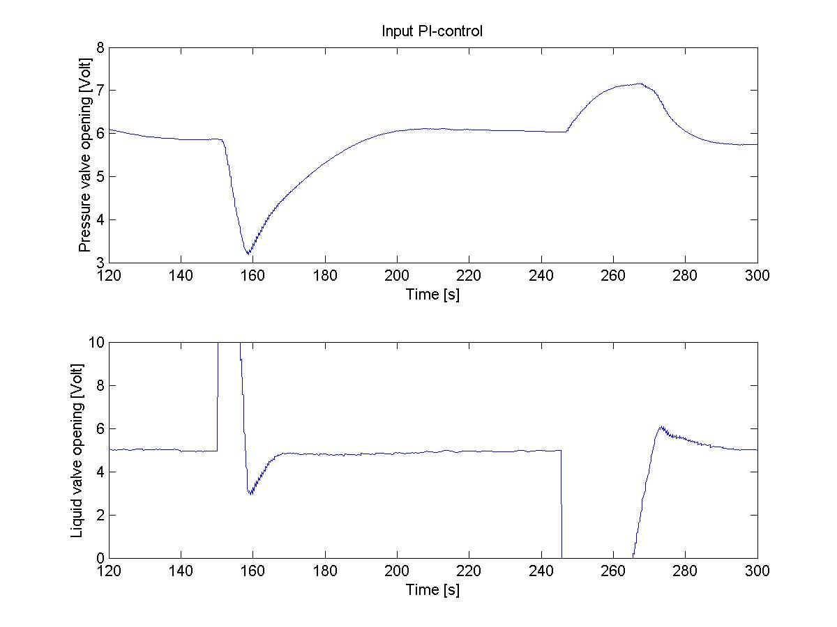 | 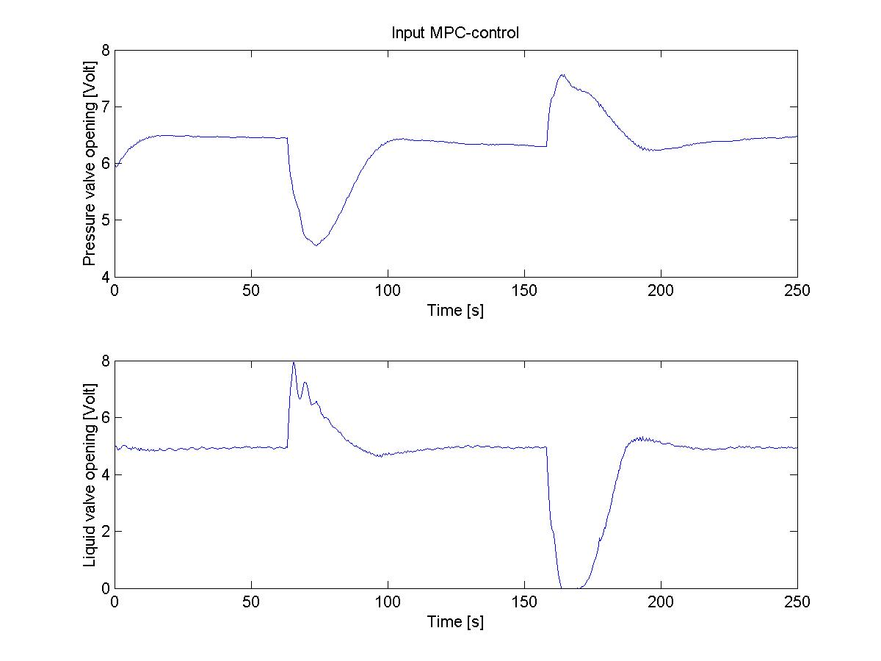

Figure 5.1 Level and pressure inputs and measurements for PI and MPC-controller.

As can be seen from the plots the MPC controller has several advantages. There is an overshoot in the level of almost 1 cm when the setpoint changes from 30 cm to 25 cm. For the MPC controller there is no significant overshoot at all. The level stabilizes after about 20 seconds, while the MPC uses 25 seconds. This shows that the PI-controller is a lot more aggressive then the MPC, but the MPC is more stable. For the pressure the level setpoint change from 30 cm to 25 cm causes the value to drop to 1.5 bar for the PI-controller, while the MPC never drops below 1.65 bar. The two controllers use almost the same amount of time to stabilize the pressure, with the MPC-controller a few seconds faster. Looking at the inputs one sees that the PI-controller is more aggressive than the MPC. The MPC has a more smooth input use with less sudden changes. All in all the MPC –controller gives a smoother control with less deviation from the setpoints, and the PI-controller is a little bit faster.

Figure 5.2 shows the figure for the PI and MPC controller for a set-point change in the pressure from 1.7 bar to 1.5 bar.

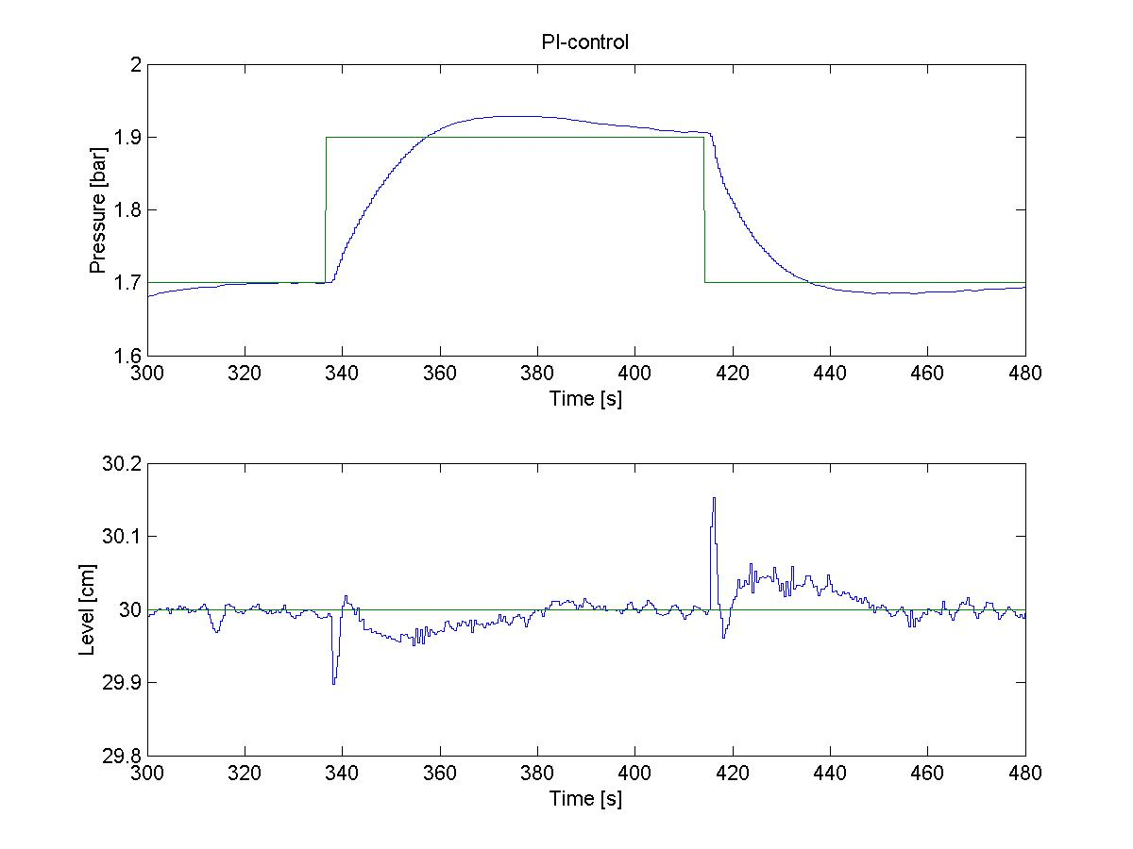 | 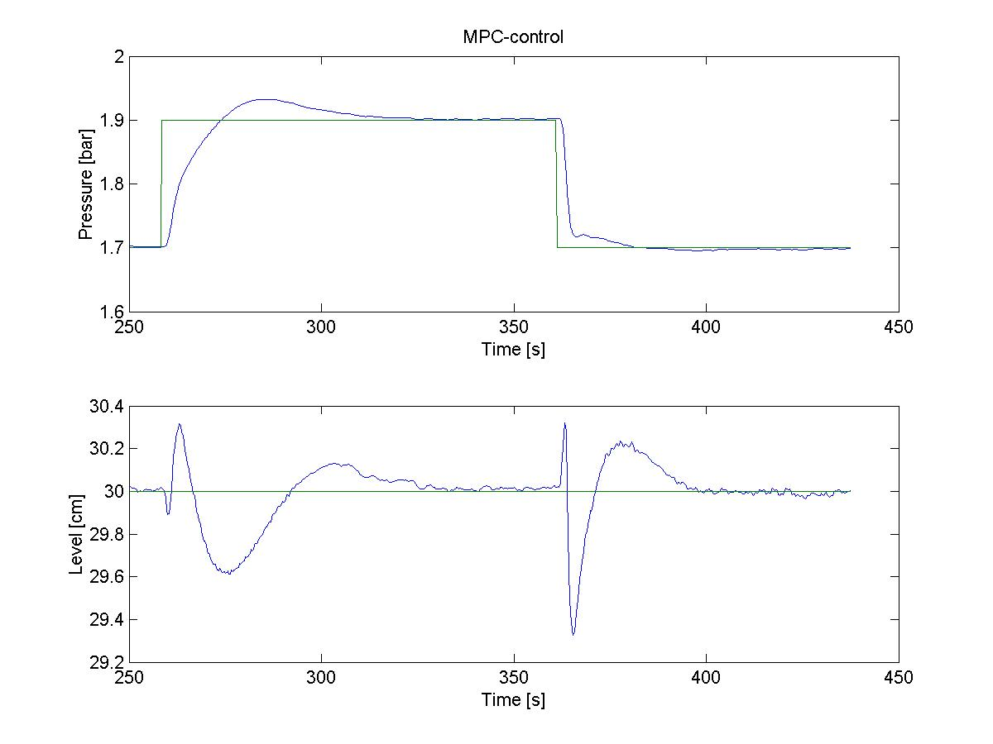
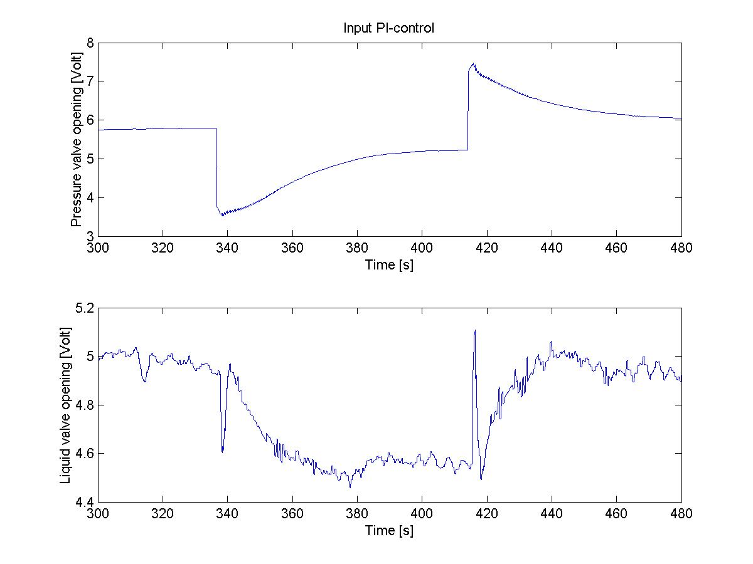 | 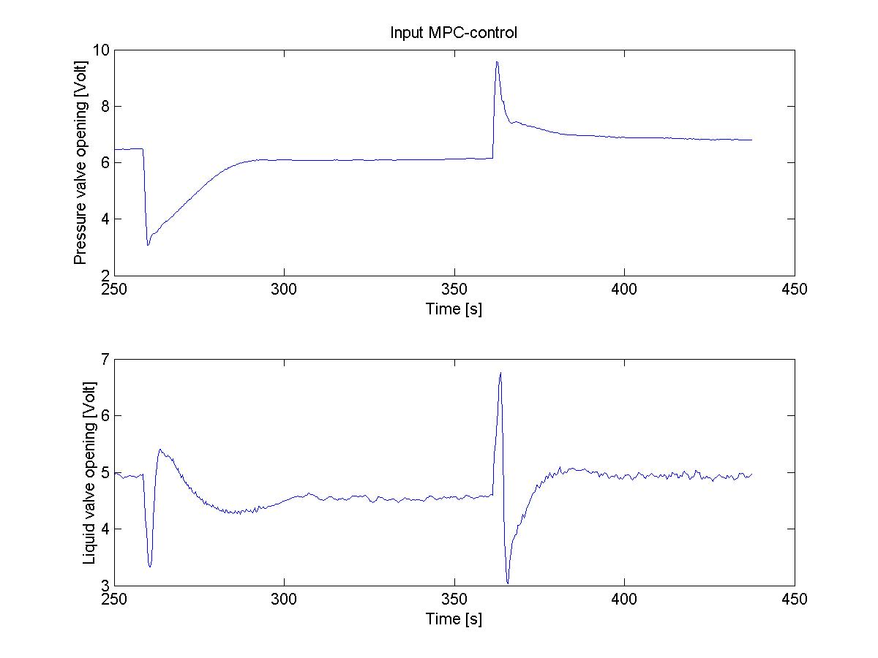
Figure 5.2 Level and pressure inputs and measurements for PI and MPC-controller.

Both controllers have an overshoot when the pressure setpoint changes from 1.7 bar to 1.9 bar. They behave almost identical but the MPC controller stabilizes the pressure output faster. The MPC controller stabilizes the pressure in 50 seconds, while the PI-controller uses 65 seconds. When the setpoint changes back from 1.9 bar to 1.7 bar, the MPC-controller is a lot faster than the PI-controller and do not experience the overshoot that the PI-controller has. The drawback for this can be seen for the level output. While the PI-controller manages to keep the level stable around the setpoint, the MPC have larger deviation. The reason for this is that the MPC controller uses both inputs to controll the pressure output. The weight on the pressure output is about 4 times higher than the weight on the level output. This was done because the level deviation for the MPC-controller is still rather small and it was seen more important to control the pressure. The inputs show the same trend. While the PI-inputs for the liquid valve is almost constant, the MPC inputs for the same valve is used whenever there is a setpoint change. Note also the more erratic behavior for the liquid valve PI-input.
To conclude the MPC controller is clearly superior to the PI-controller for pressure control. The larger deviations from the setpoint for the level are almost neglectable.

Figure 5.3 shows the plots for a disturbance in the water inlet from ca. 5 lb/in² to ca. 6.5 lb/in² at 100 seconds and a disturbance in pressure inlet from ca. 2 lb/in² to ca. 3 lb/in² at 250 second.

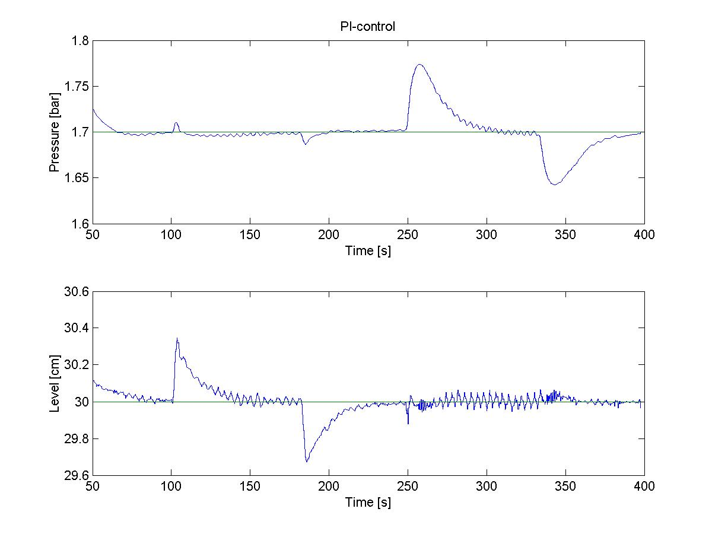 | 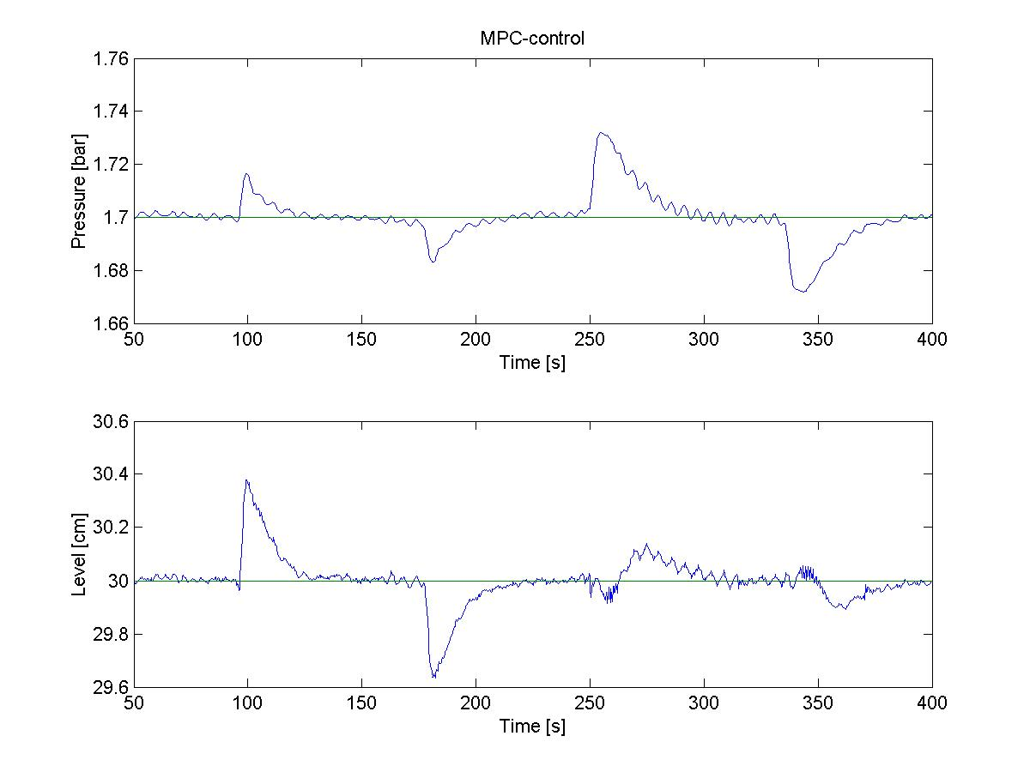
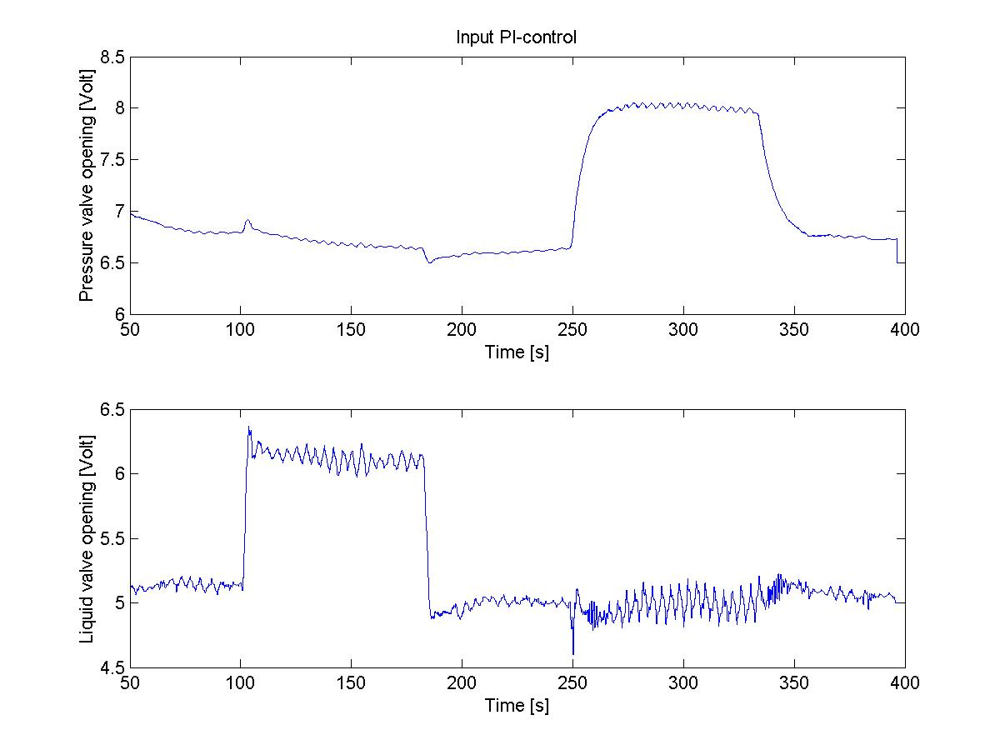 | 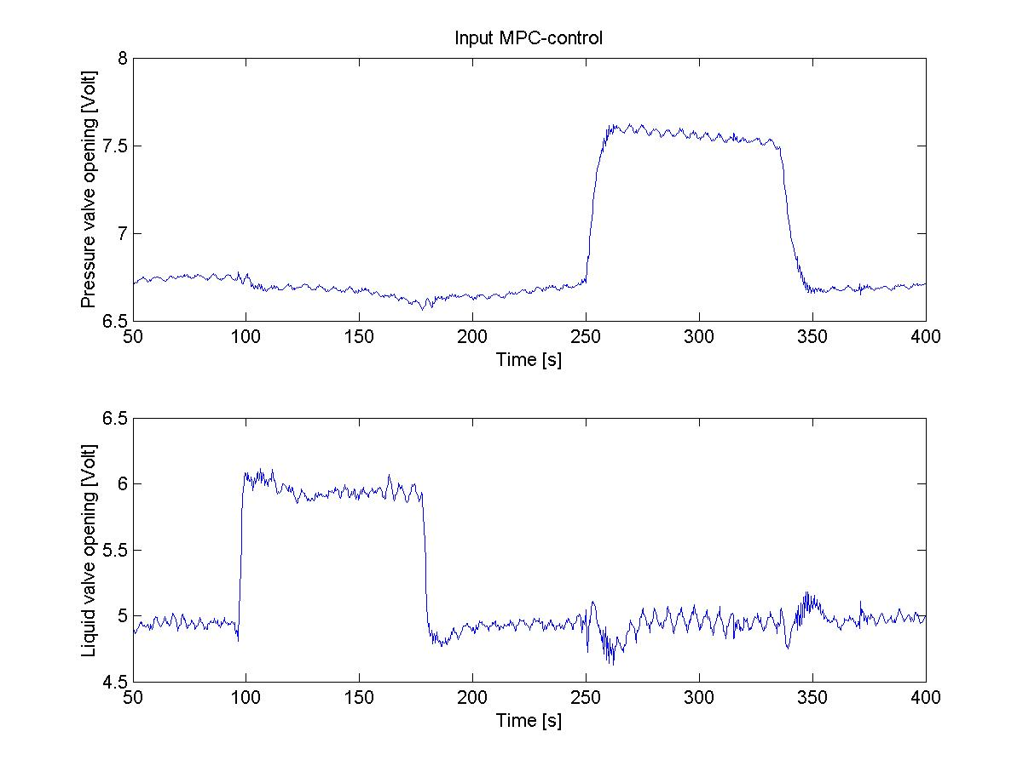
Figure 5.3 Level and pressure inputs and measurements for PI and MPC-controller.

It is difficult to compare the controllers when a disturbance in the inlets was made, because it was impossible to know if the disturbance was the same in both cases. So even though the pressure seems to be controlled far worse for the PI-controller than for the MPC, it is not possible to know that for sure. One can however look at how the inputs are used to reject the disturbances. When the water flow in is increased, the PI-controller opens the pressure valve to keep the pressure at setpoint. This helps control the pressure, but makes the disturbance worse for the level. The MPC controller however closes the pressure valve somewhat, thereby using both inputs to reject the disturbance. When imposing a disturbance in the air inlet flow, the liquid valve inputs become erratic, with the PI-controller somewhat worse than the MPC.

5.1.2 Two MPC controllers with different models

To see what impact the process model had for the MPC controller, the model from (4.2) was compared to a MPC controller with a different model. The new MPC model is the one found in (4.3). The tuning for that controller is $w_{I}=\left[\begin{matrix}6 \\ \text{10}\end{matrix}\right]$, $w_{O}=\left[\begin{matrix}\text{72} \\ 1\end{matrix}\right]$, P=330 and C=150. The MPC controller with the old model is tuned with $w_{I}=\left[\begin{matrix}6 \\ 8\end{matrix}\right]$, $w_{O}=\left[\begin{matrix}\text{72} \\ 1\end{matrix}\right]$, P=300 and C=150.

Figure 5.4 shows the plot for the old MPC-controller to the left and the MPC-controller with the new model to the right, both with a setpoint change in the water level from 30 cm to 25 cm.

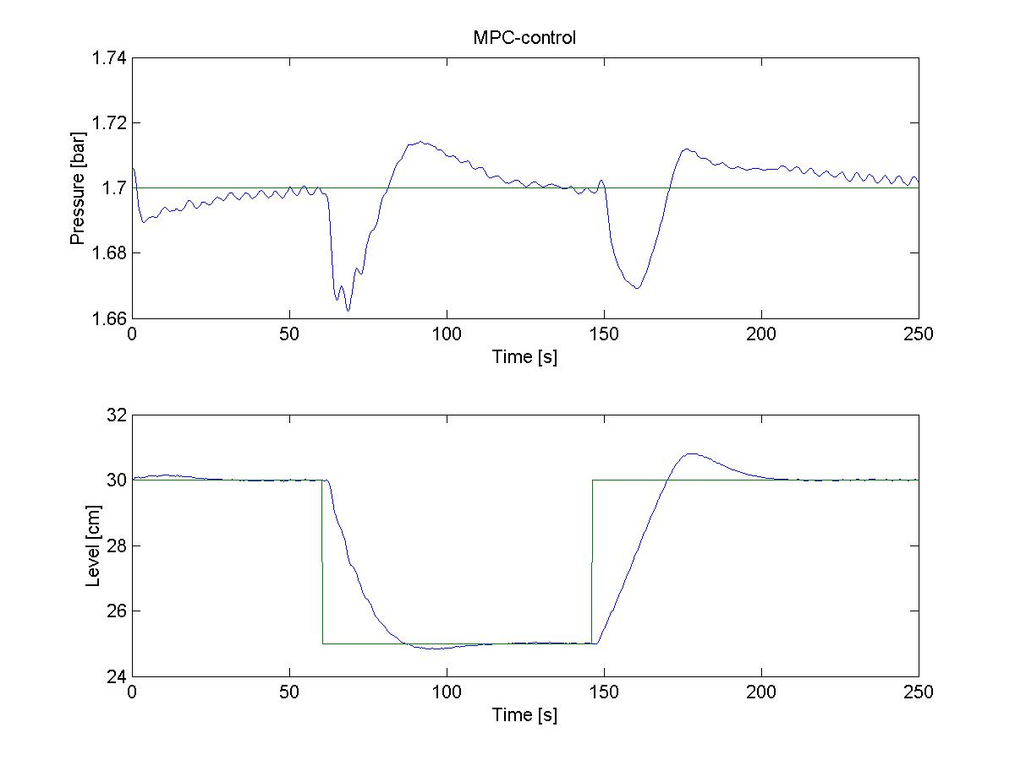
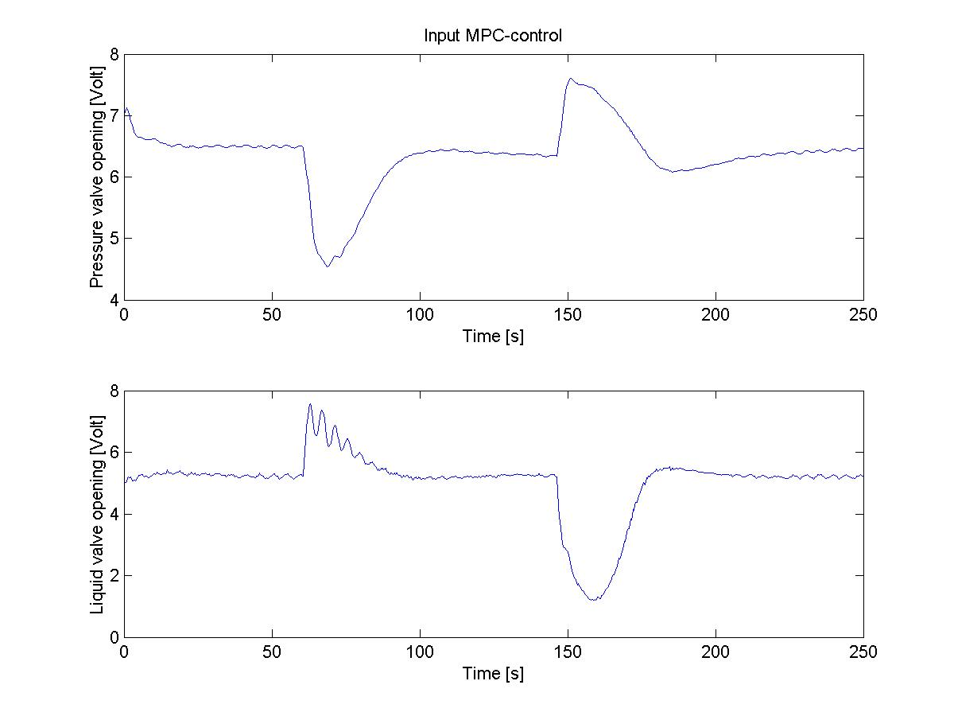
Figure 5.4 Level and pressure inputs and measurements for two MPC-controllers.

There seems to be no significant difference for the level output for the two controllers. The behaviour is close to identical. The pressure is controlled somewhat better with the new model when the level setpoint changes from 30 cm to 25 cm. But when the setpoint changes back to 30 cm, the old model seems to control the pressure better. The pressure also has a somewhat erratic behavior when controlled with the new model. The input usage is almost identical, the liquid valve is more aggressive with the old model, but the pressure valves behaves the same. Since the biggest differences between the two models lies in the pressure output and the liquid valve input, the interactions between that output and input seems to be most sensitive to model error. When looking at (4.2) and (4.3) one can see that the gain for the transfer functions is almost 20% larger for the model in (4.3). This explains the more aggressive input usage for the liquid valve for the old model.
Figure 5.5 shows the figure for the MPC controller with the old model to the left and the MPC controller with the new model to the right, both with a setpoint change in the pressure from 1.7 bar to 1.5 bar.

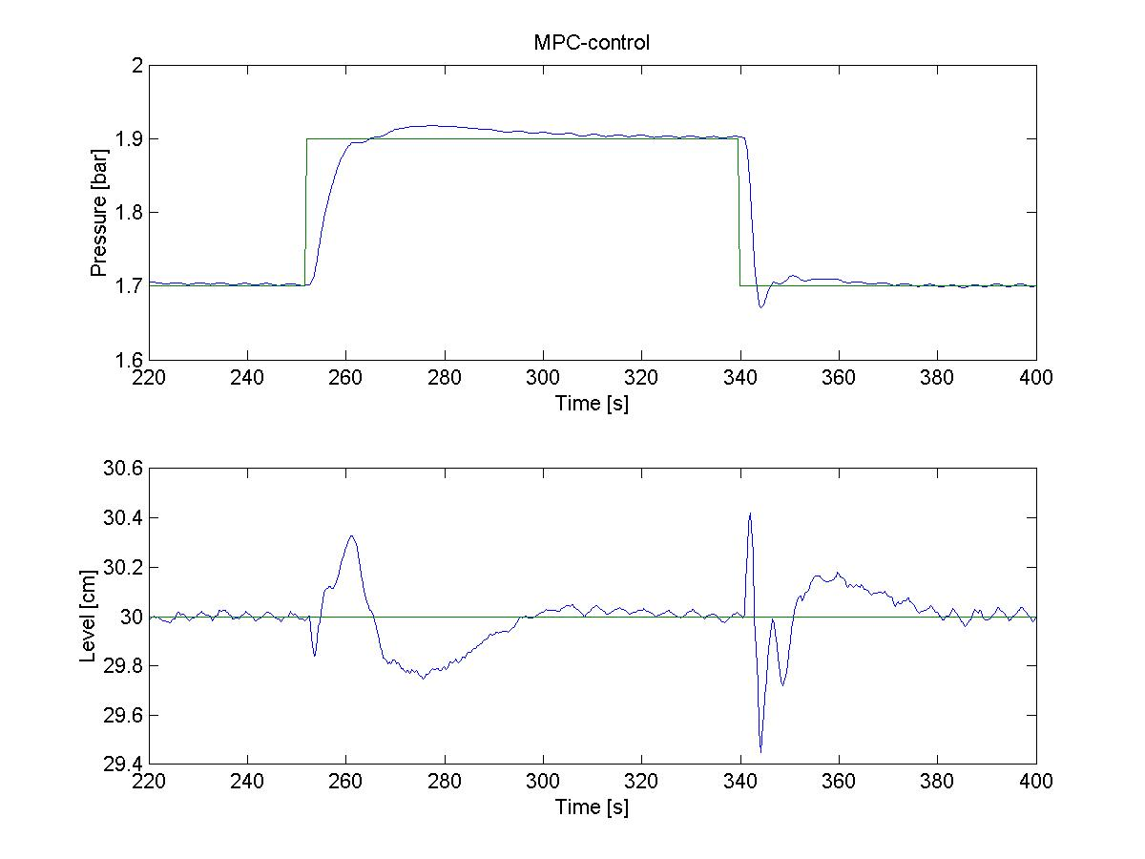
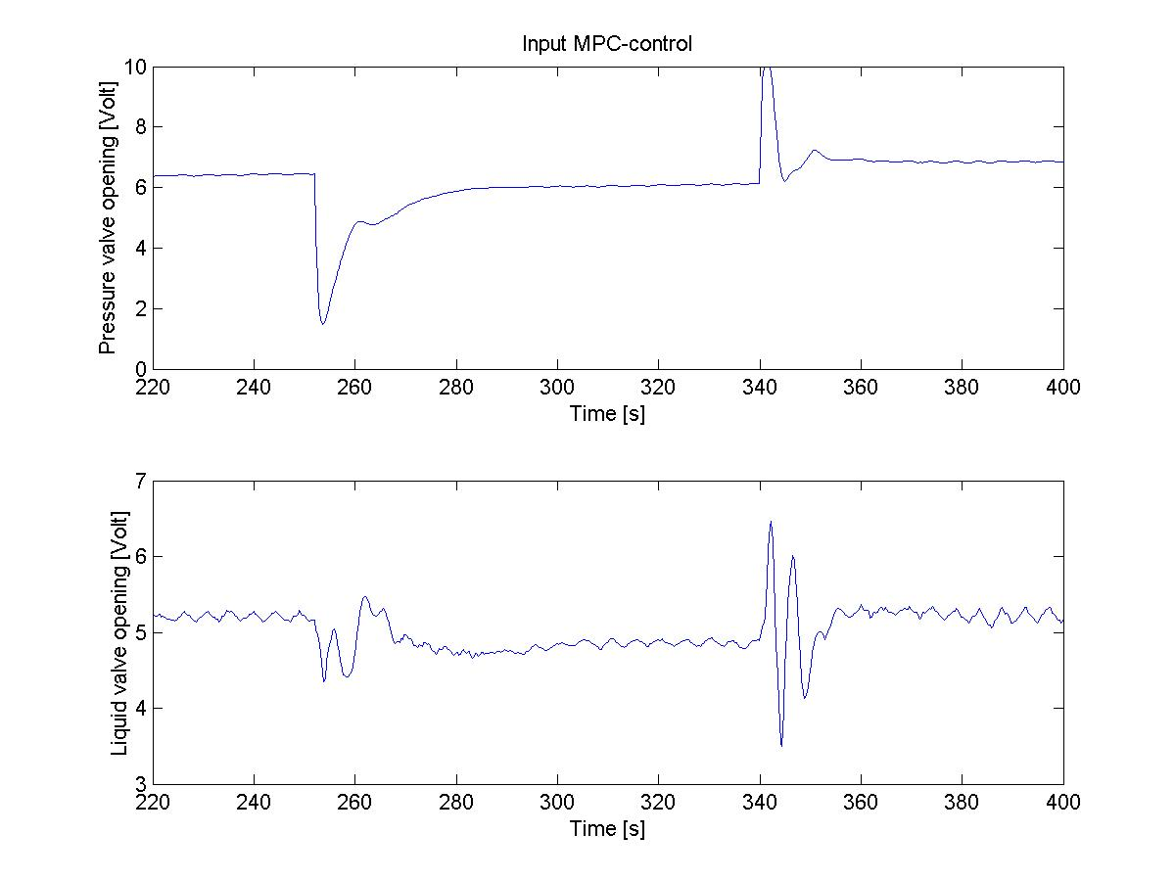
Figure 5.5 Level and pressure inputs and measurements for two MPC-controllers.

After the pressure setpoint change there is a larger overshoot for the pressure for the new model, but both uses the same amount of time to stabilize the pressure. The level outputs have somewhat larger deviations from the setpoint for the old model. The pressure valve input is a bit more aggressive for the new model, but the liquid valve input is more aggressive for the old model. This is in accordance to the models (4.2) and (4.3) and also with the findings for the level setpoint change. However, here the new model seems to be a bit better at controlling the process.

Figure 5.6 shows the plots for a disturbance in the water inlet from 5 lb/in² to 6.5 lb/in² at 100 seconds and a disturbance in pressure inlet from 2 lb/in² to 3 lb/in² at 250 second. The MPC controller with the old model is to the left and the MPC controller with the new model to the right.

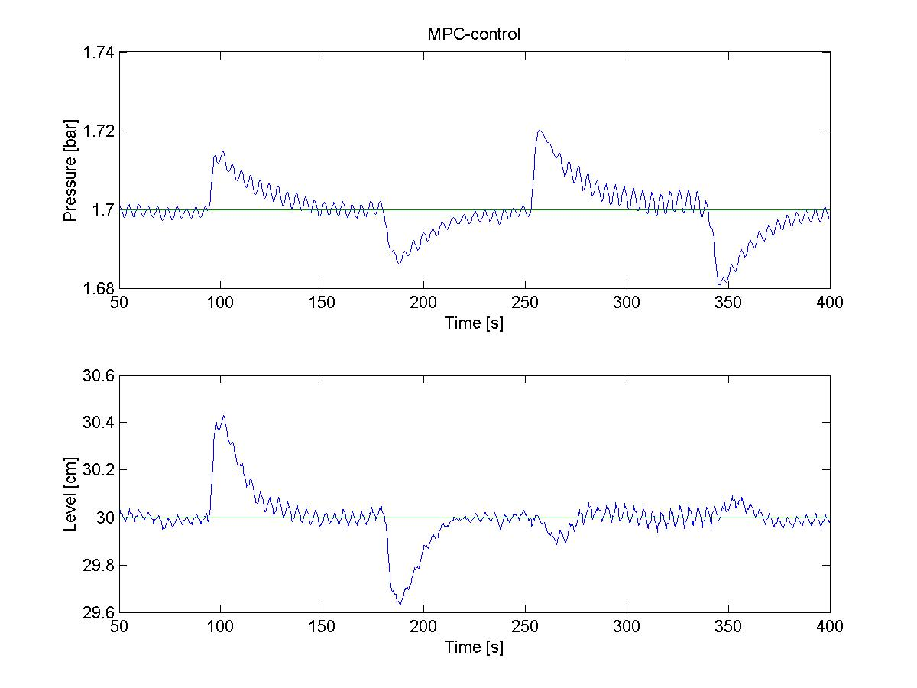
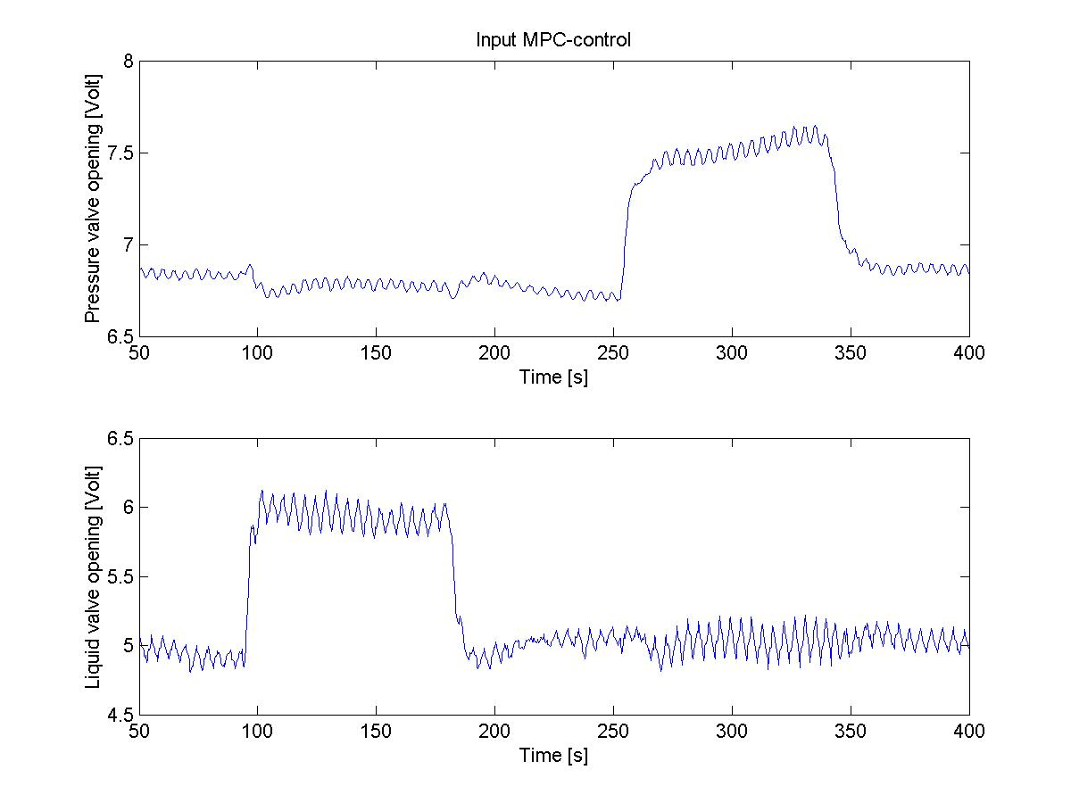
Figure 5.6 Level and pressure inputs and measurements for the two MPC-controllers.

When looking at the outputs one sees that the deviations from the setpoints are identical in the two cases. But the output for the new model is a lot more erratic and does not stabilize very well. The same can be said for the input usage. It is difficult to say why this happens. The old model is clearly more accurate for handling disturbances. Most likely the old model is valid over a larger area then the new model, and therefore handles disturbances better.

All in all the old model (4.2) was better than the new model (4.3). The difference was not large when it came to setpoint changes, but was clearly evident for disturbance rejection. The most sensitive part with regards to error was the modelling of the interactions between the pressure output and liquid valve input.

5.1.3 MPC with a model error

To see how the MPC controller would behave with a model error, an experiment was run were the model had no interaction variables. The model is the same as the model in (5.2), but without the transfer functions g₂₁ and g₁₂. The tuning was $w_{I}=\left[\begin{matrix}6 \\ 8\end{matrix}\right]$, $w_{O}=\left[\begin{matrix}\text{72} \\ 1\end{matrix}\right]$, P=300 and C=150. This was compared with the same MPC controller that was used in figure 6.1. Figure 5.7 shows the plots for a level setpoint change.

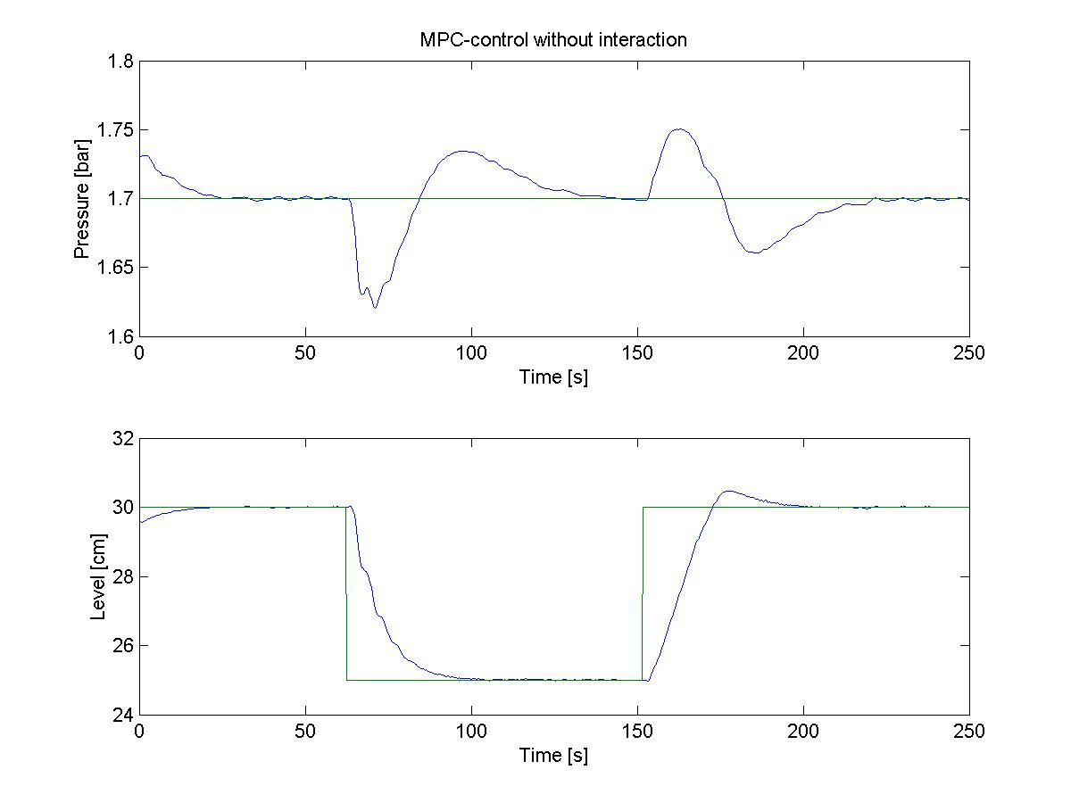
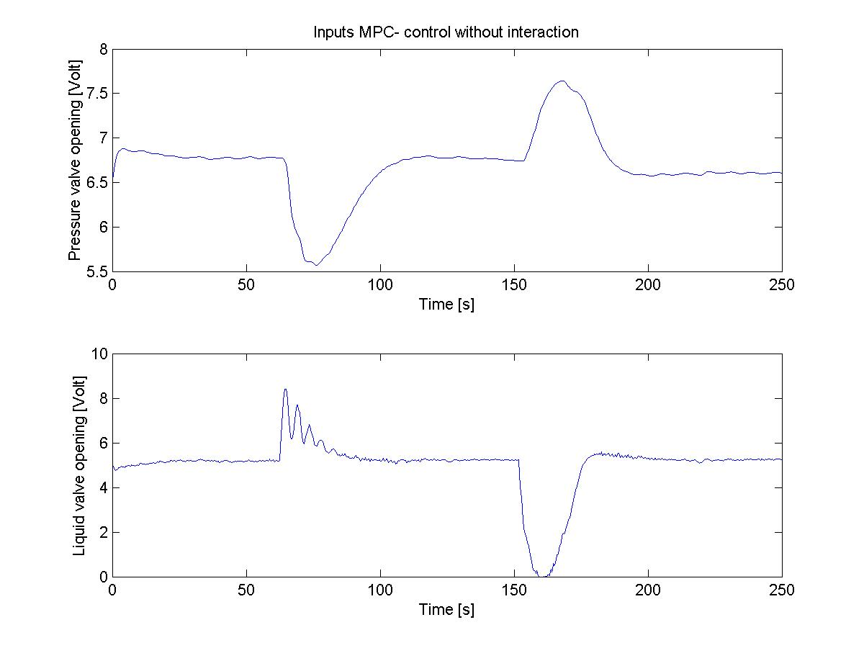
Figure 5.7: Comparison of a MPC controller with interaction and without interaction.

This shows somewhat surprisingly that the level is controlled almost excactly the same with the two controllers. The big difference here is for the pressure control. First the deviation from steady-state is larger for the erroneous model when the setpoint changes from 30 cm to 25 cm. When the setpoint changes back to 30 cm, the pressure profile is opposite for the two controller. For the erroneous model the pressure increases in the beginning and the decreases, while the “real” model does the opposite. This can be explained by the fact that the “real” model knows that decreasing the pressure somewhat makes it easier for the level to reach the setpoint. The other model does not take these interactions into account, and behaves different. It does not, however, seem to have a significant effect on the level in this case.

The input profiles are very similar for the two controllers. The pressure input is slighly more aggressive for the “real” model, but the difference is small.

Figure 5.8 show the plots for a pressure setpoint change.

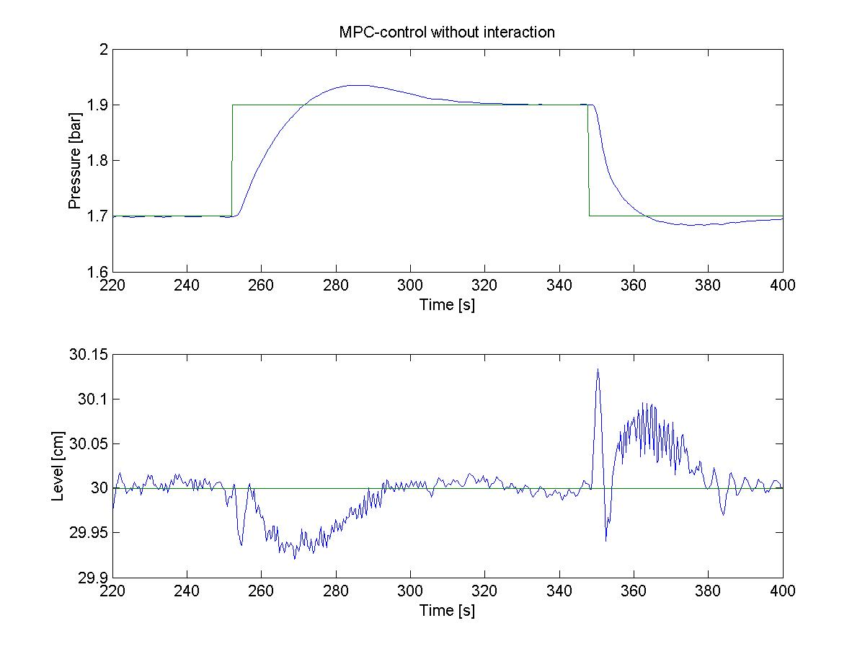
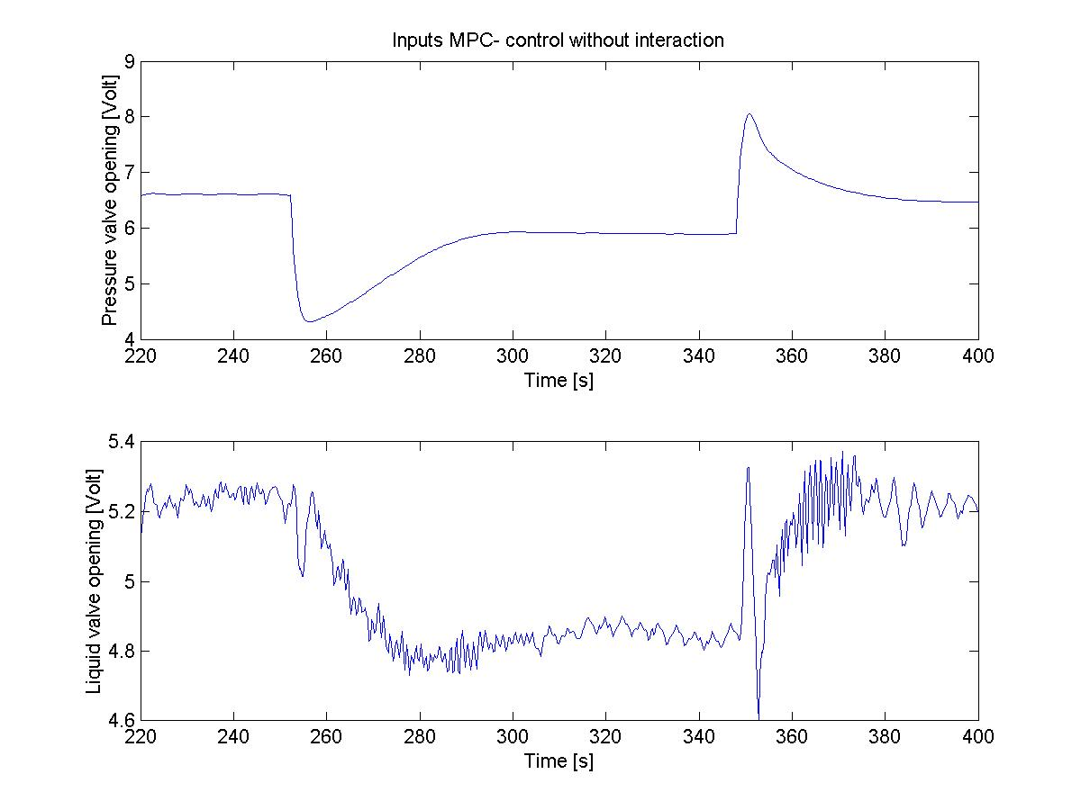
Figure 5.8 Pressure setpoint change for model with and without interactions.

The pressure seems to be controlled worse by the controller without model interactions. The “real” model controls and stabilizes the pressure faster. The reason for this can be seen in the inputs for the liquid valves. The controller with the erronous model makes only small input changes to stabilize the level, while the controller with the real model makes large input changes at every setpoint change to help the pressure. The drawback to this is a slightly worse level control. The erronous model keeps the level very close to the setpoint at all time, with the largest deviation at about 0.12 cm. The real model has larger deviation, the largest being 0.6 cm. The level is however controlled back to the setpoint very fast, so the overall control is far better for the “real model”.

5.1.4 Summary

The MPC controllers are somewhat better than their PI counterparts. When a setpoint disturbance occur the MPC usually controls the output a lot more stable and just as fast as the PI. The other output is also kept a lot closer to its setpoint with the MPC. As said before it is difficult to compare the controllers for disturbances in the inlet. But in no case was the MPC worse than the PI-controller. The input usage showed clearly how the MPC used both inputs to combat disturbances and setpoint changes, thereby getting smoother and less aggressive control. The tuning for the PI-controller was a lot faster than for the MPC. So which controller that should be used must also depend on how much time one has to do the tuning.

5.2 Model discussion

A MPC-controller will never be any better than the model it uses. A correct model is the most critical part. Here the model was found using input step-responses, and linear 1. order transfer functions was derived from those. As can be seen in Appendix A4 these plots do not follow true 1. order behavior. This leads to an error in the model. Higher order transfer functions may fix that problem.

The use of step-responses describes the model well at lower frequencies. For feedback control information of higher frequencies is also desirable. Such information is not provided with this model.

The PI-controller has been tuned using Skogestad’s PID-tuning rules. These tunings will normally give satisfactory tuning with regards to stability and fast response. It may not be the optimal tuning for this process. However it was not attempted to use other tuning rules since Skogestad’s rules gave a good enough basis of comparison to the MPC controller.

The difficult part of tuning the MPC controller was how to choose the tuning parameters. As far as the candidate knows, there is not much litterature on this topic. The weights were scaled as proposed by Maciejowski^{/5/}, but from there on it was more a case of trial and error. The prediction and control horizon was choosed based on the theory from Gjerstad^{/2/}. It was however clear that the control was improved when those values were changed.

It is hard to say if these values are the best choices, but from the experiments carried out, they seem to be the best.

5.3 Software discussion

Ricker proposed a sampling period of 1 second, and using a lower value was not recommended. This could have been a problem, since the process has a gas dynamic that is very fast. Luckily this proved not to be much of a problem. It was no problem running with a sample time of down to 0.3 seconds for the MPC controller. When the sample time was reduced further down to 0.1 seconds, the program did not manage to catch up with real time. Whether this was a limitation in the program or in the MPC algorithm is uncertain. Still, a sample time of 0.3 seconds was seen as more than adequate enough for this process.

The MPC alorithm used for the control program was a standard algorithm by Matlab. The main reason for using this algorithm was time-constraints. It would have taken a lot of time to develop an alorithm independently. The controller needed to use step-respons models and take into account that one of the processes was integrating. The Matlab version solved both of those issues. The problem with using a standard Matlab controller was that it was difficult to find out what went on inside the program. This was especially true whenever there was a problem. It was also difficult to find out if the program used any “short-cuts” or assumptions that was not explained in the help text. Overall the Matlab algorithm was easy to use, and seemed to give fast optimizing and was easily compatible with Simulink. The biggest drawback was not being able to change models and weights on-line.

There were some problems using the DAQ card, since it was not supported directly by Matlab. Somehow this version had been left out when they had made their last update. After installing a new patch and some fiddling around the card worked, but Windows 98 crashed on numerous occasions. Installing Windows 2000 solved that problem, and the card worked fine.

The control program consisted of a GUI that communicated with a Simulink program. In this Simulink program was the data acqusition program made by Ricker that connected everything to the real process. The program from Ricker was very easy to use. The blocks were self-explanatory and fast to set up in the Simulink environment.

Making the GUI was not an easy task. While most of the programming went OK, some obstacles were not overcome. Collecting and using data on-line were often difficult, as Simulink did not allow them to be used before the simulation was over. The plan was among others to have the plots inside the GUI, have the valve openings constant when switching from automatic to manual control and allow saved file names to be changed on-line. These functions are not in the final version, but should be implemented in the future. In the end the GUIs work just fine. They seem, at least to the creator, to be intuitive and easy to use. There are no known bugs and the programs have been stable at all times.

Every measurement experiences noise. To combat such noise usually a filter of some sort is used to filter the signals, e.g. low-pass filter or Kalmann filter. In this project this has not been done. The DAQ card makes 500 measurements between every sampling period, and uses the average of these measurements. It was decided that this would be more than adequate enough to remove the noise.

5.4 Further work

The program is ready to be used as it is, but several improvements can be made.
- The storage of data can be made safer and easier if the students can name the storage files on-line instead of off-line.
- When swapping between automatic and manual control the valve opening should not change.
- A different (better) MPC algorithm could be implemented, for instance a true non-linear MPC-controller.

For the PID-controller a decoupled system could be implemented.

6. Conclusion

The control program is working properly, but several improvements can be made. Data storage and data plotting are the main areas where it can be improved.

Using Matlab/Simulink with Rickers program to control the process worked fine. It was stable and easy to set up, and the sample time was not a problem.

The MPC controller worked better than the PID controller. The MPC was a lot more stable and just as fast or faster than the PID controller. The MPC controller took the strong interactions of the system into account. The tuning of the PID controller was a lot easier and faster however. The MPC controller was cumbersome and time consuming to tune properly.

The largest uncertainty lies in the modelling of the interactions between the pressure output and the liquid valve input for the pressure tank.

MPC control will be a better alternative than PID control if one has enough time to tune the controller properly.

Tronheim 6. June 2002

............................................................
References

/1/ Skogestad, S., ”Probably the best simple PID tuning rules in the world”, NTNU, Trondheim, 2001.

/2/ Gjerstad, A. K., ”Optimalisering for modellbasert predektiv regulering”, NTNU, Instituttet for teknisk kybernetikk, Trondheim, 1997.

/3/ Muske, K.R. and Rawlings, J. B., “Model Predictive Control with Linear Models”, Process Systems Engineering, volume 39, No. 2, February 1993.

/4/ Ricker, N.L., “Using Matlab/Simuling for Data Acquisition and Control”, Chemical Engineering Education, Fall 2001.

/5/ Maciejowski, J. M., “Predictive Control with Constraints”, Pearson Education Limited 2002, Great Britain 2002.

/6/ Seborg, Dale E., ”Process dynamics and Control”, John Wiley & Sons, USA 1989

List of symbols

h Liquid level in the pressuretank cm
Pg Gaspressure in the pressuretank Bar
Pl Liquid pressure in the pressuretank Bar
n Air flow mol/s
q Liquid flow m³/s
K Gain
τ Time constant s
θ Dead time s
Q Weight of outputs
R Weight of inputs
P Prediction horizon
N Control horizon
M Length of step respons
u Input
y Output

A1: The Data Acqusition Card

The data acqusition card used was NI-6036E. Information about the card is given in figure A1.1.


Figure A1.1 Information about the DAQ card

The connection scheme for the card is given in figure A1.2.

Figure A1.2 Connection scheme for NI-6036E

A2: Calibration of level and pressure

To be able to convert the voltage signals from the level and pressure measurments to cm and bar, a calibration needed to be carried out. The calibrations were performed by reading the level and pressure values manually and compare them with the voltage signals they gave. It was then assumed that they had a 1. order behavior.
The number used is found in table A2.1

Table A2.1 Level and voltage values
Voltage | Level
9 | 14
7,85 | 23
6,75 | 30
5,95 | 37
5 | 44
5,5 | 40
6 | 36,5
6,5 | 33
7 | 29
7,5 | 25,5
8 | 22
8,5 | 18
9 | 14

Figure A2.1 shows the plot for the level compared to voltage signals.

Figure A2.1 Level plot compared to voltage signals

The calibration equation that will be used is then:

[cm]=-7.4236[Volt]+81.004 (A2.1)

Table A2.2 shows the pressure and voltage values used.

Tabel A2.2 Pressure and voltage values
Voltage | Pressure
4,55 | 0,8
6,45 | 1,25
5,5 | 1,1
3,6 | 0,6
7,35 | 1,55
6,4 | 1,3
5,3 | 1,05
4,35 | 0,8
7,2 | 1,5
6,7 | 1,4
6,2 | 1,25
5,7 | 1,15
5,2 | 1
4,7 | 0,9
4,2 | 0,8
3,7 | 0,65
3,25 | 0,55
2,75 | 0,4
3,35 | 0,5
3,6 | 0,6
3,1 | 0,5

Figure A2.2 shows the plot for the pressure compared to voltage signals.

Figure A2.2 Pressure values compared to voltage signals

The equation to be used will be:

[bar]=0.2471[Volt]-0.2871 (A2.2)

A3 Manual for the control programs

A3.1 The PID-control program

For more information on PID-control, see Skogestad^{/1/}. For more information on this control program, see chapter 3.

A3.1.1 Startup

To start the control program, Matlab must be started first. At the command prompt write kontrollab. This will bring up the program as seen in figure A3.1.

Figure A3.1 The GUI for the PID control program (The tuning parameters are not recommended ☺)

The interface is dived in to two parts. The left side controls the liquid valve, and the right side controls the pressure valve. At the top there is the choice to control the valve automatically or manual. Under is the PID-parameters for the liquid valve on the left side, and the pressure valve on the right side. Next to the PID-parameters are the setpoint sliders and next to them the manual control sliders. Underneath them all is the start, stop and quit buttons, and the buttons to start and stop data saving.

To get the program to run, press the start button. This will open the Simulink window where the control program itself lies. Changing anything on this window may cause the program to malfunction. Everything needed to control the tank is found in the interface program, so the Simulink window can be ignored. Two Simulink graph windows will also open. The left window will plot the setpoints and outputs for the liquid level in the upper part, and inputs from the liquid valve in the lower part. Likewise the right window shows the setpoint and output for the pressure level in the top part, and the inputs of the pressure valve in the lower part. Values for both PID-controllers have been loaded, and both controllers have been set to manual with the valves fully open. The data logging have been set to not logg data.

A3.1.2 Controlling the process manually

To control the liquid valve manually, check that the controller is put to manual. E.g. that the check box at the upper left is marked at manual and not at PID. Then use the slider under manual level control. The liquid plot will show a change in the input and probably a change in the output as well. If the controller is put at PID, nothing will happen when the manual controller is used. Alternatively one can type in a number at the edit box next to the slider. The manual controller values ranges from 10 (fully open valve) to 0 (fully closed valve). The pressure valve functions at exactly the same way.

A3.1.3 Controlling the process automatically

To control the liquid valve automatically first the PID parametres need to have real values. (When the program starts, default values are loaded. These are not necessarily good tuning parametres, and both PID controllers need to be tuned to function properly.) To use only a PI-controller, make sure the Td value is zero. To use only a P-controller, make sure the Td value is zero and the Ti value is inf. (Meaning the the Ti value is infinite large, thus making the controller a true P-controller. See Skogestad^{/1/}.) Once the PID-controller has parameters, mark the check box named PID, and the controller starts to get the process towards the setpoint. (If the parameters are OK.) There is no problem to have one controller at automatic and the other at PID, but to ensure real automatic control, both must be in PID mode.

A3.1.4 Adjusting the setpoints

The setpoints can be changed easily using the sliders or by typing in a number in the text box. Note that the level setpoint range is from 0 cm to 50 cm, and the pressure setpoint range is from 1 bar to 3 bar.

A3.1.5 Data logging

When the program starts, the program does not save the data produced. To make the program save the data, press the check box named start logging. To pause the logging during an experiment press the check box named not logging, but remember to check the start logging button again when needed.

NB! There is one big problem with the data logging. If the stop button is pressed during an experiment and then re-started, all previous data will be lost. To save the data for further use the file need to be renamed into something else. One way of doing this is as follows:
When the stop button is pressed go to the Matlab prompt. In the lower left corner is a window which shows the files in the current folder. Rightclick the file named tankvar.mat and select rename. Change the name into something else, but keep the .mat extension. Now the experiment can continue, and a new tankvar.mat file will be made.

The data is stored in a matrix. To access and plot the data, double click the file (which now has a new name that you choosed). The data are now stored in the workspace. The matrix is dived up as follows:

$\begin{aligned}\left[\text{Time} | \right]\left[\text{Pr}\text{essure} \text{setpoi}\text{nt} | \right]\left[\text{Pr}\text{essure} \text{output} | \right]\left[\text{Input}\text{pressure} \text{valve} | \right]\left[\text{Input} \text{liquid} \text{valve} | \right]\left[\text{Level} \text{output} | \right] \\ \end{aligned}$

So if you want to plot the pressure output with respect to time, the command is plot(filename(1,:),filename(3,:)).
Whenever the program was set to not plot any data, the values of all the parameters will be zero. That makes it easy to find the places of importance on the plot.

A3.1.6 Safety measures

To avoid accidents some safty features have been implemented. Whenever the pressure value reaches 3 bar, or the level reaches 50 cm, their respective controllers will turn to manual, and open fully. They will not be able to be controlled automatically again until the values are under those thresholds. Please try to keep the tank under those values at all times.

A3.1.7 Quit

To quit the program, put the controllers at manual and open them up fully (E.g to the value 10.) Then press the quit button, and confirm. Remember to turn of the liquid and pressure flow coming in to the tank.

A3.2 The MPC program

For more information about MPC see Maciejowski^{/5/}. For more information about this program see chapter 3.

A3.2.1 Startup

To start the control program, Matlab must be started first. At the command prompt write mpcprogram. This will bring up the program as seen in figure A3.2.

Figure A3.2 The GUI for the MPC control program (The tuning parameters are not recommended. ☺)

At the top are check boxes for whether the controllers are in manual or automatic (MPC) mode. Here both valves are either in manual or automatic mode. There are four transfer functions boxes, two on each side. Under them are the weights on the outputs and inputs for the pressure on the left, and the level on the right. In the middle are the setpoint sliders and the manual control sliders. Under them is an initialize button, which loads default values, and start and stop buttons. Besides them are control and prediction horizon values, the start/stop logging boxes and the quit button.

To get the program to run, press the initialize button. This will open the Simulink window where the control program itself lies. Changing anything on this window may cause the program to malfunction. Everything needed to control the tank is found on the interface program, so the Simulink window can be ignored. Two Simulink graph windows will also open. The left window will plot the setpoints and outputs for the tank pressure in the upper part, and inputs from the pressure valve in the lower part. Likewise the right window shows the setpoint and output for the liquid level in the top part, and the inputs of the liquid valve in the lower part. Values for MPC-controller has been loaded, and the controller have been set to manual with the valves fully open. The data logging have been set to not logg data.

A3.2.2 The transfer functions

To identify the model four transfer functions are needed. They will be on the form of a 2x2 matrix like this:

$\left[\begin{matrix}\text{pressure} \text{output} \\ \text{level} \text{output}\end{matrix}\right]=\left[\begin{matrix}g_{\text{11}} & g_{\text{12}} \\ g_{\text{21}} & g_{\text{22}}\end{matrix}\right]⋅\left[\begin{matrix}\text{pressure} \text{input} \\ \text{level} \text{input}\end{matrix}\right]$ (A3.1)

where g₁₁ is the transfer function found for the pressure output when a change in the pressure input is made, g₁₂ is the transfer function found for the pressure output when a change in the level input is made, g₂₁ is the transfer function for the level output when a change in the pressure input is made and g₂₂ is the transfer function for the level output when a change in the level input is made.

Remember that the transfer functions for the level, g21 and g22, are integrating. So the values of k and τ should reflect the slope of the integrating curve. E.g. $\frac{k'⋅e^{−θs}}{s}$ where k’=k/τ.

A3.2.3 The weights and horizons

The weights are the weights for the object function the MPC controller uses to calculate the inputs. (See chapter 2.3.5.) These values can be difficult to tune properly, so the default values loaded are reasonably good, and do not need to be changed drastically.

The control horizon tells how many moves ahead the MPC controllers calculates before implementing the first move on the process. The prediction horizon tells how many moves the controller “sees” ahead. Again, these values can be difficult to tune, so the default values are also here reasonably good.

A3.2.4 Controlling the process manually

To control the liquid valve manually, check that the controller is put to manual. E.g. that the check box at the top is marked at manual and not at MPC. Then press the start button. It will take a few seconds to start controlling, because the computer need to do a few calculations first. Then use the slider under manual level control. The liquid plot will show a change in the input, and probably a change in the output as well. If the controller is put at MPC, nothing will happen when the manual controller is used. Alternatively one can type in a number at the edit box next to the slider. The manual controller values ranges from 10 (fully open valve) to 0 (fully closed valve). The pressure valve functions at exactly the same way.

A3.2.5 Controlling the process automatically

To controll the process automatically ensure that all the transfer functions, weights and horizon have values. If the controll program is already running in manual mode, just press the MPC check box. If not, press the start button first and then the MPC check box. The controller will then try to control the outputs towards the setpoints. To change the setpoints just use the slider or the text box next to the slider to change to the desired value.

Note that while the program is controlling the tank, transfer functions, weights and horizon may not be changed. The program will not take any of those changes into account before the controller is restarted.

A3.2.6 Adjusting the setpoints

This is the same as for the PID program. See A3.1.4.

A3.2.7 Data logging

This is the same as for the PID program. The data is stored in a file named MPCvar.mat. Remember to change the file name in the same way as mentioned for the PID program. See A3.5

The data is stored in the same way as for the PID program. The matrix looks like this:

$$\begin{aligned}\left[\text{Time} | \right]\left[\text{Pr}\text{essure} \text{setpoi}\text{nt} | \right]\left[\text{Pr}\text{essure} \text{output} | \right]\left[\text{Input}\text{pressure} \text{valve} | \right]\left[\text{Input} \text{liquid} \text{valve} | \right]\left[\text{Level} \text{output} | \right] \\ \end{aligned}$$

A3.2.8 Safety measures

For the MPC controller the safty feature only kicks in whenever the pressure value reaches 3 bar. Then both valves are open fully and will not be able to be controlled automatically again until the values are under the threshold. Please do not operate the tank close to that value, and keep the tank level well under 50 cm even if the safty feature does not work here.

A3.2.9 Quit

To quit the program, put the controller at manual and open both valves up fully (E.g to the value 10.) Then press the quit button, and confirm. Remember to turn of the liquid and pressure flow coming in to the tank.

A4: System identification and PI-tuning

The PI-controller was tuned using Skogestads tuning rules on 1. order transfer functions derived from step-responses in the input.

A4.1 Liquid valve controller

The process was driven to steady-state values at 1.7 bar pressure and 30 cm liquid height. The controllers were put in manual and a step in the liquid valve of 0.5 V was performed. The plot is shown in figure A4.1.

Figure A4.1: Plot for levelrespons for a 0.5 V step in the liquid valve opening.

This process can be seen to have a dead-time of 2 seconds. The gradient of plot is $k^{'}=\frac{Δ\text{height}}{Δt⋅Δu}=\frac{\text{26}\text{.}\text{96}\text{cm}−\text{30}\text{cm}}{\left(\text{340}s−\text{260}s\right)⋅0\text{.}5V}=−0\text{.}\text{076}\frac{\text{cm}}{s⋅V}$. Since this is an integrating process the transfer function will be:

$g_{\text{22}}=−\frac{0\text{.}\text{076}e^{−2s}}{s}$ (A4.1)

Using Skogestads rules the PI tuning will be:

$K_{C}=\frac{1}{k'⋅\left(τ_{C}+θ\right)}=\frac{1}{−0\text{.}\text{076}⋅4}=−3\text{.}\text{76}\frac{V}{\text{cm}}$ (A4.2)
$τ_{I}=8θ=\text{16}\text{sec}$ (A4.3)

A4.2 Pressure valve controller

The process was driven to steady-state values at 1.7 bar pressure and 30 cm liquid height. The controllers were put in manual and a step in the pressure valve of 0.5 V was performed. The plot is shown in figure A4.2.

Figure A4.2 Pressure values for 0.5 Volt change in the pressure valve

This plot does not show true 1. order behaviour, but it can be approximated as:

$k=\frac{Δy}{Δu}=\frac{1\text{.}\text{548}\text{bar}−1\text{.}\text{697}\text{bar}}{0\text{.}5V}=−0\text{.}\text{298}\frac{\text{bar}}{\text{Volt}}$ . The time constant is found when finding the time where the output reaches 63% of its steady-state. 63% is 1.697 bar-0.63*0.149 bar=1.603 bar. This valued is found after 786 seconds, so $τ=\text{786}s−\text{774}s=\text{12}s$. The dead-time is 1 second.

The transfer function then becomes:

$g_{\text{11}}=−\frac{0\text{.}\text{298}e^{−s}}{\text{12}s+1}$ (A4.4)

Using Skogestads rules the PI tuning will be:
$K_{C}=\frac{τ_{1}}{k⋅\left(τ_{C}+θ\right)}=\frac{\text{12}}{−0\text{.}\text{298}⋅2}=−\text{20}\text{.}\text{14}\frac{V}{\text{bar}}$ (A4.5)
$τ_{I}=\text{min}(τ_{I},8θ)=\text{12}\text{sec}$ (A4.6)

Note, since the dead-time was so small it was hard to measure it accurate. The integral time was chosen to be equal to the time-constant to avoid uncertainties.

A4.3 System identification of the interactions

To find the model for the MPC-controller the step-responses for the pressure when a step in the liquid valve was made had to be found. The plot is shown in figure A4.3.

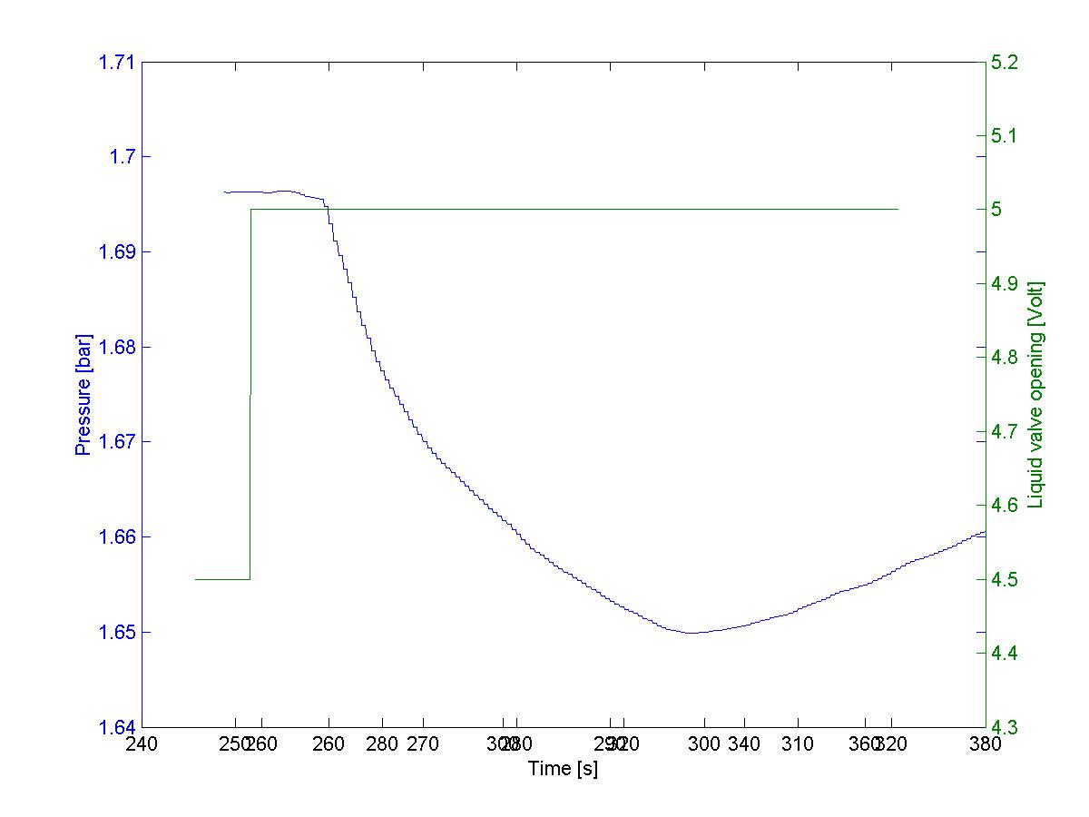
Figure A4.3 Plot of pressure output for a step in liquid valve

This plot does not show 1. order behaviour either, but can be approximated as:

$k=\frac{Δy}{Δu}=\frac{1\text{.}\text{696}\text{bar}−1\text{.}\text{65}\text{bar}}{0\text{.}5V}=−0\text{.}\text{092}\frac{\text{bar}}{V}$ The time constant is found when finding the time where the output reaches 63% of its steady-state. 63% is 1.696 bar-0.63*0.046 bar=1.668 bar. This valued is found after 272 seconds, so $τ=\text{272}s−\text{259}s=\text{13}s$. The dead-time is 1 second.
The transfer function then becomes:

$g_{\text{12}}=−\frac{0\text{.}\text{092}e^{−s}}{\text{13}s+1}$ (A4.7)

The step respons for the liquid level when a change in the pressure valve occurs is shown in figure A4.4.

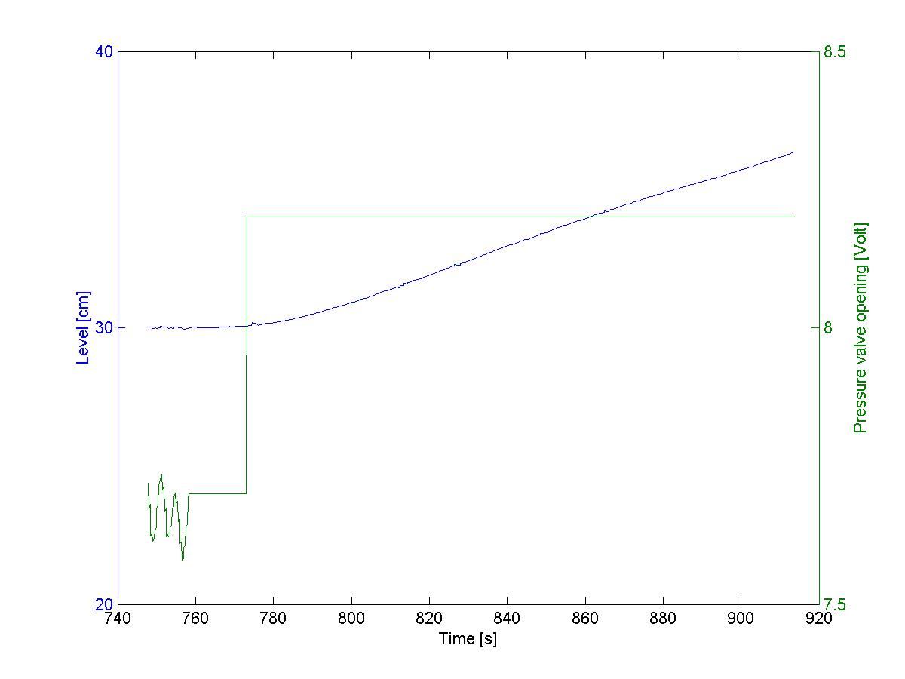
Figure A4.4 Plot of liquid respons for step in pressure valve

This process can be seen to have a dead-time of 2 seconds. The gradient of plot is $k^{'}=\frac{Δ\text{height}}{Δt⋅Δu}=\frac{\text{33}\text{.}2\text{cm}−\text{30}\text{.}\text{02}\text{cm}}{\left(\text{845}s−\text{775}s\right)⋅0\text{.}5V}=0\text{.}\text{091}\frac{\text{cm}}{s⋅V}$. Since this is an integrating process the transfer function will be:

$g_{\text{21}}=\frac{0\text{.}\text{091}e^{−2s}}{s}$ (A4.8)

The final model then becomes
$y=\left[\begin{matrix}\frac{−0\text{.}\text{298}e^{−s}}{\text{12}s+1} & \frac{−0\text{.}\text{092}e^{−s}}{\text{13}s+1} \\ \frac{0\text{.}\text{091}e^{−2s}}{s} & \frac{−0\text{.}\text{076}e^{−2s}}{s}\end{matrix}\right]u$ (A4.9)

A4.4 System identification for a new model

The process was driven to steady-state values at 1.7 bar pressure and 30 cm liquid height. The controllers were put in manual and a step in the liquid valve of -0.5 V was performed. The plot is shown in figure A4.5.

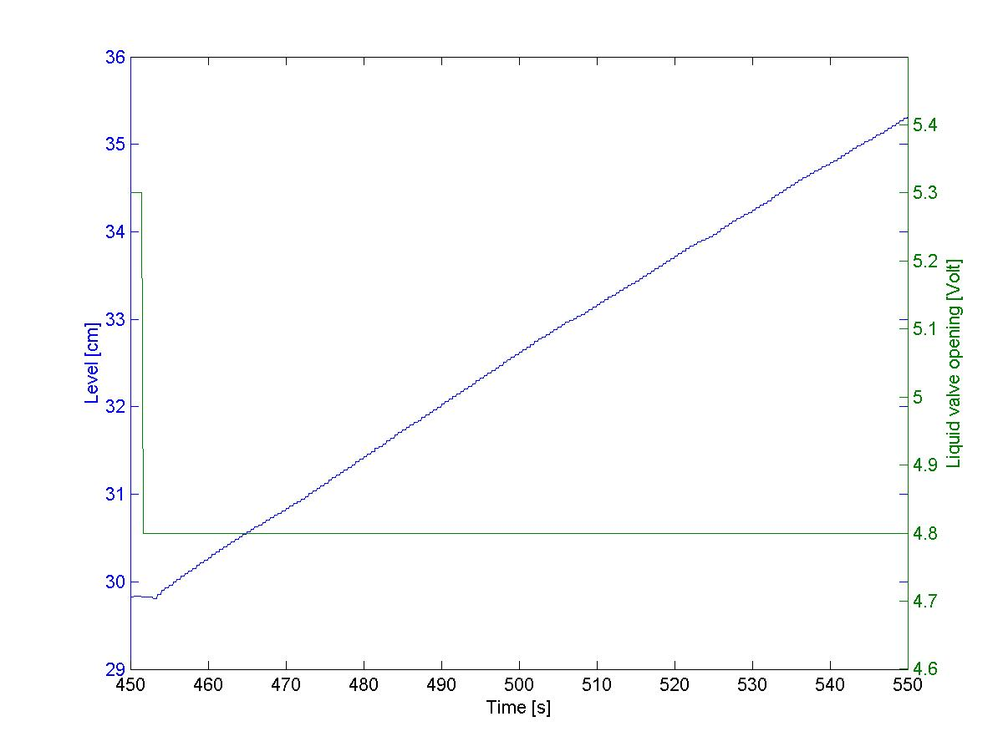
Figure A4.5: Plot for levelrespons for a -0.5 V step in the liquid valve opening.

This process can be seen to have a dead-time of 2.5 seconds. The gradient of plot is $k^{'}=\frac{Δ\text{height}}{Δt⋅Δu}=\frac{\text{36}\text{cm}−\text{31}\text{cm}}{\left(\text{563}s−\text{473}s\right)⋅−0\text{.}5V}=−0\text{.}\text{11}\frac{\text{cm}}{s⋅V}$. Since this is an integrating process the transfer function will be:

$g_{\text{22}}=−\frac{0\text{.}\text{11}e^{−2\text{.}5s}}{s}$ (A4.10)

The process was runned to steady-state values at 1.7 bar pressure and 30 cm liquid height. The controllers were put in manual and a step in the pressure valve of -0.5 V was performed. The plot is shown in figure A4.6.

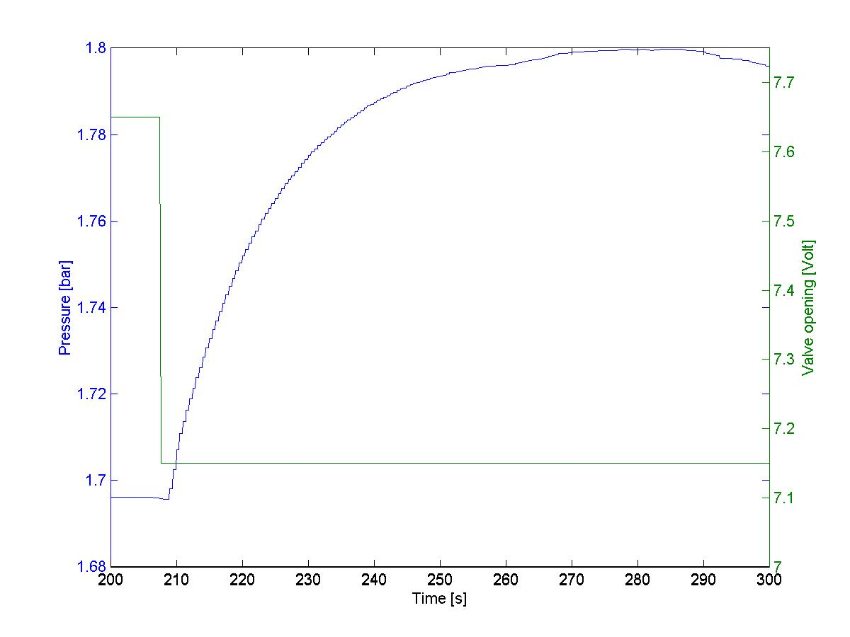
Figure A4.6 Pressure values for -0.5 Volt change in the pressure valve

This plot can be approximated as:

$k=\frac{Δy}{Δu}=\frac{1\text{.}\text{800}\text{bar}−1\text{.}\text{695}\text{bar}}{−0\text{.}5V}=−0\text{.}\text{21}\frac{\text{bar}}{\text{Volt}}$ . The time constant is found when finding the time where the output reaches 63% of its steady-state. 63% is 1.695 bar+0.63*0.105 bar=1.761 bar. This valued is found after 223.5 seconds, so $τ=\text{223}\text{.}5s−\text{209}s=\text{14}\text{.}5s$. The dead-time is 1 second.

The transfer function then becomes:

$g_{\text{11}}=−\frac{0\text{.}\text{21}e^{−s}}{\text{14}\text{.}5s+1}$ (A4.11)

To find the model for the MPC-controller the step-responses for the pressure when a step in the liquid valve was made had to be found. The plot is shown in figure A4.7.

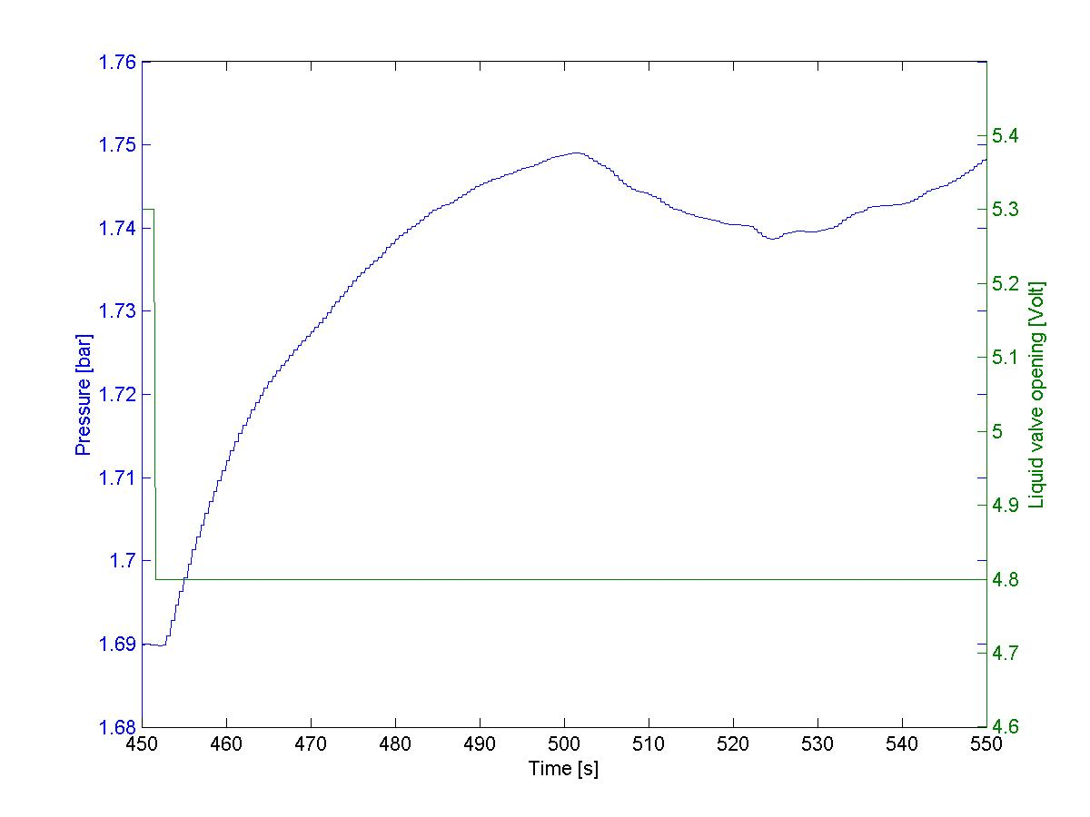
Figure A4.7 Plot of pressure output for a step in liquid valve

This plot does not show 1. order behaviour either, but can be approximated as:

$k=\frac{Δy}{Δu}=\frac{1\text{.}\text{75}\text{bar}−1\text{.}\text{69}\text{bar}}{−0\text{.}5V}=−0\text{.}\text{12}\frac{\text{bar}}{V}$ The time constant is found when finding the time where the output reaches 63% of its steady-state. 63% is 1.69 bar+0.63*0.06 bar=1.73 bar. This valued is found after 470.5 seconds, so $τ=\text{470}\text{.}5s−\text{452}\text{.}5s=\text{18}s$. The dead-time is 2 second.
The transfer function then becomes:

$g_{\text{12}}=−\frac{0\text{.}\text{12}e^{−2s}}{\text{18}s+1}$ (A4.12)

The step respons for the liquid level when a change in the pressure valve occurs is shown in figure A4.8.

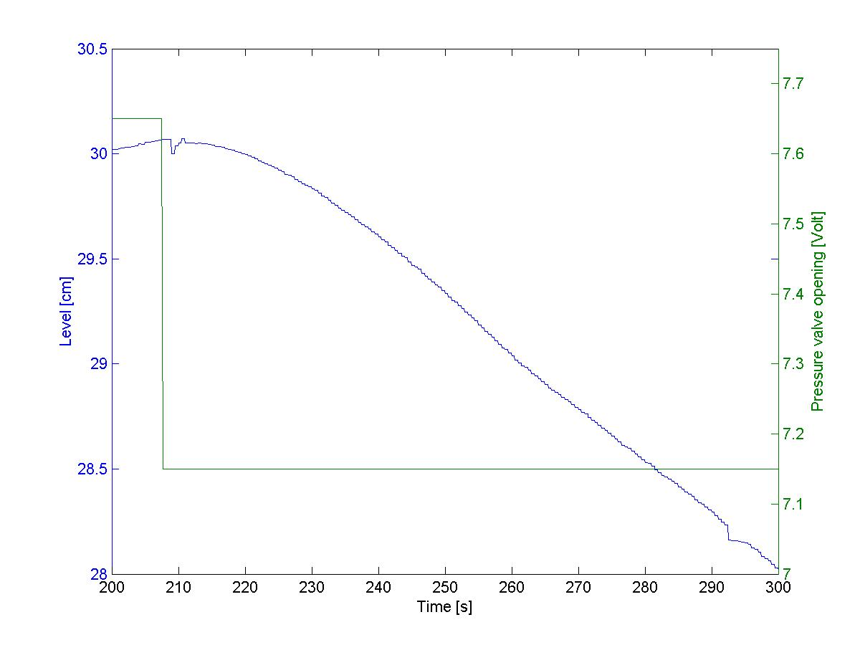
Figure A4.8 Plot of liquid respons for step in pressure valve

This process can be seen to have a dead-time of 7 seconds. The gradient of plot is $k^{'}=\frac{Δ\text{height}}{Δt⋅Δu}=\frac{\text{27}\text{.}5\text{cm}−\text{29}\text{.}5\text{cm}}{\left(\text{321}s−\text{244}\text{.}5s\right)⋅−0\text{.}5V}=0\text{.}\text{052}\frac{\text{cm}}{s⋅V}$. Since this is an integrating process the transfer function will be:

$g_{\text{21}}=\frac{0\text{.}\text{052}e^{−7s}}{s}$ (A4.13)

The final model then becomes:

$y=\left[\begin{matrix}\frac{−0\text{.}\text{21}e^{−s}}{\text{14}\text{.}5s+1} & \frac{−0\text{.}\text{12}e^{−2s}}{\text{18}s+1} \\ \frac{0\text{.}\text{052}e^{−7s}}{s} & \frac{−0\text{.}\text{11}e^{−2\text{.}5s}}{s}\end{matrix}\right]u$ (A4.14)

A5: Matlab code

A5.1 The PID control program

function varargout = kontrollab(varargin)

if nargin == 0 % LAUNCH GUI

fig = openfig(mfilename,'reuse');

% Generate a structure of handles to pass to callbacks, and store it.
handles = guihandles(fig);
guidata(fig, handles);
if nargout > 0
varargout{1} = fig;
end

elseif ischar(varargin{1}) % INVOKE NAMED SUBFUNCTION OR CALLBACK

try
if (nargout)
[varargout{1:nargout}] = feval(varargin{:}); % FEVAL switchyard
else
feval(varargin{:}); % FEVAL switchyard
end
catch
disp(lasterr);
end

end

function model_open(handles)
% Make sure the diagram is still open
if isempty(find_system('Name','kontroll')),
open_system('kontroll'); open_system('kontroll/Pressurescope');open_system('kontroll/Levelscope');
openfig('kontrollab.fig','reuse')

end

% --------------------------------------------------------------------
function varargout = manuallevelslider_Callback(h, eventdata, handles, varargin)

model_open(handles)

% Get the new value for the levelinput from the slider
NewVal1 = get(h,'Value');

% Set the value of the levelinputCurrentValue to the new value set by slider
set(handles.manuallevelvalue,'String',NewVal1)

% Set the value parameter of the manuallevel_input to the new value
set_param('kontroll/manuallevel_input','Value',num2str(NewVal1))

% --------------------------------------------------------------------
function varargout = manuallevelvalue_Callback(h, eventdata, handles, varargin)

model_open(handles)
% Get the new value for the manuallevelvalue
NewStrVal1 = get(h,'String');
NewVal1 = str2double(NewStrVal1);

% Check that the entered value falls within the allowable range
if isempty(NewVal1) | (NewVal1< 0) | (NewVal1>10),
% Revert to last value, as indicated by manuallevelslider
OldVal1 = get(handles.manuallevelslider,'Value');
set(h,'String',OldVal1)

else
% Set the value of the manuallevelslider to the new value
set(handles.manuallevelslider,'Value',NewVal1)

% Set the value parameter of the manuallevel_input to the new value
set_param('kontroll/manuallevel_input','Value',NewStrVal1)
end

% --------------------------------------------------------------------
function varargout = manualpressureslider_Callback(h, eventdata, handles, varargin)

model_open(handles)

NewVal = get(h,'Value');
set(handles.manualpressurevalue,'String',NewVal)
set_param('kontroll/manualpressure_input','Value',num2str(NewVal))

% --------------------------------------------------------------------
function varargout = manualpressurevalue_Callback(h, eventdata, handles, varargin)

model_open(handles)

NewStrVal = get(h,'String');
NewVal = str2double(NewStrVal);

if isempty(NewVal) | (NewVal< 0) | (NewVal>10),
OldVal = get(handles.manualpressureslider,'Value');
set(h,'String',OldVal)

else
set(handles.manualpressureslider,'Value',NewVal)
set_param('kontroll/manualpressure_input','Value',NewStrVal)
end

% --------------------------------------------------------------------
function varargout = levelsetpointslider_Callback(h, eventdata, handles, varargin)
model_open(handles)

NewVal = get(h,'Value');

set(handles.levelsetpointvalue,'String',NewVal)
set_param('kontroll/levelsetpoint','Value',num2str(NewVal))

% --------------------------------------------------------------------
function varargout = levelsetpointvalue_Callback(h, eventdata, handles, varargin)

model_open(handles)

NewStrVal = get(h,'String');
NewVal = str2double(NewStrVal);

if isempty(NewVal) | (NewVal< 0) | (NewVal>50),
OldVal = get(handles.levelsetpointslider,'Value');
set(h,'String',OldVal)

else
set(handles.levelsetpointslider,'Value',NewVal)
set_param('kontroll/levelsetpoint','Value',NewStrVal)
end

% --------------------------------------------------------------------
function varargout = pressuresetpointslider_Callback(h, eventdata, handles, varargin)

model_open(handles)

NewVal = get(h,'Value');

set(handles.pressuresetpointvalue,'String',NewVal)
set_param('kontroll/pressuresetpoint','Value',num2str(NewVal))

% --------------------------------------------------------------------
function varargout = pressuresetpointvalue_Callback(h, eventdata, handles, varargin)
model_open(handles)

NewStrVal = get(h,'String');
NewVal = str2double(NewStrVal);

if isempty(NewVal) | (NewVal< 1) | (NewVal>3.5),

OldVal = get(handles.pressuresetpointslider,'Value');
set(h,'String',OldVal)

else
set(handles.pressuresetpointslider,'Value',NewVal)
set_param('kontroll/pressuresetpoint','Value',NewStrVal)
end

% --------------------------------------------------------------------
function varargout = KcValuePIDlevel_Callback(h, eventdata, handles, varargin)
model_open(handles)

NewStrVal=get(h,'String');
NewVal = str2double(NewStrVal);

set(h,'String',NewVal);
set_param('kontroll/PIDlevelcontroller','Kc',NewStrVal)

% --------------------------------------------------------------------
function varargout = TiValuePIDlevel_Callback(h, eventdata, handles, varargin)
model_open(handles)

NewStrVal=get(h,'String');
NewVal = str2double(NewStrVal);

set(h,'String',NewVal);
set_param('kontroll/PIDlevelcontroller','Ti',NewStrVal)

% --------------------------------------------------------------------
function varargout = TdValuePIDlevel_Callback(h, eventdata, handles, varargin)
model_open(handles)

NewStrVal=get(h,'String');
NewVal = str2double(NewStrVal);

set(h,'String',NewVal);
set_param('kontroll/PIDlevelcontroller','Td',NewStrVal)

% --------------------------------------------------------------------
function varargout = KcValuePIDpressure_Callback(h, eventdata, handles, varargin)
model_open(handles)

NewStrVal=get(h,'String');
NewVal = str2double(NewStrVal);

set(h,'String',NewVal);
set_param('kontroll/PIDpressurecontroller','Kc',NewStrVal)

% --------------------------------------------------------------------
function varargout = TiValuePIDpressure_Callback(h, eventdata, handles, varargin)
model_open(handles)

NewStrVal=get(h,'String');
NewVal = str2double(NewStrVal);

set(h,'String',NewVal);
set_param('kontroll/PIDpressurecontroller','Ti',NewStrVal)

% --------------------------------------------------------------------
function varargout = TdValuePIDpressure_Callback(h, eventdata, handles, varargin)
model_open(handles)

NewStrVal=get(h,'String');
NewVal = str2double(NewStrVal);

set(h,'String',NewVal);
set_param('kontroll/PIDpressurecontroller','Td',NewStrVal)

% --------------------------------------------------------------------
function varargout = start_Callback(h, eventdata, handles, varargin)
model_open(handles)

%sets the last used values as default when the program starts
oldval=get_param('kontroll/manuallevel_input','value');
set(handles.manuallevelvalue,'string',str2double(oldval));
set(handles.manuallevelslider,'value',str2double(oldval));
oldval=get_param('kontroll/manualpressure_input','value');
set(handles.manualpressurevalue,'string',str2double(oldval));
set(handles.manualpressureslider,'value',str2double(oldval));

oldval=get_param('kontroll/pressuresetpoint','value');
set(handles.pressuresetpointvalue,'string',str2double(oldval));
set(handles.pressuresetpointslider,'value',str2double(oldval));

oldval=get_param('kontroll/levelsetpoint','value');
set(handles.levelsetpointvalue,'string',str2double(oldval));
set(handles.levelsetpointslider,'value',str2double(oldval));

%sets the last used PID parametres as default when the program starts.
oldval=get_param('kontroll/PIDpressurecontroller','Kc');
set(handles.KcValuePIDpressure,'string',str2double(oldval));
oldval=get_param('kontroll/PIDpressurecontroller','Ti');
set(handles.TiValuePIDpressure,'string',str2double(oldval));
oldval=get_param('kontroll/PIDpressurecontroller','Td');
set(handles.TdValuePIDpressure,'string',str2double(oldval));

oldval=get_param('kontroll/PIDlevelcontroller','Kc');
set(handles.KcValuePIDlevel,'string',str2double(oldval));
oldval=get_param('kontroll/PIDlevelcontroller','Ti');
set(handles.TiValuePIDlevel,'string',str2double(oldval));
oldval=get_param('kontroll/PIDlevelcontroller','Td');
set(handles.TdValuePIDlevel,'string',str2double(oldval));

%sets the controllers to manual and the simulink ready to start
set_param('kontroll/Constant1','Value',num2str(0))
set_param('kontroll/Constant2','Value',num2str(1))
set_param('kontroll/Constant3','Value',num2str(2))

%sets the log to not start logging
off = [handles.startlog];
mutual_exclude(off);
set(handles.stoplog,'Value',1);

set_param('kontroll/Constant4','Value',num2str(1));
set_param('kontroll/To File','Filename','tankvar.mat');

%sets the controller to manual at start
set(handles.Manuallevelbutton,'Value',1)
set(handles.Manualpressurebutton,'Value',1)

%starts the simulation
sim('kontroll')

% --------------------------------------------------------------------
function varargout = startlog_Callback(h, eventdata, handles, varargin)
model_open(handles)
off = [handles.stoplog];
mutual_exclude(off);

set_param('kontroll/Constant4','Value',num2str(2));

% --------------------------------------------------------------------
function varargout = stoplog_Callback(h, eventdata, handles, varargin)
model_open(handles)
off = [handles.startlog];
mutual_exclude(off);

set_param('kontroll/Constant4','Value',num2str(1));

% --------------------------------------------------------------------
function varargout = quit_Callback(h, eventdata, handles, varargin)
model_open(handles);

pos_size = get(handles.figure1,'Position');
user_response = modaldlg([pos_size(1)+pos_size(3)/5 pos_size(2)+pos_size(4)/5]);
switch user_response
case {'no','cancel'}
% take no action
case 'yes'
% Prepare to close GUI application window
% .
%sets the controllers to manual and the valves to open
set_param('kontroll/Constant3','Value',num2str(2))
set_param('kontroll/Constant2','Value',num2str(1))
set_param('kontroll/manualpressure_input','Value',num2str(10))
set_param('kontroll/manuallevel_input','Value',num2str(10))
pause(0.05);
%stops the simulation
set_param('kontroll/Constant1','Value',num2str(1))
pause(0.05);
save_system('kontroll')
pause(0.05);

delete(handles.figure1)
close_system('kontroll')
end
%-------------------------------------------------------------------
function varargout = figure1_CloseRequestFcn(h, eventdata, handles, varargin)
quit_Callback(h,eventdata,handles)

% --------------------------------------------------------------------
function varargout = Manuallevelbutton_Callback(h, eventdata, handles, varargin)

model_open(handles)
off = [handles.PIDlevelbutton];
mutual_exclude(off)

set_param('kontroll/Constant2','Value',num2str(1))
set_param('kontroll/PIDlevelcontroller/Constant1','Value',num2str(0));

% --------------------------------------------------------------------
function varargout = PIDlevelbutton_Callback(h, eventdata, handles, varargin)
model_open(handles)

off = [handles.Manuallevelbutton];
mutual_exclude(off)
set_param('kontroll/Constant2','Value',num2str(2))
%resets the integrator for the PIDcontroller
set_param('kontroll/PIDlevelcontroller/Constant1','Value',num2str(1));

%-----------------------------------------------------------------------
function mutual_exclude(off)
set(off,'Value',0)

% --------------------------------------------------------------------
function varargout = Manualpressurebutton_Callback(h, eventdata, handles, varargin)
model_open(handles)

off = [handles.PIDpressurebutton];
mutual_exclude(off)

%switches to manual control
set_param('kontroll/Constant3','Value',num2str(2))
set_param('kontroll/PIDpressurecontroller/Constant1','Value',num2str(0));

% --------------------------------------------------------------------
function varargout = PIDpressurebutton_Callback(h, eventdata, handles, varargin)

model_open(handles)
off = [handles.Manualpressurebutton];
mutual_exclude(off)

%Swithces to automatic mode
set_param('kontroll/Constant3','Value',num2str(1))
set_param('kontroll/PIDpressurecontroller/Constant1','Value',num2str(1));

% --------------------------------------------------------------------
function varargout = stopsimulation_Callback(h, eventdata, handles, varargin)
set_param('kontroll/Constant1','Value',num2str(1))

% --------------------------------------------------------------------
function varargout = figure1_ResizeFcn(h, eventdata, handles, varargin)
% %

A5.2 The MPC control program

function varargout = MPCprogram(varargin)

if nargin == 0 % LAUNCH GUI

fig = openfig(mfilename,'reuse');

% Generate a structure of handles to pass to callbacks, and store it.
handles = guihandles(fig);
guidata(fig, handles);

if nargout > 0
varargout{1} = fig;
end

elseif ischar(varargin{1}) % INVOKE NAMED SUBFUNCTION OR CALLBACK

try
if (nargout)
[varargout{1:nargout}] = feval(varargin{:}); % FEVAL switchyard
else
feval(varargin{:}); % FEVAL switchyard
end
catch
disp(lasterr);
end

end

function model_open(handles)
% Make sure the diagram is still open
if isempty(find_system('Name','MPCcontrol')),
open_system('MPCcontrol'); open_system('MPCcontrol/PressureScope');open_system('MPCcontrol/LevelScope');
openfig('MPCprogram.fig','reuse')

end

% --------------------------------------------------------------------
function varargout = manuallevelslider_Callback(h, eventdata, handles, varargin)
model_open(handles)

% Get the new value for the levelinput from the slider
NewVal1 = get(h,'Value');

% Set the value of the levelinputCurrentValue to the new value set by slider
set(handles.manuallevelvalue,'String',NewVal1)

% Set the value parameter of the manuallevel_input to the new value
set_param('MPCcontrol/manuallevel_input','value',num2str(NewVal1))

% --------------------------------------------------------------------
function varargout = manuallevelvalue_Callback(h, eventdata, handles, varargin)
model_open(handles)

% Get the new value for the manuallevelvalue
NewStrVal1 = get(h,'String');
NewVal1 = str2double(NewStrVal1);

% Check that the entered value falls within the allowable range
if isempty(NewVal1) | (NewVal1< 0) | (NewVal1>10),
% Revert to last value, as indicated by manuallevelslider
OldVal1 = get(handles.manuallevelslider,'Value');
set(h,'String',OldVal1)

else
% Set the value of the manuallevelslider to the new value
set(handles.manuallevelslider,'Value',NewVal1)

% Set the value parameter of the manuallevel_input to the new value
set_param('MPCcontrol/manuallevel_input','Value',NewStrVal1)
end

% --------------------------------------------------------------------
function varargout = manualpressureslider_Callback(h, eventdata, handles, varargin)

model_open(handles)

NewVal = get(h,'Value');

set(handles.manualpressurevalue,'String',NewVal)
set_param('MPCcontrol/manualpressure_input','Value',num2str(NewVal))

% --------------------------------------------------------------------
function varargout = manualpressurevalue_Callback(h, eventdata, handles, varargin)

model_open(handles)

NewStrVal = get(h,'String');
NewVal = str2double(NewStrVal);

if isempty(NewVal) | (NewVal< 0) | (NewVal>10),
OldVal = get(handles.manualpressureslider,'Value');
set(h,'String',OldVal)

else
set(handles.manualpressureslider,'Value',NewVal)
set_param('MPCcontrol/manualpressure_input','Value',NewStrVal)
end

% --------------------------------------------------------------------
function varargout = levelsetpointslider_Callback(h, eventdata, handles, varargin)

model_open(handles)

NewVal = get(h,'Value');
oldpressurevalue=get(handles.pressuresetpointslider,'Value');

set(handles.levelsetpointvalue,'String',NewVal)
set_param('MPCcontrol/nlmpcsim','r',mat2str([oldpressurevalue NewVal]));
set_param('MPCcontrol/Levelsetpoint','Value',num2str(NewVal))

% --------------------------------------------------------------------
function varargout = levelsetpointvalue_Callback(h, eventdata, handles, varargin)

model_open(handles)

NewStrVal = get(h,'String');
NewVal = str2double(NewStrVal);
oldpressurevalue=get(handles.pressuresetpointslider,'Value');

if isempty(NewVal) | (NewVal< 0) | (NewVal>50),
OldVal = get(handles.levelsetpointslider,'Value');
set(h,'String',OldVal)

else
set(handles.levelsetpointslider,'Value',NewVal)
set_param('MPCcontrol/nlmpcsim','r',mat2str([oldpressurevalue NewVal]));
set_param('MPCcontrol/Levelsetpoint','Value',NewStrVal)

end

% --------------------------------------------------------------------
function varargout = pressuresetpointslider_Callback(h, eventdata, handles, varargin)

model_open(handles)

NewVal = get(h,'Value');
oldlevelvalue = get(handles.levelsetpointslider,'Value');

set(handles.pressuresetpointvalue,'String',NewVal)

set_param('MPCcontrol/nlmpcsim','r',mat2str([NewVal oldlevelvalue]))
set_param('MPCcontrol/Pressuresetpoint','Value',num2str(NewVal))

% --------------------------------------------------------------------
function varargout = pressuresetpointvalue_Callback(h, eventdata, handles, varargin)

model_open(handles)

NewStrVal = get(h,'String');
NewVal = str2double(NewStrVal);
oldlevelvalue = get(handles.levelsetpointslider,'Value');

if isempty(NewVal) | (NewVal< 0) | (NewVal>3.5),

OldVal = get(handles.pressuresetpointslider,'Value');
set(h,'String',OldVal)

else
set(handles.pressuresetpointslider,'Value',NewVal)
set_param('MPCcontrol/nlmpcsim','r',mat2str([NewVal oldlevelvalue]));
set_param('MPCcontrol/Pressuresetpoint','Value',NewStrVal)

end

% --------------------------------------------------------------------
function varargout = manualbutton_Callback(h, eventdata, handles, varargin)
model_open(handles)

off = [handles.MPCbutton];
mutual_exclude(off)

set_param('MPCcontrol/manualswitch','Value',num2str(2))

% --------------------------------------------------------------------
function varargout = MPCbutton_Callback(h, eventdata, handles, varargin)
model_open(handles)

off = [handles.manualbutton];
mutual_exclude(off)

set_param('MPCcontrol/manualswitch','Value',num2str(1))

% --------------------------------------------------------------------
function varargout = levelKvalue_Callback(h, eventdata, handles, varargin)
%None of these functions do anything. They are only called upon when the start
%or initialize button is pressed. This is because it was not possible to change
%these values while the simulation was running.
% --------------------------------------------------------------------
function varargout = levelTauvalue_Callback(h, eventdata, handles, varargin)
% --------------------------------------------------------------------
function varargout = levelDelayvalue_Callback(h, eventdata, handles, varargin)
% --------------------------------------------------------------------
function varargout = pressureKvalue_Callback(h, eventdata, handles, varargin)
% --------------------------------------------------------------------
function varargout = pressureTauvalue_Callback(h, eventdata, handles, varargin)
% --------------------------------------------------------------------
function varargout = pressureDelayvalue_Callback(h, eventdata, handles, varargin)
% --------------------------------------------------------------------
function varargout = pressuremeasureweight_Callback(h, eventdata, handles, varargin)
% --------------------------------------------------------------------
function varargout = pressureinputweight_Callback(h, eventdata, handles, varargin)
% --------------------------------------------------------------------
function varargout = levelmeasureweight_Callback(h, eventdata, handles, varargin)
% --------------------------------------------------------------------
function varargout = levelinputweight_Callback(h, eventdata, handles, varargin)
% --------------------------------------------------------------------
function varargout = predictionhorizon_Callback(h, eventdata, handles, varargin)
% --------------------------------------------------------------------
function varargout = controlhorizon_Callback(h, eventdata, handles, varargin)
% --------------------------------------------------------------------
function varargout = Startbutton_Callback(h, eventdata, handles, varargin)
model_open(handles)

%Here the values from the transferfunction is called, and the parameters for the
%MPC controller is calculated
numlev=str2num(get(handles.levelKvalue,'String'));
denlev=str2num(get(handles.levelTauvalue,'String'));
delaylev=str2num(get(handles.levelDelayvalue,'String'));

numpre=str2num(get(handles.pressureKvalue,'String'));
denpre=str2num(get(handles.pressureTauvalue,'String'));
delaypre=str2num(get(handles.pressureDelayvalue,'String'));

numlevpre=str2num(get(handles.levpreKvalue,'String'));
denlevpre=str2num(get(handles.levpreTauvalue,'String'));
delaylevpre=str2num(get(handles.levpreDelayvalue,'String'));

numprelev=str2num(get(handles.prelevKvalue,'String'));
denprelev=str2num(get(handles.prelevTauvalue,'String'));
delayprelev=str2num(get(handles.prelevDelayvalue,'String'));

g22=poly2tfd(numlev,[denlev 0],0,delaylev);
g12=poly2tfd(numlevpre,[denlevpre 1],0,delaylevpre);
g21=poly2tfd(numprelev,[denprelev 0],0,delayprelev);
g11=poly2tfd(numpre,[denpre 1],0,delaypre);

%Because the level output is integrating
nout=[1 0]';
%The length of the step-respons
tfinal=100;
%The sample time is set in the Simulink diagram
delt=get_param('MPCcontrol/Control Lab DA','Dt');
delt=str2num(delt);
model=tfd2step(tfinal,delt,nout,g11,g21,g12,g22);

dmodel=[];

set_param('MPCcontrol/nlmpcsim','modelpd',mat2str([model dmodel]));

%checks the setpointvalues
levelset = get_param('MPCcontrol/Levelsetpoint','Value');
pressureset =get_param('MPCcontrol/Pressuresetpoint','Value');
pressureset=str2num(pressureset);
levelset=str2num(levelset);
r=[pressureset levelset];
set_param('MPCcontrol/nlmpcsim','r',mat2str(r));

%The weights of the object function
lywt=str2num(get(handles.levelmeasureweight,'String'));
pywt=str2num(get(handles.pressuremeasureweight,'String'));
ywt=[pywt lywt];
luwt=str2num(get(handles.levelinputweight,'String'));
puwt=str2num(get(handles.pressureinputweight,'String'));
uwt=[puwt luwt];

m=get(handles.controlhorizon,'String');
p=get(handles.predictionhorizon,'String');
m=str2num(m);
p=str2num(p);
Kmpc=mpccon(model,ywt,uwt,m,p);

set_param('MPCcontrol/nlmpcsim','Kmpc',mat2str(Kmpc));

%starter simuleringen
set_param('MPCcontrol/Constant2','Value',num2str(0));

sim('MPCcontrol');
% --------------------------------------------------------------------
function varargout = stopbutton_Callback(h, eventdata, handles, varargin)

set_param('MPCcontrol/Constant2','Value',num2str(1));

% --------------------------------------------------------------------
function varargout = quitbutton_Callback(h, eventdata, handles, varargin)

model_open(handles);

pos_size = get(handles.figure1,'Position');
user_response = modaldlg([pos_size(1)+pos_size(3)/5 pos_size(2)+pos_size(4)/5]);
switch user_response
case {'no','cancel'}
% take no action
case 'yes'
% Prepare to close GUI application window
% .
%sets the controllers to manual and the valves to open

set_param('MPCcontrol/manualswitch','Value',num2str(2))
set_param('MPCcontrol/manualpressure_input','Value',num2str(10))
set_param('MPCcontrol/manuallevel_input','Value',num2str(10))
pause(0.05);
%stops the simulation
set_param('MPCcontrol/Constant2','Value',num2str(1));

pause(0.05);
save_system('MPCcontrol')
pause(0.05);

delete(handles.figure1)
close_system('MPCcontrol')
end

% --------------------------------------------------------------------
function varargout = figure1_ResizeFcn(h, eventdata, handles, varargin)
%---------------------------------------------------------------------
function mutual_exclude(off)
set(off,'Value',0)

% --------------------------------------------------------------------
function varargout = levpreKvalue_Callback(h, eventdata, handles, varargin)
% --------------------------------------------------------------------
function varargout = levpreTauvalue_Callback(h, eventdata, handles, varargin)
% --------------------------------------------------------------------
function varargout = levpreDelayvalue_Callback(h, eventdata, handles, varargin)
% --------------------------------------------------------------------
function varargout = prelevTauvalue_Callback(h, eventdata, handles, varargin)
% --------------------------------------------------------------------
function varargout = prelevKvalue_Callback(h, eventdata, handles, varargin)
% --------------------------------------------------------------------
function varargout = prelevDelayvalue_Callback(h, eventdata, handles, varargin)
% --------------------------------------------------------------------
function varargout = Initialise_Callback(h, eventdata, handles, varargin)
model_open(handles);

%Here is a temporary model loaded. This has to be done here, and not in the simulink
%diagram.
set(handles.levelKvalue,'String',num2str(-0.76));
set(handles.levelTauvalue,'String',num2str(10));
set(handles.levelDelayvalue,'String',num2str(2));

set(handles.pressureKvalue,'String',num2str(-0.3));
set(handles.pressureTauvalue,'String',num2str(12));
set(handles.pressureDelayvalue,'String',num2str(1));

set(handles.levpreKvalue,'String',num2str(-0.09));
set(handles.levpreTauvalue,'String',num2str(13));
set(handles.levpreDelayvalue,'String',num2str(1));

set(handles.prelevKvalue,'String',num2str(0.91));
set(handles.prelevTauvalue,'String',num2str(10));
set(handles.prelevDelayvalue,'String',num2str(2));

set(handles.levelmeasureweight,'String',num2str(1));
set(handles.levelinputweight,'String',num2str(1));
set(handles.pressuremeasureweight,'String',num2str(1));
set(handles.pressureinputweight,'String',num2str(1));

set(handles.predictionhorizon,'String',num2str(50));
set(handles.controlhorizon,'String',num2str(10));

%puts the controller in manual at start
off = [handles.MPCbutton];
mutual_exclude(off)
set(handles.manualbutton,'value',1);
model_open(handles)
set_param('MPCcontrol/manualswitch','Value',num2str(2));

numlev=str2num(get(handles.levelKvalue,'String'));
denlev=str2num(get(handles.levelTauvalue,'String'));
delaylev=str2num(get(handles.levelDelayvalue,'String'));

numpre=str2num(get(handles.pressureKvalue,'String'));
denpre=str2num(get(handles.pressureTauvalue,'String'));
delaypre=str2num(get(handles.pressureDelayvalue,'String'));

numlevpre=str2num(get(handles.levpreKvalue,'String'));
denlevpre=str2num(get(handles.levpreTauvalue,'String'));
delaylevpre=str2num(get(handles.levpreDelayvalue,'String'));

numprelev=str2num(get(handles.prelevKvalue,'String'));
denprelev=str2num(get(handles.prelevTauvalue,'String'));
delayprelev=str2num(get(handles.prelevDelayvalue,'String'));

g22=poly2tfd(numlev,[denlev 0],0,delaylev);
g12=poly2tfd(numlevpre,[denlevpre 1],0,delaylevpre);
g21=poly2tfd(numprelev,[denprelev 0],0,delayprelev);
g11=poly2tfd(numpre,[denpre 1],0,delaypre);

nout=[1 0]';
tfinal=100;
set_param('MPCcontrol/Control Lab DA','Dt',num2str(0.3));
set_param('MPCcontrol/Control Lab AD','Dt',num2str(0.3));
delt=get_param('MPCcontrol/Control Lab DA','Dt');
delt=str2num(delt);
model=tfd2step(tfinal,delt,nout,g11,g21,g12,g22);

dmodel=[];

set_param('MPCcontrol/nlmpcsim','modelpd',mat2str([model dmodel]));

lywt=str2num(get(handles.levelmeasureweight,'String'));
pywt=str2num(get(handles.pressuremeasureweight,'String'));
ywt=[pywt lywt];
luwt=str2num(get(handles.levelinputweight,'String'));
puwt=str2num(get(handles.pressureinputweight,'String'));
uwt=[puwt luwt];
m=get(handles.controlhorizon,'String');
p=get(handles.predictionhorizon,'String');
m=str2num(m);
p=str2num(p);
Kmpc=mpccon(model,ywt,uwt,m,p);

set_param('MPCcontrol/nlmpcsim','Kmpc',mat2str(Kmpc));

%puts constraints on the inputs
usat=[0 0 10 10 10 10];
set_param('MPCcontrol/nlmpcsim','usat',mat2str(usat));

tfilter=[0 0];
set_param('MPCcontrol/nlmpcsim','tfilter',mat2str(tfilter));

%gives the value of ud0
u0=[6.5 5];
d0=[];
ud0=[u0 d0];
set_param('MPCcontrol/nlmpcsim','ud0',mat2str(ud0));

%gives setpoints at startup
set(handles.levelsetpointvalue,'String',num2str(30));
set(handles.levelsetpointslider,'Value',30);
set(handles.pressuresetpointvalue,'String',num2str(1.7));
set(handles.pressuresetpointslider,'Value',1.7);
set_param('MPCcontrol/Pressuresetpoint','value',num2str(1.7));
set_param('MPCcontrol/Levelsetpoint','value',num2str(30));
r=[1.7 30];
set_param('MPCcontrol/nlmpcsim','r',mat2str(r));

%opens the valves at startup
set(handles.manuallevelvalue,'string',num2str(10));
set(handles.manuallevelslider,'value',10);

set(handles.manualpressurevalue,'string',num2str(10));
set(handles.manualpressureslider,'value',10);

set_param('MPCcontrol/To File','Filename','MPCvar');

off = [handles.startlog];
mutual_exclude(off)

set_param('MPCcontrol/Constant1','Value',num2str(1));
set(handles.stoplog,'value',1);

% --------------------------------------------------------------------
function varargout = startlog_Callback(h, eventdata, handles, varargin)
model_open(handles)

off = [handles.stoplog];
mutual_exclude(off)

set_param('MPCcontrol/Constant1','Value',num2str(2));

% --------------------------------------------------------------------
function varargout = stoplog_Callback(h, eventdata, handles, varargin)
model_open(handles)
off = [handles.startlog];
mutual_exclude(off)

set_param('MPCcontrol/Constant1','Value',num2str(1));

