



The University of Queensland
Faculty of Engineering
Department of Chemical Engineering
Centre for Computer Aided Process Engineering

Individual Enquiry Project

Modelling and control studies of high recycle granulation circuits

Author: Thomas Haugan
Supervisor: Associate Professor Ian Cameron

October 2000



ABSTRACT
In the beginning of the 1980s model predictive control (MPC) appeared in industry as an effective way to deal with multivariable control problems, [1]. The advantages of this algorithm were simplicity and the use of impulse or step input model. These models are usually preferred as being more intuitive for their identification.

This work looked at the implementation of Dynamic Matrix Control (DMC) on the granulation drum, and in order to make a framework to construct the DMC from, a test problem consisting of a heat exchanger was chosen. DaeSim was used to carry out the simulations.

As a reference point to measure the DMC performance a conventional PI controller was constructed. Open loop studies on the system were carried out in order to construct both controllers. Tuning rules developed by Cohen and Coon was followed for tuning of the PI controller, and the guidelines set out in Marlin [2] were followed to tune the DMC controller.

The PI controller is continuos in the time domain, while the DMC is discrete. The DMC controller is activated every 20 second by an event file. The results clearly show that the PI has a better performance than the DMC on the SISO system, with lower settling time and less overshoot. However, with taking all the past control actions into account in the DMC algorithm instead of just the last control action sent to the plant, the DMC performance is improved.

One of the big advantages with MPC is the possibility of centralising the control when implemented on a MIMO system. Step response studies were carried out to construct the dynamic matrix and control matrix in order to calculate the control law.

Finally, it is recommended that instead of a matrix description of the system, state space theory should be used when constructing the MPC algorithm. This will simplify the algorithm since the size of the matrices tends to be large when this method is used to describe the system.

ACKNOWLEDGEMENTS

I would like to thank the following people who have assisted me greatly in the completion of this individual enquiry:

Supervisor:
Associate Professor Ian Cameron

Others:
Nicoleta Balliu

TABLE OF CONTENTS
ABSTRACT 1-2
ACKNOWLEDGEMENTS 1-3
TABLE OF CONTENTS 1-4
LIST OF FIGURES 1-5
LIST OF TABLES 1-5
NOMENCLATURE 1-5
1 INTRODUCTION 1-6
1.1 What is Model Predictive Control? 1-6
1.2 MPC strategy 1-7
1.3 Literature review 1-8
1.4 Scope of work 1-9
2 THEORY 2-10
2.1 Granulation 2-10
2.2 Description of the granulation circuit pilot plant 2-11
2.3 Conventional controllers 2-11
2.3.1 Proportional-Integral (PI) controller 2-12
2.4 Dynamic Matrix Control (DMC) 2-12
2.4.1 Controller parameters forming dynamic matrix A 2-14
2.4.2 The control law 2-15
2.4.3 The reference trajectory 2-15
2.4.4 The free response 2-15
2.5 Tuning of PI controller 2-16
2.6 Tuning of Dynamic Matrix Controller 2-17
3 RESULTS 3-18
3.1 Test Problem: Heat Exchanger 3-18
3.1.1 Building the PI controller 3-19
3.1.2 Building the MPC controller 3-21
3.1.2.1 Controller performance with only taking the last control action into account 3-22
3.1.2.2 Controller performance with taking all the past control actions into account 3-24
3.2 Implementation of MPC on granulation drum 3-26
3.2.1 Tuning 3-31
3.2.2 Performance 3-31
4 DISCUSSION 4-32
5 CONCLUSION 5-34
6 RECOMMENDATIONS 6-34
REFERENCES 6-35
APPENDIX 1: DaeSim code for DMC controller 6-36
APPENDIX 2: DaeSim code for PI controller 6-39
APPENDIX 3: DaeSim code for temperature sensor 6-40
APPENDIX 4: DaeSim code for heat exchanger 6-41
APPENDIX 5: Matlab code for matrix calculations 6-43
Appendix 6: DaeSim code for DMC controller on granulation drum 6-44

LIST OF FIGURES
Figure 1.1-1: Predictive control structure 1-6
Figure 2.2-1: Schematic diagram of fertiliser granulation circuit 2-11
Figure 2.4-1: Predictive control algorithm flow chart 2-13
Figure 2.4-2: Step response method to determine coefficients 2-14
Figure 2.4-3: Dynamic response of variables for DMC control 2-16
Figure 2.5-1: Process reaction curve. 2-17
Figure 3.1-1: Schematic view of heat exchanger 3-18
Figure 3.1-2: Free response of step change in hot in flowrate. 3-19
Figure 3.1-3: PI controller on heat exchanger 3-20
Figure 3.1-4: Response to a step change in cold water flowrate with PI controller implemented 3-21
Figure 3.1-5: MPC controller on heat exchanger 3-21
Figure 3.1-6: Response to a step change in cold water flowrate with MPC activated every 20 second, only taking the last control action into account 3-24
Figure 3.1-7: Response to a step change in cold water flowrate with MPC activated every 20 second, taking past control actions into account. 3-26
Figure 3.2-1: Closed loop system of granulation drum 3-26
Figure 3.2-2: Step response with a step change in binder1 flowrate at time t = 500 3-28
Figure 3.2-3: Step response with a step change in binder2 flowrate at time t = 500 3-28

LIST OF TABLES
Table 3.1-1: Parameter values for heat exchanger 3-19
Table 3.1-2: Parameter values for PI controller 3-20
Table 3.1-3: Dynamic matrix [A] for heat exchanger 3-22
Table 3.1-4: Control matrix [K] for heat exchanger 3-22
Table 3.1-5: Parameter values for MPC 3-23
Table 3.1-6: Control matrix [K] for heat exchanger 3-24
Table 3.1-7: Parameter values for MPC 3-25
Table 3.2-1: Dynamic matrix [A₁₁] for granulation drum 3-29
Table 3.2-2: Dynamic matrix [A₁₂] for granulation drum 3-29
Table 3.2-3: Dynamic matrix [A₂₁] for granulation drum 3-29
Table 3.2-4: Dynamic matrix [A₂₂] for granulation drum 3-29

NOMENCLATURE

INTRODUCTION

What is Model Predictive Control?
Model predictive control (MPC), or receding horizon control (RHC), is an optimisation-based strategy that uses a plant model to predict the effect of a control action on the plant. This is obtained by solving on-line, at each time step, an open-loop optimal control problem. The state of the plant is used as an initial state, and the first control action is applied to the plant. When a new measurement is available, a new open-loop simulation is solved.

Model Predictive Control (MPC) has become a preferred control strategy for a large number of processes over the last 15 years, [1]. The main reasons for this preference include the ability to handle multivariable constrained control problems in an optimal way and flexible formulation in the time domain. Linear MPC schemes, i.e. MPC schemes for which the prediction is based on a linear description of the plant, are by now routinely used in a number of industrial sectors. However, a practical disadvantage is the computational cost, which tends to limit MPC applications to linear processes with relatively slow dynamics.

On the contrary, Non-linear Model Predictive Control (NMPC), i.e. MPC based on a non-linear plant description has only emerged in the last decade, and there is a need for better understanding in this area. Since chemical and petroleum processes in general are non-linear, the expectation of NMPC is high.

Marlin [2] has given a general predictive control structure as showed in figure 1.1-1. Three transfer functions represent the true process with the final element and sensor, G_{p}(s); the controller, G_{cp}(s); and a dynamic model of the process, G_{m}(s). The feedback signal E_{m} is the difference between the measured and predicted controlled variable values. The variable E_{m} is, however, equal to the effect of the disturbance, G_{d}(s)*D(s), if the model is perfect. However, the model is never exact, so that the feedback signal includes the effect of the disturbance together with model inaccuracy.

CV(s)
D(s)
E_{m}(s)
MV(s)
T_{p}(s)
-
+
+
+
-
+
SP(s)
G_{cp}(s)
G_{p}(s)
G_{d}(s)
G_{m}(s)

Figure 1.1-1: Predictive control structure

MPC strategy
Levine [3] states that MPC utilises the available system model to incorporate the predicted future behaviour of the process into the controller design procedure. This method of control design and implementation usually comprises
- A process model; often a linear discrete system model obtained experimentally
- A predictor equation; this is run forward for a fixed number of time steps to predict the likely process behaviour
- A known future reference trajectory
- A cost function; this is usually quadratic and costs future process output errors (w.r.t. the known reference) and controls.
Model-based predictive control algorithms are versatile and robust in applications, outperforming minimum variance and PID in challenging control situations.

The methodology of all the controllers belonging to the MPC family is characterised by a strategy specified by Camacho and Bordons [4]. In order to implement this strategy, the basic structure shown in figure 1.1-1 is used. The model is used to predict the future plants outputs based on past and current values and on the proposed optimal future control actions. This methodology can be divided into future outputs, future control signals and repeating:

Future outputs
The future outputs for a determined horizon N, called the prediction horizon, are predicted at each instant t using the process model. These predicted outputs depend on the known values up to instant t and on the future control signals, which are those to be sent to the system and to be calculated.

Future control signals
The set of future control signals is calculated by optimising a determined criterion in order to keep the process as close as possible to the reference trajectory (which can be the set point itself or a close approximation of it). This criterion usually takes the form of a quadratic function of the errors between the predicted output signal and the predicted reference trajectory. The control effort is included in the objective function in most cases. An explicit solution can be obtained if the criterion is quadratic, the model is linear and there are no constraints otherwise an iterative optimisation has to be used. Some assumptions on the future control law have to be made in some cases, such as that it will be constant from a given instant.

Repeating
The control signal is sent to the process whilst the next control signals calculated are rejected. Because at the next sampling instant y(t+1) is already known and first step is repeated with this new value and all the sequences are brought up to date.

All MPC algorithms possess common elements, and different options can be chosen for each one of these elements giving rise to different algorithms. These elements are:
- Prediction model
- Objective function
- Obtaining control law

In this work dynamic matrix control is considered. It uses the step resonse to model the process, only taking the N first terms into account. Therefore assuming that the process is stable and without integrators.

Literature review
Eek and Bosgra [6] have made research about selecting a sensor for the control of the particle size distribution (PSD) in particulate processes, such as crystallisers, yet-mills and granulators. As an example, the control of the crystal size distribution (CSD) dynamics in a continuous crystallization process is taken. Different methods are discussed to derive process information from a typical PSD sensor, comprising an array detector. It is shown that generally a limited number of degrees of freedom are present in the process output signals. Factors limiting the controllability of processes are discussed. It is shown that proper placement of the sensor in the particle size domain is important for feedback control, because the sensor characteristics will determine the location of the zeros in the process transfer function. For an industrial crystallization process, it is shown that measurement of the CSD below 30 μm limits the achievable closed-loop speed of response, due to the presence of a right halve plane zero. Effective control of the CSD is achieved, using a simple feedback controller that measures only the fine crystals in the range of 40-200 μm.

Ye et.al.[7] presents a system, which integrates the advanced process control and full-scale dynamic simulation. The advanced process control uses multivariable model predictive control techniques. The model used in the predictive control algorithms is generated from the dynamic simulated process. The advanced process controller
can control the simulated plant directly, or through a DCS system to control the simulated plant. This environment is very useful for engineers in designing and tuning the advanced process controllers, and in testing communication between the advanced process controller and the DCS systems.

Reddy et.al. [8] investigates the effect of operating variables on the continuous rotary drum granulation of fertilizers. The fertilisers, viz. urea and potassium chloride with bentonite as a binder, were taken as feed materials. The effects of moisture content and feed rate on continuous rotary drum granulation are discussed. Step response experiments with respect to the above two variables were also conducted to investigate the dynamic behaviour of the system, which will be of use in the control of the granulator.

Reddy et.al. [9] developed a two-parameter phenomenological model for fertilizer granulation taking into account the growth and death function. It was assumed that the growth and death functions were governed by layering and breakage mechanisms,
respectively. Experiments were conducted in a rotary drum granulator on an N-K system and the data were used for obtaining the model parameters with reference to the operating conditions and to validate the model. It is concluded that the proposed model adequately describes the complexities of the fertilizer granulation process.

Walker et.al. [11] identified three factors affecting the degree of fertilizer granulation; solution to solid phase ratio, the binder viscosity and the optimal rotation speed of the drum. Experimental results indicated that a critical solution to solid phase ratio is required for an increase in granulation in terms of mass median diameter. The saturated solution viscosity in this system was measured and correlated well to binder viscosity granulation theory with the critical Stokes number calculated at 700. The optimum rotation speed for flighted and unflighted drums correlated with the Froude number relationship for full-scale granulation units.

A survey of the most popular multivariable control methods is provided by Morari & Zafiriou [12], while some introductory and general aspects are highlighted in Levine [3]. Camacho & Bordons [4] provides an extensive review concerning the theoretical and practical aspects of predictive controllers. Nise [5] gives a basic understanding of control issues, and an introduction in state space theory and techniques, both in s- and z-domain.

Marlin [2] gives an extensive overview of the theory behind MPC and examples on implementation of DMC on both SISO and MIMO systems. Tuning issues are also covered, and general guidelines are set out. The framework given by Marlin is used as basis for this paper.

Steffens [15] developed a DMC controller on an activated sludge system. He identified the model offline by means of Matlab, and used the step response model for describing the system. In order to minimise the error the least squares solution was used. The DMC is controlling a MIMO system, with two inputs, two outputs and four manipulated variables.

Scope of work
This work will look at the implementation of model predictive control to the control of the granulation circuit. For granulation circuits, there is still a need for better understanding of linear MPC, and this project is going to be focused on implementation of linear MPC. As basis for the MPC the Dynamic Matrix Control (DMC) approach is chosen. The work will provide an initial assessment of the control performance of MPC, which will be implemented at a later stage through the DCS system attached to the pilot plant. A framework for construction of the DMC algorithm will be developed.

As a test problem, a simple heat exchanger is studied. This is a single-input-single-output (SISO) system, in contrast to the granulation drum, which is a multiple-input-multiple-output (MIMO) system.

Open loop studies are done in order to construct and tune the controllers. The performance of the DMC is compared against the performance of a conventional PI controller.

THEORY

Granulation
Granulation is defined in Rhodes [17] as particle size enlargement by sticking together smaller particles using agitation methods to distribute liquid binder. The driving force is the motion of the particles, which causes them to collide and thereby grow by coalescence and coating. Every granulation process is controlled by four mechanisms;
- Wetting. Wetting of the original particles.
- Growth. This mechanism is consisting of nucleation, coalescence and layering.
- Consolidation. Increase in granule density.
- Granule breakage.

Hounslow et.al. [18] discretized the volume domain into intervals of geometric series, and based on this method the total rate of change of the particle number in the i^{th} size interval is given by:

$\frac{∂N(v_{i},t)}{∂t}=N^{\text{in}}(v)−N^{\text{out}}(v)+B_{i}^{(1)}+B_{i}^{(2)}−D_{i}^{(1)}−D_{i}^{(2)}$
(2.1.1)

B_{i} and D_{i} are birth and death rate, respectively.
N – number of particles

The model requires a geometric discretization of particle volume. About 20 size ranges are needed for most simulations with the last 3 being empty to ensure accuracy is maintained. The model assumes perfect mixing in the volume and only accounts for aggregation mechanisms of birth and death. There is an assumption on constant mass hold-up in the drum.

The birth and death rate mechanisms are given by:

$B_{i}^{(1)}=\sum_{j=1}^{i−2}{2^{j−i−1}β_{i−1,j}N_{i−1}N_{j}}$
(2.1.2)

$D_{i}^{(1)}=\sum_{j=1}^{i−1}{2^{j−i}β_{i,j}N_{i}N_{j}}$
(2.1.3)

β - coalescence kernel

The birth and death terms take the coalescence kernel into account, which is an indication on how successful the collisions between the particles are regarding growth. However, Adetayo proposed a two-stage kernel model, given by:

$β_{i,j}=a_{1}S_{\text{sat}}$
t<=t1 (2.1.4)
$β_{i,j}=a_{2}(v_{i}+v_{j})$
t > t1 (2.1.5)

In this particular model we are using a constant kernel given by equation (2.1.4).

Description of the granulation circuit pilot plant
A di-ammonium phosphate (DAP) granulation process is employed as a pilot plant at the CAPE/Particle Centre within the department of chemical engineering at University of Queensland. Figure 2.1-1 shows a schematic diagram of fertiliser granulation circuit. A solution of DAP is produced by a reaction between phosphoric acid and ammonia and sprayed onto the recycled granules in the granulator. Ammonia is also sprayed into the granulator to complete the reaction and to contribute to the drying process of the wet granules. The granulator drum is rotating, and the granule growth occurs along the drum. The granule growth consists of nucleation, growth, random coalescence, pseudo-layering and crushing and layering. Litster and Liu [10] have found that coalescence is the most probable mechanism for low temperature fertilizer granulation. Coalescence (agglomeration) occurs when two or more particles adhere together using a liquid as the binding agent. Granules leaving the granulator are first dried in a drier and then screened to separate out the desired product. Unfortunately this process has a very high recycle ratio (typically 5:1), which reduces the efficiency and increases the cost of the process. The undersize fraction is recycled together with the oversize fraction after crushing. There is a lag time of about 20 minutes before recycled granules return to the granulation drum. This lag is mainly due to the residence time of the drier and the granulation drum.

Screens
Product
Undersize
Oversize
Dry particles
Air
Air
Gas
Ammonia
Slurry
Water addition
Granulation Drum
Drier
Recycle granules
Crusher

Figure 2.2-2: Schematic diagram of fertiliser granulation circuit

Conventional controllers
As stated by Nise, [5], there are basically three different types of conventional controllers; Proportional-Integral (PI) controller, Proportional-Derivative (PD) controller and Proportional-Integral-Derivative (PID) controller. In order to compare the MPC controller with conventional controllers, a PI controller was chosen as reference.

Proportional-Integral (PI) controller
The main function of a PI-compensator is to improve steady-state error. An ideal integral compensator has a pole at origin and a zero close to the pole. An open loop pole is placed at origin to increase the system type and to drive steady state error to zero. The zero is placed close to origin to make sure that the original closed-loop poles on the original root locus are unaffected. This compensator has several characteristics such as increasing the system type, error becomes zero, zero at –z_{c} is small and negative and active circuits required to implement. The transfer function G_{c} of a PI-compensator is given by equation 2.3.1.1.
$G_{c}=K\frac{s+z_{c}}{s}$ (2.3.1.1)

Stephanopoulos [15] defines the controller in terms of its parameters, consisting of an proportional term and an integral term, and has the form:
$O_{c}=B+K_{c}(e+\frac{1}{τ_{I}}\int{e}\text{dt})$ (2.3.1.2)

B – Controller’s bias signal (i.e., its actuating signal when e = 0)
K_{c} – Proportional gain of the controller
t_{I} – Reset time
e – Error, deviation from setpoint (i.e., e = y_{sp} – y_{m})

The bias is the signal sent to the plant during steady state operation, where there is no deviation from set point. Reset time is the time needed by the controller to repeat the initial proportional action change in its output.

Dynamic Matrix Control (DMC)
Dynamic Matrix Control (DMC) is widely used throughout the industry and in academic circles. Cutler and Ramaker [14] presented the idea of using DMC to improve control performance over conventional controllers. Camacho &Bordons [4] points out successful and somewhat simple implementation in industrial life, decent performance and robustness. DMC is capable of handling multivariable systems. It uses a step response to model the system in terms of a system matrix A to describe the system instead of a transfer function G(s). DMC calculates a series of future control signals in such a way that a cost function, shown in equation 2.4.1, is minimised. The cost function is defined over a horizon, called the prediction horizon. N₁ and N₂ are the minimum and maximum costing horizons and N_{u} is the control horizon. δ(j) and λ(j) are weighting sequences, and can be used as tuning parameters.

$J(N_{1},N_{2},N_{u})=\sum_{j=N_{1}}^{N_{2}}{δ(j)[\hat{y}(t+j|t)−w(t+j)]^{2}+\sum_{j=1}^{N_{u}}{λ(j)[Δu(t+j−1)]^{2}}}$ (2.4.1)

By minimising equation 2.4.1, we are able to reach the objective of all predictive control strategies, which is to compute the series of control actions, which drives the plant output close to the reference trajectory ω(t+j). The reference trajectory can be constant and equal to set point, or a first order approximation. A reference trajectory is normally a smooth approximation towards the known reference. One of the basic ideas in MPC is that we know how the reference is going to change before the actual change in the process has been made. By knowing this we can cope with the problem of large time-delays in the process.

The steps involved in designing and implementing a DMC controller is shown in figure 2.4-1 and discussed in more detail in Steffens [15].

1. Model structure
Choose variables included in the model and model order
2. Data collection
Generate identification data for model parameter estimation
3. Identification
Estimate model parameters from the data
4. Control
Use model to manipulate variable values in order to minimise error
5. Sample
Implement control action and take next data sample
6. Adaptive control algorithm?
yes
no

Figure 2.4-3: Predictive control algorithm flow chart

Controller parameters forming dynamic matrix A
In order to calculate the control output, it is necessary to know the matrix A (as shown in section 2.3.3) and the free response of the plant. The A matrix can be calculated by knowing the plant step response coefficients, a, b₀ and b₁. Equation 2.3.1.1 shows how to calculate the first N coefficients. The plant step response coefficients can be found from equation 2.4.1.2 to 2.4.1.5.
$a_{j}=−\sum_{i=1}^{j}{b_{i}a_{j−i}}+\sum_{i=0}^{j−1}{c_{i}}$ with a_{k}=0 ∀k=0 (2.4.1.1)

$b=e^{−\frac{T}{τ}}$ (2.4.1.2)

$c_{0}=K(1−b)(1−α)$ (2.4.1.3)

$c_{1}=K(1−b)α$ (2.4.1.4)

$α=\frac{a(a^{−ε}−1)}{1−a}$ (2.4.1.5)

The matrix A can be written as:

$$A=\left[\begin{matrix}a_{0} & 0 & ⋯ & 0 \\ a_{1} & a_{0} & ⋯ & 0 \\ ⋮ & ⋮ & ⋮ & ⋮ \\ a_{N−1} & a_{N−2} & ⋯ & a_{0}\end{matrix}\right]$$

In this paper the coefficients was taken from the step response curve, as shown in figure 2.4-2.

y
b₄du
b₃du
b₂du
b₁du
t+4
t+3
t+2
t+1
y₀
t
a₁

a₂

a₃

a₄

Figure 2.4-4: Step response method to determine coefficients

The control law
The control law is computed to drive the output as close to the set point as possible.
The matrix K is calculated from A as given by equation (2.4.2.1), and K is used to calculate the control law, given by equation (2.4.2.2). The control law is calculated at every sample, and the first element is sent to the plant. The K-matrix is given by:

$$K=\left[\begin{matrix}k_{0} & 0 & ⋯ & 0 \\ k_{1} & k_{0} & ⋯ & 0 \\ ⋮ & ⋮ & ⋮ & ⋮ \\ k_{N−1} & k_{N−2} & ⋯ & k_{0}\end{matrix}\right]$$

$K=(A^{T}A+λI)^{−1}A^{T}∗{\text{ww}}_{\text{nc}}I$ (2.4.2.1)

$Δ\text{MV}=K(ω−f)$ (2.4.2.2)

K = dynamic matrix controller
ω – reference trajectory
f –free response
λ - tuning parameter for MPC
ww_{nc}-tuning parameter for MPC

The reference trajectory
There are two basic situations with regards to the reference trajectory. One is a disturbance, which causes a deviation in the controlled variables from set point. In this case ω is simply the value we want to drive the plant output to, ω is constant and equals set point for the controller. In the other situation consists of a change in set-point value. This is often introduced as a step input and the reference trajectory can be modelled as a first order approximation, as shown in equation 2.4.3.1.

$\frac{\text{dy}}{\text{dt}}=\frac{1}{τ}(y_{s}−y)$ (2.4.3.1)

The free response
One approach to figure out the free response of the plant is to realise that the free response is the response of the plant assuming that future control equals the previous and that the disturbance is constant. This means that there is no change in control behaviour, delta u equals zero in the control law given by equation 2.4.2.2. The free response is the natural response to an event without any control action taken, including the control actions taken before event at time t occurs.

Steffens [15] states that when updating the prediction vector y, the effect of the past control moves does not require calculation. His reason for this is that this effect already is included in the previous samples values of y and that the model is using the error between prediction and measured value of y to correct y at every sample. The controller performance following this approach is shown in section 3.1.2.1.

However, this is in contrast with Marlin [2], where all the past control moves for the number of sample periods required for the process to reach steady state are calculated and incorporated in the calculation of the free response. This approach is shown in figure 2.3-3 and the controller performance following this approach is shown in section 3.1.2.2. In order to do this it is necessary to store all the past control moves in a vector and shuffle them ahead one sample time each time the controller is activated. It is indicated that this approach gives a better performance of the MPC and a better stability and robustness. This approach is preferable when the MPC is implemented on complex MIMO systems with a large dead time, because of the ability to calculate the effects the control moves sent to the system which at the calculation time still are working.

Figure 2.4-5: Dynamic response of variables for DMC control

Tuning of PI controller
One of the most popular empirical tuning methods is known as the process reaction curve method. This model estimates the values of static gain, K, dead time, τ_{d} and time constant τ from the curve. Behind this theory is a realisation of the fact that most processes have a sigmoidal shape on the response curve to an input change. The parameter settings are based on performance criteria such as one-quarter-decay ratio, minimum offset, minimum integral error (ISE), Stephanopoulos [16]. For a PI controller Stephanopoulos [16] suggests the following controller settings:

$K_{c}=\frac{1}{K}∗\frac{τ}{τ_{d}}∗(0\text{.}9+\frac{τ_{d}}{\text{12}τ})$ (2.5.1)

$t_{I}=\frac{τ_{d}(\text{30}+3\frac{τ_{d}}{τ})}{(9+\text{20}\frac{τ_{d}}{τ})}$ (2.5.2)

The parameters taken from the reaction curve is shown in figure 2.5-1.
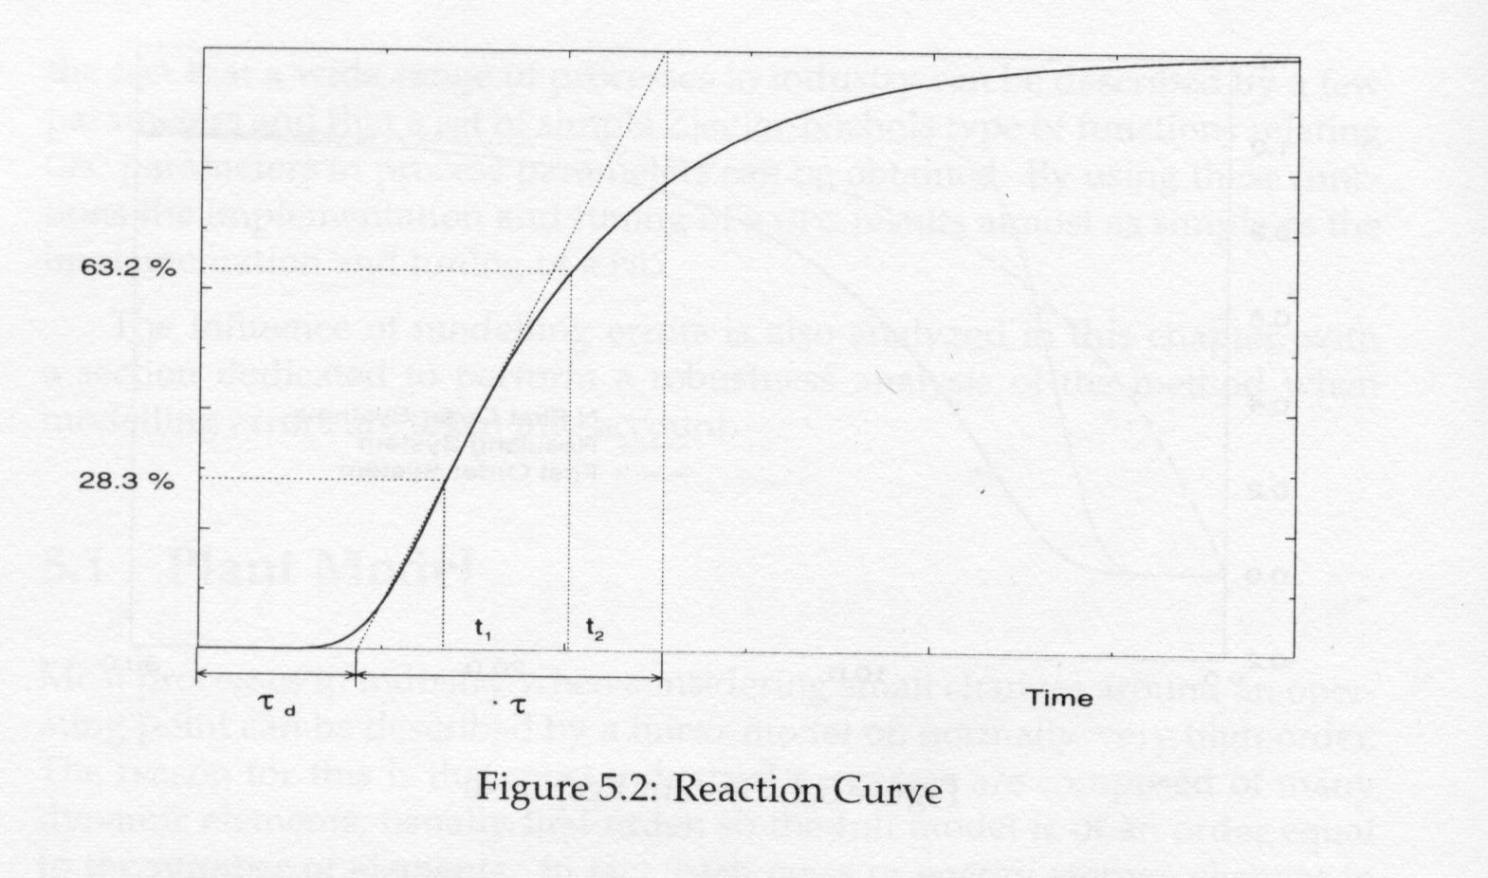

Figure 2.5-6: Process reaction curve.

Tuning of Dynamic Matrix Controller
The DMC has a large number of parameters, which can be adjusted and influences the control performance. In addition to this, some of them are dependent of the values of the others, which make it more difficult to tune the controller properly. However, some guidelines are available in the literature, such as Marlin [2] and Camacho and Bordons [4].

dt The execution period should only be a fraction of the closed loop dynamics, e.g. dt = 0.05(θ + τ).
NN The prediction horizon should be sufficient to let the closed-loop system approach the steady state value. Typical values indicated in the literature are 20 to 70.
MM The control horizon should always be selected to be shorter then the prediction horizon, and typically 1/3 of the prediction horizon.
ww_{nc} The weighting of the controlled variable adjusts the influence deviation from set point on the controller performance should have. Increasing this number tends to decrease the deviation from set point.
λ This tuning parameter controls how aggressive the controller behaviour is. The most aggressive behaviour occurs when λ equals zero. However, throughout the literature MPC tends to have an excessive behaviour when its parameters are set to be too aggressive.

Since there are interactions between the parameters simulation studies are often required to determine good tuning. It should be noted that dt has to be small enough not to loose important dynamic information of the system, but with a smaller dt the prediction horizon has to be increased, which in general is undesirable because of the size of the matrices in the MPC.

By making use of these guidelines the area of magnitude on these parameters is given. However, it is necessary to find the exact values by trial and error and look at the performance by varying these parameters.

RESULTS

Test Problem: Heat Exchanger
This system is a single-input-single-output (SISO) system, where the controlled variable is the cold out temperature. There is no phase change or mass transfer taking place, only heat transfer through the boundary between hot and cold stream. The code for the heat exchanger is shown in appendix 4, with the parameter values given in table 3.1-1. A schematic view of the system is shown in figure 3.1-1.

Cold Out
Cold In

Heat Exchanger
Hot In
Hot Out

Figure 3.1-7: Schematic view of heat exchanger

To define the system by a dynamic matrix, a step input in the manipulated variable was taken, and the response was used to determine the coefficients of the dynamic matrix, as shown in section 2.4.1. The free response of the system is shown in figure 3.1-2. The time constant τ, which is the time the system takes to reach 63% of its final value is approximately 2000 seconds, with no dead time.
Table 3.1-1: Parameter values for heat exchanger
Parameter | Value | Units
design_UA | 80 | kJ/C*s
V-coldside | 1 | m³
V-hotside | 1.5 | m³
cp-liquid | 4.2 | kJ/C*kg
Liquid density | 900 | kg/m³

Figure 3.1-8: Free response of step change in hot in flowrate.
Cold out temperature
Hot in flowrate

Building the PI controller
In order to check the performance of the MPC controller, I built a PI controller on my heat exchanger. A schematic overview of the system is shown in figure 3.1-3.

Figure 3.1-9: PI controller on heat exchanger

For simplicity a pointer is used to transfer the value of cold out temperature to the sensor, S1. This sensor takes the value of the controlled variable and applies a first order lag. The signal is sent to the PI controller, where both a proportional and integral action term is implemented. The response of a step input in the manipulated variable is shown in figure 3.1-4. In order to get a correct comparison of the two types of controllers, the MPC versus the conventional PI, I have used the rules of the process reaction curve method as shown in section 2.3.5 to tune the PI controller. The values of the parameters are shown in table 3.1-2. The code for the PI controller is shown in appendix 2.

Table 3.1-2: Parameter values for PI controller
Parameter | Value | Units
τ_{d} | 50 | s
τ | 10 | s
t_{I} | 300 | s
Kc | 2 | none

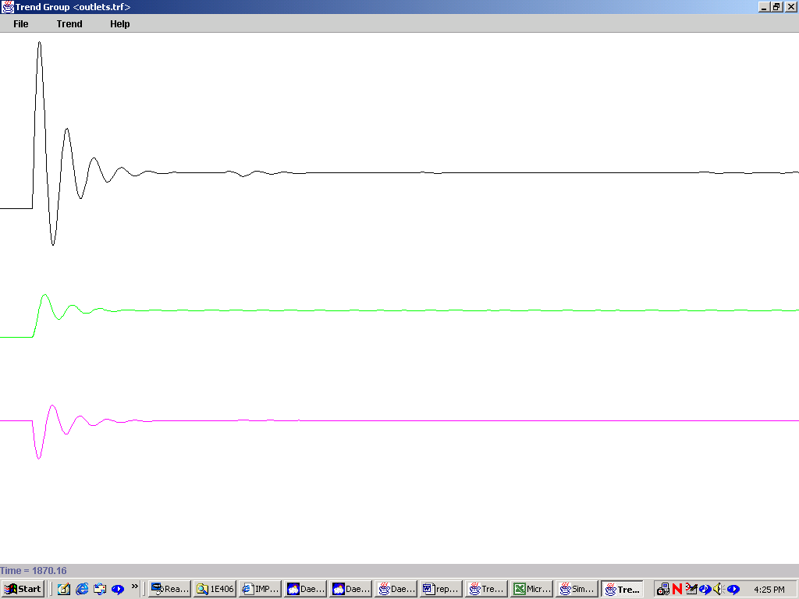
Manipulated variable flowrate
Duty
Cold out temperature
Figure 3.1-10: Response to a step change in cold water flowrate with PI controller implemented

These parameter values gives a maximum overshoot of 0.2% and thereby a very small settling time. By looking at the response the oscillations are negligible after 250 seconds.

Building the MPC controller
In order to try out the controller circuit on a simplified problem, a heat exchanger with two liquid streams, no phase change or heat loss was chosen. The cold stream is the wild stream, and the cold streams outlet temperature is the controlled variable. The manipulated variable is the hot in flowrate. A schematic view of the system is shown in figure 3.1.5.

Figure 3.1-11: MPC controller on heat exchanger

The model was built within DaeSim, see appendix 1. The matrix calculations were done in Matlab 5.1, see appendix 5. To model the system the free response with a step change in duty was studied. The response is shown in figure 3.1.2. From this curve the coefficients for the A-matrix was calculated with interpolation to each sampling period. The sampling time was chosen to be 20 seconds. From the curve it can be seen that 50% of the change in controlled variable happens within 10 sampling periods, and to limit the number of calculations taken at each sampling time the prediction horizon was chosen to be 10. The control horizon was chosen to be 5. The prediction horizon gives the number of rows and the control horizon gives the number of columns in A. The coefficients in the A matrix is given in table 3.1-3. In a SISO system it is only the first column of the A matrix which is used in the calculation of the control law.

Table 3.1-3: Dynamic matrix [A] for heat exchanger
0.9802 | 0 | 0 | 0 | 0
2.4802 | 0.9802 | 0 | 0 | 0
3.4802 | 2.4802 | 0.9802 | 0 | 0
6.1802 | 3.4802 | 2.4802 | 0.9802 | 0
8.7802 | 6.1802 | 3.4802 | 2.4802 | 0.9802
10.6802 | 8.7802 | 6.1802 | 3.4802 | 2.4802
11.6802 | 10.6802 | 8.7802 | 6.1802 | 3.4802
13.6802 | 11.6802 | 10.6802 | 8.7802 | 6.1802
15.5802 | 13.6802 | 11.6802 | 10.6802 | 8.7802
17.1802 | 15.5802 | 13.6802 | 11.6802 | 10.6802

Controller performance with only taking the last control action into account
Steffens [15] states that it is only necessary to take the last control action sent to the plant into account when the free response is calculated, see section 2.3.4. The different controller performances with this strategy versus the one outlined in Marlin [2] are shown below in figure 3.1-6 and 3.1-7.

The K matrix was calculated in Matlab 5.1, and is given in table 3.1-4. In a SISO system only the first row of this matrix is used in obtaining the control law.

Table 3.1-4: Control matrix [K] for heat exchanger
Columns/Rows | 1 | 2 | 3 | 4 | 5 | 6
1 | 1.0598 | 0.9657 | -0.0936 | 1.7230 | 0.4429 | -0.3872
2 | -1.7135 | -0.5290 | 1.0764 | -2.9813 | 1.0513 | 1.2139
3 | 0.4827 | -1.2506 | -0.5347 | 1.9504 | -2.8184 | 0.7473
4 | -0.0906 | 0.3323 | -1.3542 | -0.8764 | 1.9214 | -2.5764
5 | 0.2776 | 0.4567 | 0.791 | -0.0287 | -0.8447 | 0.8383

Columns/Rows | 7 | 8 | 9 | 10
1 | -1.3148 | 0.5577 | 0.1671 | 0.0044
2 | 1.5849 | -2.0074 | 0.3532 | -0.0118
3 | 0.7517 | 1.6509 | -1.9929 | 0.5029
4 | 0.6520 | 1.1770 | 1.9500 | -1.9798
5 | -1.9313 | -1.2932 | -0.0844 | 2.0899

Tuning
Because of the fact that I wanted to build a simple MPC on this test problem with a first order behaviour, I chose the prediction horizon to be 10 instead of the suggested value in literature ranging from 20 to 70. The control horizon was chosen to be 5.
By making use of the guidelines outlined in section 2.5 and by trial and error I chose the parameters in order to minimise the overshoot and settling time and keeping the system stable. The values are given in table 3.1-5.

Table 3.1-5: Parameter values for MPC
Parameter | Value | Units
dt | 20 | s
NN | 10 | none
MM | 5 | none
ww_{nc} | 9 | none
λ | 0.5 | none

Controller performance with only taking the last control action implemented into account.

The response after a step change in the cold water flowrate at time 150 seconds from 1.1 kg/s to 1.2 kg/s and the controller activated every 20 second by event file called flag_true.evt is given in figure 3.1-6.

The maximum overshoot is 0.56% and after approximately 1000 seconds the oscillations are negligible.
Manipulated variable flowrate
Control moves
Duty
Cold out temperature

Figure 3.1-12: Response to a step change in cold water flowrate with MPC activated every 20 second, only taking the last control action into account

Controller performance with taking all the past control actions into account
The past control actions sent to the plant are stored in a vector, and used in calculation of the free response.

The K matrix was calculated in Matlab 5.1, and is given in table 3.1-6.

Table 3.1-6: Control matrix [K] for heat exchanger
Columns/Rows | 1 | 2 | 3 | 4 | 5 | 6
1 | 11.7650 | 10.7300 | -1.0396 | 19.1447 | 4.9214 | -4.3023
2 | -19.0390 | -5.8775 | 11.9596 | -33.1254 | 11.6814 | 13.4873
3 | 5.3630 | -13.8961 | -5.9415 | 21.6716 | -31.3151 | 8.3036
4 | -1.0064 | 3.6924 | -15.0464 | -9.7375 | 21.3484 | -28.6265
5 | 3.0845 | 5.0744 | 8.7894 | -0.3186 | -9.3859 | 9.3144

Columns/Rows | 7 | 8 | 9 | 10
1 | -14.6091 | 6.1965 | 1.8566 | 0.0486
2 | 17.6103 | -22.3045 | 3.9244 | -0.1316
3 | 8.3519 | 18.3430 | -22.1438 | 5.5876
4 | 7.2448 | 13.0777 | 21.6672 | -21.9978
5 | -21.4584 | -14.3684 | -0.9379 | 23.2212

Tuning
The tuning parameters remained the same as in section 3.1.3.1, with the weighting factor ww_{nc} as the only exception. It was necessary to increase this value to a magnitude of 100 in order to stabilise the system. By making use of the guidelines outlined in section 2.5 and by trial and error I chose the parameters in order to minimise the overshoot and settling time and keeping the system stable. The values are given in table 3.1-7.

Table 3.1-7: Parameter values for MPC
Parameter | Value | Units
dt | 20 | s
NN | 10 | none
MM | 5 | none
ww_{nc} | 100 | none
λ | 0.5 | none

Controller performance with taking all the past control actions implemented into account.

The response after a step change in the cold water flowrate at time 150 seconds from 1.1 kg/s to 1.2 kg/s and the controller activated every 20 second by event file called flag_true.evt is given in figure 3.1-7.

The maximum overshoot is 0.7% and after approximately 1000 seconds the oscillations are negligible. The performance is smooth, with small variations in the manipulated variable after the initial overshoot.

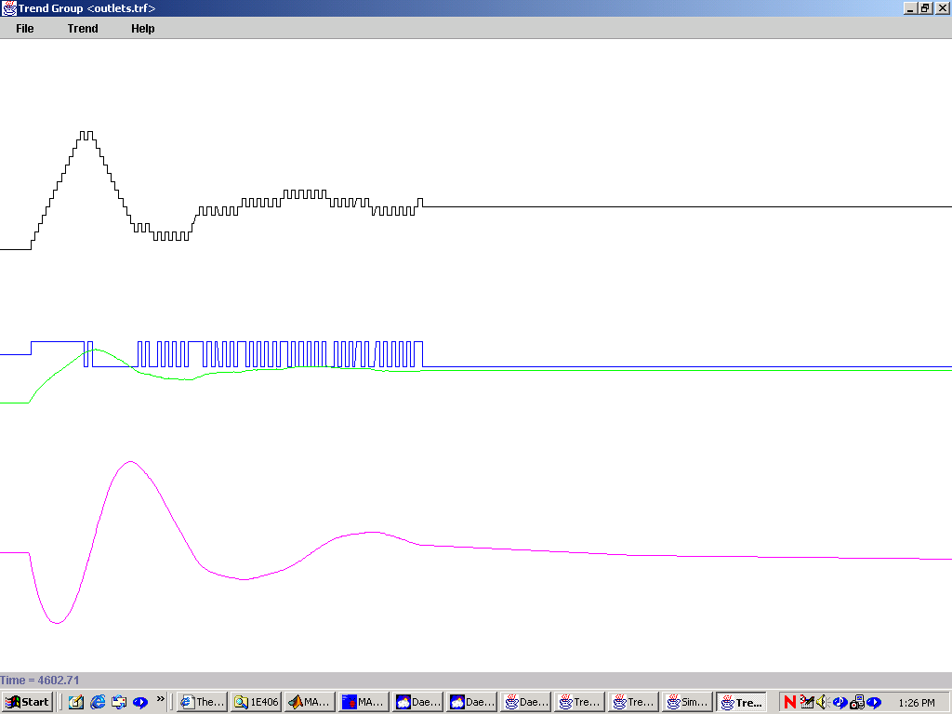
Figure 3.1-13: Response to a step change in cold water flowrate with MPC activated every 20 second, taking past control actions into account.

Implementation of MPC on granulation drum
The granulation circuit is described in section 2.1, and the MPC was implemented on the granulation drum. A schematic view of the closed loop system is given in figure 3.2-1.

Figure 3.2-14: Closed loop system of granulation drum
The nature of the DMC algorithm makes it possible to easily extend it to multivariable systems. In this case standard deviation and mean is the controlled variables, and the flowrate in binder 1 and binder 2 is the manipulated variables. This is a 2x2 system, and the equations used are essentially the same as for the SISO system. The structure of the matrices is shown in equation 3.2.1 to 3.2.4.

(3.2.1)

$K=(A^{T}[\text{WW}]A+[\text{QQ}])^{−1}∗A^{T}[\text{WW}]$ (3.2.2)

$\text{WW}=\left[\begin{matrix}[{\text{WW}}_{1}] & 0 \\ 0 & [{\text{WW}}_{2}]\end{matrix}\right]$
(3.2.3)

$\text{QQ}=\left[\begin{matrix}[{\text{QQ}}_{1}] & 0 \\ 0 & [{\text{QQ}}_{2}]\end{matrix}\right]$
(3.2.4)

where

A – dynamic matrix
[WW] – diagonal matrix = ww * I
[QQ] – diagonal matrix = qq * I
qq – tuning parameter
ww – tuning parameter

In order to find the coefficients for the A-matrix, I used the step response method by implementing a step input in each manipulated variable and look at the response in each controlled variable. The results are given in table 3.2-1 to 3.2-4, and the step responses are shown in figure 3.2-2 and 3.2-3.

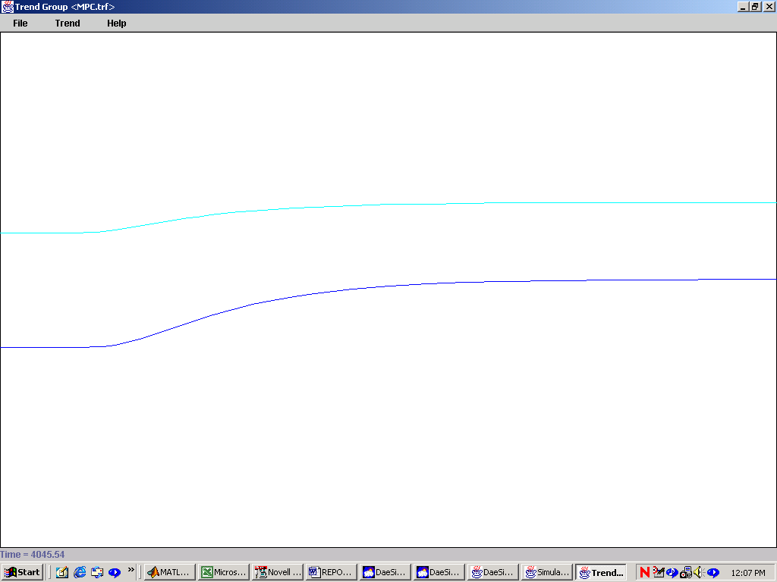
Mean
Variance
Figure 3.2-15: Step response with a step change in binder1 flowrate at time t = 500

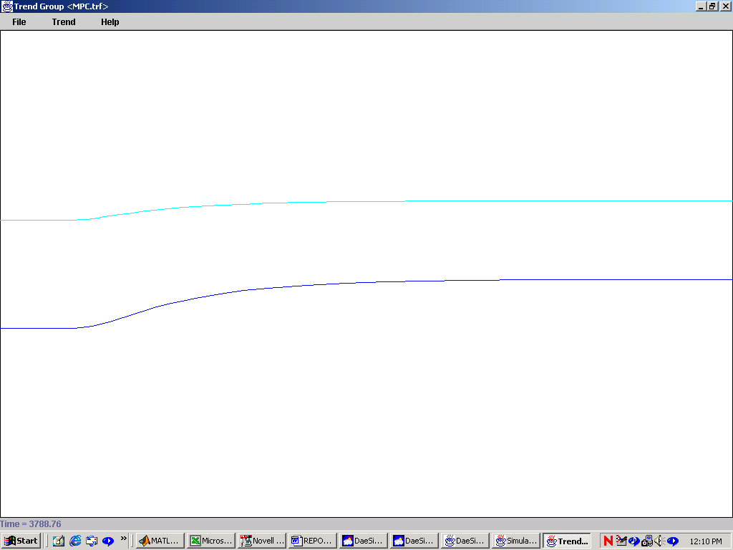
Mean
Variance
Figure 3.2-16: Step response with a step change in binder2 flowrate at time t = 500
Table 3.2-8: Dynamic matrix [A₁₁] for granulation drum
0.0017 | 0 | 0 | 0 | 0
0.0098 | 0.0017 | 0 | 0 | 0
0.0268 | 0.0098 | 0.0017 | 0 | 0
0.0488 | 0.0268 | 0.0098 | 0.0017 | 0
0.0778 | 0.0488 | 0.0268 | 0.0098 | 0.0017
0.1078 | 0.0778 | 0.0488 | 0.0268 | 0.0098
0.1438 | 0.1078 | 0.0778 | 0.0488 | 0.0268
0.1738 | 0.1438 | 0.1078 | 0.0778 | 0.0488
0.2038 | 0.1738 | 0.1438 | 0.1078 | 0.0778
0.2338 | 0.2038 | 0.1738 | 0.1438 | 0.1078

Table 3.2-9: Dynamic matrix [A₁₂] for granulation drum
0.0068 | 0 | 0 | 0 | 0
0.028 | 0.0068 | 0 | 0 | 0
0.0488 | 0.028 | 0.0068 | 0 | 0
0.0788 | 0.0488 | 0.028 | 0.0068 | 0
0.1056 | 0.0788 | 0.0488 | 0.028 | 0.0068
0.1315 | 0.1056 | 0.0788 | 0.0488 | 0.028
0.1548 | 0.1315 | 0.1056 | 0.0788 | 0.0488
0.1781 | 0.1548 | 0.1315 | 0.1056 | 0.0788
0.1986 | 0.1781 | 0.1548 | 0.1315 | 0.1056
0.2188 | 0.1986 | 0.1781 | 0.1548 | 0.1315

Table 3.2-10: Dynamic matrix [A₂₁] for granulation drum
0.0001 | 0 | 0 | 0 | 0
0.0006 | 0.0001 | 0 | 0 | 0
0.0022 | 0.0006 | 0.0001 | 0 | 0
0.0045 | 0.0022 | 0.0006 | 0.0001 | 0
0.0081 | 0.0045 | 0.0022 | 0.0006 | 0.0001
0.0126 | 0.0081 | 0.0045 | 0.0022 | 0.0006
0.0182 | 0.0126 | 0.0081 | 0.0045 | 0.0022
0.0242 | 0.0182 | 0.0126 | 0.0081 | 0.0045
0.0327 | 0.0242 | 0.0182 | 0.0126 | 0.0081
0.0372 | 0.0327 | 0.0242 | 0.0182 | 0.0126

Table 3.2-11: Dynamic matrix [A₂₂] for granulation drum
0.0012 | 0 | 0 | 0 | 0
0.0039 | 0.0012 | 0 | 0 | 0
0.0087 | 0.0039 | 0.0012 | 0 | 0
0.0131 | 0.0087 | 0.0039 | 0.0012 | 0
0.0187 | 0.0131 | 0.0087 | 0.0039 | 0.0012
0.0244 | 0.0187 | 0.0131 | 0.0087 | 0.0039
0.0301 | 0.0244 | 0.0187 | 0.0131 | 0.0087
0.0358 | 0.0301 | 0.0244 | 0.0187 | 0.0131
0.0412 | 0.0358 | 0.0301 | 0.0244 | 0.0187
0.0447 | 0.0412 | 0.0358 | 0.0301 | 0.0244

Table 3.2-12: Control matrix [K] for granulation drum
Columns/Rows | 1 | 2 | 3 | 4 | 5 | 6 | 7
1 | 0.1283 | 0.8408 | 2.5452 | 4.2609 | 6.5005 | 8.3323 | 10.9855
2 | -0.1669 | -0.5471 | -0.2890 | 0.9382 | 2.4294 | 4.7986 | 7.0407
3 | -0.1257 | -0.6720 | -1.3782 | -1.4418 | -0.3189 | 1.3730 | 4.1929
4 | -0.0894 | -0.4809 | -1.2402 | -2.1328 | -2.1979 | -0.8195 | 1.3452
5 | -0.0588 | -0.3179 | -0.8264 | -1.6588 | -2.4684 | -2.2389 | -0.3835
6 | 1.1286 | 4.3868 | 6.7448 | 9.9238 | 11.5934 | 12.5006 | 12.5295
7 | -0.1934 | 0.3404 | 3.0462 | 4.7878 | 7.5973 | 9.2388 | 10.3738
8 | -0.1558 | -0.8263 | -0.7278 | 1.5067 | 2.9941 | 5.8542 | 7.7832
9 | -0.1198 | -0.6395 | -1.6312 | -1.8626 | 0.2323 | 1.8492 | 5.0562
10 | -0.0872 | -0.4684 | -1.2064 | -2.4029 | -2.6754 | -0.3907 | 1.6102

Table 3.2-5 continues
Columns/Rows | 8 | 9 | 10 | 11 | 12 | 13 | 14
1 | 12.3535 | 13.8479 | 15.4737 | -0.0125 | -0.0202 | 0.0496 | 0.1345
2 | 10.3977 | 12.6517 | 15.0124 | -0.0255 | -0.0908 | -0.1902 | -0.1725
3 | 7.1324 | 11.3418 | 14.4339 | -0.0191 | -0.0835 | -0.2155 | -0.3486
4 | 4.8390 | 8.5799 | 13.5809 | -0.0135 | -0.0595 | -0.1689 | -0.3187
5 | 2.4161 | 6.6445 | 11.1132 | -0.0089 | -0.0392 | -0.1119 | -0.2259
6 | 12.4984 | 12.0502 | 11.6797 | 0.2042 | 0.6271 | 1.3181 | 1.8012
7 | 10.9228 | 11.5898 | 11.8155 | -0.0298 | 0.1119 | 0.4245 | 1.0455
8 | 9.4620 | 10.7138 | 12.0644 | -0.0239 | -0.1034 | -0.0489 | 0.2113
9 | 7.5528 | 9.9381 | 11.8819 | -0.0183 | -0.0797 | -0.2242 | -0.2051
10 | 5.3847 | 8.5664 | 11.6269 | -0.0132 | -0.0581 | -0.1646 | -0.3297

Table 3.2-5 continues
Columns/Rows | 15 | 16 | 17 | 18 | 19 | 20
1 | 0.3189 | 0.5428 | 0.8661 | 1.1902 | 1.9027 | 1.8907
2 | -0.1476 | 0.0197 | 0.2654 | 0.6641 | 1.0489 | 1.9908
3 | -0.3670 | -0.3399 | -0.1352 | 0.1951 | 0.6693 | 1.2644
4 | -0.4674 | -0.4680 | -0.3917 | -0.0974 | 0.3188 | 0.9822
5 | -0.3745 | -0.4934 | -0.4367 | -0.2697 | 0.1163 | 0.6990
6 | 2.3610 | 2.8005 | 3.1209 | 3.3635 | 3.4360 | 3.2152
7 | 1.4436 | 1.9577 | 2.3859 | 2.7447 | 3.0057 | 3.2770
8 | 0.7701 | 1.1423 | 1.6626 | 2.1426 | 2.5379 | 2.9877
9 | 0.0152 | 0.5673 | 0.9628 | 1.5479 | 2.0824 | 2.6567
10 | -0.3312 | -0.1019 | 0.4866 | 0.9550 | 1.6075 | 2.3070

Tuning

Table 3.2-13: Parameter values for MPC
Parameter | Value | Units
dt | 20 | s
NN | 10 | none
MM | 5 | none
ww_{nc} | 94 0  0 94 | none
λ | 0.5 0  0 0.5 | none

Performance

The performance of the DMC controller is shown in figure 3.2-4. The controller is activated every 20 second by an event-file called flag_true.evt. It sets the variable sample_switch to equal one, and the code runs through and sets the flag back to nil. The code is shown in appendix 6. The DMC is activated when the event takes place and is run up to 900 seconds.

From the figure it can be seen that the overshoot is approximately 0.5% and has a settling time of 1000 seconds. The tuning is crucial for the DMC performance, and is difficult for a MIMO system due to the strong interference between the parameters. However, by trial and the parameters were chosen. Their value can be seen in table 3.2-6.

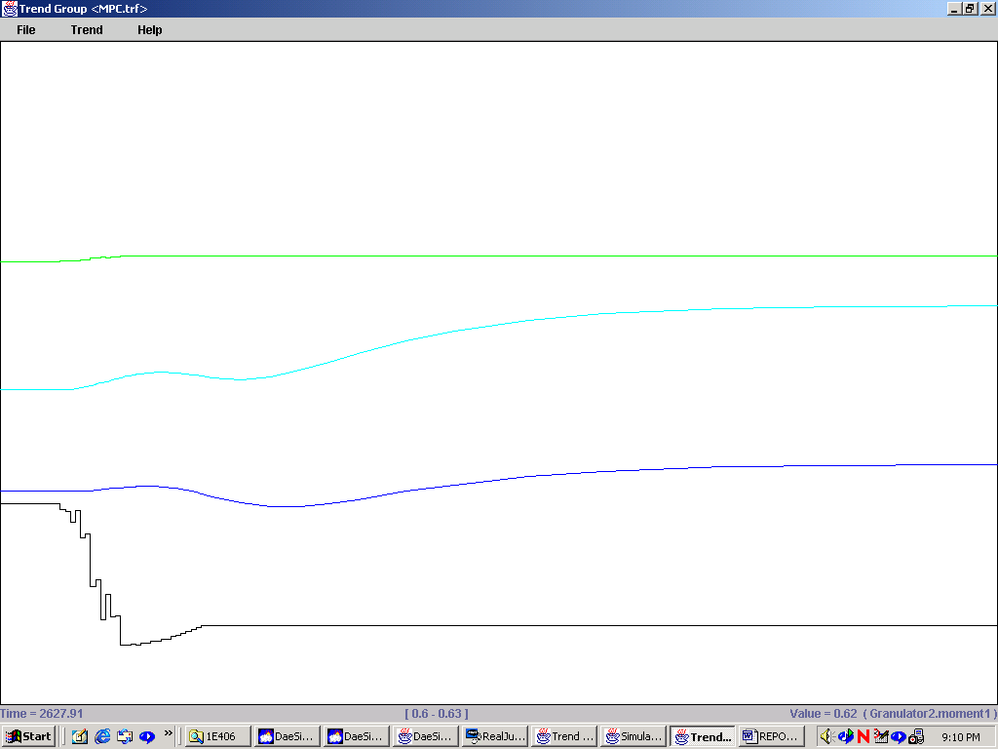
Manipulated variable binder2
Mean size
Variance
Manipulated variable binder1
Figure 3.2-17: DMC performance with a step change in water in feed at time t = 200.

DISCUSSION
The PI controller chosen as a reference point to check the performance of the MPC controller was tuned by the rules outlined in Stephanopoulos [15]. In general a conventional PI controller has a very good performance on flow control systems, which is clearly shown in figure 3.1.2.2. In contrast to the DMC, which is discrete, this PI controller is continuos. The result of having the PI giving the best performance was expected because of the nature of the system and the continuos versus discrete nature. It is, however, useful to compare the advanced control up against the best conventional controller available. This gives an indication on how good the DMC is performing in each case.

The test problem was examined to a great extent in order to look into the nature of the DMC controller, and two different approaches for calculation of the free response was carried out. The test problem chosen was a heat exchanger, which is a simple SISO system. The idea was to make a framework for a DMC on this problem, study the behaviour in detail and then implement on the granulation drum. Several key issues came up in constructing the controller, where the most important are mentioned below.

In order to make the DMC cope with model inaccuracies, a current measurement is implemented to correct the predicted output vector. This is a form of feedback control, which assures accuracy of the DMC and robustness against model inaccuracies. By doing this, the general stability and robustness of the DMC is increased. When a model inaccuracy exists, such as the implementation of a DMC based on a linear model onto a non-linear system, feedback is important. The results clearly show an oscillatory behaviour, which indicates a model error. Both the controlled variable and the manipulated variable have excessive behaviour. The feedback improves the performance in terms of bringing the controlled variable back to setpoint, but the closed-loop systems dynamic behaviour could have been improved by reduction of the model mismatch. This could be done with minimisation of the mismatch between dynamic matrix A and the step response.

Tuning is of crucial importance for the closed loop system behaviour with the DMC implemented. There is a strong interference between the tuning parameters which make efficient tuning difficult. However, by making use of the guidelines outlined in section 2.5 and trial and error in order to minimise overshoot and settling time the magnitude of the parameters was found. The weighting factor ww_{nc} and λ are making the closed loop system stable, and are deciding how much weight a deviation from set point should have on the magnitude of control action sent to the system. In general, an increase in this value tends to decrease the deviation from the set point. The aggressiveness of the controller is controlled by the parameter λ. When this value approaches zero, the more aggressive the controller performance will be. There is also a need for boundaries on the control moves in order to restrict the DMC to take excessive moves. The lower and upper boundary should be of a magnitude of 10⁻².

The different responses with and without taking the last control actions sent to the plant into account are clearly shown in figure 3.1.3.2.1 and 3.1.3.1.1. When taking the last control actions into account, the performance is smoother and the controller is not driving the system as hard. The overshoot is approximately the same in both cases, but in the last case the settling time is smaller. There is also less variance in the manipulated variable, which in general is desirable. The improved behaviour of the system was expected when more than the last control move was incorporated in the calculations, due to the fact that the full effect of the past control moves not yet can be measured in the controlled variable at every time sample. The realisation of this is one of the key differences between conventional controllers and advanced control strategies such as DMC.

Another important decision to make is to set appropriate horizons. In literature the prediction horizon should be in range from 20 to 50 samples ahead, and the control horizon 25 – 35 % of this value. In order to improve the controller performance in this example it is necessary to increase the prediction horizon, control horizon and also the number of control actions taken into account when calculating the free response. This is especially important when dealing with systems with relatively big dead time and complexity in number of outputs and inputs. The number of control moves taken into account in the calculation of the free response should equal the number of sample times the system need to stabilise. The implementation of DMC on a MIMO system, it is somewhat straightforward, using the framework I have outlined in this paper. It is only a matter of extension of the dynamic matrix A, computation of the control law and tuning.

When deciding on the appropriate horizons the sample time have to be set as well. As the computational power accessible at every time sample is increasing with better computers, it is possible to decrease the sample time to a small fraction of the lag time. However, it is important to realise that when decreasing the sample time it is necessary to increase the prediction horizon, which in general in undesireable since a large number of coefficients leads to an excessive use of computer memory and a high computational load. In order to avoid this limitation of the need for a large number of coefficients to minimise model mismatch, a state space model could be used instead of a step response model. Lundstroem et al [16] outlines the limitations of DMC further.

The performance of the DMC implemented on the granulation drum is satisfactory, bearing in mind the large dead time in the system and the strong interaction between the variables. It should be noted from figure 3.2-4 that the prediction causes a change in the manipulated variable a significant amount of time before the change can be measured in the controlled variable. The nature of the DMC makes it into a centralised control taking into account the interactions between the controlled and manipulated variables. These interactions are represented by the dynamic matrix A. Since the code is correcting the prediction at every scan with the measured value, it is coping with model mismatch. This aspect is very important when implementing a controller based on a linear model onto a non-linear system. For most processes there is a common recognition that a non-linear model can be linearised around steady state operating point without building in excessive error due to model mismatch in the controller algorithm.

CONCLUSION
On the test problem the performance of the DMC controller was not as good as the conventional controller. This could be due to several things, such model mismatch or non-optimal tuning. It is also important to bear in mind that the PI controller is continous in the time domain, while the DMC is discretized.

DMC has a good performance on a MIMO system, and the extension from a SISO to a MIMO system was successfully accomplished. To systems which are notoriously difficult to control such as granulation circuits, the concept of centralised control makes it possible of taking into account the interference between different parameters.

RECOMMENDATIONS
MPC has also been formulated in state space context. This makes it possible to use well-known concepts and theories, and is a powerful tool when it comes to solve more complex cases with disturbances and noise. State space representation can be seen as a generalisation of the MPC, and the MPC controller can be seen as a compensator based on an observer. The stability and performance of these are determined by the poles, which again easily can be controlled by adjustable parameters such as horizons, weightings, etc. I will therefore recommend using state space representation of the system in order to get a more compact way of describing the system. Finding the transfer functions can be done by means of Matlab.

REFERENCES

- Morari, M. and Lee Jay H., ‘Model Predictive control: past, present and future’, Computers and Chemical Engineering, 23 (1999) 667-682
- Marlin, Thomas E. 1995, PROCESS CONTROL. Designing processes and control systems for dynamic performance, McGraw-Hill Inc., New York
- Levine, William S. 1996, The Control Handbook, CRC Press Inc.
- Camacho, E.F. & Bordons, C. 1999, Model Predictive Control, Springer Verlag, London Limited
- Nise, Norman S. 1995, Control Systems Engineering, The Benjamin/Cummings Publishing Inc.
- Eek, Rob A. & Bosgra, Okko H., ‘Controllability of particulate processes in relation to the sensor characteristics’, Powder Technology vol. 108, Issues 2-3, pp. 137-146
- Nan Ye, Sairam Valluri, Mitch Barker and Po-Yang Yu, ‘Integration of advanced process control and full-scale dynamic simulation’, ISA Transactions vol. 39, Issue 2, pp. 273-280
- Reddy, Bathala C., Murthy, Dodlaty V.S. & Rao, Chamarti D.P., ‘Continuous rotary drum granulation of N-K fertilizers’, Particle & Particle Systems Characterization vol. 14, Issue 5, pp. 257-262
- Reddy, B.C., Murthy, D.V.S., Ananth, M.S. & Rao, Ch.D.P., ‘Modeling of continuous fertilizer granulation process for control’, Particle & Particle Systems Characterization vol. 15, Issue 3, pp. 156-160
- Litster, J.D., Liu, L.X., ‘Population balance modelling of fertilizer granulation’, Proceedings of the 5th International Symposium on Agglomeration, 1989, 611¯617, ICHEME.
- Walker, G. M., Holland, C. R., Ahmad, M. N., Fox, J. N. & Kells, A. G., ‘Drum granulation of NPK fertilizers’, Powder Technology vol. 107, Issue 3, pp. 282-288
- Morari, M. and Zafiriou, E. 1989, Robust process control, Prentice Hall, Englewood Cliffs, NJ
- Cutler, C.R. &Ramaker, B.L., Dynamic Matrix Control: A computer control algorithm, Proc. Joint Automatic Control Conf., San Francisco, CA, Paper WP5-B, 1980
- Steffens, M., , PhD thesis, University of Queensland, Brisbane, Australia, 1997
- Stephanopoulos, G. 1984, Chemical Process Control, Prentice Hall Inc., Englewood Cliffs, New Jersey,
- Lundstroem, P., Lee, J.H., Morari, M. and Skogestad, S., 1994. ‘Limitations of dynamic matrix control’, Computers chemical engineering vol. 19, no.4, p.409-421,
- Rhodes, M. J. 1998, Introduction to particle technology, John Wiley & Sons, New York
- Hounslow, M. J., Ryall, R. L. and Marshall, V. R., 1988. ‘A discretized population balance for nucleation, growth and aggregation’, J.AIChe, vol.34, no.11, p.1821-1832

APPENDIX 1: DaeSim code for DMC controller implemented on heat exchanger

(************************************************************************)
(* Block Name: Model_predictive_controller *)
(* *)
(* Description: Dynamic Matrix Control controller for heat exchanger. The *)
(* matrix calculations are made by means of Matlab 5.1. The *)
(* sample_switch switches the controller on every 20 s. *)
(* The sample_switch is controlled by eventfile flag_true.evt. *)
(* A pointer is used to control flowrate in hi. *)
(* *)
(* *)
(* *)
(* No. State Variables/Equations: 0 *)
(* No. Algebraic Variables: 1 *)
(* No. Algebraic Equations: 1 *)
(* Author: Thomas Haugan *)
(* Organization: CAPE, UQ *)
(* Version and Date version 01, 13-10-00 *)
(************************************************************************)

function_block model_predictive_cont

#include "sys_defs.h"

var_in_out
i1 : signal = (input) ; (* input signal *)
end_var

var_input
p_flow : int = (none); (*pointer to hot inlet flow*)
setpoint : real = (C) ;
K : array ( 1 .. nsize ) of real = (none); (*coefficients from K-matrix*)
A : array ( 1 .. nsize ) of real = (none); (*Dynamic matrix, [A], coefficients*)
sample_switch : real = (none); (*Flag*)
y : array ( 1 .. prediction_horizon ) of real = (none);
dMV_min : real = (none);
dMV_max : real = (none);
end_var

var
E : array ( 1 .. nsize ) of real = (none); (*setpoint error column vector*)
dMV : array ( 1 .. control_horizon ) of real = (none);
i : real = (none);
y0 : real = (none);
MM : int = (none); (*Same terminology as in Marlin*)
NN : int = (none); (*Same terminology as in Marlin*)
SP : array ( 1 .. prediction_horizon ) of real = (none);
flow_hot_in : real = (none);
dMV0 : real = (none);
MVpast : array ( 1 .. prediction_horizon ) of real = (none);
end_var

(* function block calculations *)

if sample_switch ==1 then (*Check if sample time is up*)

MM := control_horizon;
NN := prediction_horizon;

for i := 1 to NN do
SP(i) := setpoint; (*Make array consisting of setpoint*)
end_for

(*Step 0: Storing the past control moves in the vector MVpast*)

MVpast(1) := dMV(1);
for i := 0 to (NN - 2) do
MVpast(NN-i) := MVpast(NN-1-i);
end_for

(*Step 1: Use current measurement to correct predicted variable vector*)
(* and move one sample time ahead*)

y0 := y(1);
for i := 1 to (NN - 1) do
y(i) := y(i+1) + (i1.z_value - y0);
end_for

(*Step 2: Calculate the new set of predicted y values using the past*)
(* control moves*)

for i := 1 to (NN - 1) do
y(i) := A(i)*MVpast(i) + y(i);
end_for
y(NN) := y(NN - 1);

(*Step 3: Calculate the setpoint error vector*)

for i := 1 to NN do
E(i) := SP(i) - y(i);
end_for

(*Step 4: Calculate the control law*)

for i := 1 to MM do
dMV(i) := K(i)*E(i) + dMV(i);
end_for

(*Step 5: Implementation of the first variable calculated control move*)
(* for manipulated variable, setting boundaries on control move*)

if dMV(1) <= dMV_min then
dMV(1) := dMV_min;

elsif dMV(1) >= dMV_max then
dMV(1) := dMV_max;
end_if

flow_hot_in := flow_hot_in + dMV(1);

if flow_hot_in <= 0 then
flow_hot_in := 0;
end_if

p_flow := flow_hot_in ; (*pointer to set flowrate in liq.source*)

sample_switch := 0;

end_if

end_function_block

APPENDIX 2: DaeSim code for PI controller

(*****************************************************************)
(* Name: PI_CONTROLLER *)
(* *)
(* Description: Proportional-plus-Integral controller. Gain is positive *)
(* for reverse action and negative for direct action. *)
(* Reset is large for approximate proportional control *)
(* *)
(* State Variables/Equations: 1 *)
(* Algebraic Variables: 0 *)
(* Algebraic Equations: 0 *)
(* Author: Thomas Haugan *)
(* Organization: CAPE Centre, Univ of Qld *)
(* Version: 09-10-00 *)
(*****************************************************************)

function_block pi_controller

#include "sys_defs.h"

var_in_out
i1 : signal = (input_signal);
end_var

var_input
p_flow : int = (none); (*pointer to manipulated variable*)
x_error : real = (s); (* integral of error signal *)
setpoint : real = (none); (* desired input signal ( 0 -> 1 ) *)
gain : real = (none); (* proportional gain (-) *)
reset : real = (s); (* integral reset time (s) *)
bias : real = (none); (* output bias (-) *)
sample_switch : int = (none);
end_var

var_output
deriv_error : real = (none);
end_var

var
MV : real = (none);
end_var

(* function block calculations *)

(* error integral *)

deriv_error := setpoint - i1.z_value ;

(* proportional plus integral algorithm *)

MV := bias + gain * (setpoint - i1.z_value + x_error/reset);

p_flow := MV ;

end_if

end_function_block

APPENDIX 3: DaeSim code for temperature sensor

(*****************************************************************)
(* Block Name: Temperature_sensor *)
(* *)
(* Description: Takes the value of assigned variable and *)
(* apply a lag. *)
(* *)
(* *)
(* *)
(* No. State Variables/Equations: 1 *)
(* No. Algebraic Variables: 0 *)
(* No. Algebraic Equations: 1 *)
(* Author: Thomas Haugan *)
(* Organization: CAPE centre, UQ *)
(* Version and Date 10-10-00 *)
(*****************************************************************)

function_block temperature_sensor

#include "sys_defs.h"

var_in_out
o1 : signal = (outlet); (* measurement signal *)
end_var

var_input
x_raw_meas : real = (none); (* lagged measurement (meas_units) *)
p_sensor_input : real = (none); (* pointer to variable *)
range : real = (none); (* sensor range (meas_units) *)
zero : real = (none); (* sensor zero (meas_units) *)
tau : real = (s); (* sensor time constant *)
end_var

var_output
deriv_raw_meas : real = (none/s);
resid_value : real = (none);
end_var

(* function block calculations *)

resid_value := o1.z_value - ( x_raw_meas - zero ) / range ; (*Assigning output to o1*)

deriv_raw_meas := ( p_sensor_input - x_raw_meas ) / tau ; (* first order lag *)

end_function_block

APPENDIX 4: DaeSim code for heat exchanger

(*****************************************************************)
(* Block Name: Process heat exchanger *)
(* *)
(* Description: Liquid-liquid heat exchanger *)
(* *)
(* Implements a simple liquid-liquid heat exchanger with *)
(* steady state mass balance but dynamic energy balance *)
(* *)
(* *)
(* *)
(* No. State Variables/Equations: *)
(* No. Algebraic Variables: *)
(* No. Algebraic Equations: *)
(* Author: Ian Cameron *)
(* Organization: DaeSim Technologies *)
(* Version and Date 1.0 August 24, 2000 *)
(*****************************************************************)

function_block process_hx

#include "sys_defs.h"

var_in_out
i1 : liquid = (hot_inlet) ;
i2 : liquid = (cold_inlet) ;
o1 : liquid = (hot_outlet) ;
o2 : liquid = (cold_outlet) ;
end_var

var_input
x_temphot : real = (C) ;
x_tempcold : real = (C) ;
design_ua : real = (kJ/C*s) ;
v_hotside : real = (m3) ;
v_coldside : real = (m3) ;
cp_liquid : real = (kJ/kg*C) ;
liquid_den : real = (kg/m3) ;
end_var

var_output
deriv_temphot : real = (C/s) ;
deriv_tempcold : real = (C/s) ;
resid_tout1 : real = (C) ;
resid_tout2 : real = (C) ;
resid_flow1 : real = (kg/s) ;
resid_flow2 : real = (kg/s) ;
end_var

var
mean_temp : real = (C) ;
duty : real = (kJ/s) ;

end_var

function error ( errcode : int; ) end_function

mean_temp := ((i1.z_temperature - x_tempcold) +
(x_temphot - i2.z_temperature))/2 ;

duty := design_ua * mean_temp ;

deriv_temphot := (i1.z_flow * (i1.z_temperature - x_temphot))/
(v_hotside * liquid_den) - duty/(v_hotside * cp_liquid *
liquid_den) ;
deriv_tempcold := (i2.z_flow * (i2.z_temperature - x_tempcold))/
(v_coldside * liquid_den) + duty/(v_coldside * cp_liquid *
liquid_den) ;
resid_tout1 := x_temphot - o1.z_temperature ;
resid_tout2 := x_tempcold - o2.z_temperature ;
resid_flow1 := i1.z_flow - o1.z_flow ;
resid_flow2 := i2.z_flow - o2.z_flow ;

end_function_block

APPENDIX 5: Matlab code for matrix calculations

disp ('G-matrix coefficients are taken from step response curve, interpolated from trend tabulation in DaeSim.');
disp ('Prediction horizon is 10 and control horizon is 5.');

A = [0.9802 0 0 0 0;2.4802 0.9802 0 0 0;3.4802 2.4802 0.9802 0 0;6.1802 3.4802 2.4802 0.9802 0;8.780 6.1802 3.4802 2.4802 0.9802;10.6802 8.780 6.1802 3.4802 2.4802;11.6802 10.6802 8.780 6.1802 3.4802;13.6802 11.6802 10.6802 8.780 6.1802;15.5802 13.6802 11.6802 10.6802 8.7802;17.180 15.5802 13.6802 11.6802 10.6802];

%Tuning parameters%
lambda = 0.5;
ww = 100;

%Control matrix%
K = (inv((A')*A + lambda*eye(5))*(A'))*ww*eye(10);
A
K

Appendix 6: DaeSim code for DMC controller implemented on granulation drum

(************************************************************************)
(* Block Name: Model_predictive_controller *)
(* *)
(* Description: Dynamic Matrix Control controller for granulation drum. The matrix *)
(* calculations are made by means of Matlab 5.1. The sample_switch *)
(* switches the controller on every 20 s. The sample_switch is *)
(* controlled by eventfile flag_true.evt. Two pointers are used to control *)
(* flowrate in binder1 and binder2. *)
(* *)
(* No. State Variables/Equations: 0 *)
(* No. Algebraic Variables: 1 *)
(* No. Algebraic Equations: 1 *)
(* Author: Thomas Haugan *)
(* Organization: CAPE, UQ *)
(* Version and Date version 01, 13-10-00 *)
(************************************************************************)

function_block model_predictive_cont

#include "sys_defs.h"

type
numb_columns : (*Array to extend A matrix with columns*)
structure
col : array ( 1 .. 2 ) of real; (*number of outputs*)
end_structure ;
end_type

type
nmatrix : (*Array to extend A matrix with columns*)
structure
row : array ( 1 .. 20 ) of numb_columns;
end_structure ;
end_type

var_in_out
i1 : signal = (input) ; (* input signal *)
i2 : signal = (input) ; (* input signal *)
end_var

var_input
p_flow1 : int = (none); (*pointer to binder1*)
p_flow2 : int = (none); (*pointer to binder2*)
setpoint_mean : real = (none) ;
setpoint_variance : real = (none) ;
K : nmatrix ; (*coefficients from K-matrix*)
A : nmatrix ; (*Dynamic matrix, [A], coefficients*)
sample_switch : real = (none); (*Flag*)
y : array ( 1 .. 20 ) of real = (none); (*Dimension = prediction_horizon * # outputs*)
dMV_min : real = (none);
dMV_max : real = (none);
end_var

var
E : nmatrix ; (*setpoint error column vector*)
dMV : nmatrix;
i : real = (none);
j : real = (none);
y0 : array ( 1 .. 2 ) of real = (none);
MM : int = (none); (*Same terminology as in Marlin*)
NN : int = (none); (*Same terminology as in Marlin*)
SP : array ( 1 .. 20 ) of real = (none); (*Dimension = prediction_horizon * # outputs*)
flow_binder1 : real = (none);
flow_binder2 : real = (none);
dMV0 : real = (none);
MVpast : nmatrix;
end_var

(* function block calculations *)

if sample_switch ==1 then (*Check if sample time is up*)

MM := control_horizon;
NN := prediction_horizon;

for i := 1 to NN do
SP(i) := setpoint_mean; (*Make array consisting of setpoint mean size*)
SP(NN + i) := setpoint_variance; (*Make array consisting of setpoint variance*)
end_for

(*Step 0: Storing the past control moves in the vector MVpast*)

MVpast.row(1).col(1) := dMV.row(1).col(1);
MVpast.row(1).col(2) := dMV.row(1).col(2);

for i := 0 to (NN - 2) do
for j := 1 to 2 do
MVpast.row(NN - i).col(j) := MVpast.row(NN-1-i).col(j);
end_for
end_for

(*Step 1: Use current measurement to correct predicted variable vector*)
(* and move one sample time ahead*)

y0(1) := y(1);
y0(2) := y(NN + 1);

for i := 1 to (NN - 1) do
y(i) := y(i+1) + (i1.z_value - y0(1));
end_for

for i := NN to (NN*2) do
y(i) := y(i+1) + (i2.z_value - y0(2));
end_for

(*Step 2: Calculate the new set of predicted y values using the past*)
(* control moves*)

for i := 1 to (NN - 1) do
y(i) := A.row(i).col(1)*MVpast.row(i).col(1) + A.row(i).col(2)*MVpast.row(i).col(1) + y(i);
y(NN + i) := A.row(NN + i).col(1)*MVpast.row(i).col(2) +
A.row(NN + i).col(2)*MVpast.row(i).col(2) + y(NN + i);
end_for
y(NN) := y(NN - 1);

(*Step 3: Calculate the setpoint error vector*)

for i := 1 to NN do
for j := 1 to 2 do
E.row(i).col(j) := setpoint_mean - y(i);
E.row(NN + i).col(j) := SP(NN + i) - y(NN + i);
end_for
end_for

(*Step 4: Calculate the control law*)

for i := 1 to MM do
for j := 1 to 2 do
dMV.row(i).col(j) := K.row(i).col(j)*E.row(i).col(j) + dMV.row(i).col(j);
end_for
end_for

(*Step 5: Implementation of the first variable calculated control move*)
(* for manipulated variable*)

(*Bounderies on control moves*)

if dMV.row(1).col(1) <= dMV_min then
dMV.row(1).col(1) := dMV_min;

elsif dMV.row(1).col(1) >= dMV_max then
dMV.row(1).col(1) := dMV_max;
end_if

if dMV.row(1).col(2) <= dMV_min then
dMV.row(1).col(2) := dMV_min;

elsif dMV.row(1).col(2) >= dMV_max then
dMV.row(1).col(2) := dMV_max;
end_if

flow_binder1 := flow_binder1 + dMV.row(1).col(1);
flow_binder2 := flow_binder2 + dMV.row(1).col(2);

(*Lower limit of flowrate*)
if flow_binder1 <= 0 then
flow_binder1 := 0;
if flow_binder2 <= 0 then
flow_binder2 := 0;
end_if
end_if

p_flow1 := flow_binder1 ; (*pointer to set flowrate in liq.source*)
p_flow2 := flow_binder2 ; (*pointer to set flowrate in liq.source*)

sample_switch := 0;

end_if

end_function_block

