**Curriculum Vitae**

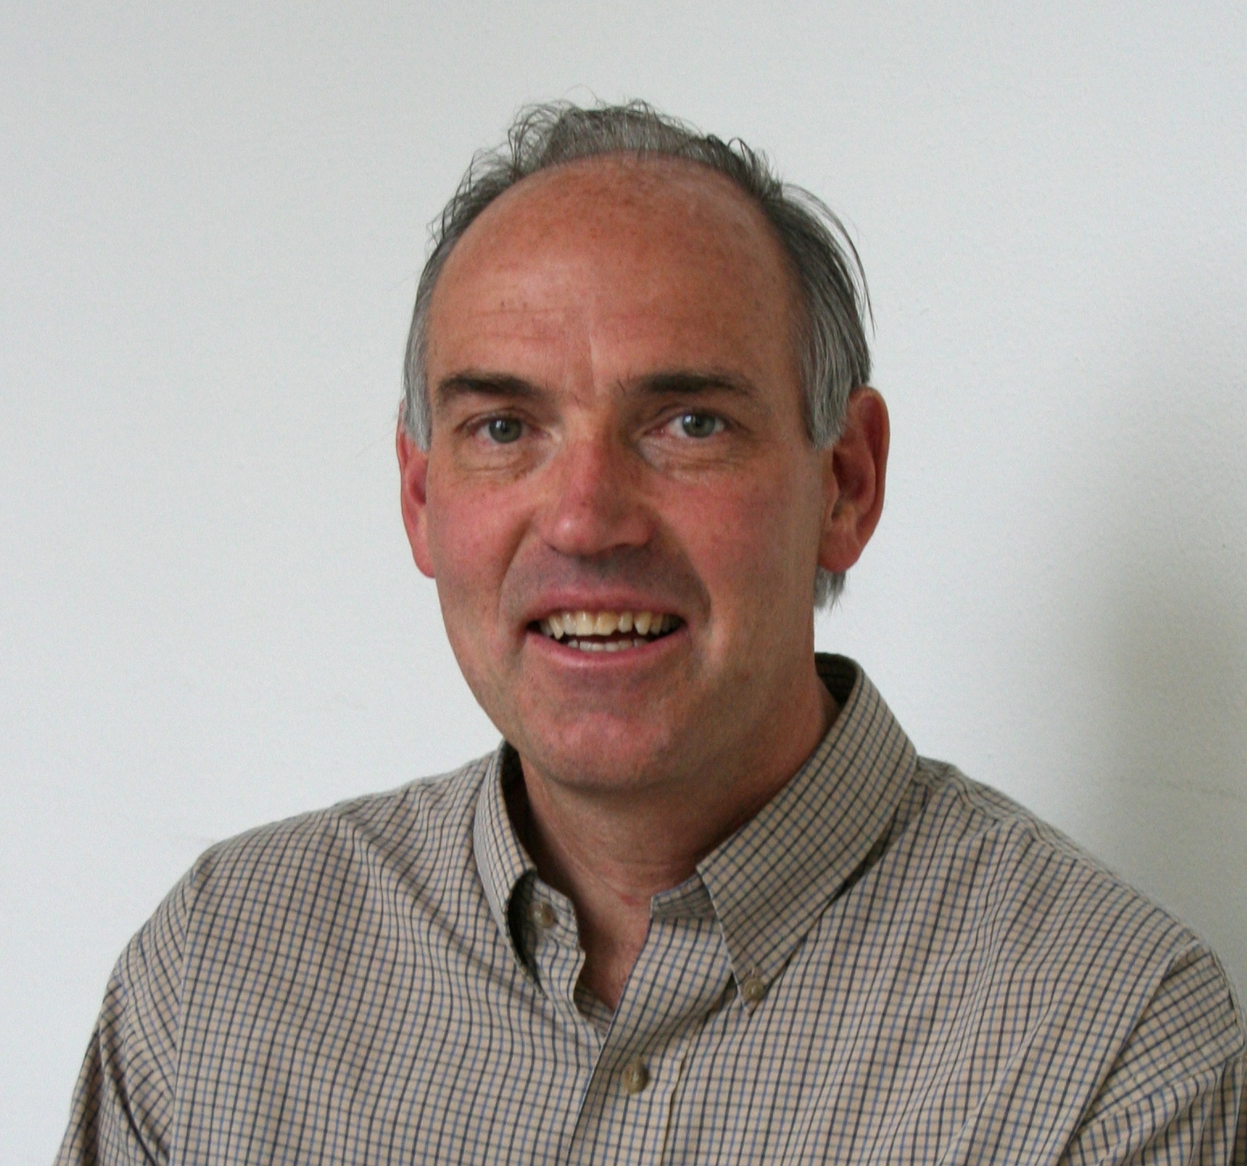

|  |  |
| --- | --- |
| Name: Sigurd Skogestad Born: 14 Aug. 1955  Nationality: Norwegian  E-mail: skoge@ntnu.no  Present position: Professor of Chemical Engineering at NTNU |  |

Education

1978: M.S. (Siv.ing.) in Chemical Engineering at NTNU, Trondheim

1987: Ph.D. in Chemical Engineering at California Institute of Technology (Caltech).

Main fields

Process control, modelling and optimization

Experience

1979: Military Service at Norwegian Defence Research Center (FFI).

1980-83: Research engineer at Norsk Hydro's Research Center in Porsgrunn, Norway.

1983-87: Ph. D. student and Research Assistant at California Institute of Technology

1987- present : Professor in Chemical Engineering at NTNU (Dept. Head 1999-2009)

1994-95: Visiting Professor at University of California, Berkeley (Departments of Chemical Engineering and Mechanical Engineering).

2001-02: Visiting Professor at University of California, Santa Barbara (5 months).

2015- present: Director of SFI SUBPRO (PhD program with funding of more than 35 millIon NOK per year)

Supervision

38 completed PhD theses as main supervisor. Currently supervising 6 PhDs and 1 postdoc

175 completed MS theses as main supervisor.

Publications

About 220 international journal publications and 320 conference publications

H-index (ISI): 44 (2018).

H-index (Google scholar): 64 (2018)

Author of 2 international text books. (1) S. Skogestad and I. Postlethwaite, ``Multivariable feedback control - analysis and design,'' Wiley (1996); 2nd Edition (2005). (2) S. Skogestad, ``Chemical and energy process engineering'', CRC Press (2009).

No. of citations to book Multivariable feedback control: 7889 (Google scholar, 2018)

## Awards and Honors

* *Innstilling* awarded for the *Siv.ing.* degree (result communicated to Norwegian King), 1979.
* *Fullbright Fellowship* (travel grant) awarded for graduate studies at Caltech, 1983.
* *Utdanningsstipend* awarded from Univ. of Trondheim for graduate studies at Caltech, 1983.
* Elected member to *The Norwegian Academy of Technical Sciences* (NTVA), 1988.
* *Ted Peterson Best Paper Award* by the CAST division of AIChE (The American Institute of Chemical Engineers), 1989.
* *George S. Axelby Outstanding Paper Award* by the Control System Society of IEEE (The Institute of Electrical and Electronic Engineers), 1990.
* Elected member to *Det Kongelige Norske Vitenskapers Selskab*, 1991.
* *O. Hugo Schuck Best Paper Award* by the American Automatic Control Council, 1992.
* Best paper award for paper published in 2004 in Computers and chemical engineering (2006)
* Member of IFAC Technical Board, 2008-2014.
* Elected member of [Process Automation Hall of Fame,](http://www.nt.ntnu.no/users/skoge/publications/2011/hall-of-fame) , Delaware, USA, 23 May 2011
* Elected Fellow of American Institute of Chemical Engineers (AIChE), 2012.
* Elected Fellow of International Federation of Automatic Control (IFAC), 2014.
* Elected member to *The Norwegian Academy of Science and Letters*, Oslo, 2015.
* Honorary member of *Norwegian Society of Automatic Control,* 2015.